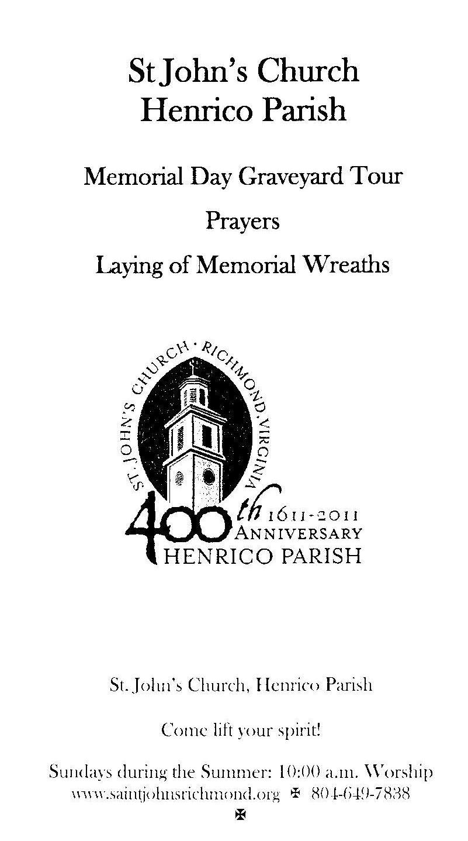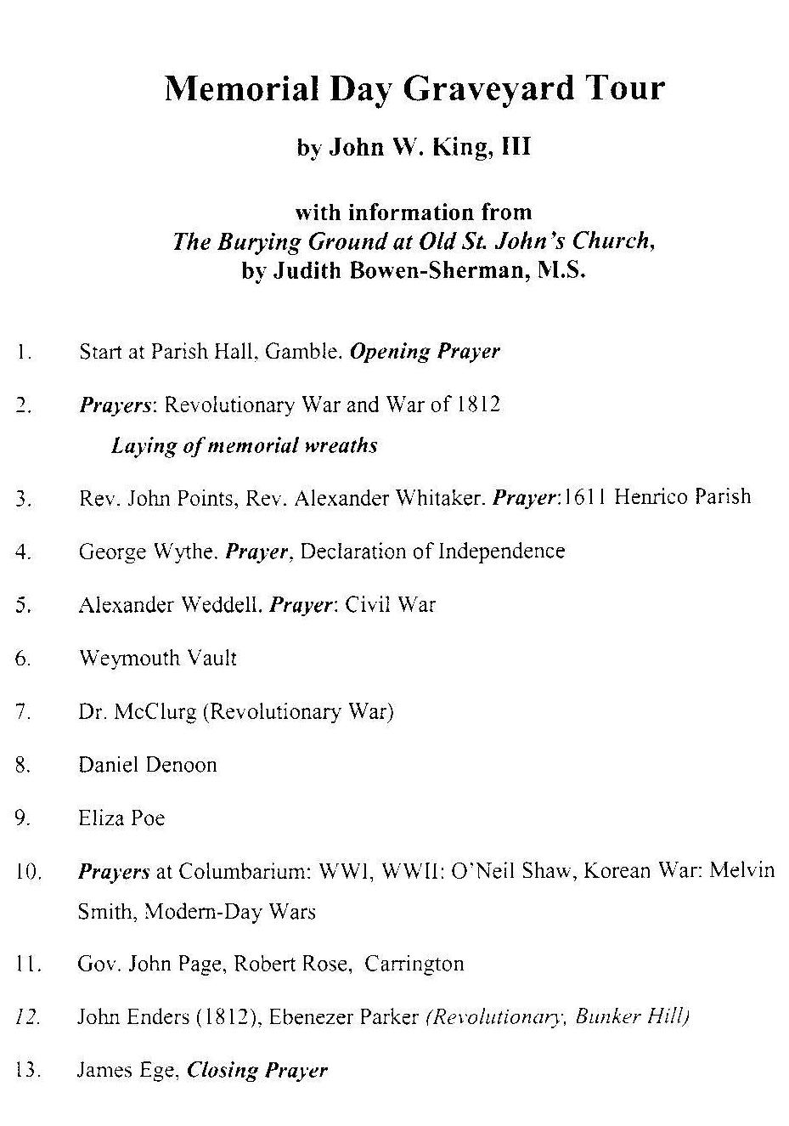

In sequential order the following were the designated wreath-bearers:
1) The Virginia Society Order of Founders & Patriots of America, honoring Rev. Alexander Whitaker (first rector of Henrico Parish) and Rev. John Points (Taylor Cowardin)
2) The Society of Colonial Wars in the State of Virginia, honoring Virginia Gov. John Page, who served in the Virginia Militia during the French & Indian War, the American Revolution, as a member of U.S. Congress and as Virginia's 13th Governor (Doug Rucker)
3) The Sons of the Revolution in the Commonwealth of Virginia, honoring George Wythe, signer of the Declaration of Independence, Continental Congressman, prominent judge and classical scholar (Matson Roberts, Doug Payne)
4) The Virginia Society of the Sons of the American Revolution, honoring the many Revolutionary War patriots buried at St. John's who served in the war securing our independence as a nation (location: VSSAR marker) (Mark Brennan)
5) The Society of the War of 1812 in Virginia, honoring the many patriots buried at St. John's who served in the War of 1812 (location: War of 1812 marker) (Mike Lyman)
6) The Virginia Society, Military Order of The Stars and Bars, honoring Rev. Alexander Watson Weddell who served as a Captain in the 41st Virginia Infantry during the War Between the States, and later, as Rector of St. John's Church (Allen Mock, Taylor Cowardin)

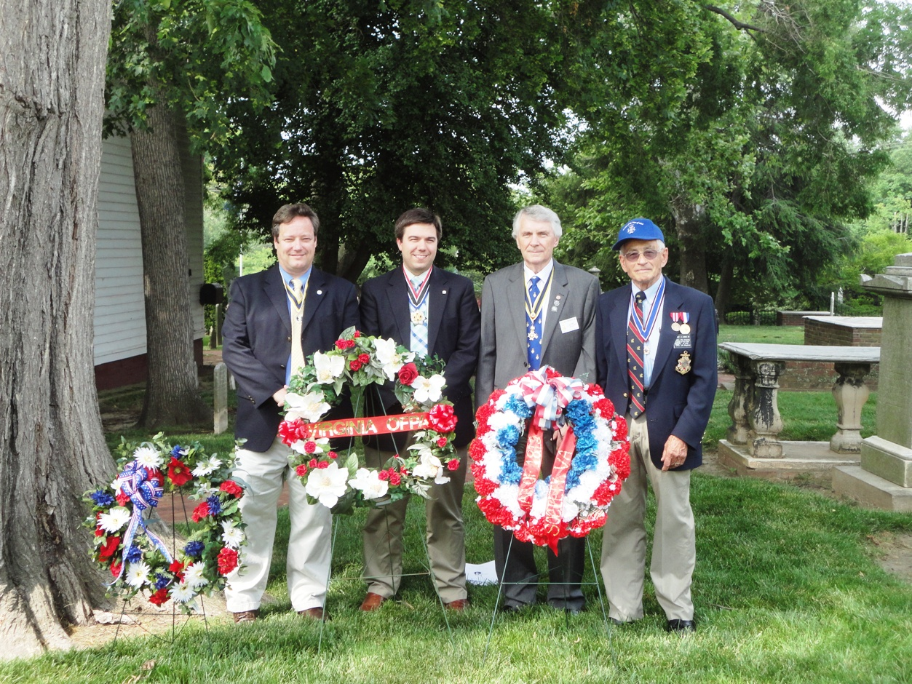
L/R Mark Brennan, President of VASSAR; Taylor Cowardin, Governor of Order of Founders & Patriots of America and a member of the War of 1812 Society; Bill Broadus, Secretary of VASSAR; and Mike Lyman, Past president of the VA Society of the War of 1812,
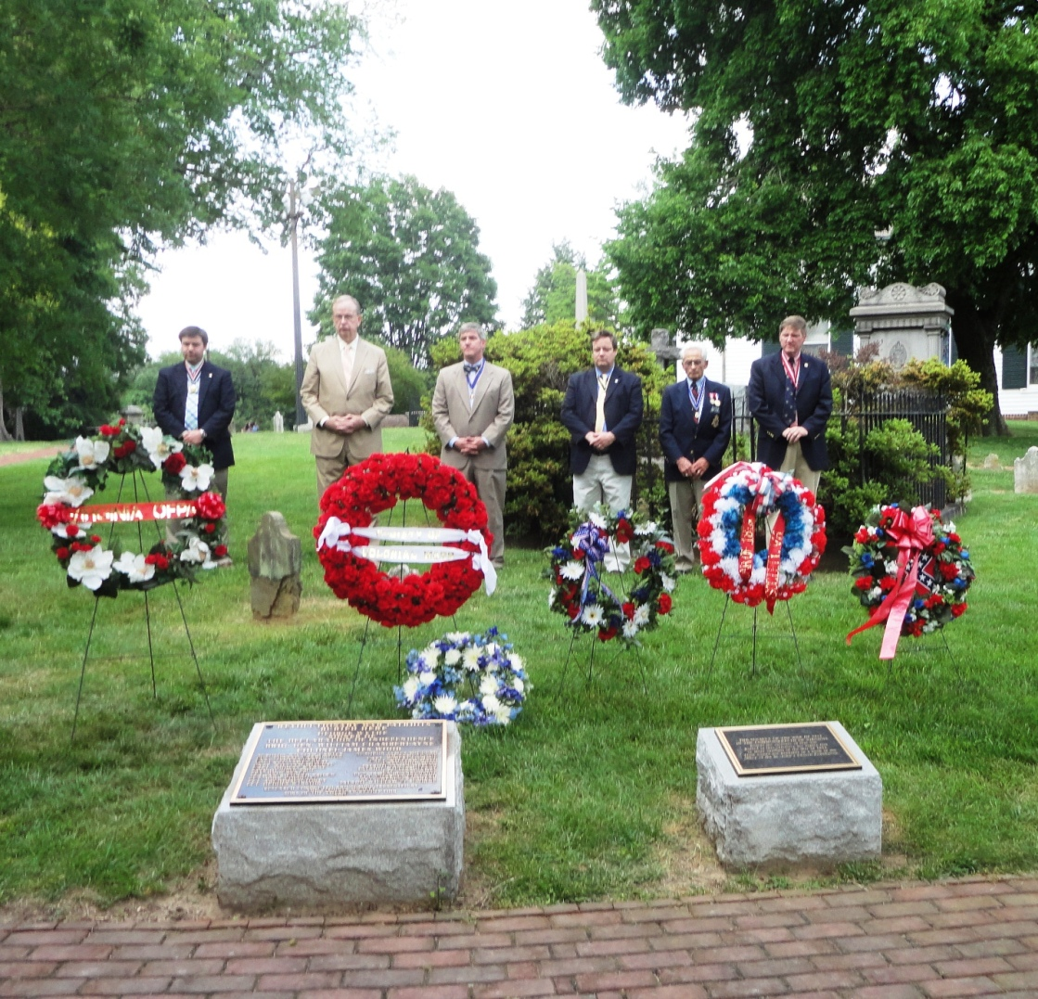
The wreath Presenters behind their wreaths and the Revolutionary War and War of 1812 plaques
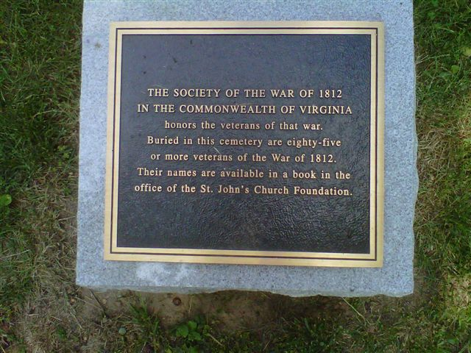

The plaque honoring the war of 1812 Veterans interred in the St John's church Cemetery that was presented by the Society in 2009 to the St John's Church Foundation

