.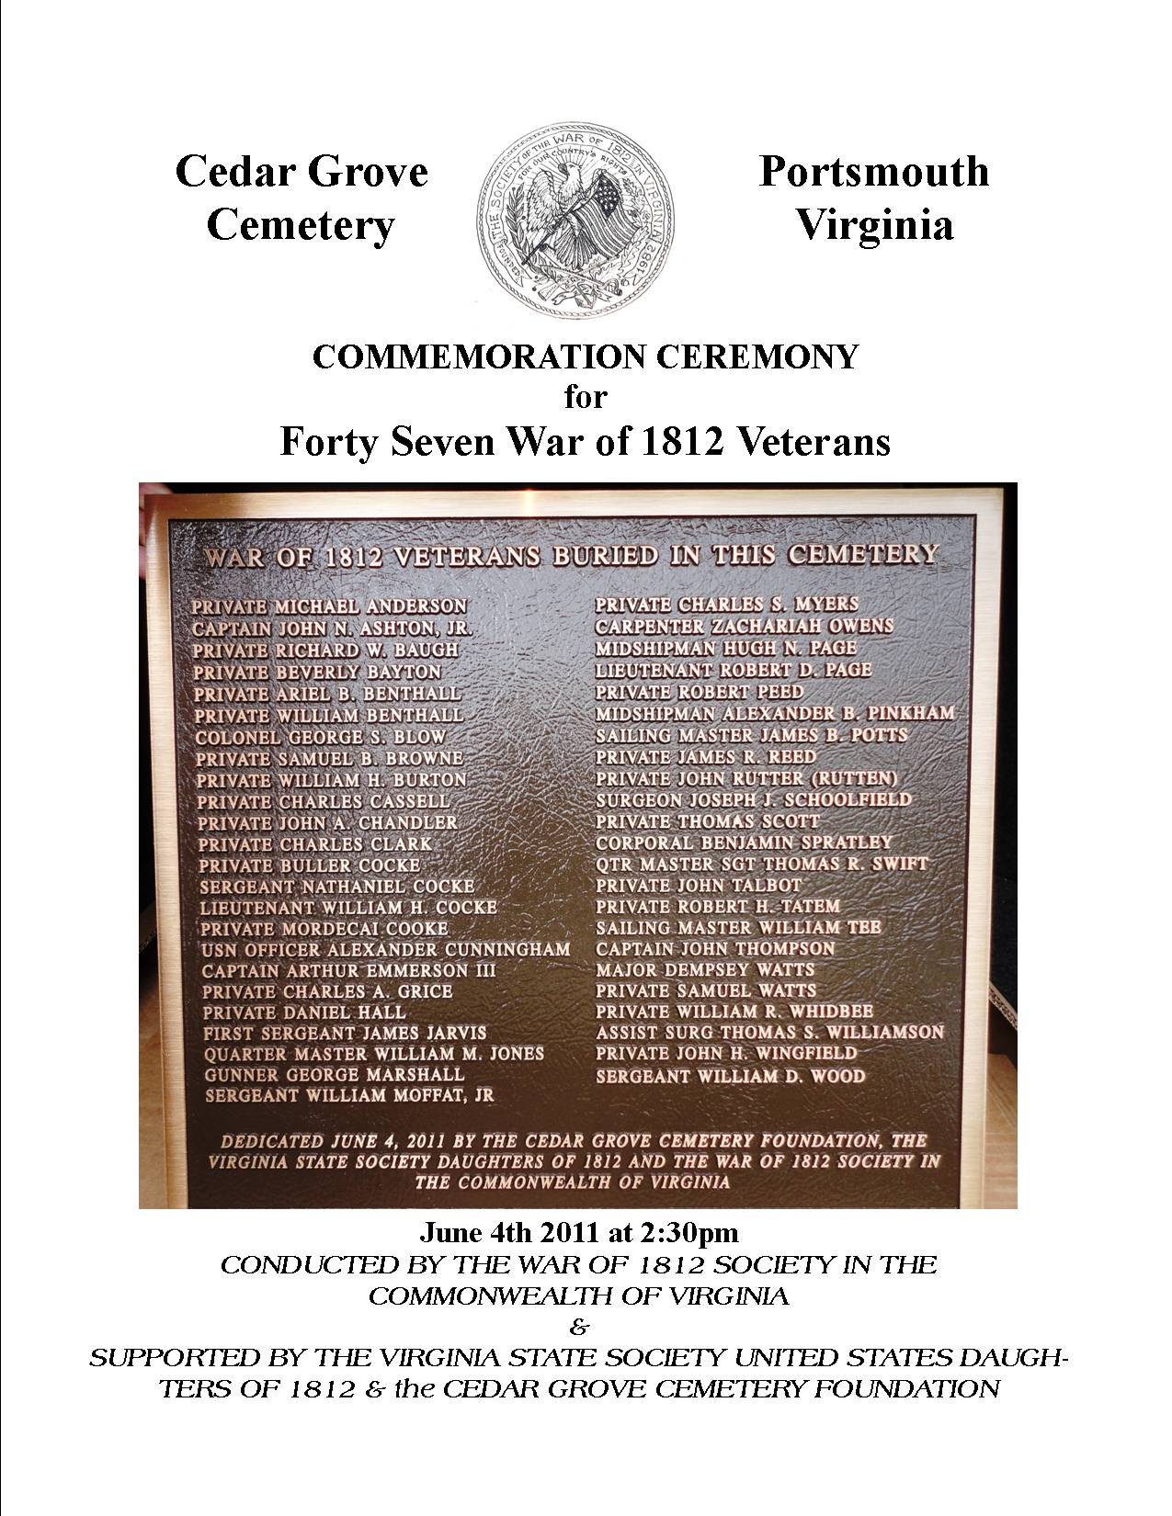
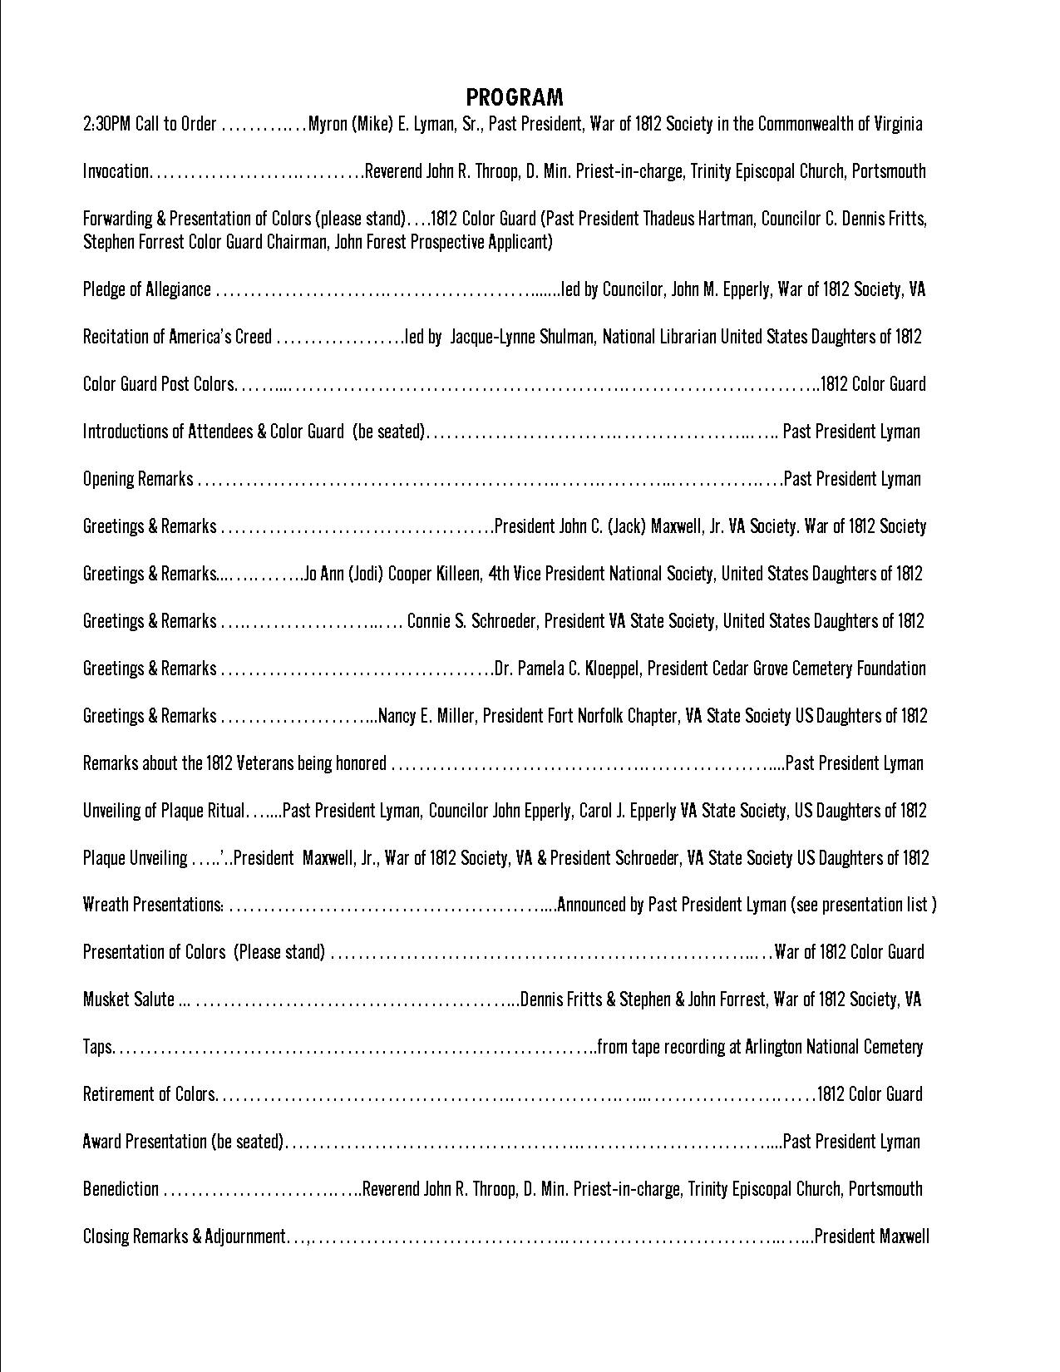
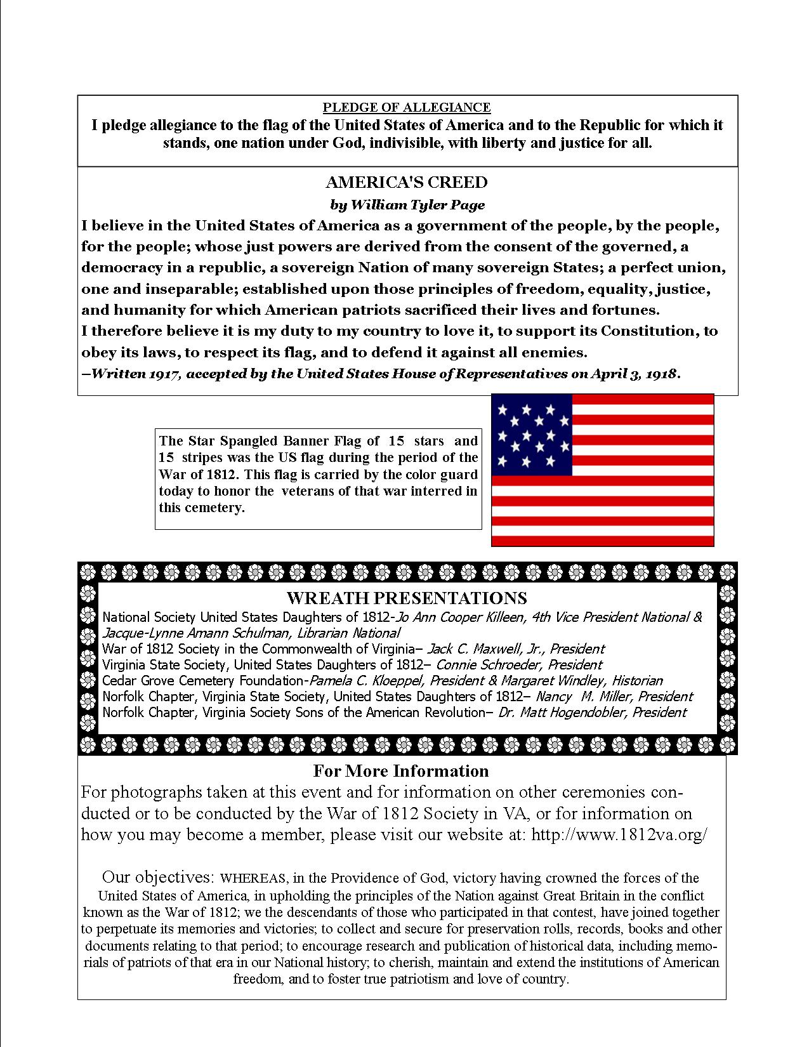

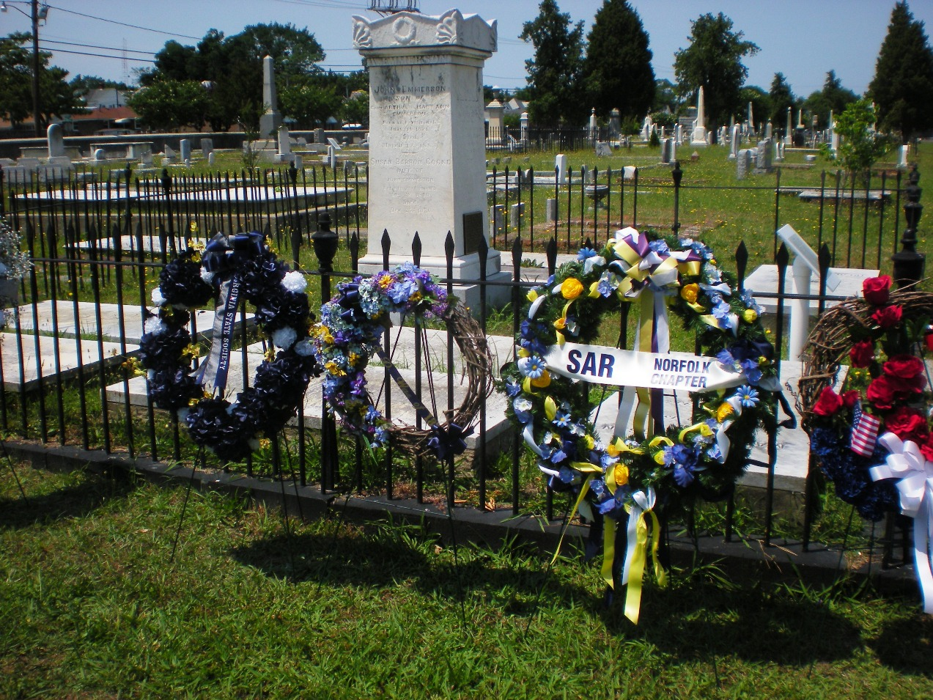
The above shows a portion of the Cedar Grove Cemetery. In the foreground some wreaths are positioned next to the fence of 1812 veteran Captain Arthur Emmerson, the acclaimed hero of the Battle of Craney Island. (Photo supplied by Schulman)

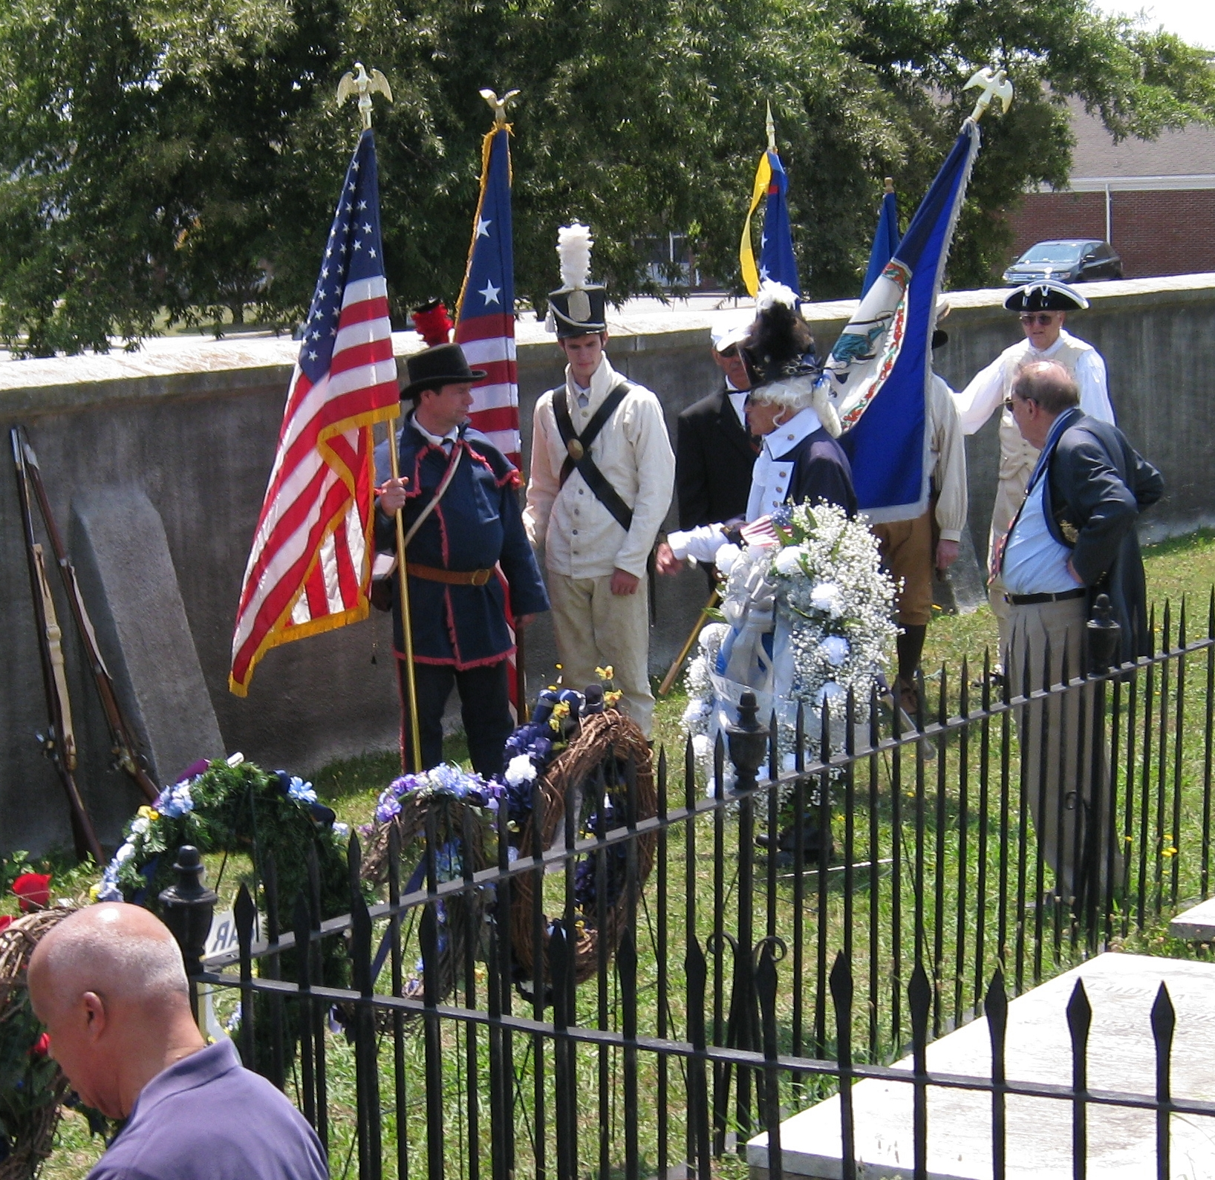
Prior to the commencement of the ceremony Master of Ceremonies, Mike Lyman instructs the Color Guard on the ceremony's procedures. He is dressed as the Captain of the Richmond Light Infantry Blues.. President Maxwell observes on the right. ( photo by Hogendobler)

.

