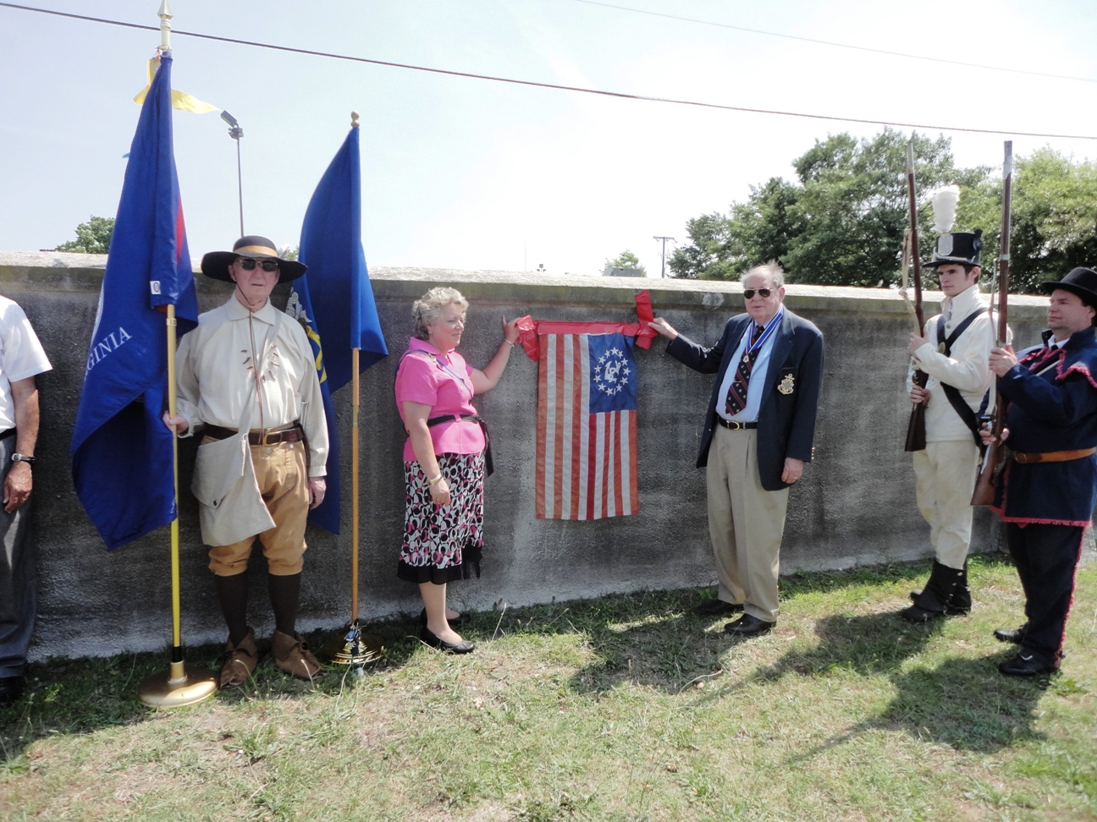
During the ceremony the plaque is unveiled that lists the names of 47 1812 buried in the cemetery. Above Connie Schroeder, President of the Fort Norfolk Chapter VA Soc. N.S.,U.S.D.of 1812 and VA Society, War of 1812 President, Jack Maxwell prepare to remove the cover. Holding the VA Society colors is Past President Thadeus Hartman.
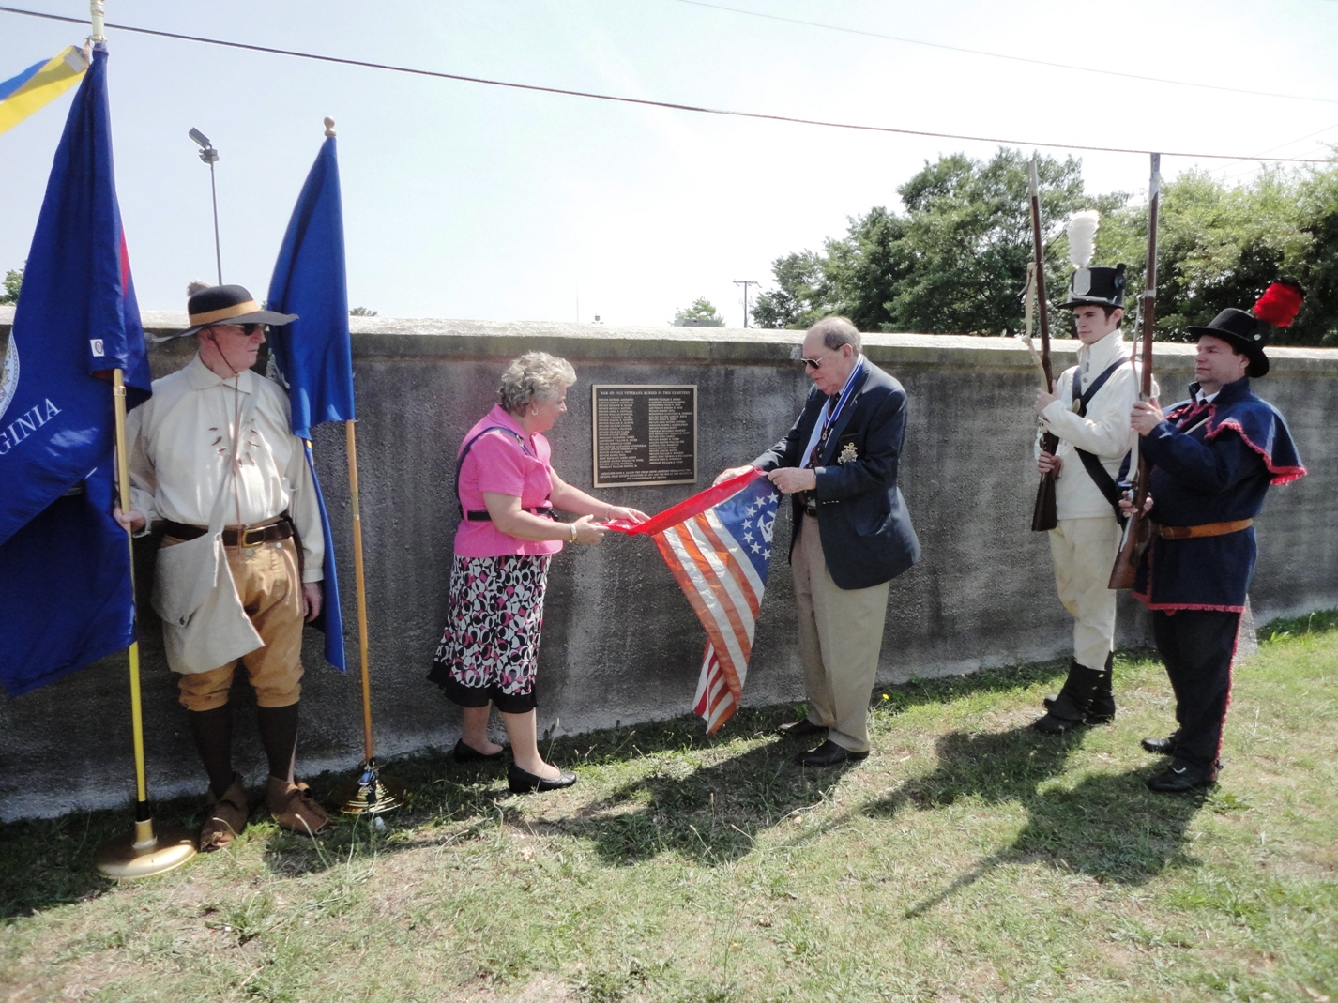
The plaque is unveiled. John & Steven Forrest on the right present arms.
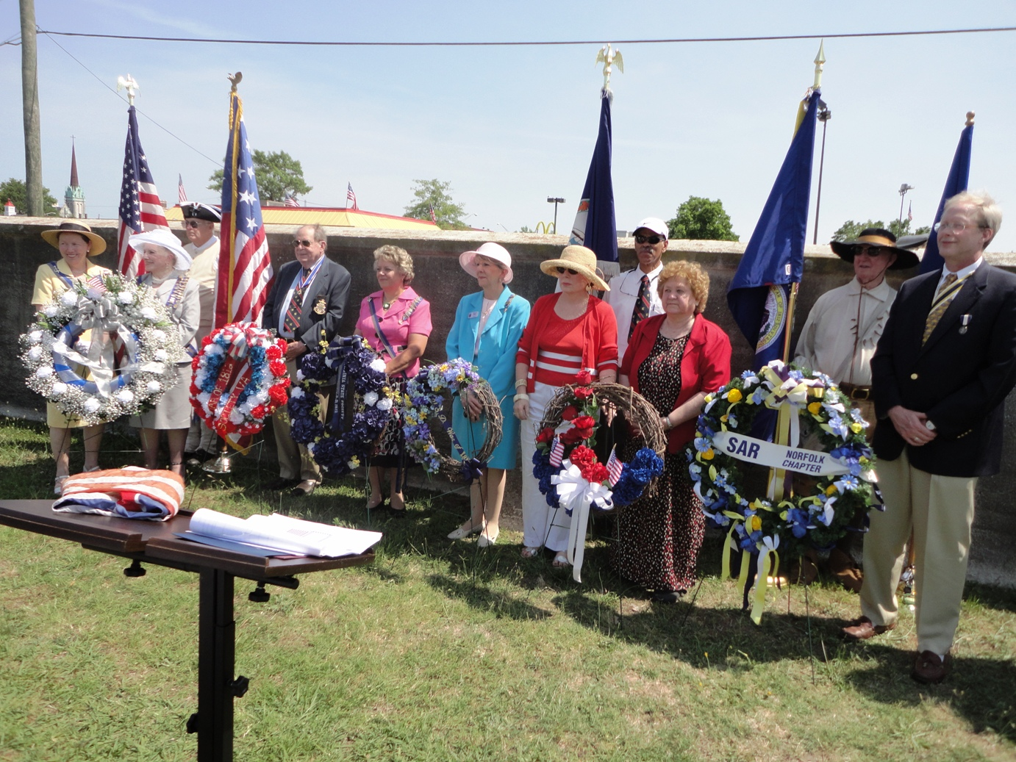
The presenters of the wreaths as listed on the program are shown behind their wreaths.
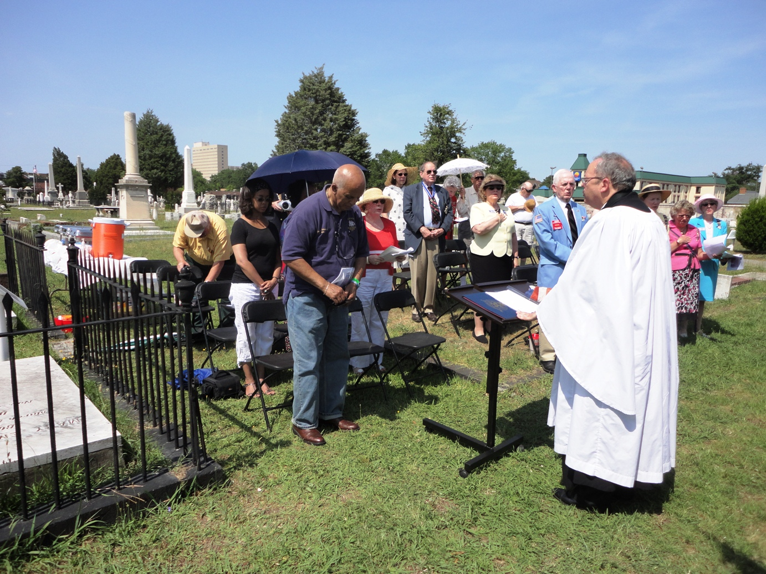
Reverend and Priest in Charge, John R. Throop of the Trinity Episcopal Church in Portsmouth provided both the Invocation and Benediction during the ceremony.
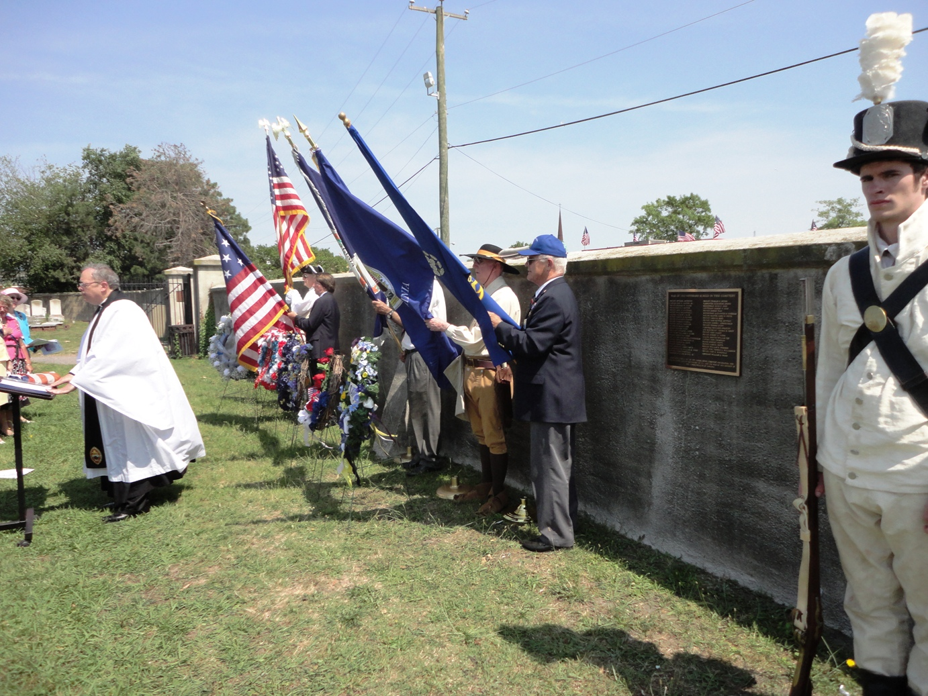
The Color Guard presented the colors during portions of the ceremony
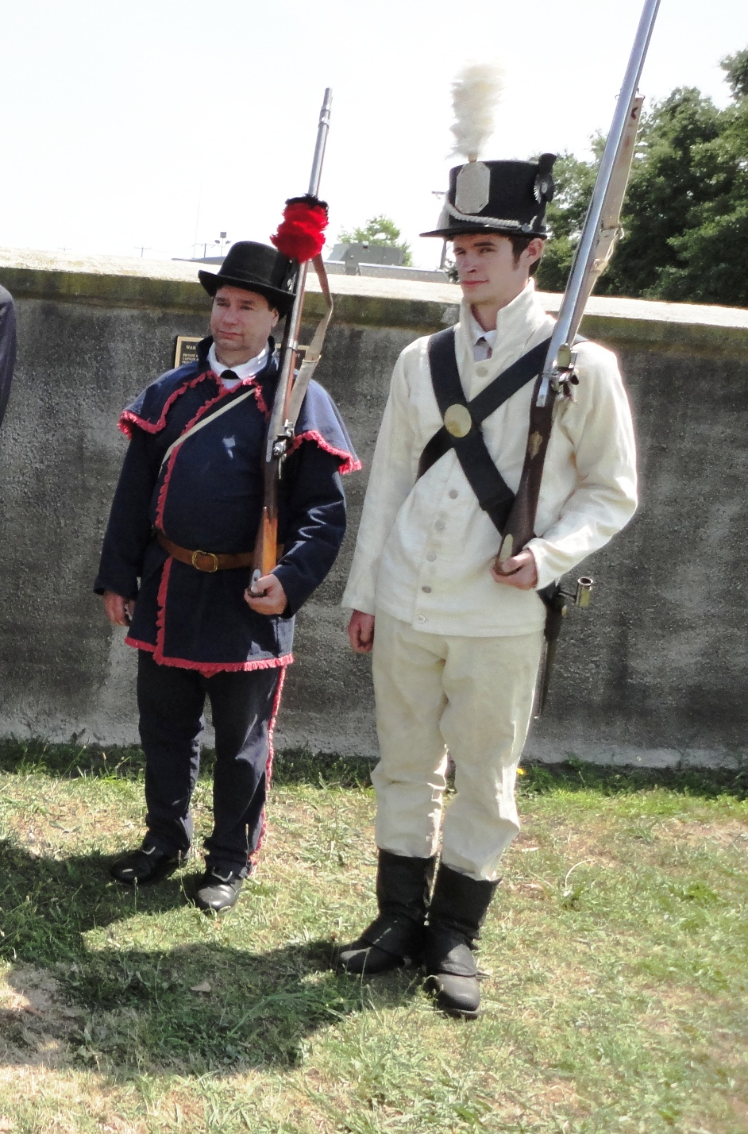
Steven Forrest dressed as a Virginia Militiaman and his son John dressed as a Regular Army soldier wearing the summer uniform.
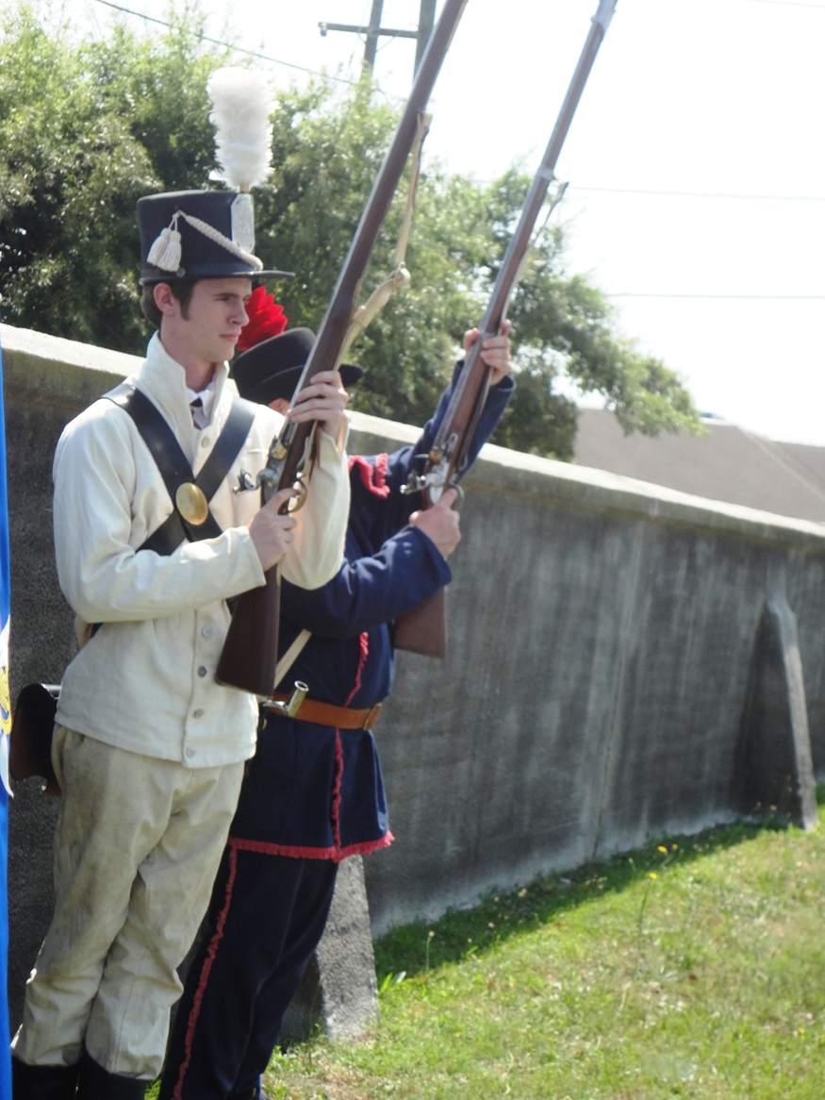
They prepare to fire the musket salute to honor the interred War of 1812 veterans

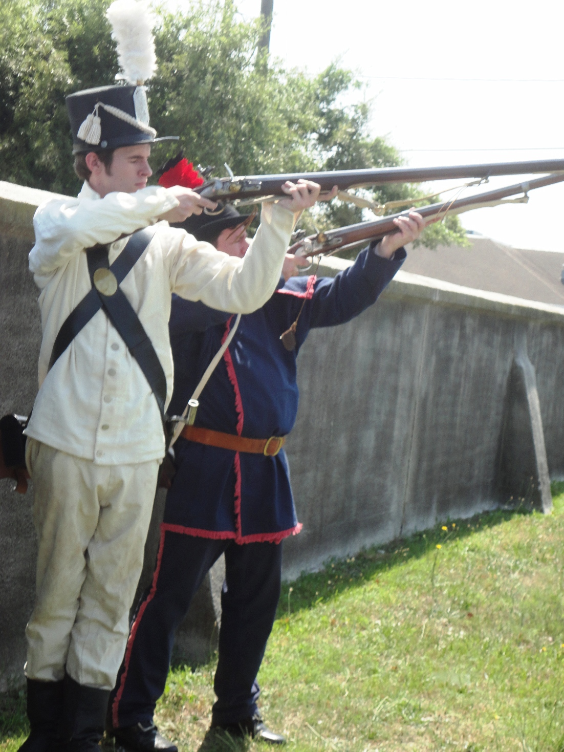
Then they fire three volleys
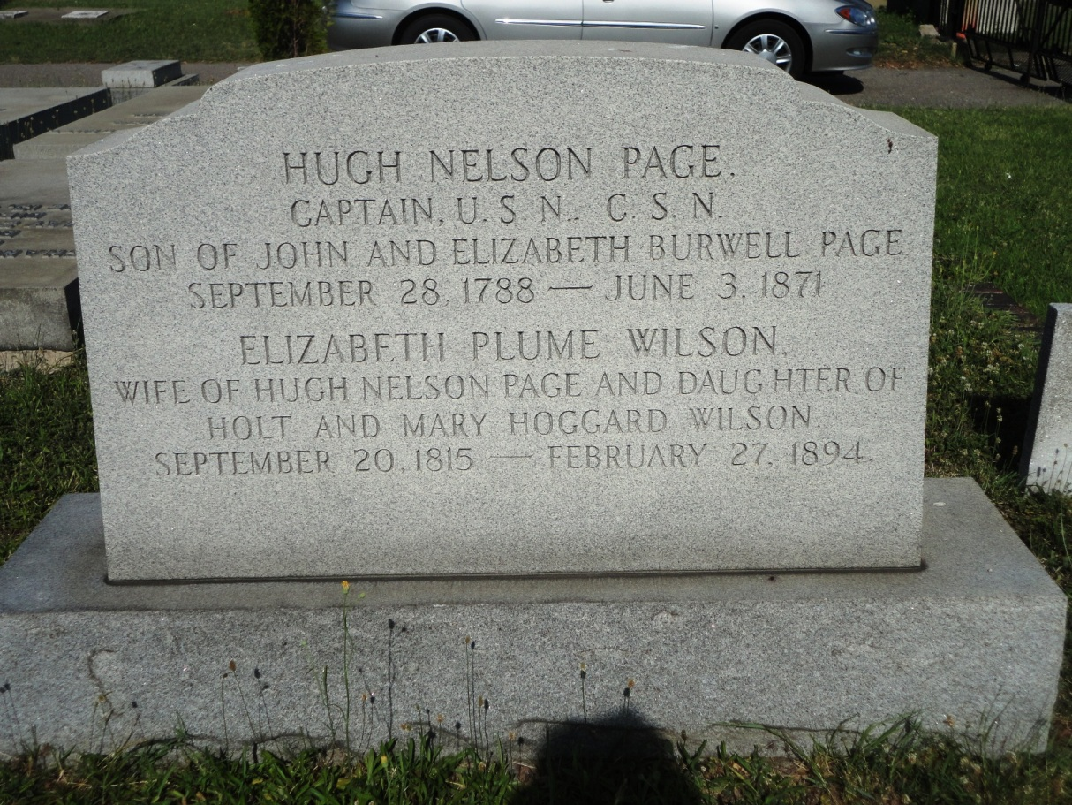
This is the gravestone of Captain Hugh Nelson Page, a nationally recognized veteran of the War of 1812 who is interred in the cemetery. He was especially honored for his service in the ceremony.

PAGE, Hugh Nelson, was born in Norfolk in 1787, son of John Page of Caroline County and Elizabeth Burwell and died in Princess Anne County on 03 Jun 1871. He entered the United States Navy as Midshipman on 01 Sep 1811 and was assigned to duty on board the schooner Tigress. In June, 1812, he was ordered to the gunboat squadron, stationed at Norfolk for the protection of the harbor. On 13 Aug 1812, he was ordered to Commodore Chauncey's squadron, on Lake Ontario; but left this, and joined Commodore Perry, on Lake Erie--volunteers for this service having been called for. He took an active part in the Battle of Lake Erie on the schooner Somers. The sea battle began at 12 midnight and finished at 3 P.M. that same day. In this action he behaved with great gallantry, and was wounded in the hand. He was placed in charge of the prisoners, and had the honor of bearing to General Harrison, who was then stationed at the mouth of Sandusky River, the immortal dispatch from Commodore Perry. In the spring of 1814, he went, under Commodore Sinclair, to Detroit, to convey Major Crogan's force to retake Mackinaw. Crogan was defeated, and his force was taken on board again. After destroying an English fort on Saginaw River, and burning a large schooner loaded with provisions, he proceeded to Erie to winter there. For his brilliant services on this occasion, he was voted a sword by the United States Congress, and one also by the State of Virginia. After the War he continued in the US Navy obtaining the rank of Captain before retiring in 1855. He married, in November 1838, Imogen, daughter of Guy Wheeler Esq., of Nansemond County. She died in 1847, without issue. He married, second, 13 Jul 1848, Elizabeth P. Wilson, daughter of Holt Wilson, Esq., of Portsmouth. Service source: Special issued pension records.

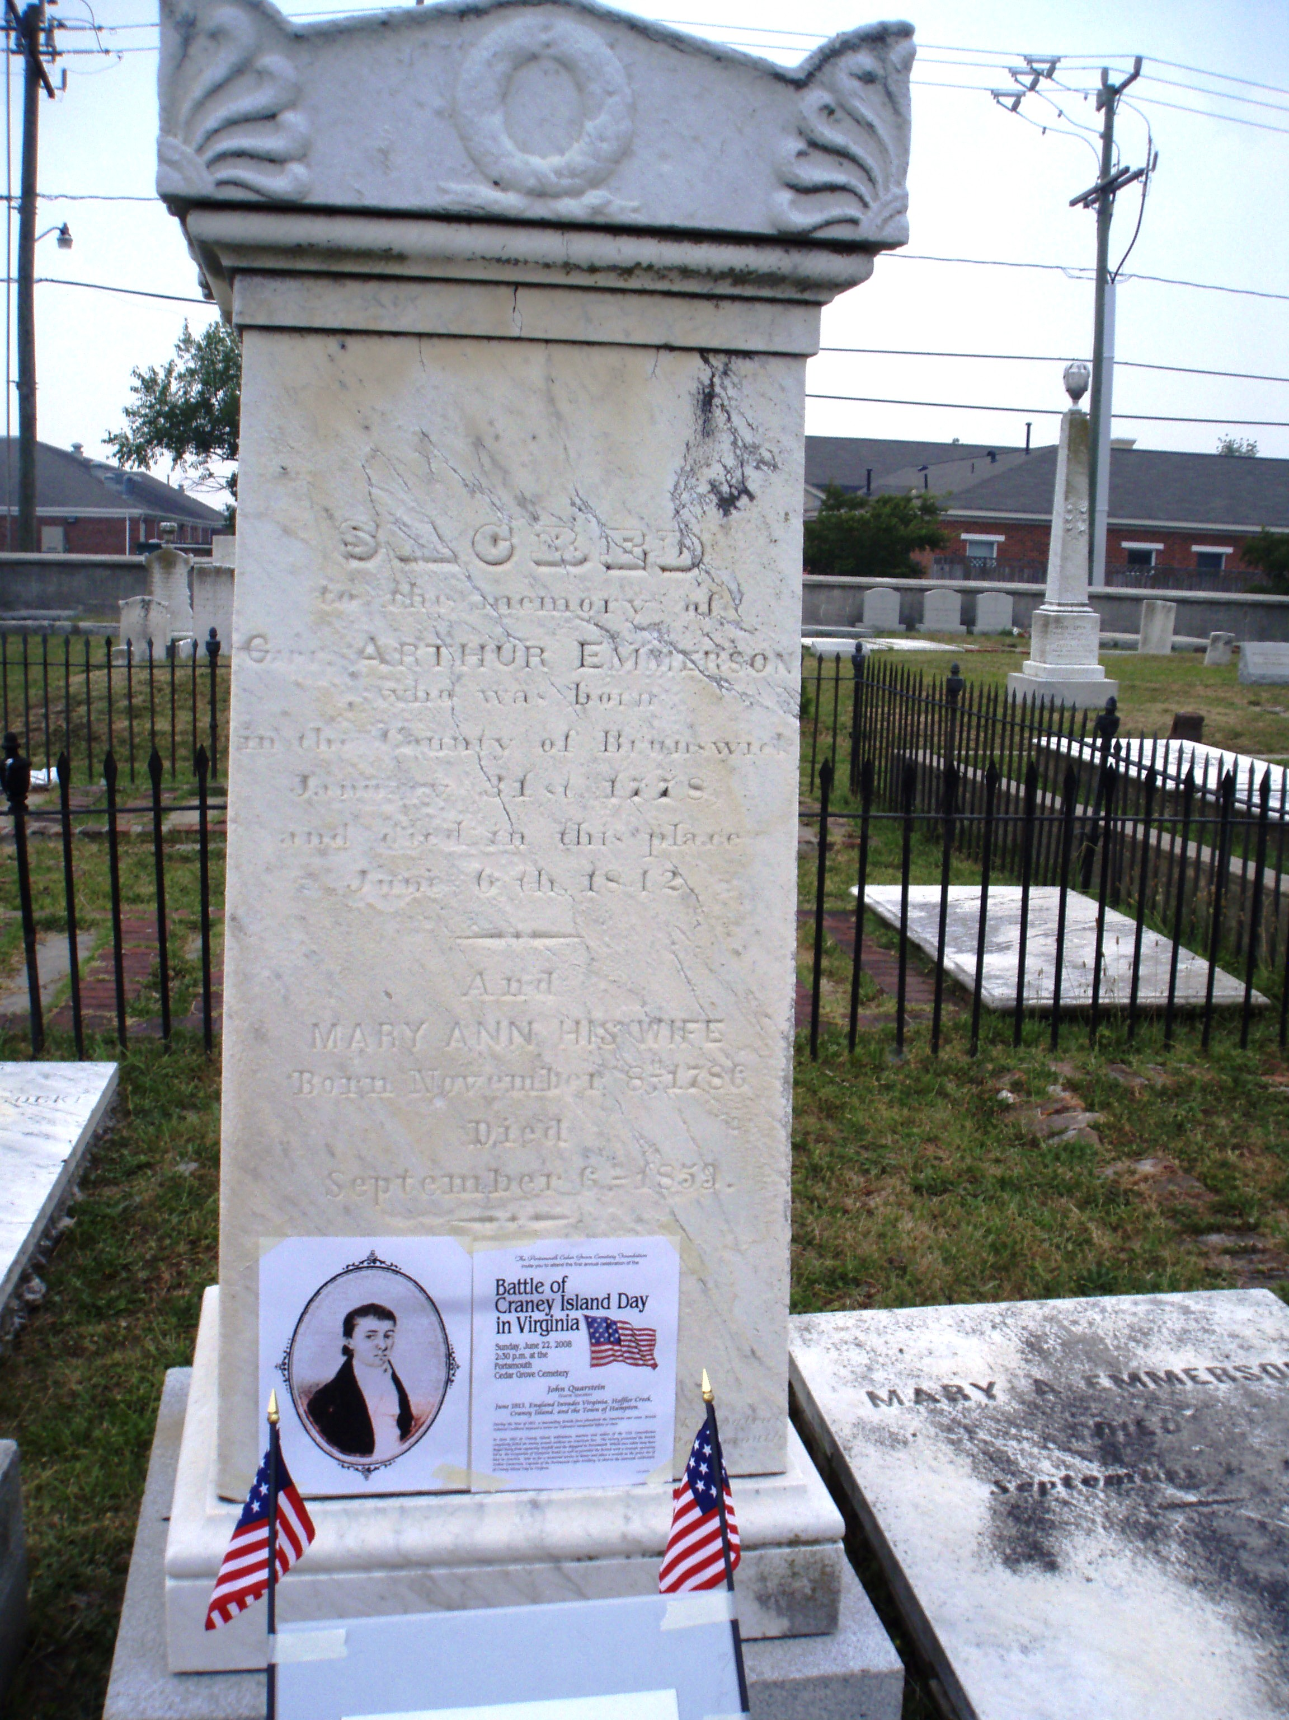
Captain Arthur Emmerson's Gravestone in the Cedar Grove Cemetery
He was especially honored in the ceremony

EMMERSON, Arthur III: was born in Brunswick County in 1778, son of Arthur Emmerson II and grandson of Reverend Arthur Emmerson, Sr. and died in Portsmouth on 06 Jun 1842. He moved with his family to Portsmouth in 1785. He served as a Captain of the Portsmouth Light Artillery Blues in the 3rd Virginia Militia Regiment in March 1813 and then again in the 6th Virginia Militia Regiment of Artillery, commanded by Lt Colonel Reade during the period April to 08 September 1813 and served again from 22 August to 25 October 1813 in the Battalion of Artillery, Virginia Militia. During the Battle of Craney Island on 22 June 1813, his unit was stationed there and delivered accurate fire on a British land force attempting to invade the island causing them to retreat with heavy casualties. Then he turned his unit's guns and attacked a British amphibious landing causing them enough casualties so they were not able to come ashore. From this action he is considered by many to be the hero of the battle.
He married Mary Ann Herbert at her parent's home in Gosport. After the War he became a merchant sea Captain. He was Captain of a schooner called "Rebecca" which was taken as a prize by a French warship, and imprisoned in Marseille. When the Trinity Church reopened in 1821 he was elected Vestryman and Warden. There is an 1812 plaque on his gravestone. Service source: NARA record 2563

