THE SOCIETY OF THE WAR OF 1812 IN THE COMMONWEALTH OF VIRGINIA CONDUCTED ITS ANNUAL CONFERENCE IN PORTSMOUTH, VIRGINIA ON JUNE 4, 2011. IT CONSISTED OF A MEETING, A GUEST SPEAKER, A LUNCHEON AND A PLAQUE UNVEILING CEREMONY

The conference was held in the Renaissance Hotel in Portsmouth. At the meeting, in addition to several reports by officers, a discussion of three plaque ceremonies and how they were to be financed and how the society would finance a pending publication of the burials of 1812 veterans in Virginia.

The speaker was member Steven Forrest, who by using a Power Point Presentation, provided information to the attendees about the War in the Hampton/Portsmouth/Norfolk area. He was assisted by his son, John. Both were dressed in 1812 attire and the details about the uniforms were a part of his presentation. The photos picture him giving the presentation.
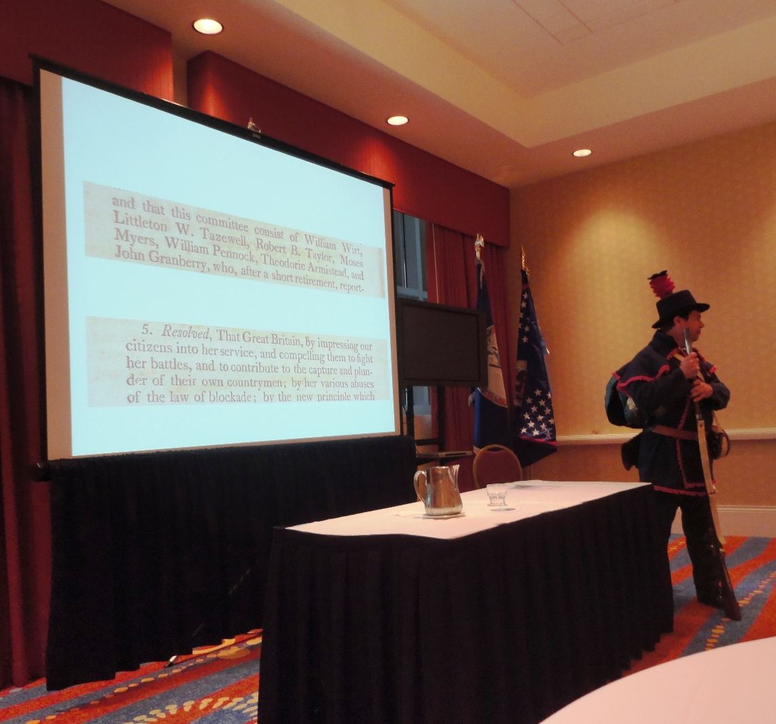
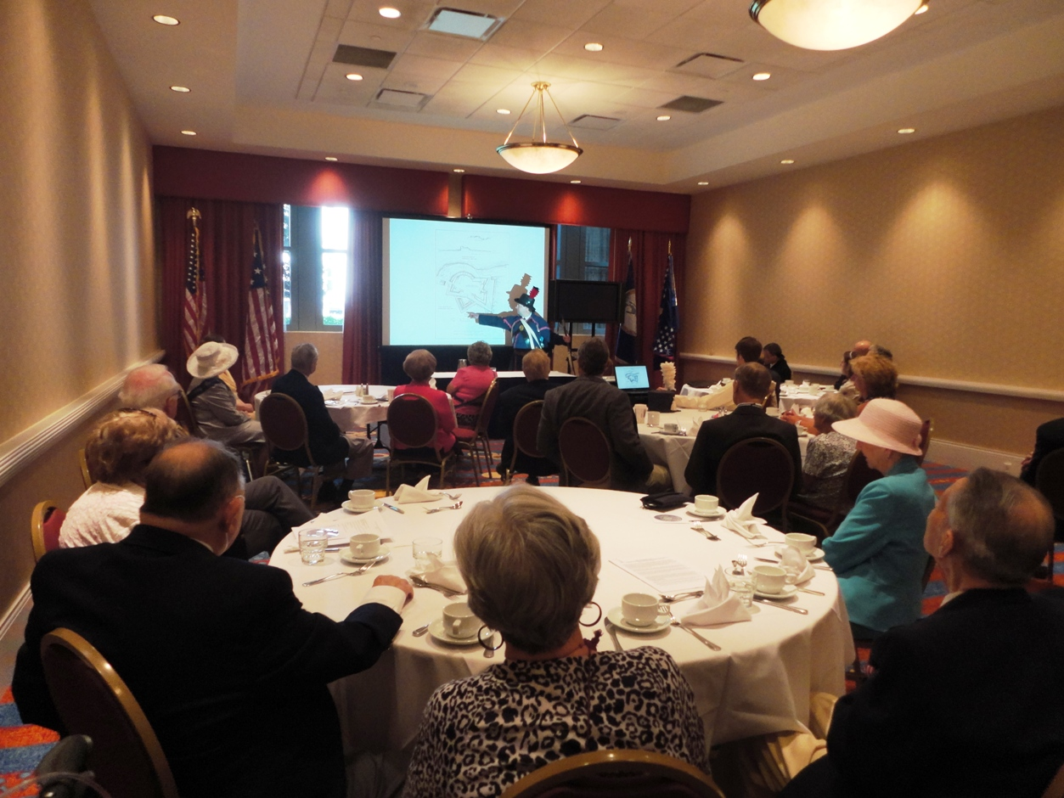

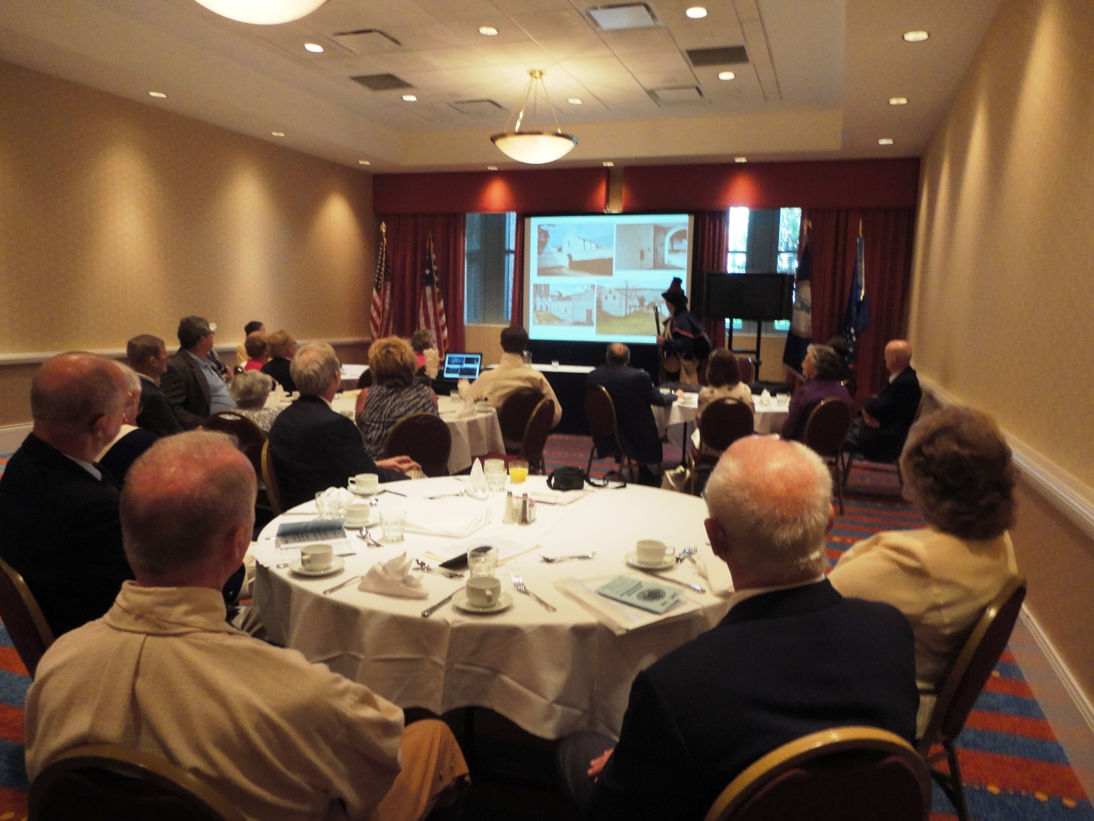

The luncheon was attended by about 35 members and guests. The photographs that follow show some of the attendees,
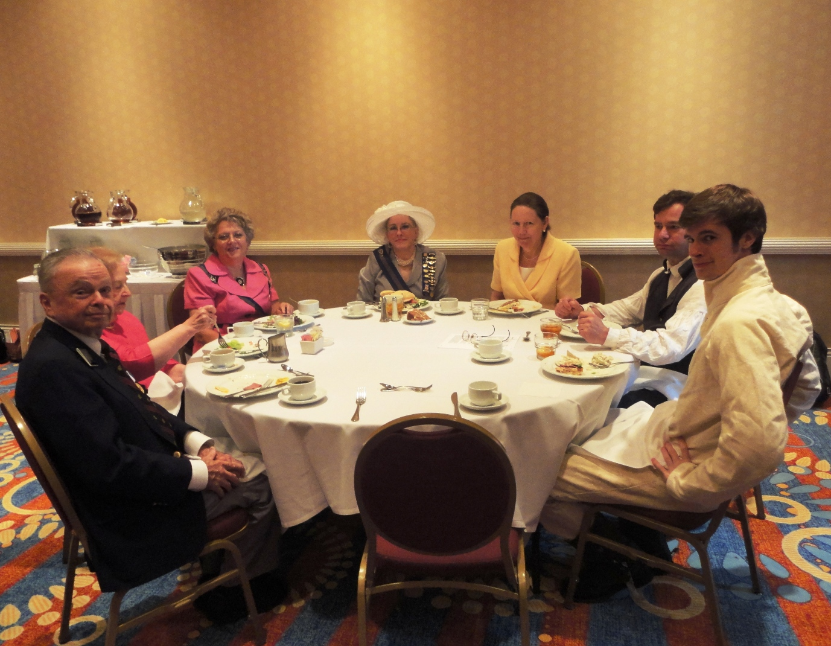

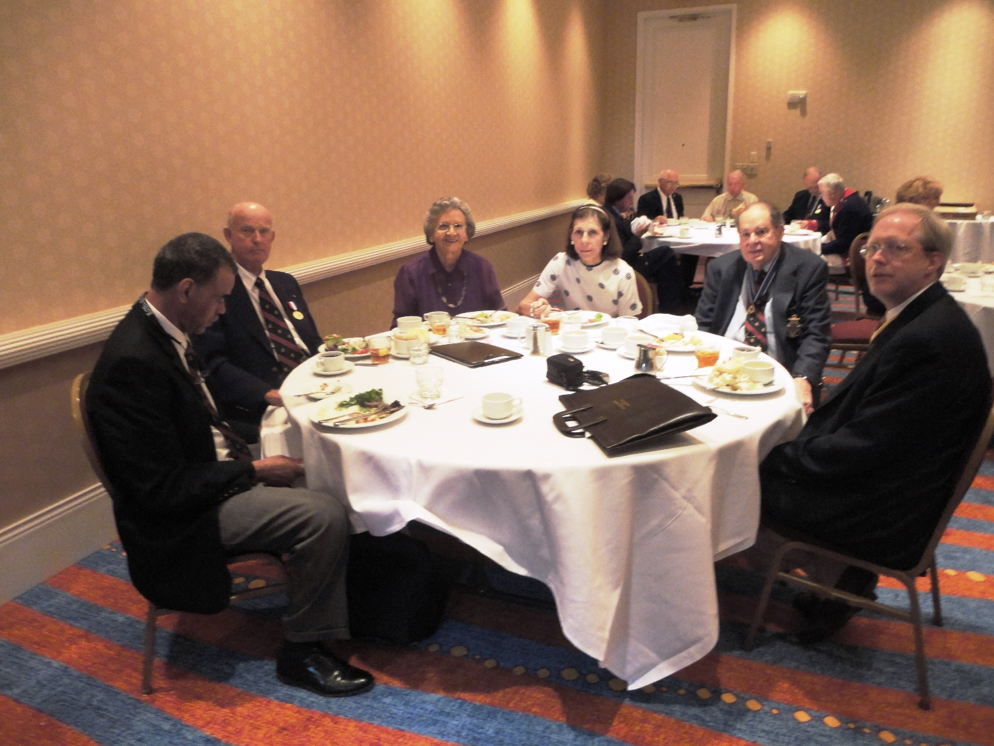

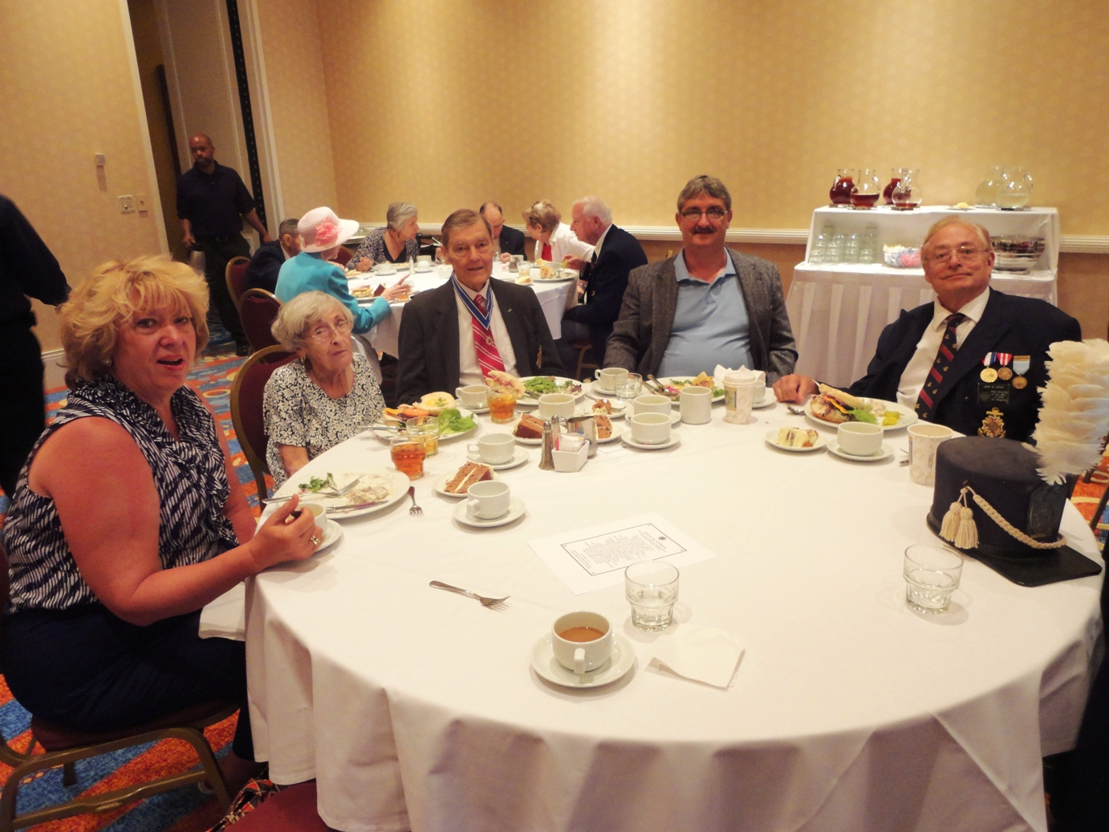

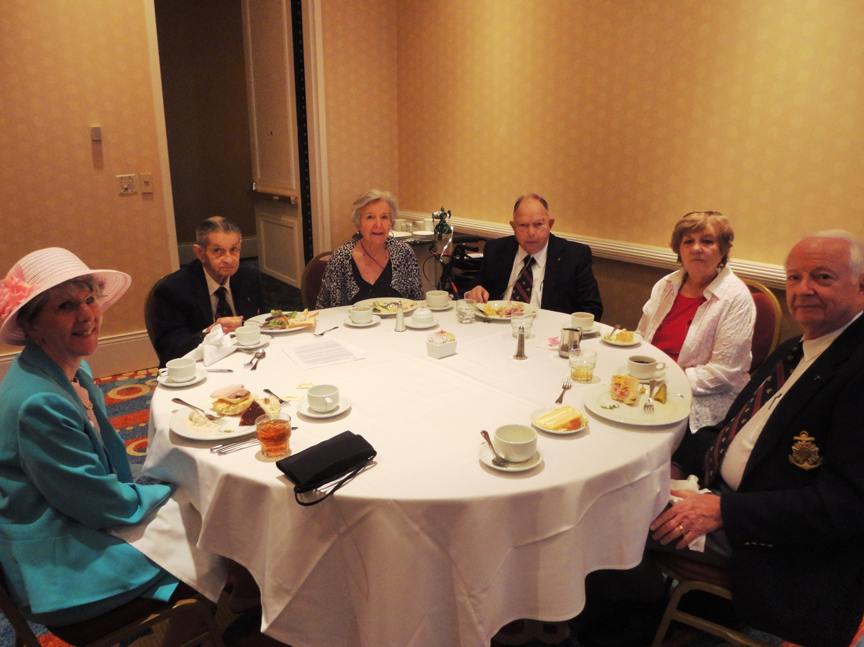
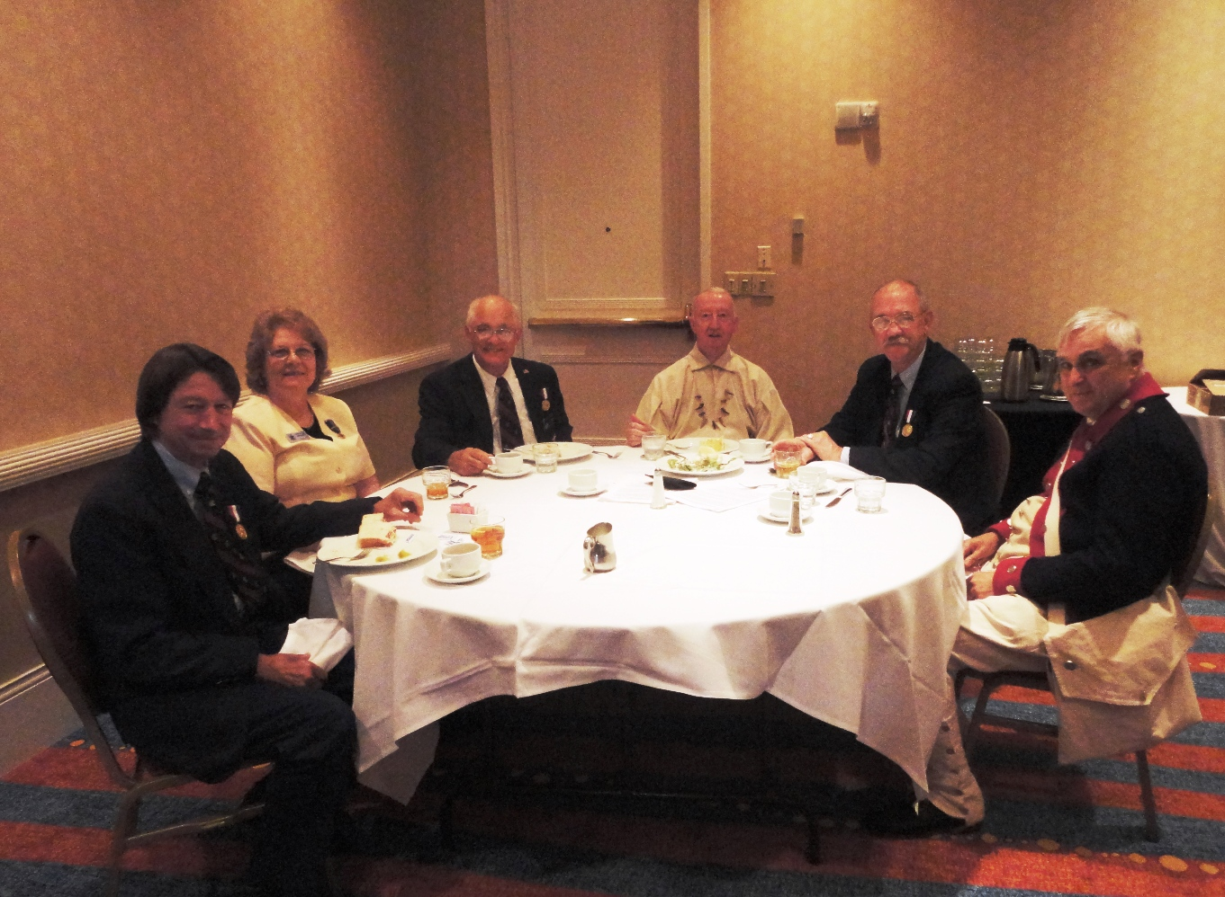

On the evening before the ceremony ten members had dinner at the Deck Restaurant in Portsmouth
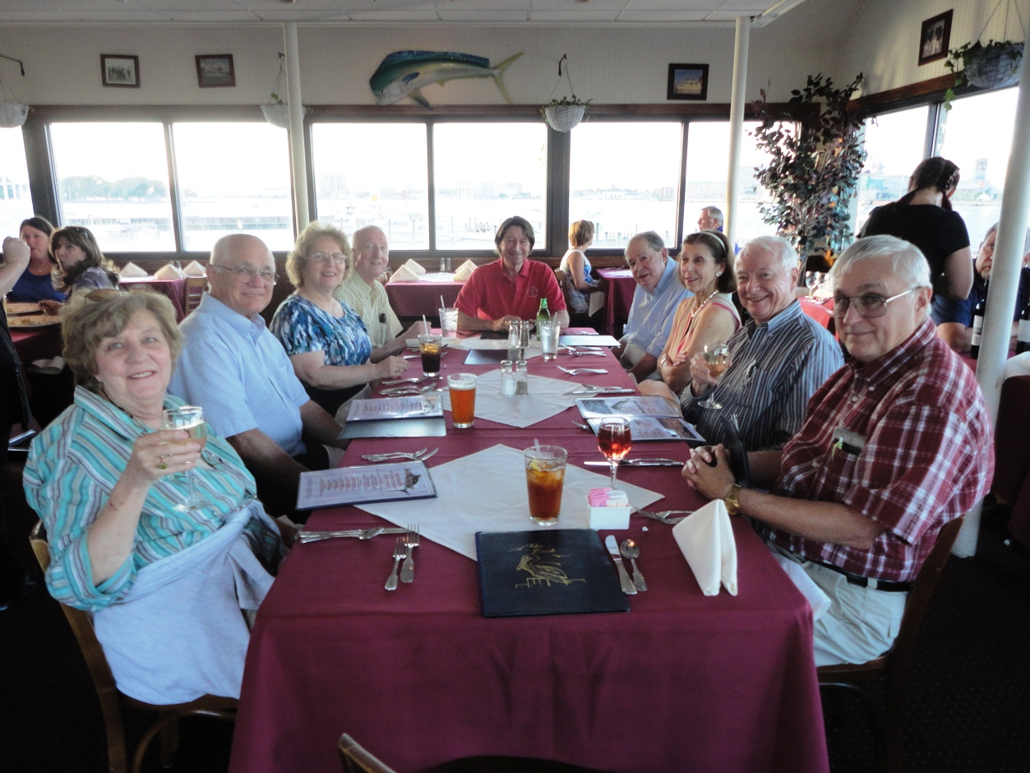

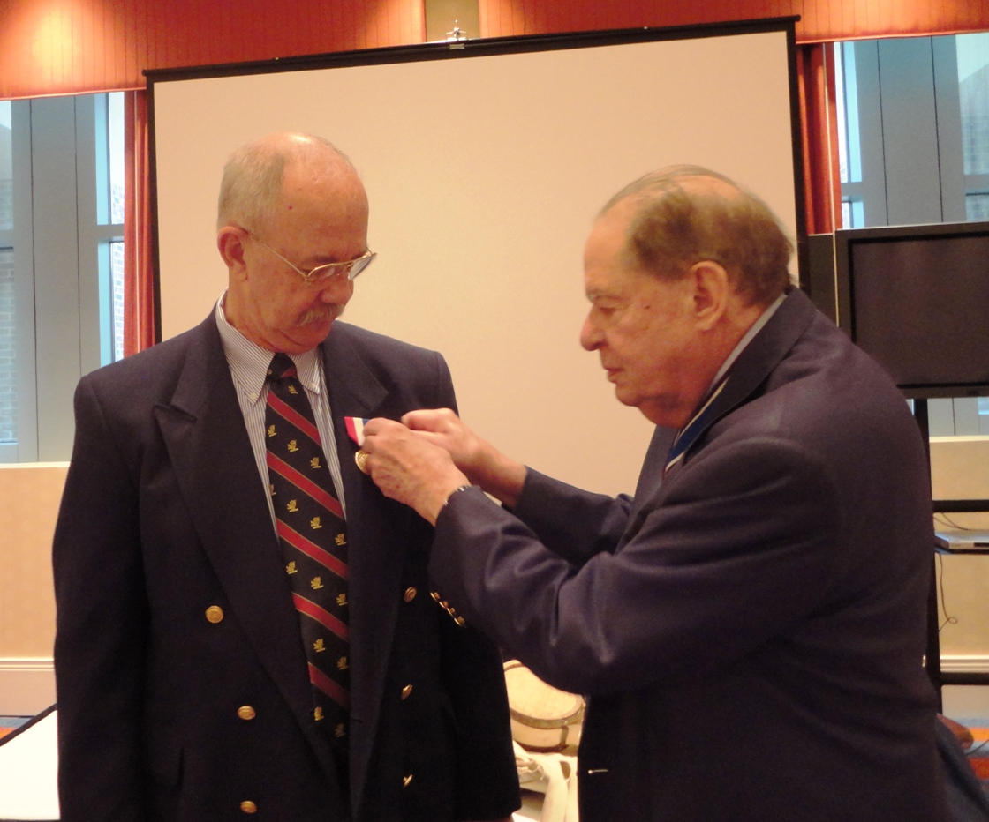

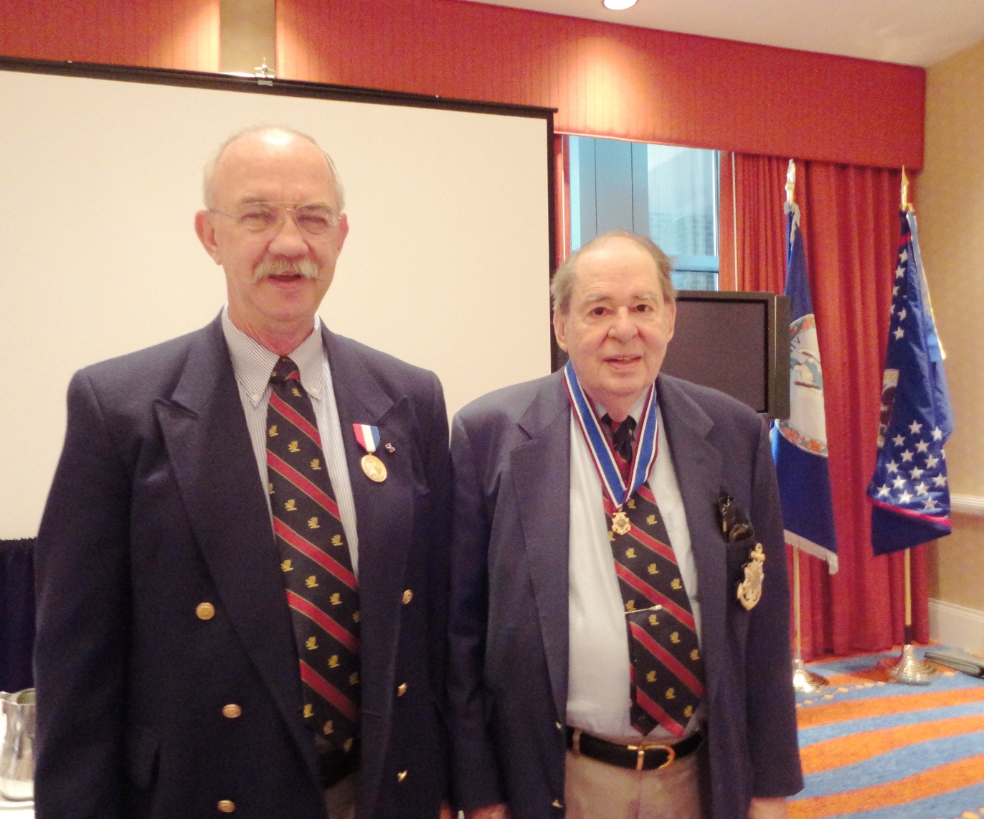
A new member is inducted into the Society during the luncheon A rosette is placed on his lapel.

