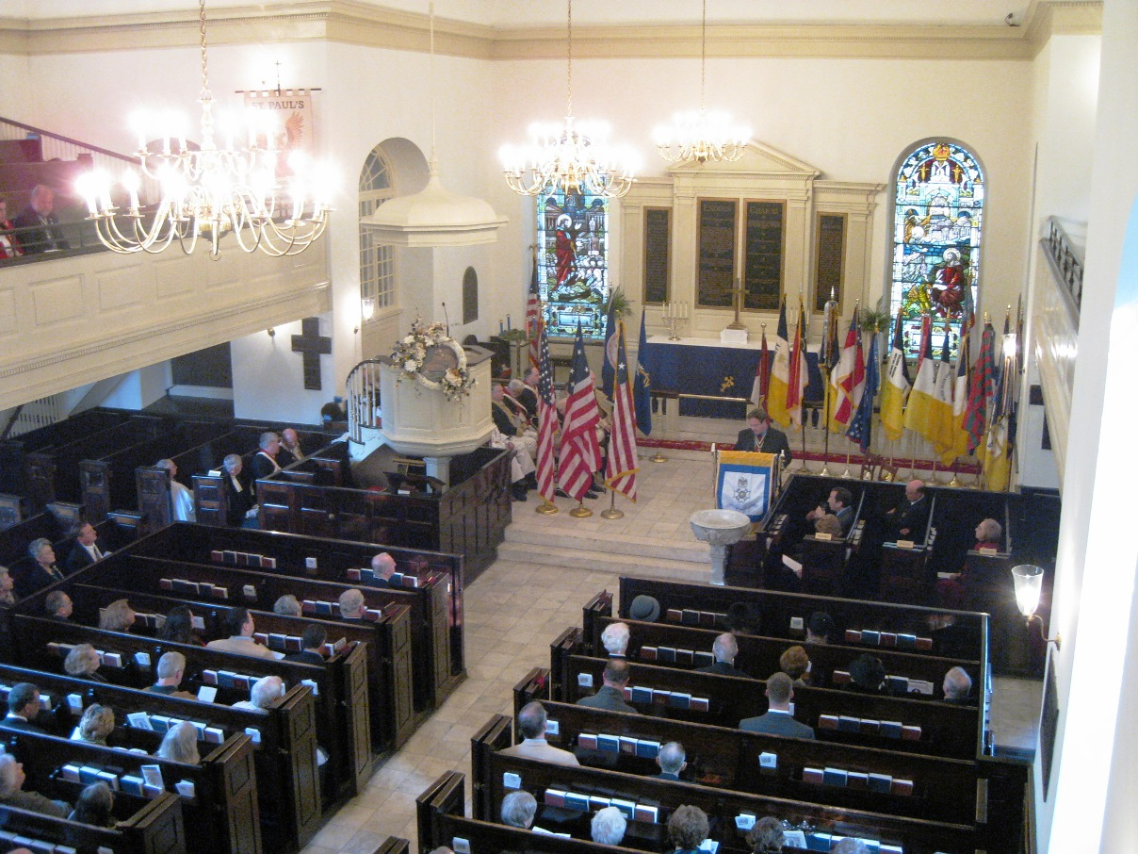

The ceremony commences after the colors are presented
President Mark Brennan, of VASSAR is shown presenting his remarks
(Paul Hanson photo)
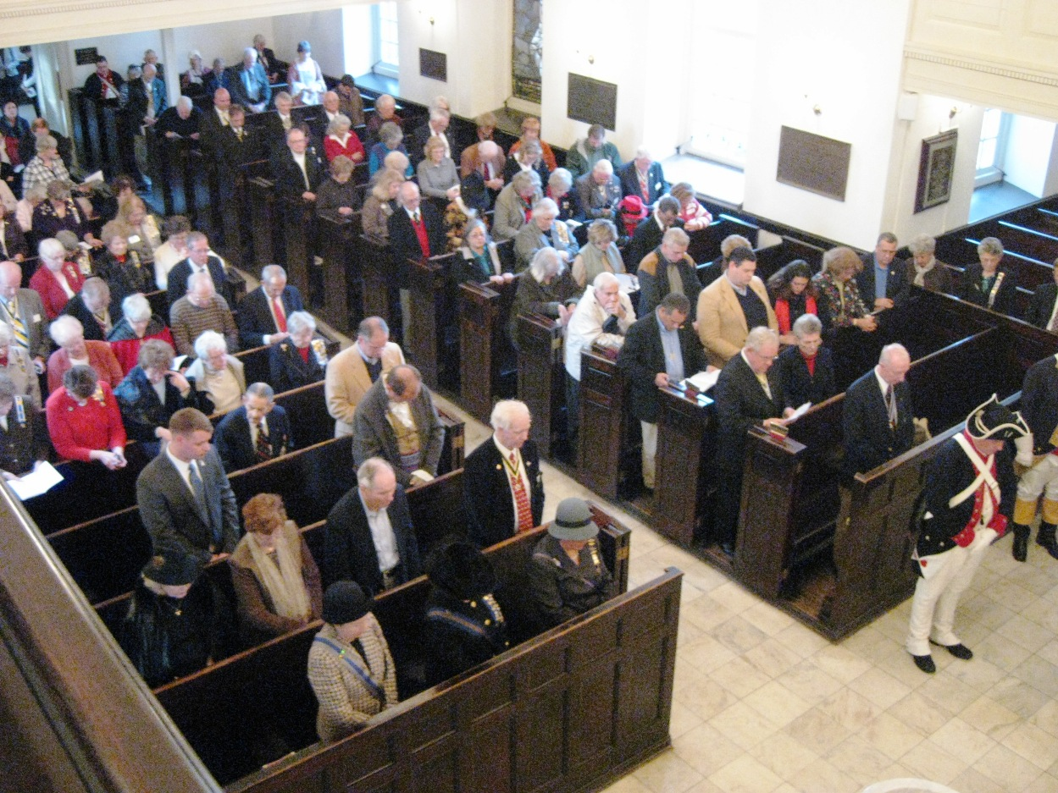
Some of the attendees
Paul Hanson photo

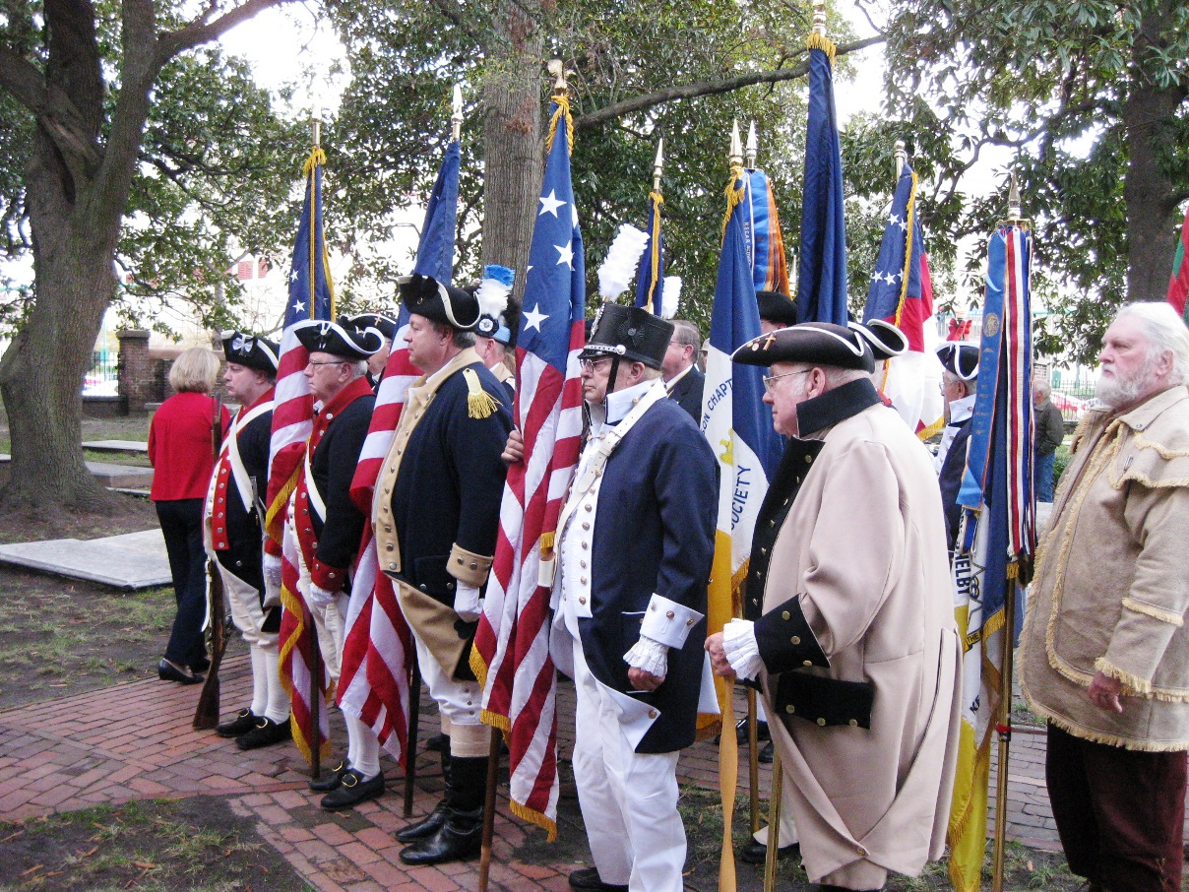
The Color Guard moves outside & the attendees follow
Bill Miner photos
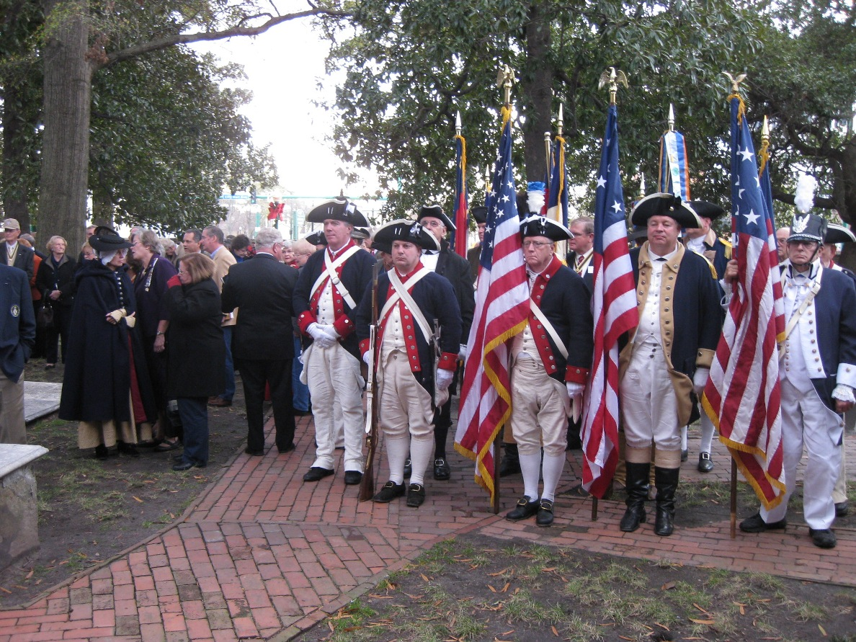

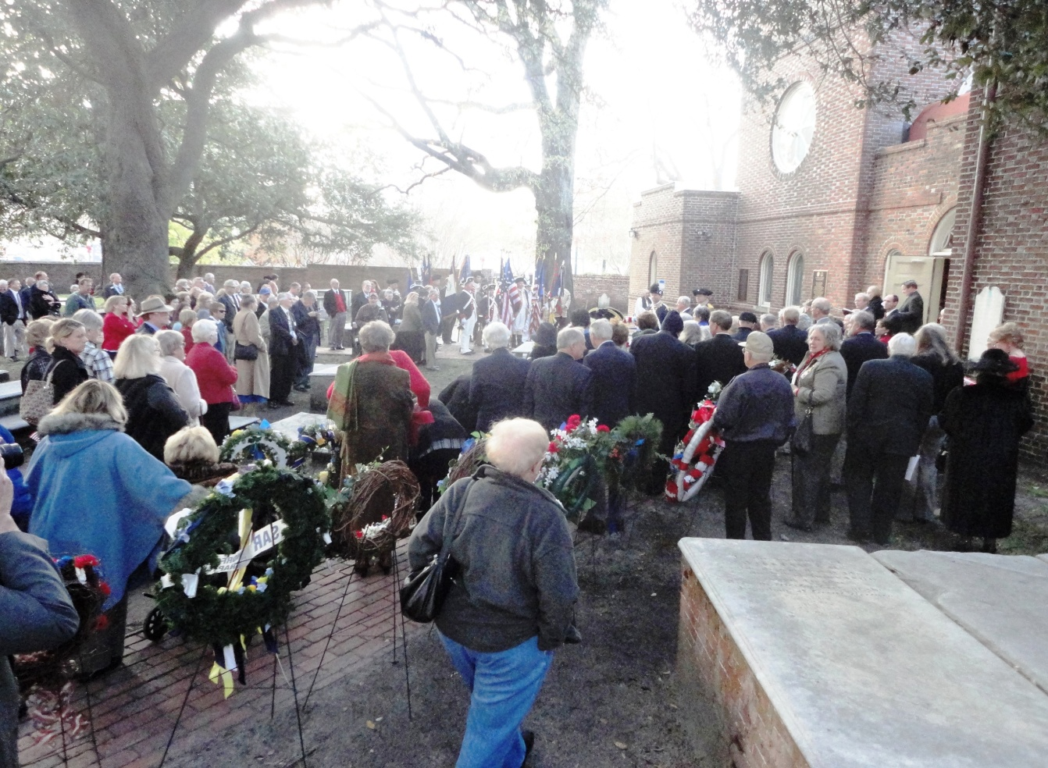
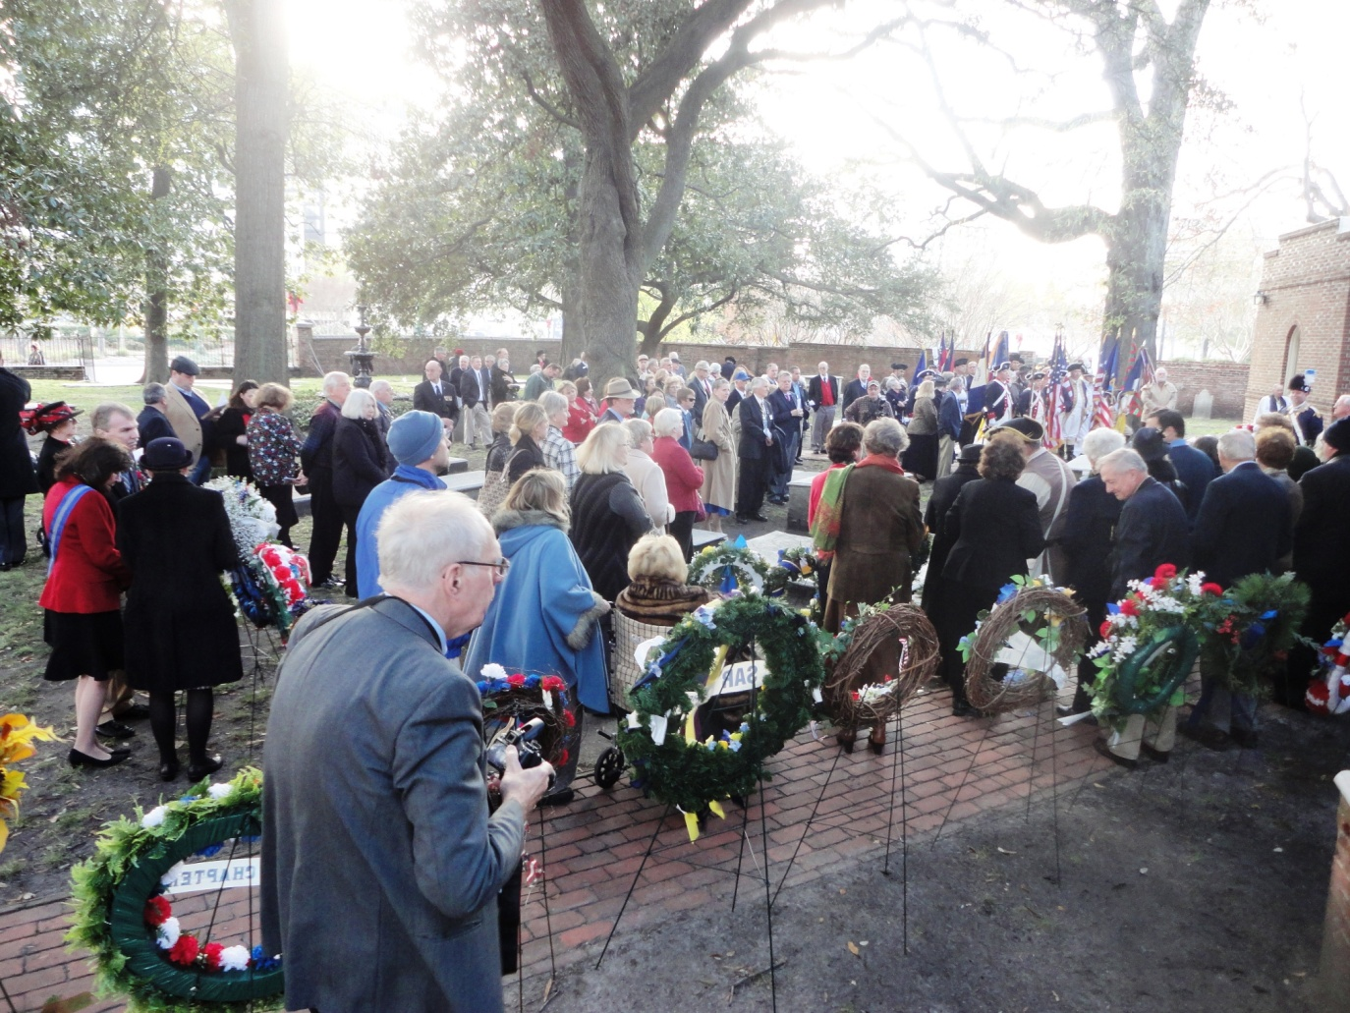
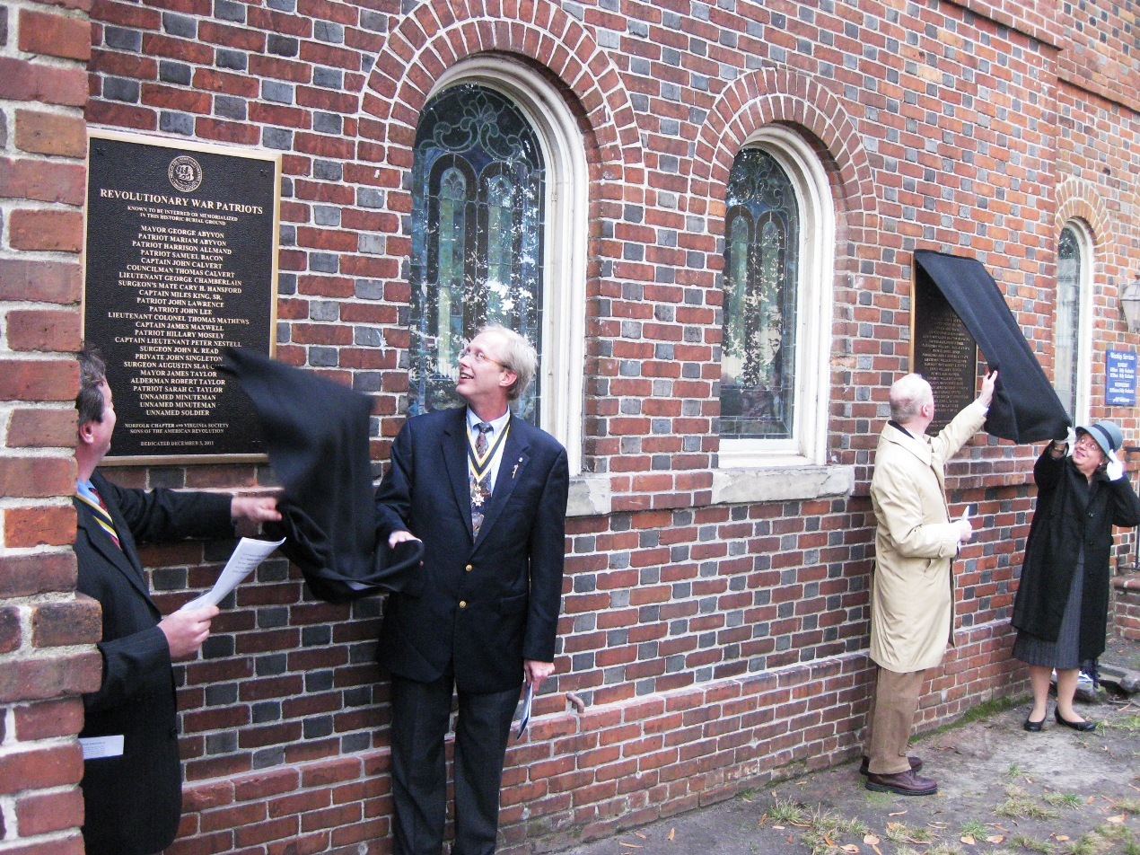
The unveiling of both plaques (photo by Bill Miner)
The Revolutionary War plaque (left) is unveiled by President Mark Brennan of the Virginia Society Sons of the American Revolution (VASSAR) & Dr. Matt Hogendobler, President of the Norfolk Chapter, VASSAR
The War of 1812 of 1812 plaque (right) is unveiled by Past President Thadeus Hartman of the VA Society War of 1812 & Connie Schroeder, VA State President U.S. Daughters of 1812

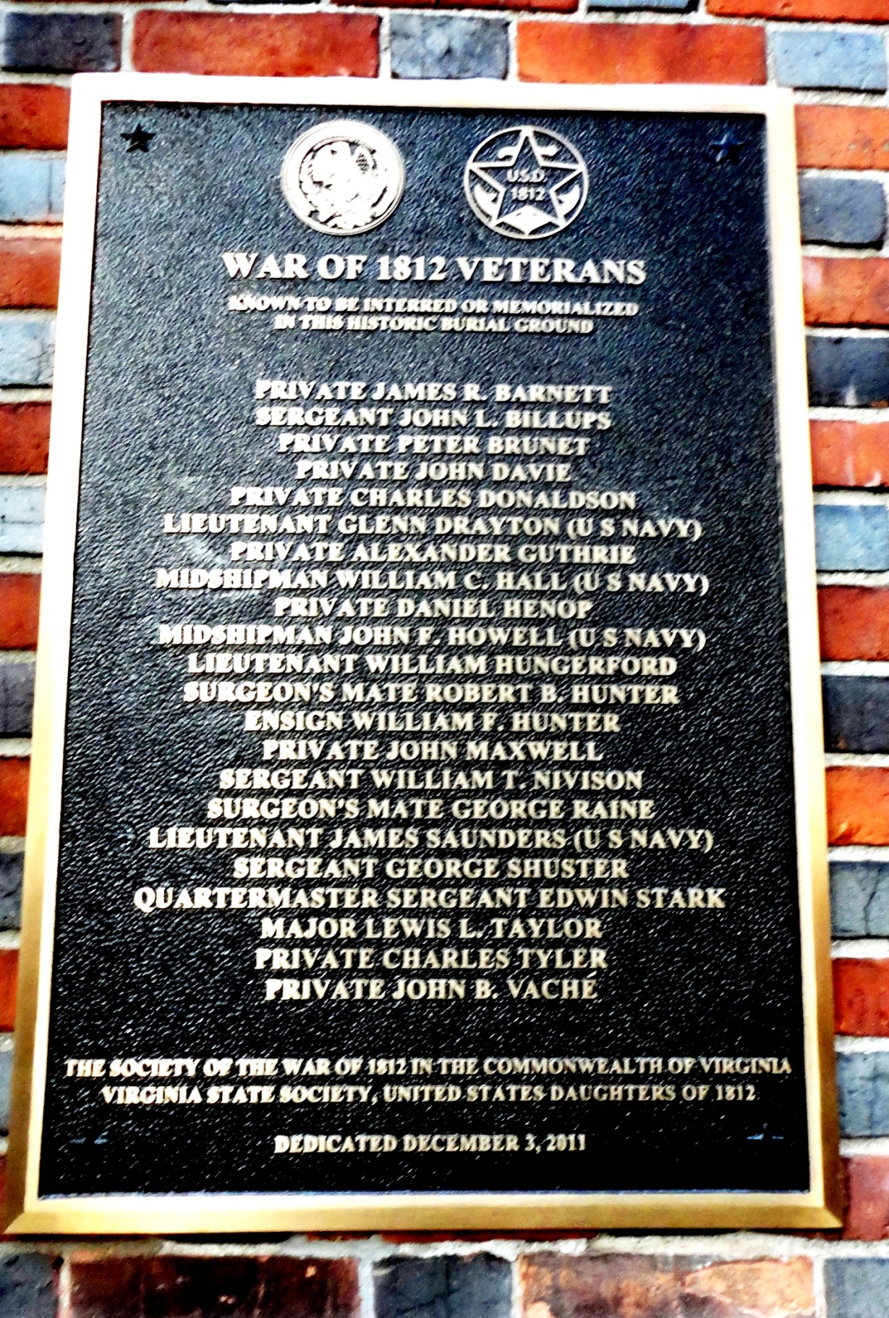
The unveiled War of 1812 Plaque
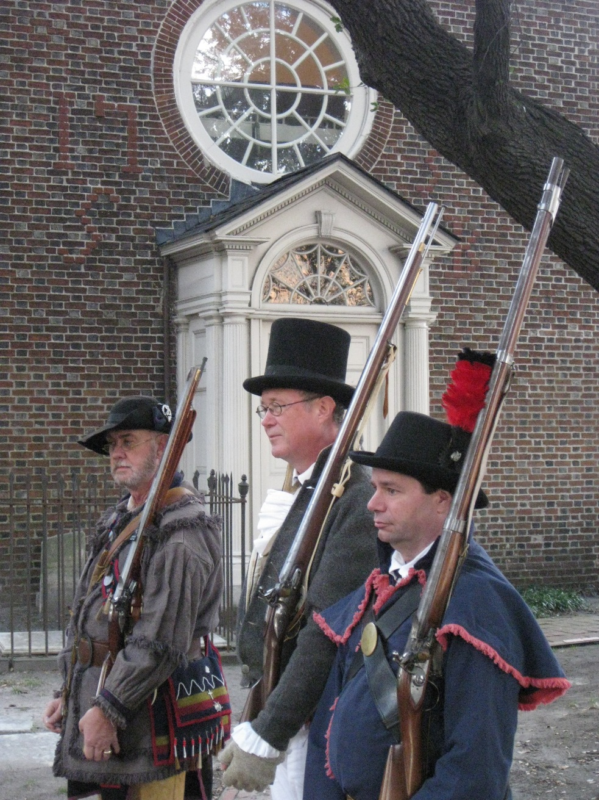
The War of 1812 Musket Salute Party
Bill Miner photo
L/R Victor Diehl, Member War of 1812 Society; G. Mark Walsh, National Advisory Board, James Monroe Memorial Foundation; and Steven A. Forrest, Color Guard Commander, War of 1812 Society

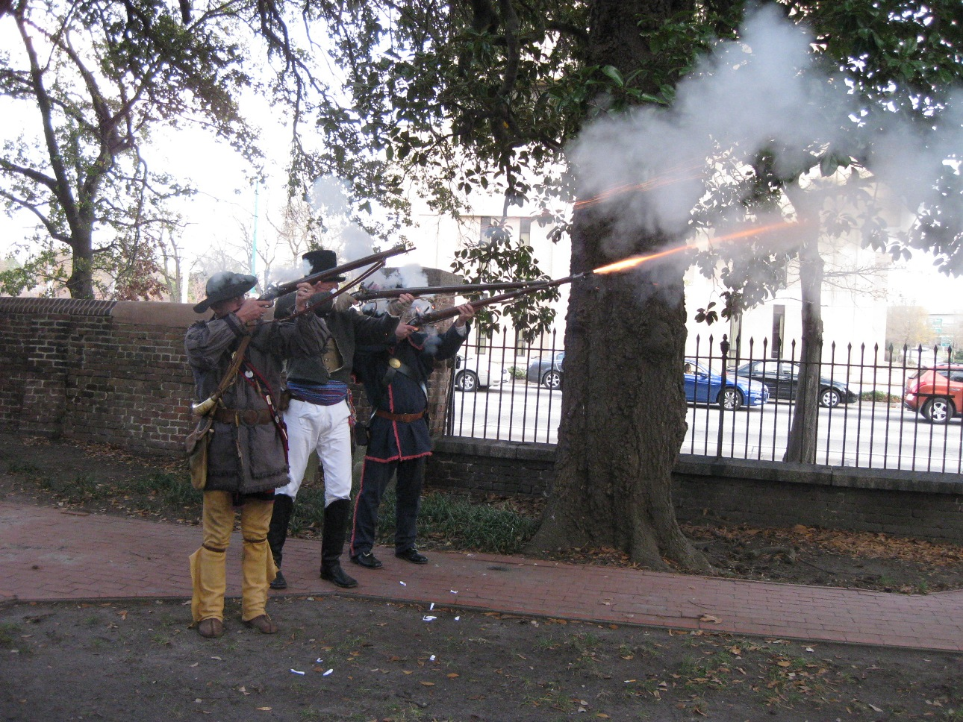
A three volley salute is fired (Bill Miner photo)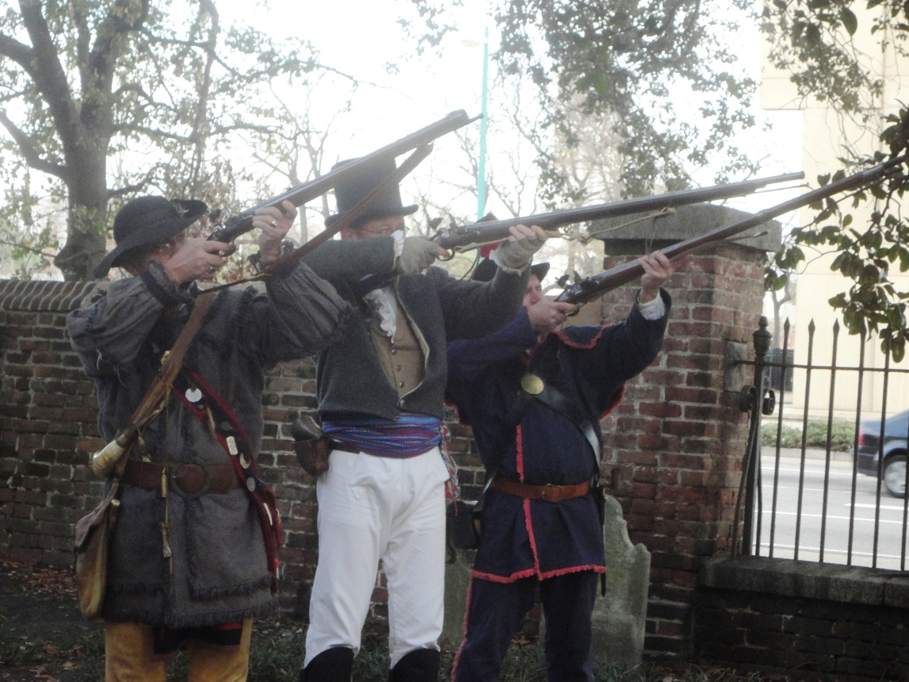
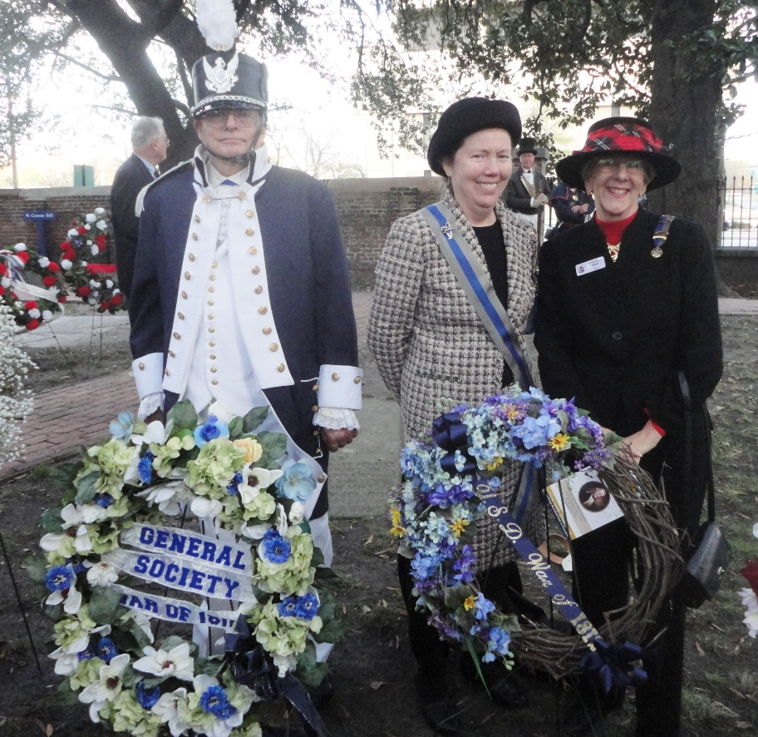
Wreaths are presented by many attending societies
Above Captain John N. Dickie, USN, Quartermaster General, General Society War of 1812 and Jacque-Lynne Schulman, Historian National, U.S. Daughters of 1812 and Nancy Miller, President Fort Norfolk Chapter, VA State Society U.S. Daughters of 1812 presents their wreaths
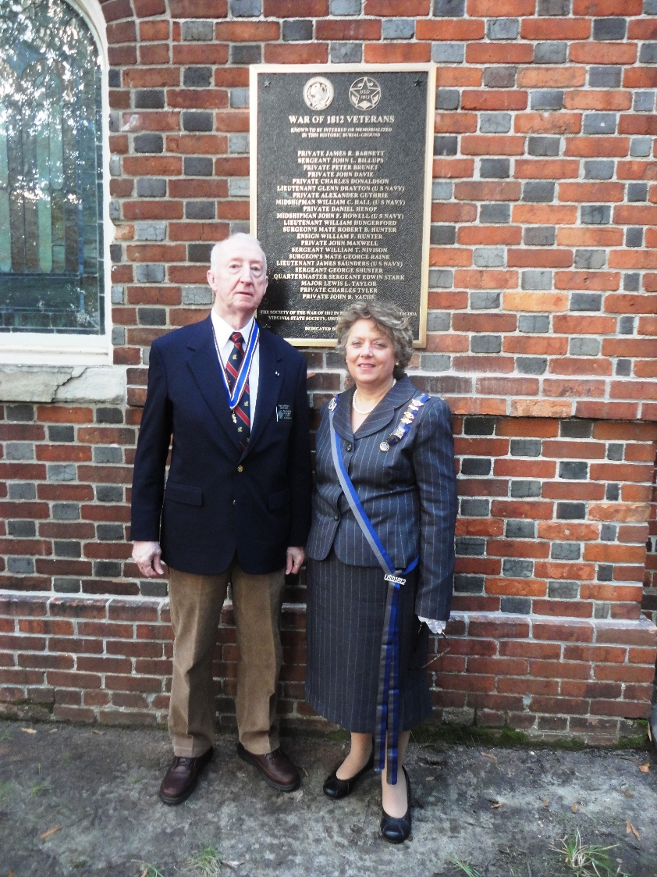
Thadeus Hartman & Connie Schroeder
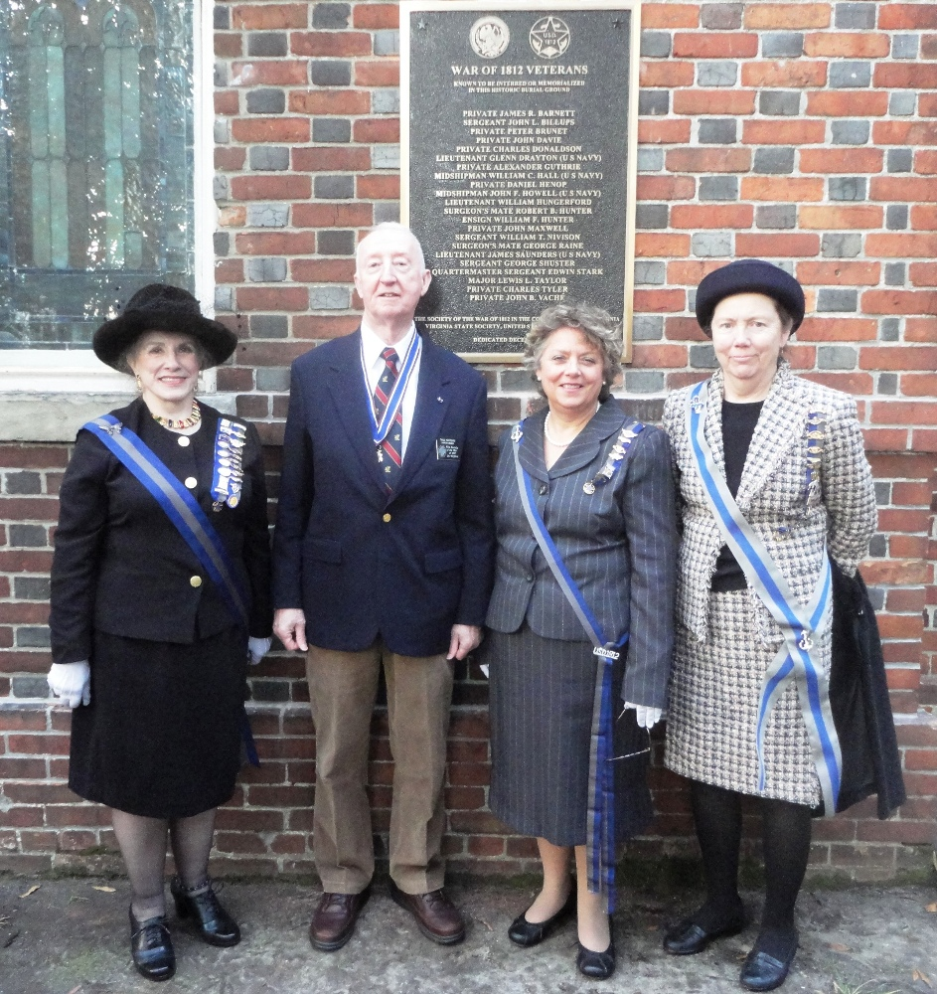
In front of the War of 1812 Plaque is L/R
Jo Ann Cooper Killeen, 4th Vice President National, N.S.U.S.D of 1812; Thadeus L. Hartman, past President & Charter member, War of 1812 Society in VA; Connie S. Schroeder, President VA State Society, U.S.D. of 1812; and Jacque-Lynne Schulman, Historian National, U.S. Daughters of 1812
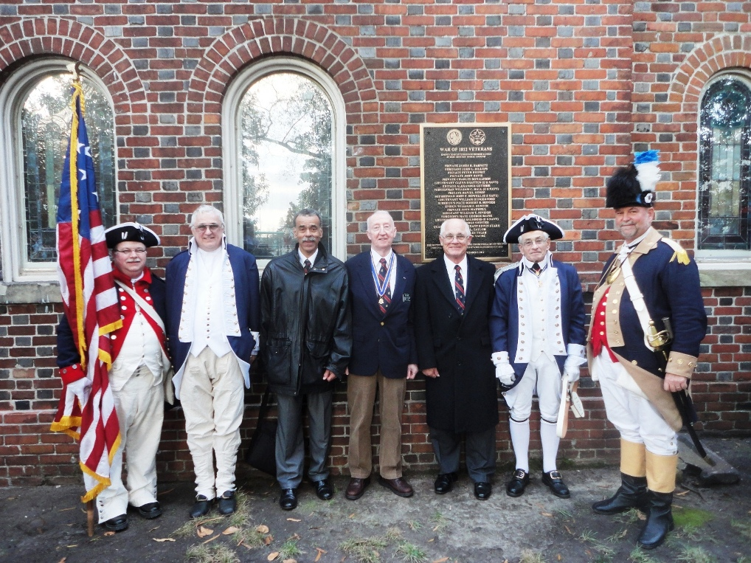
War of 1812 Society members gather for a photo by the plaque
L/R: Allen Brahin, member; C. Dennis Fritts, Councilor; James M. Green, Jr. Secretary; Thadeus L. Hartman, Past President & Charter member; John M. Epperly, Councilor; Myron E. Lyman, Sr., Past President; and J. Michael Tomme, Sr., member and National Trustee, GA Society, SAR

