WAR OF 1812 SOCIETY MEMBER, STUART BUTLER, HAS ARTICLE PUBLISHED IN RICHMOND, VA NEWSPAPER
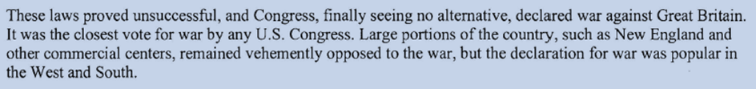
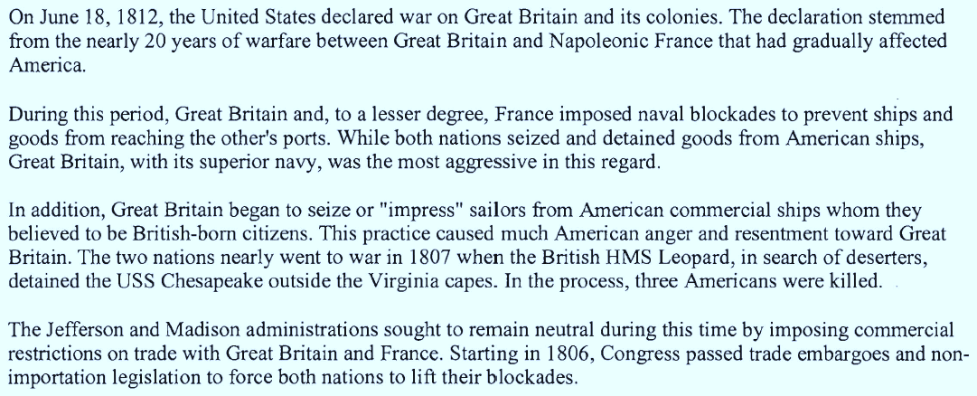

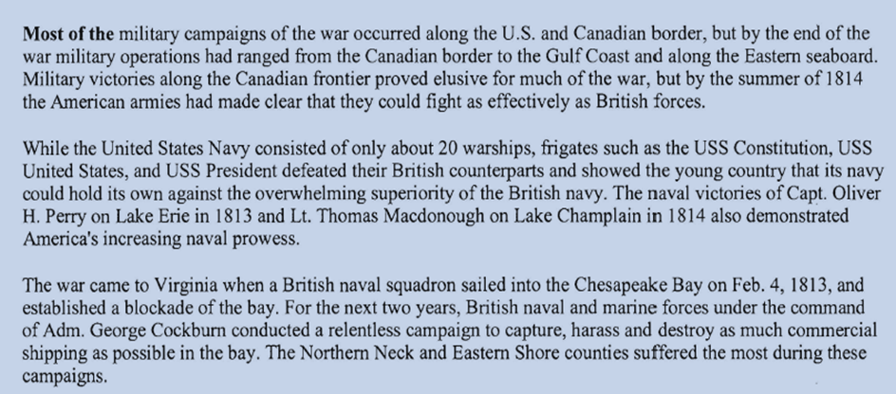

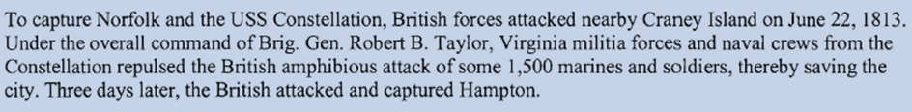

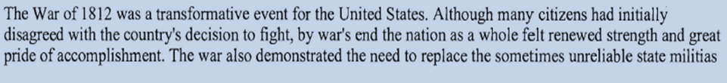

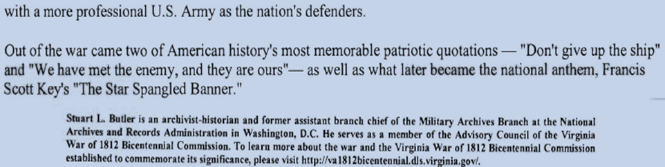

Stuart L Butler is an archivist-historian and former Assistant Branch Chief of the Military Archives Branch at the National Archives and Records Administration in Washington, DC. and a new member of our Society

