The Virginia Society of the War of 1812 holds their Board of Direction meeting in Conjunction with VASSAR’s Annual meeting 19-20 February 2012
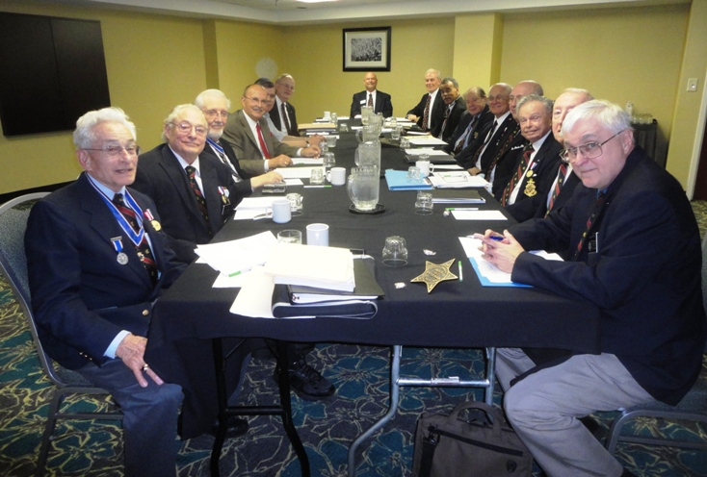
BOARD OF DIRECTORS MEETING 19 Feb 2012 Holiday Inn, Koger Conference Ctr., Richmond, VA. Attending were 20 members and guests. L/R: LTC Myron E. Lyman, Sr.-Past President; Capt John N. Dickie (USN)-QM General & VA Soc 2d Vice President; Col Andrew M. Johnson -DC Soc., Deputy President General, Chesapeake-Potomac District; Lindsey C. Brock-Fl Soc.; William A. Nash-member; Peter E. Broadbent, Esq., Historian; John M. Tomme, Sr.-GA Soc; Henry C. Howells, IV-Registrar; James M. Green, Jr. -Secretary; John C. Maxwell, Jr.-President; John M. Epperly -Councilor; Lea S. Schultz-member; Cranston Williams, Jr.-Councilor; LTC Thadeus L. Hartman-Past President; and Charles Dennis Fritts-Councilor. Arriving late and not shown, Walter J. Sheffield, Esq.-Legal Councel; George D. Dyer, Sr.-Treasurer; Burton C. Bradshaw, Sr.-Councilor; LTC William C. Collier-member; and Richard E. Hendrix-member

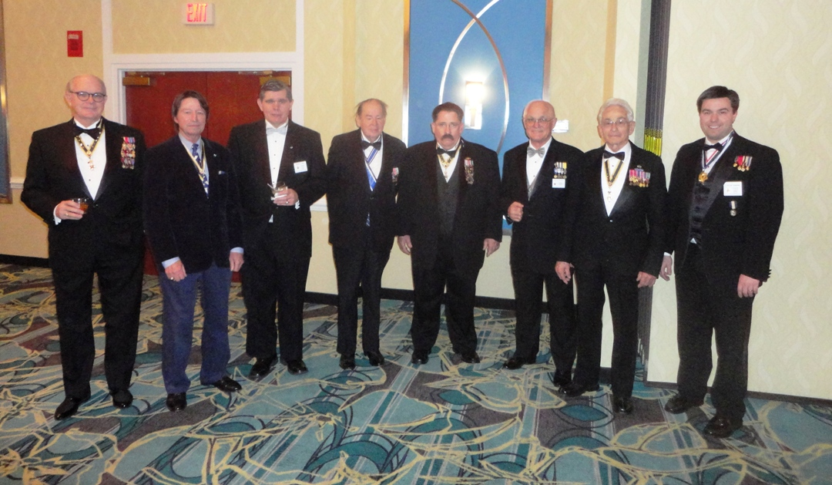
Virginia War of 1812 members attending the VASSAR banquet on 20 Feb 2010 were L/R: Walt Sheffield, George Dyer; Bill Nash; Jack Maxwell; Bill Simpson: John Epperly, Mike Lyman, and Taylor Cowardin. Also attending as shown in the photo below was John Burch, Jr., Esq.

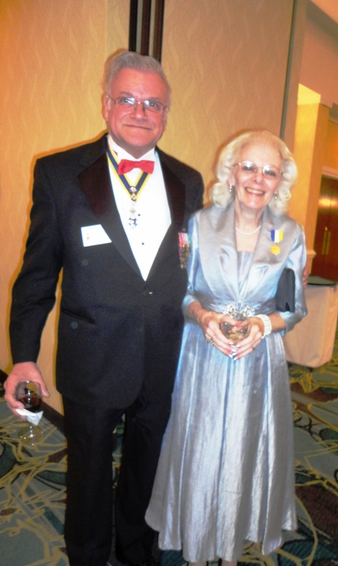
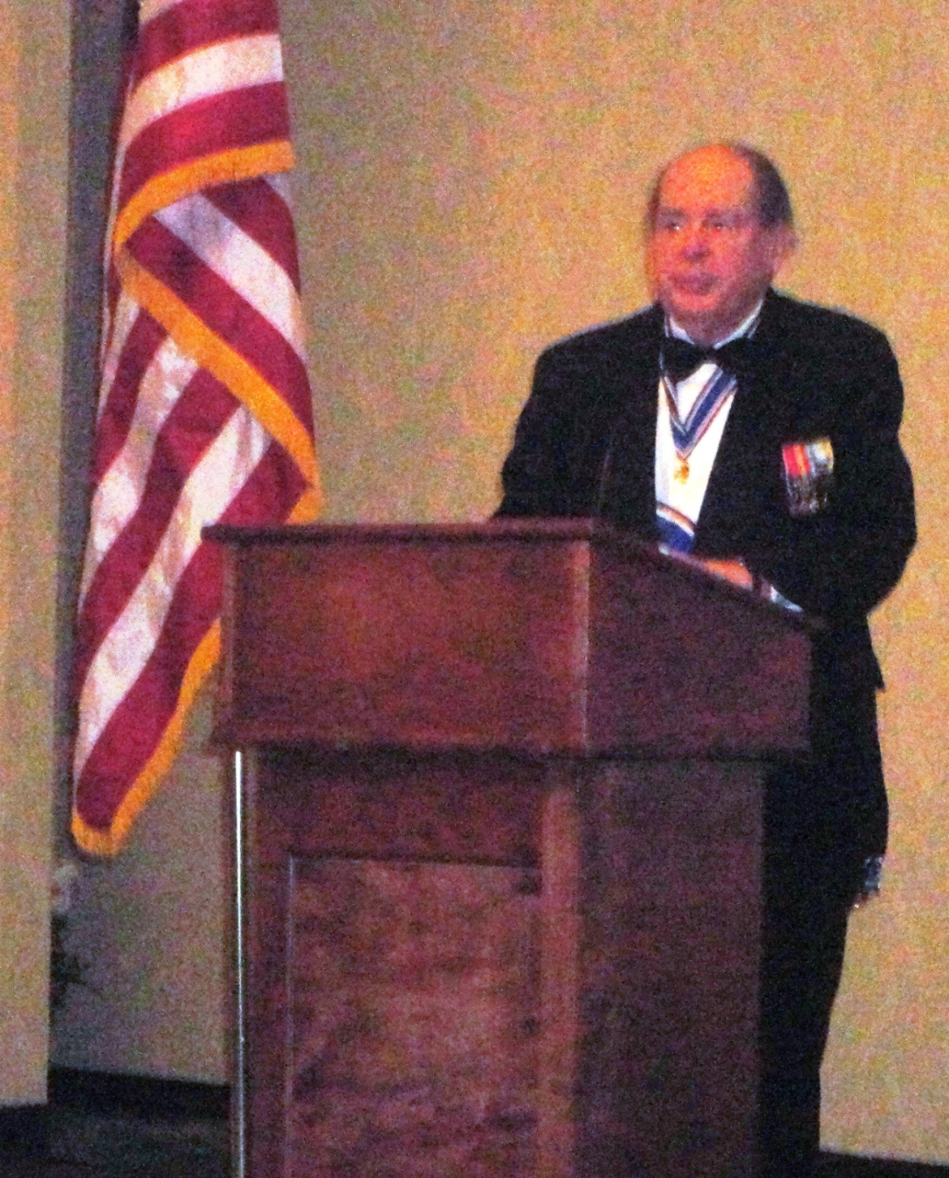
President Jack Maxwell gave greetings to the VA Society Sons of the American Revolution attendees at the banquet
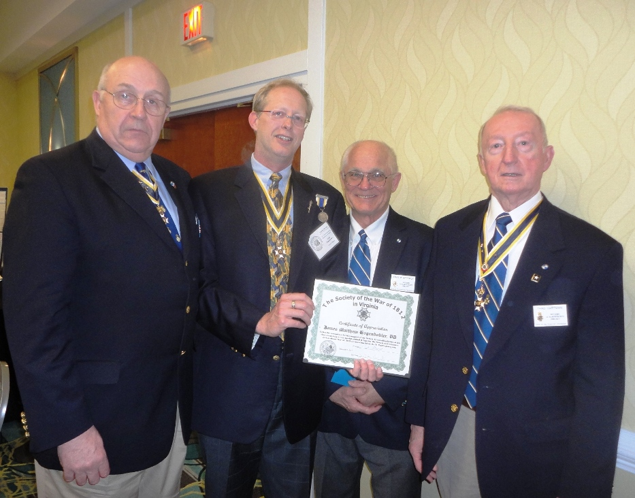

At the Dec 3rd 2011 ceremony, at Norfolk, Dr Matt Hogendobler, DDS did not receive a signed Certificate of Appreciation from our Society so it was presented at the VASSAR conference by Mike Lyman (taking photo), Bill Collier (left) and John Epperly and Thad Hartman. Matt went far beyond what was expected to support our Society at this event. Our many thanks goes to him.

