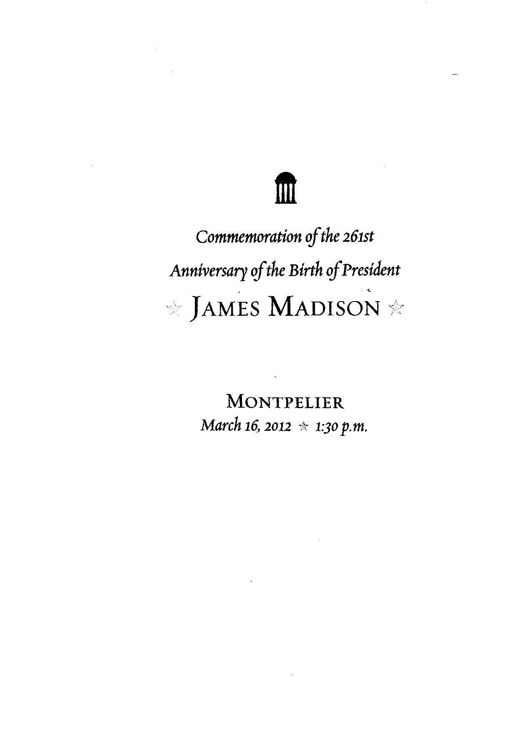
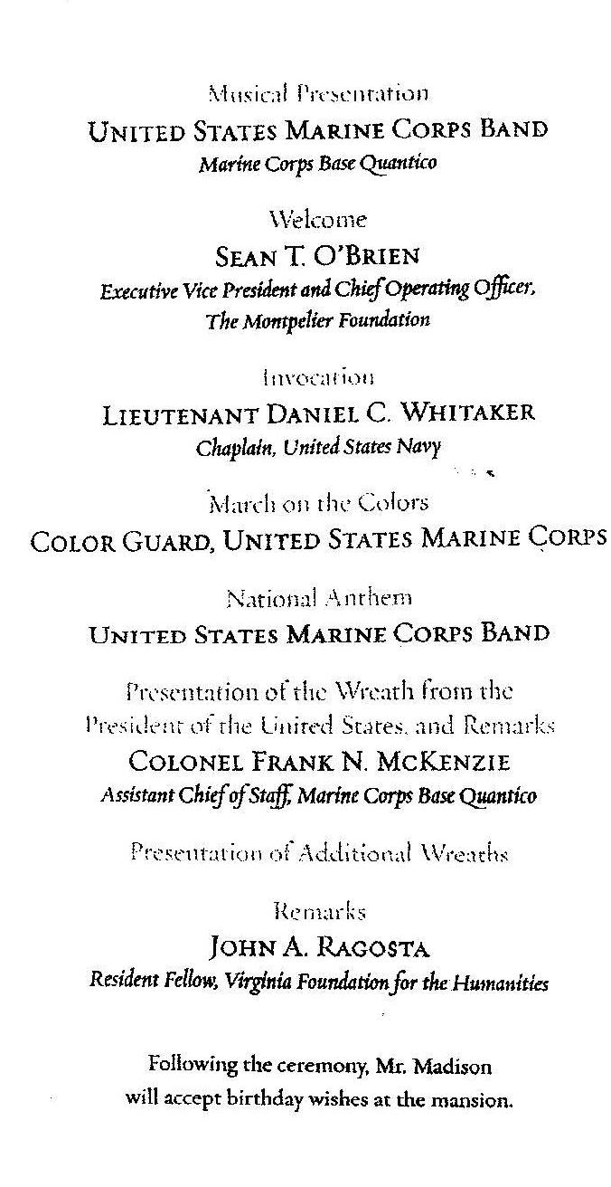
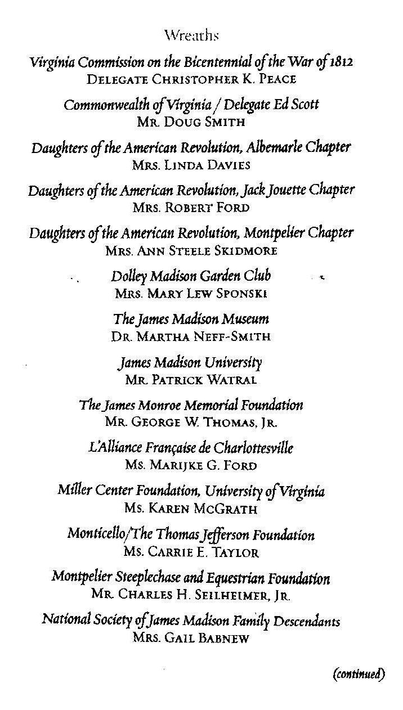

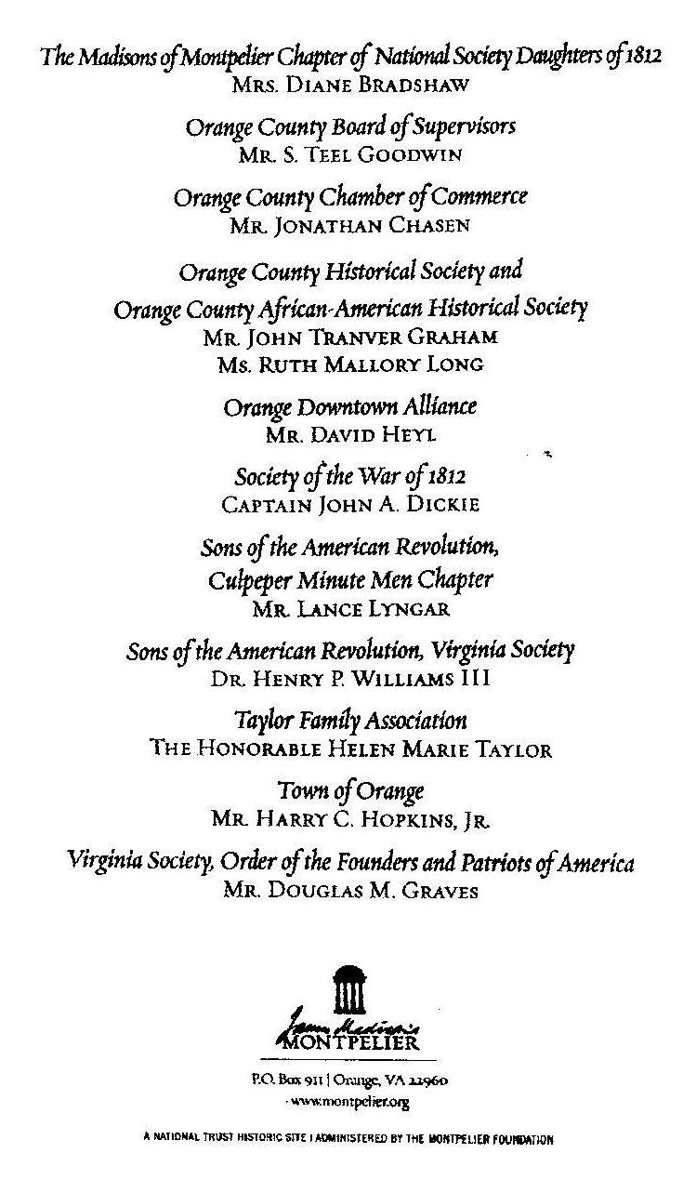

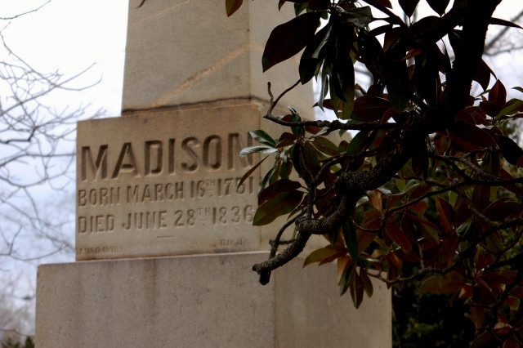
The obelisk of President James Madison

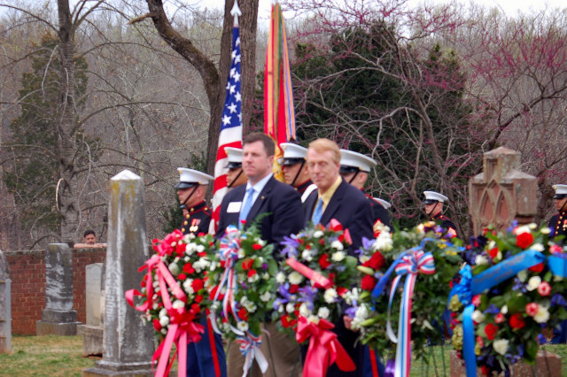
L/R: Virginia Commission Bicentennial of the War of 1812 represented by Delegate Christopher K. Peace & Commonwealth of Virginia Delegate Ed Scott represented by Mr. Doug Smith
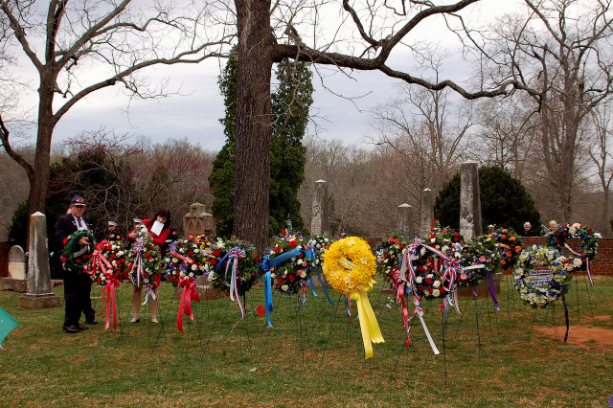
The photo shows the first line of wreaths that were being presented. On the left VA Society Sons of the Revolution President Henry P. Williams III, PhD presents his society’s wreath

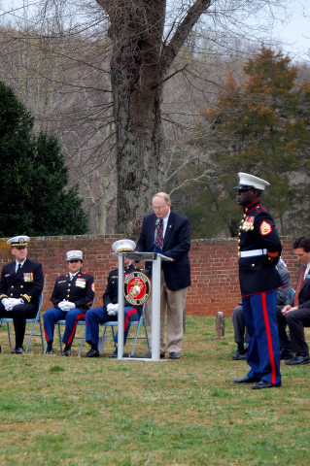
Peter E. Broadbent, Jr., Esq , Historian of the War of 1812 Society in the Commonwealth of Virginia reads the message from the Governor of Virginia

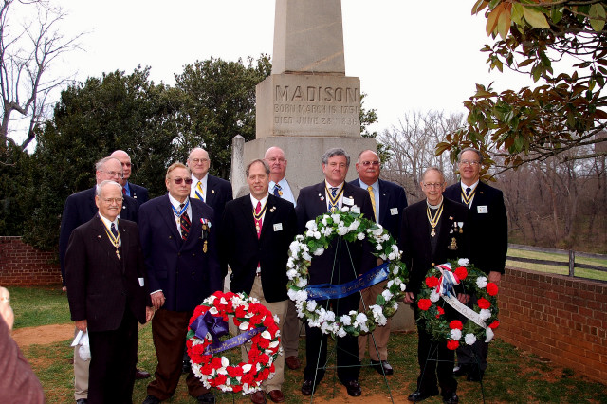
Wreath presenters from the Virginia Society SAR and the War of 1812 Society gather for a photograph after the ceremony. Behind the first person on the left is Peter E. Broadbent, Jr., Esq, Virginia society Historian and second from the left is Captain (USN) John N. Dickie, Quartermaster General War of 1812 Society and 2d Vice President of the Virginia Society War of 1812

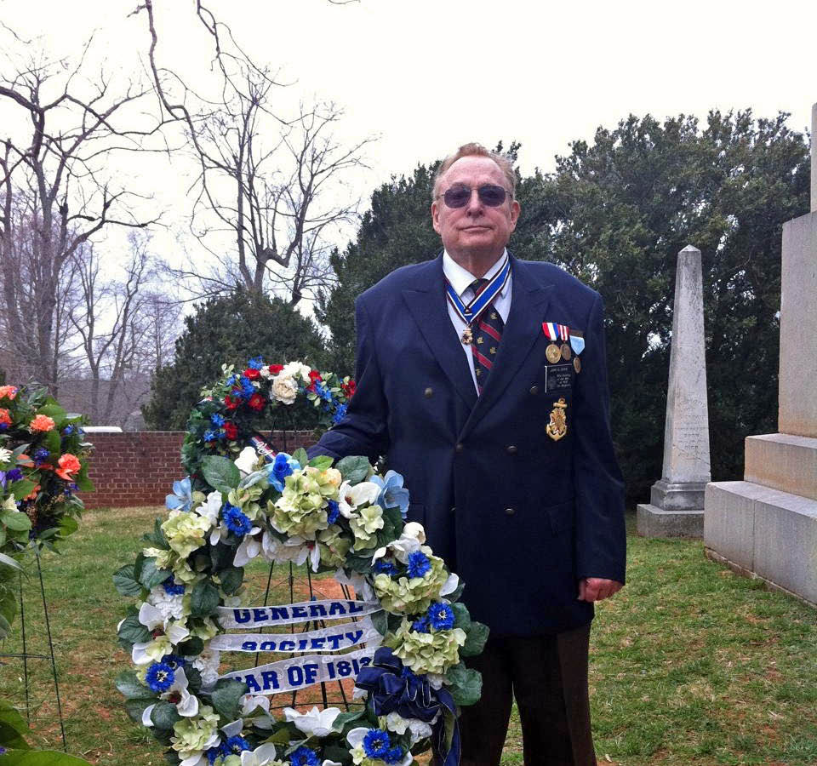
Captain (USN) John N. Dickie, Quartermaster General War of 1812 Society and 2d Vice President of the Virginia Society War of 1812 is shown with the General Society wreath

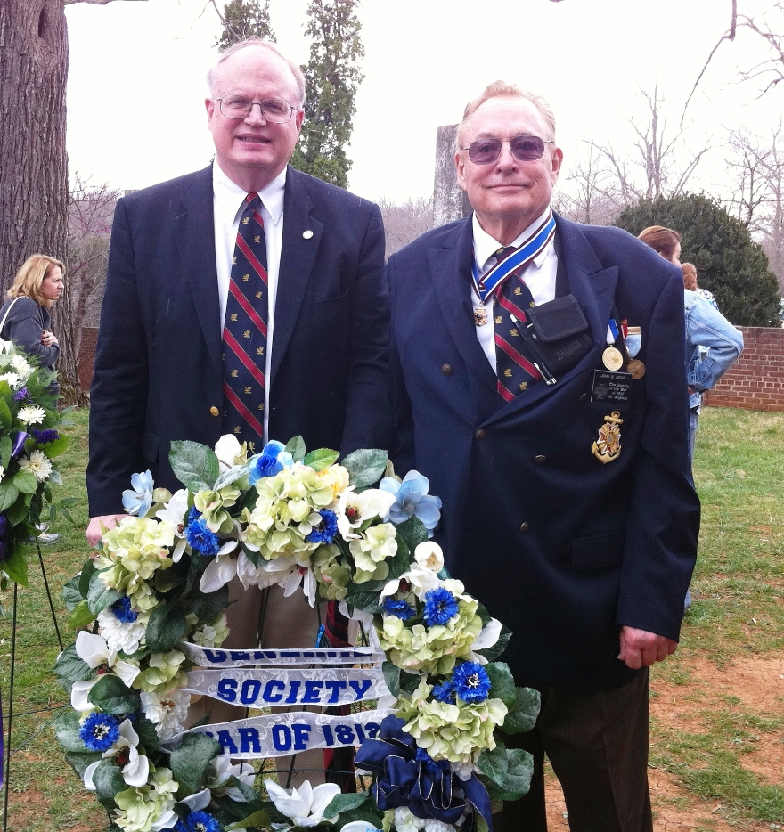
Peter E Broadbent, Jr., Esq and Captain John N. Dickie
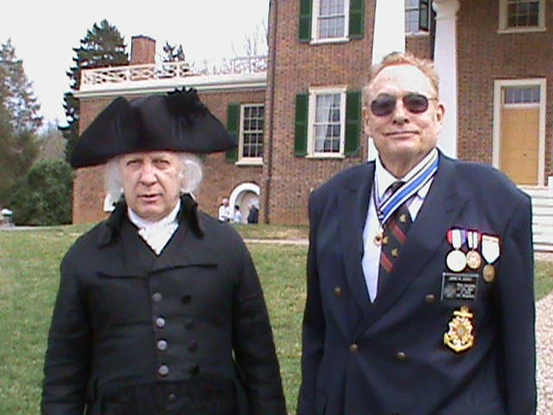

2d Vice President John Dickie is shown with James Madison’s impersonator in front of the Mansion

