**The Society of the War of 1812 in Virginia participated in the Franklin County, Virginia Court House Veterans Memorial Day Ceremony on May 26, 2012**

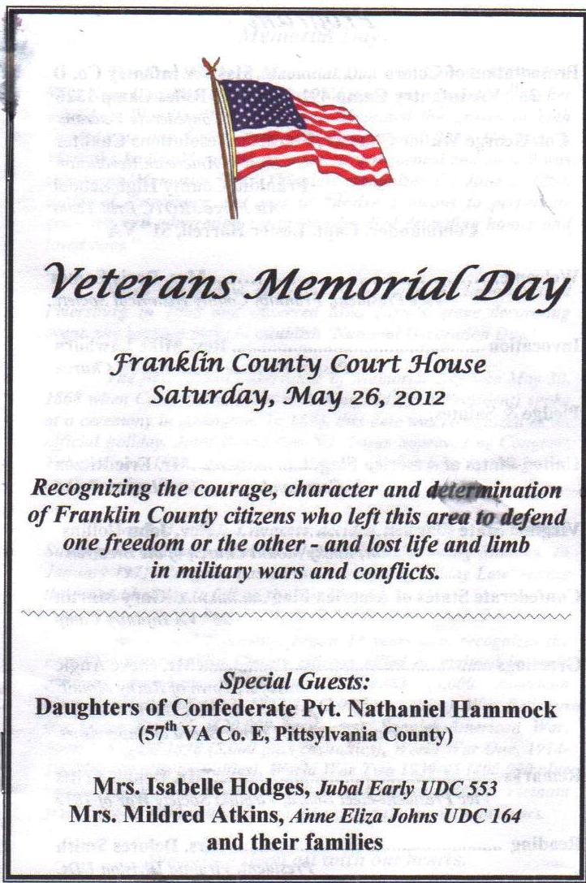

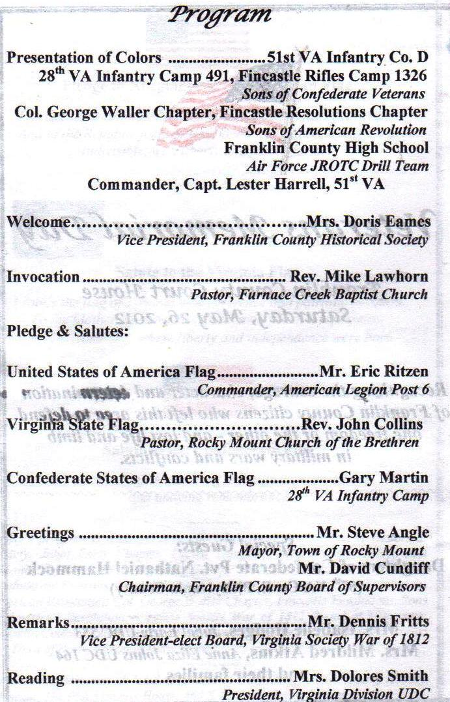

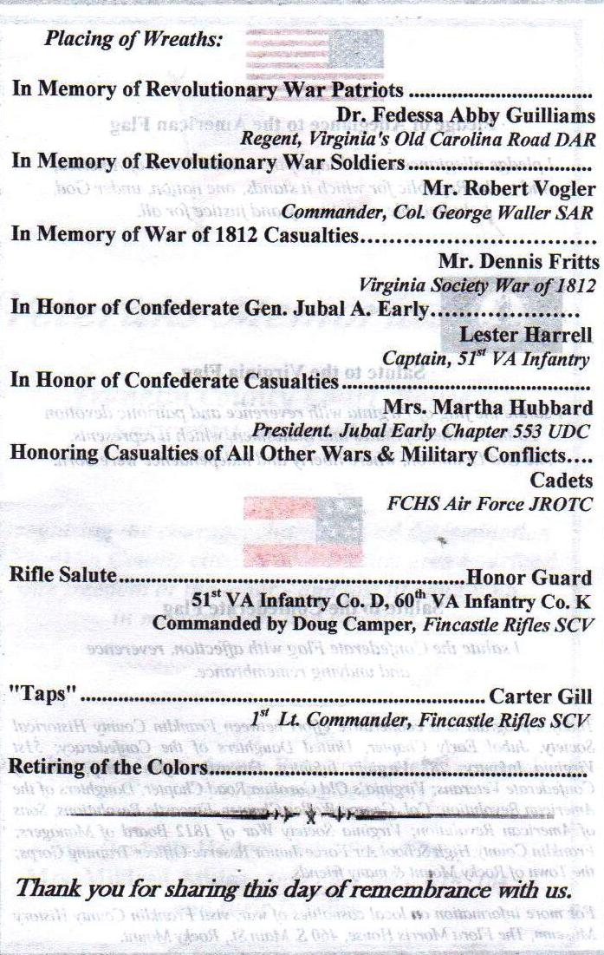

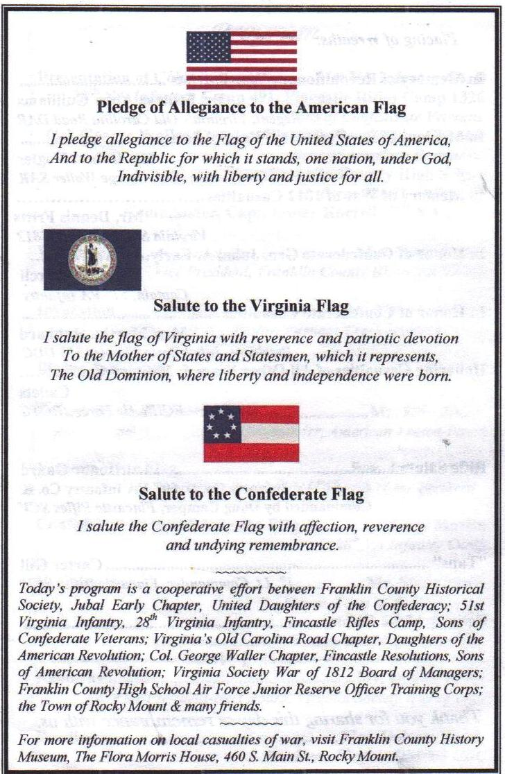

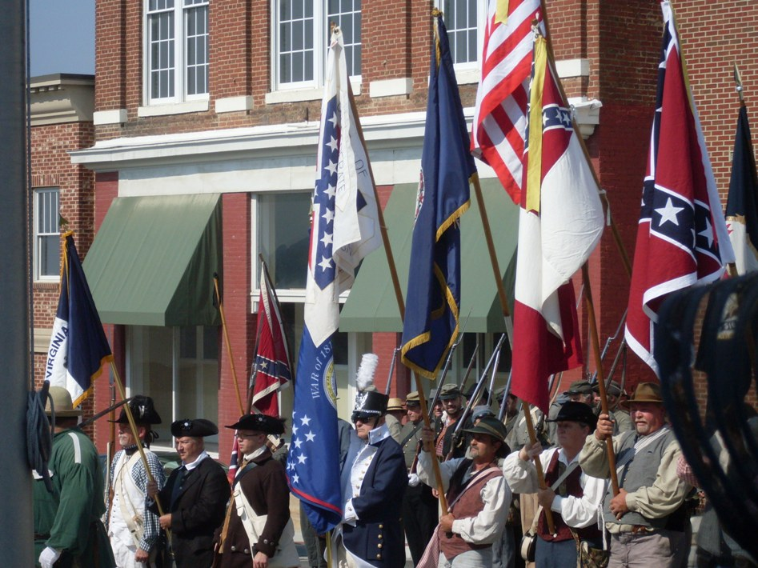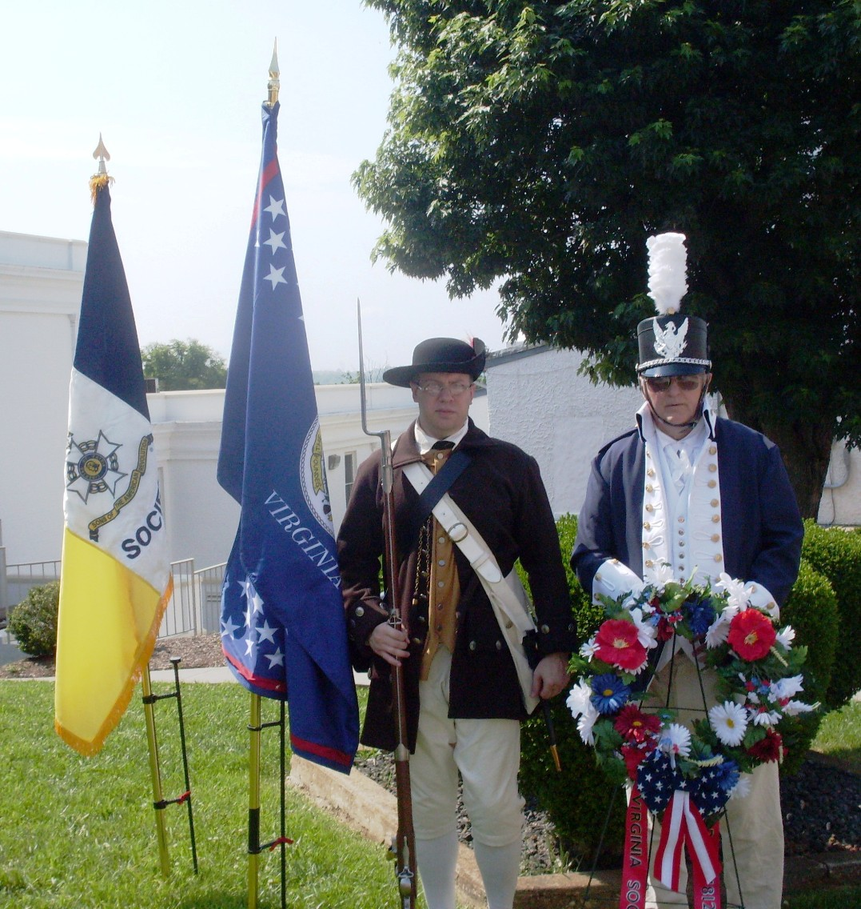

In the center carrying the Virginia Society War of 1812 flag is Councilor Dennis Fritts. In front of him with the musket is member Andrew Doss

After the ceremony is Andy Doss and Dennis Fritts with the society wreath he presented. Beside Andy is the society flag that was carried in the color guard