War of 1812 Society in Virginia’s Annual Conference June 16 2012 held at the
Fredericksburg Country Club & Thornton- Forbes -Washington Cemetery
MEETING PHOTOGRAPHS
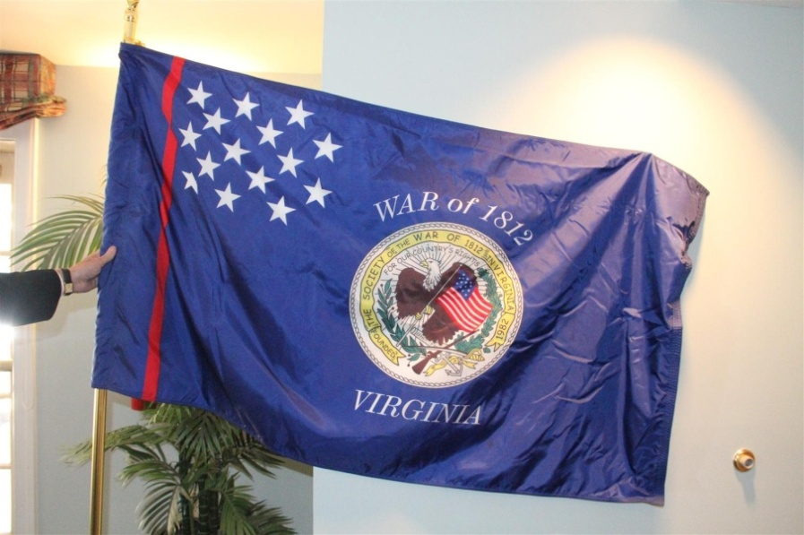

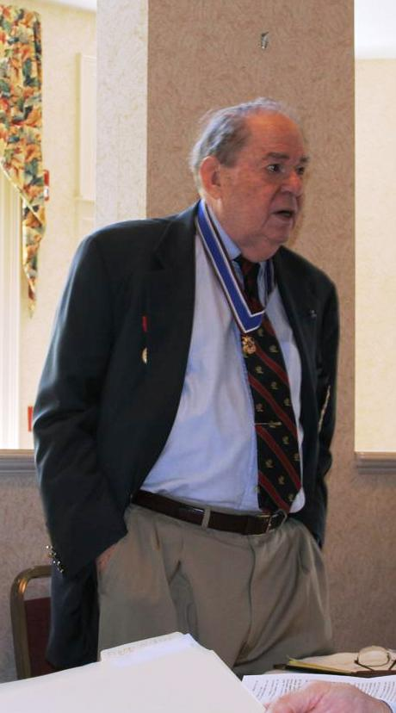
President Jack Maxwell presides
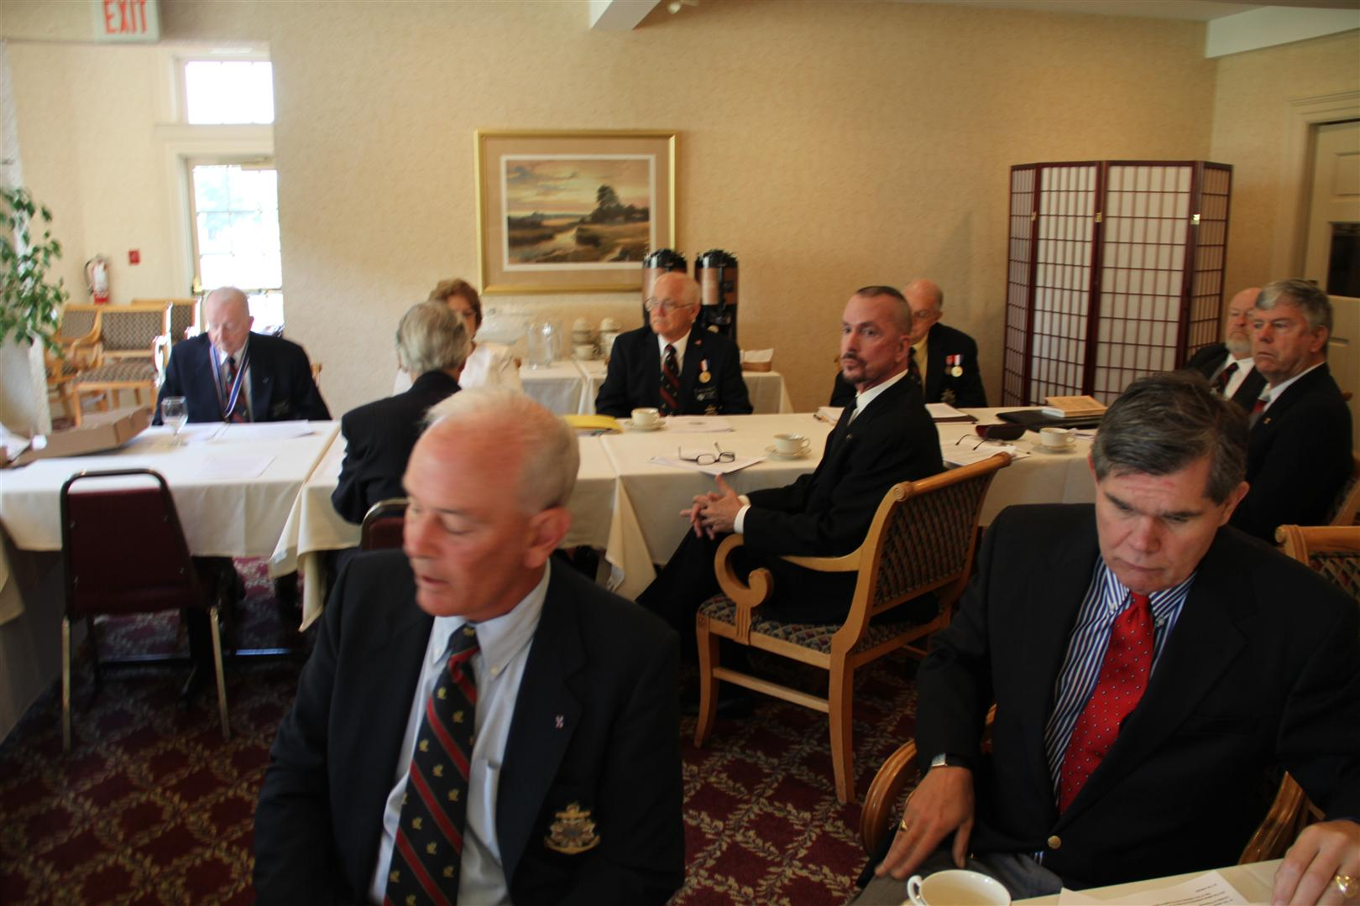

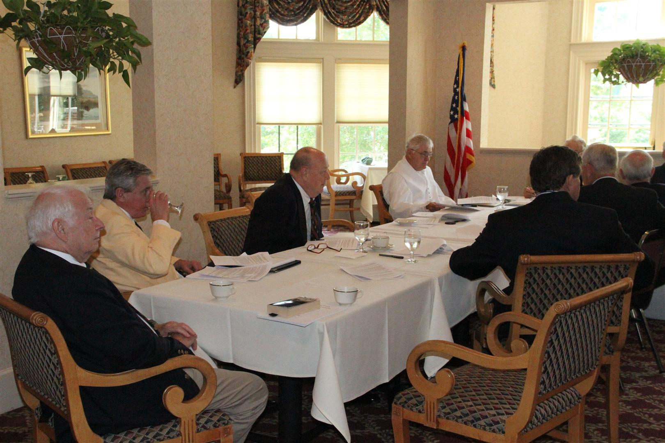
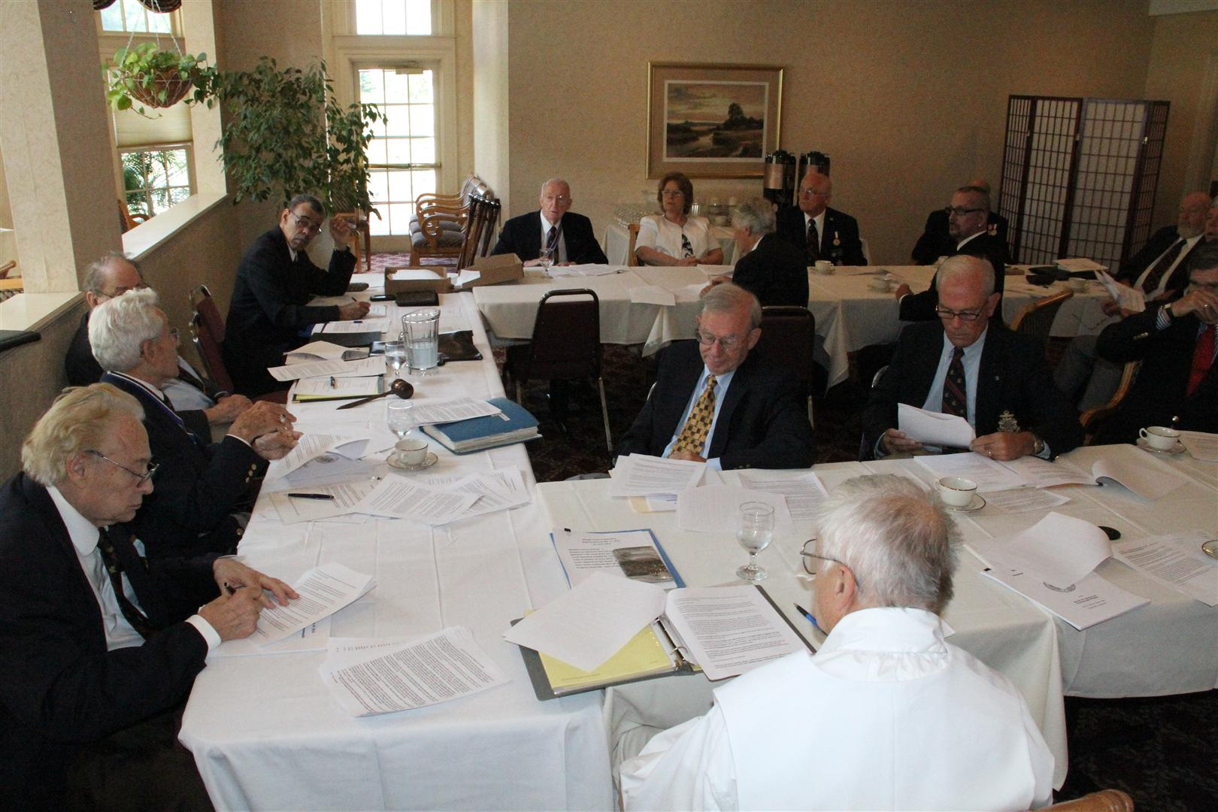

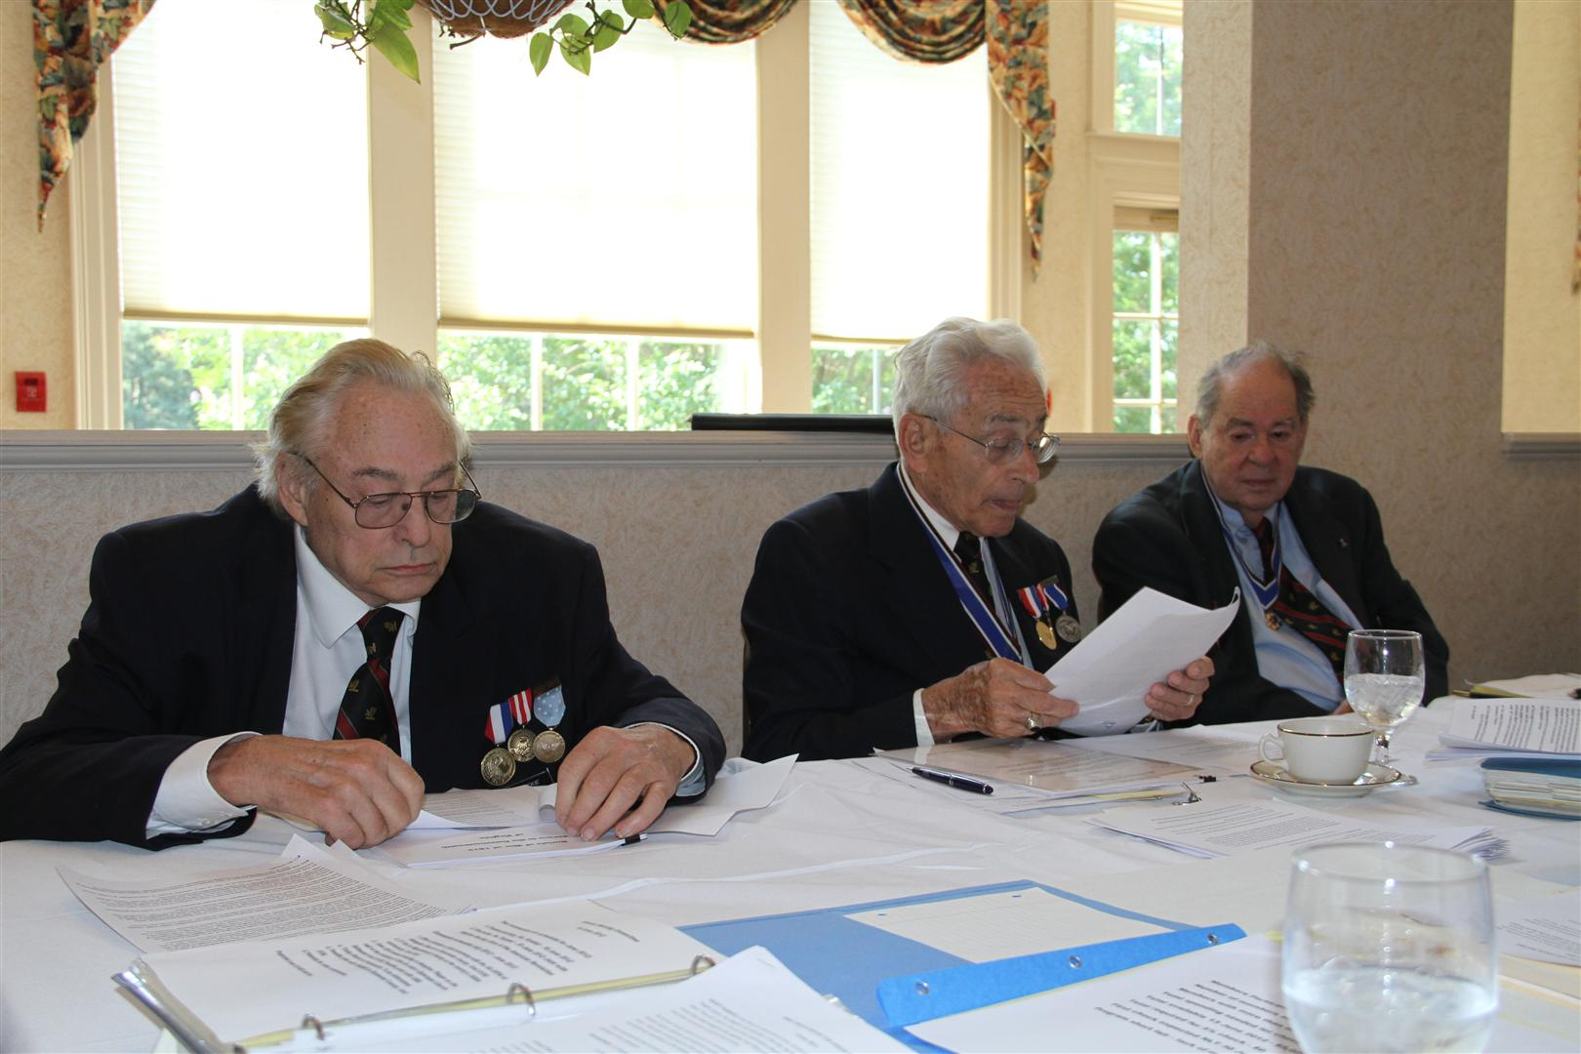

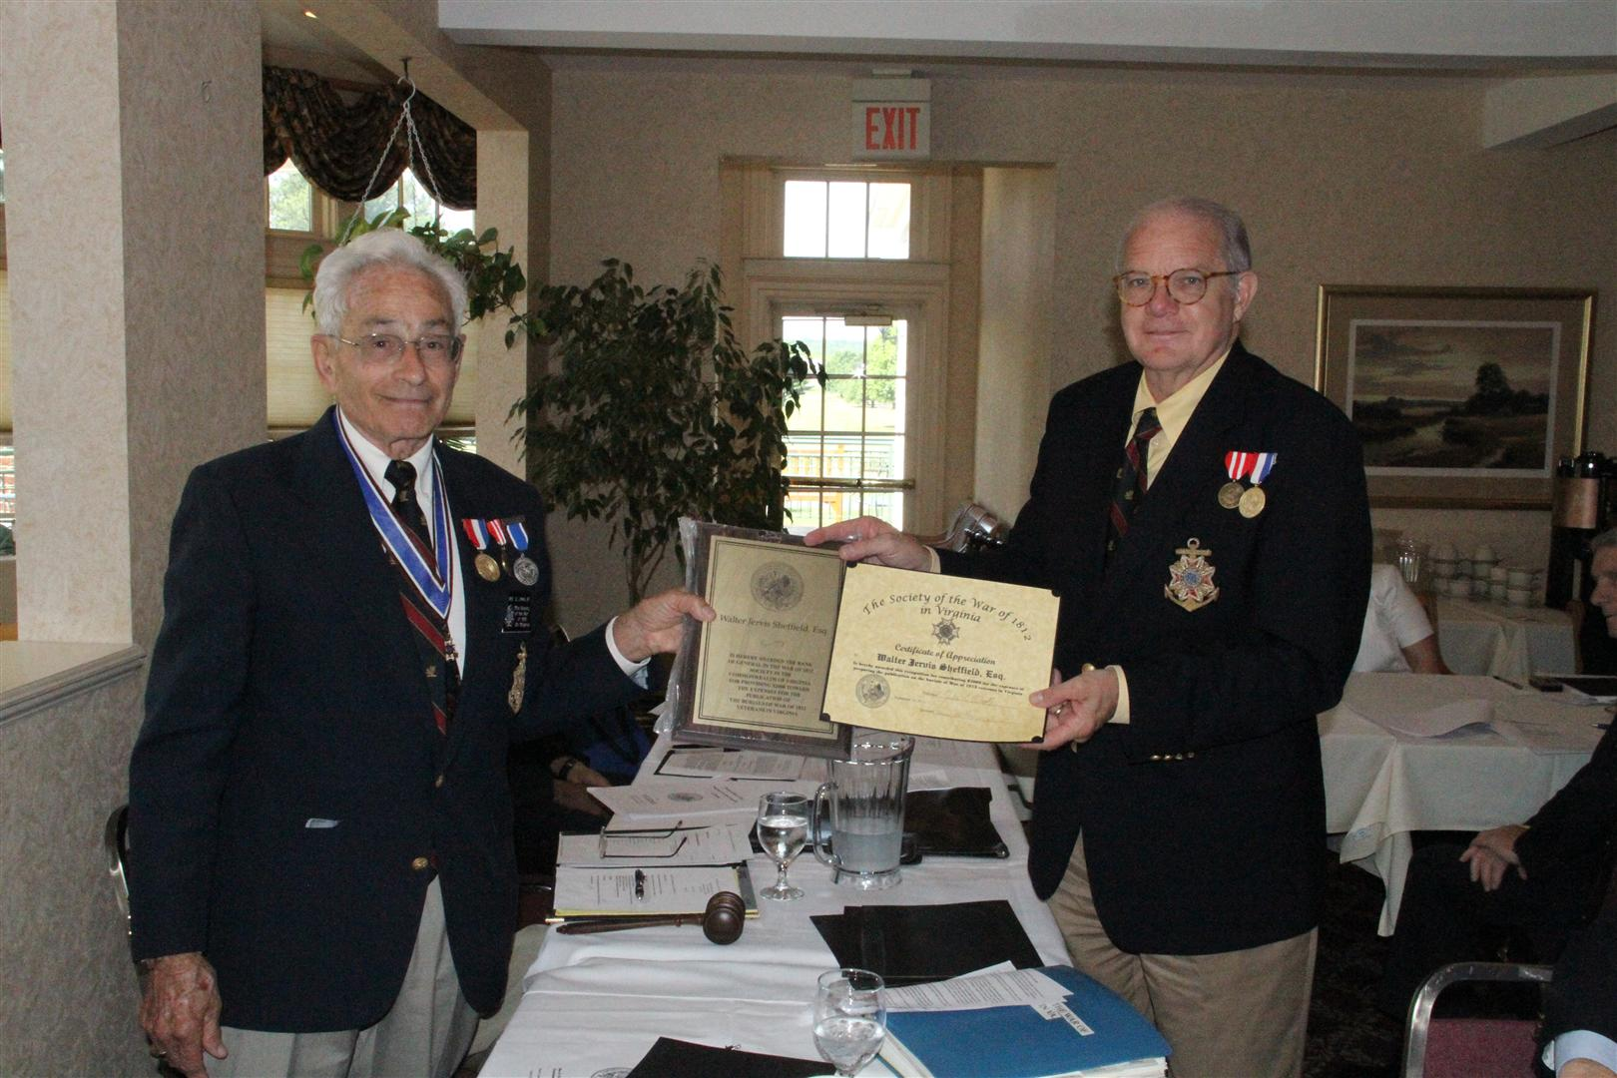
Walter Sheffield receives General’s rank, a plaque and & certificate for giving a large contribution to the expenses of the pending Burial Publication
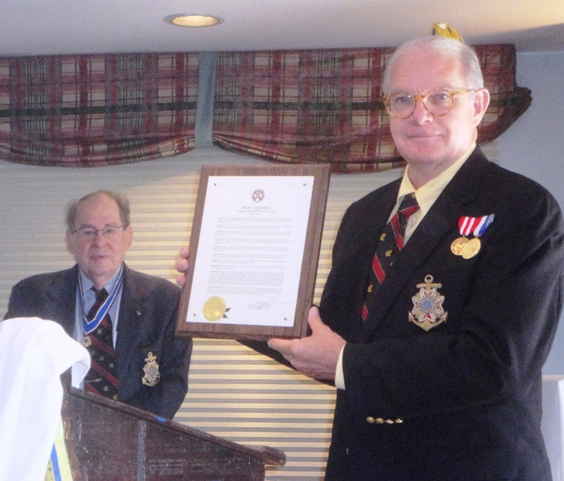
Above: Walter J. Sheffield, Esq. shows the proclamation that he prepared that was issued by the Mayor of Fredericksburg regarding The Bicentennial of the War of 1812. President Maxwell looks on
(view details on another post on this website)
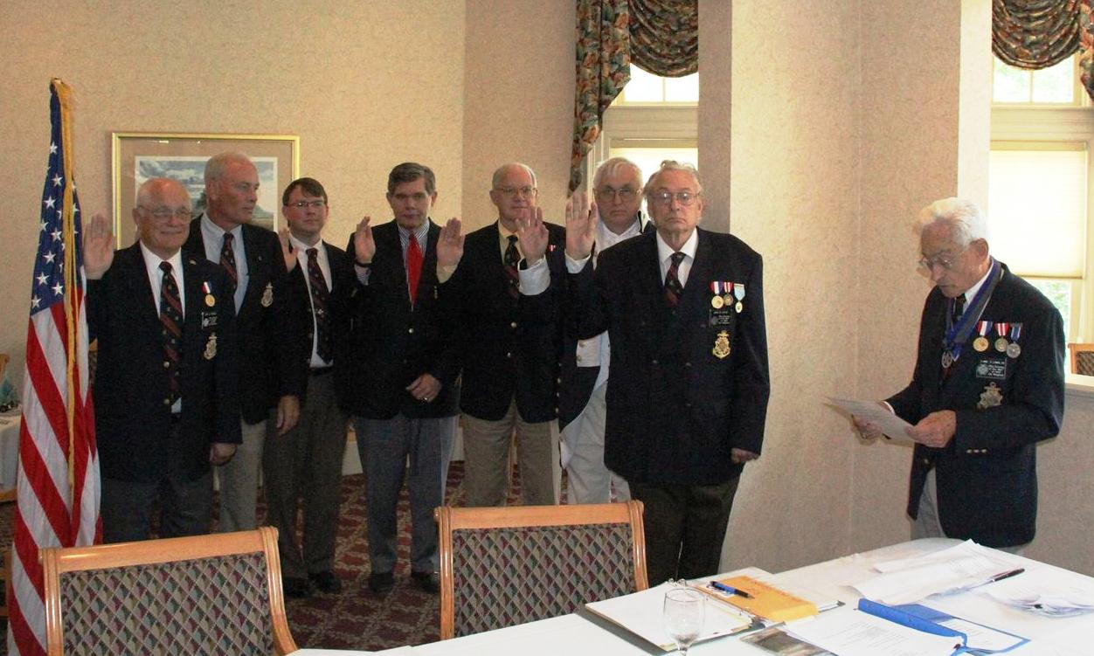
The newly elected officers that were present at the meeting were inducted by Mike Lyman acting as Assistant Historian General by administering the oath. L/R John Epperly, Councilor; Henry Howells IV as Registrar; Shane Newcombe as Quartermaster; William Nash as Treasurer; Walter Sheffield, Esq as 2d Vice President; Dennis Fritts as 1st Vice President and Captain John N. Dickie (USN) as President

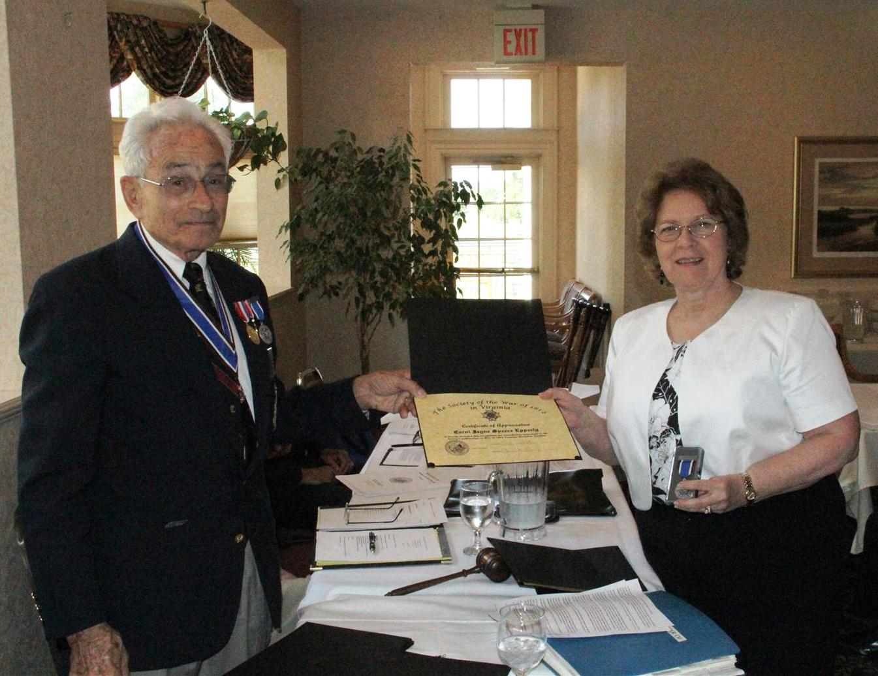
Carol Epperly receives a Certificate of Appreciation and a Bicentennial Medal for spending hours and hours of work editing the text of the Burial of War of 1812 Veterans in Virginia
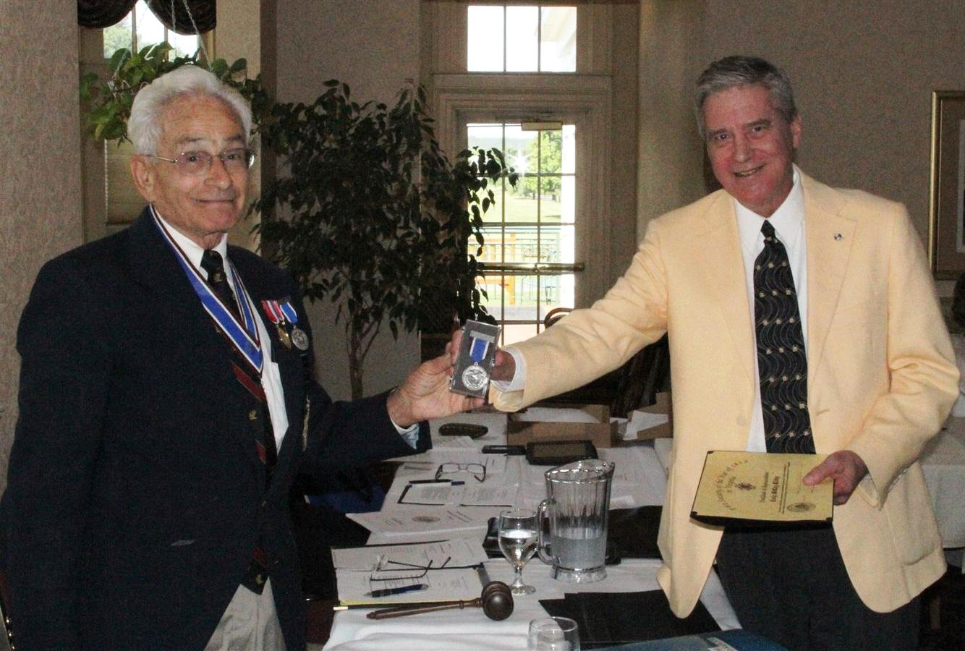

Craig Kilby as prospective member and Assistant Editor of the publication receives a Certificate of Appreciation and a Bicentennial Medal

Part 3 Luncheon & Grave Marking
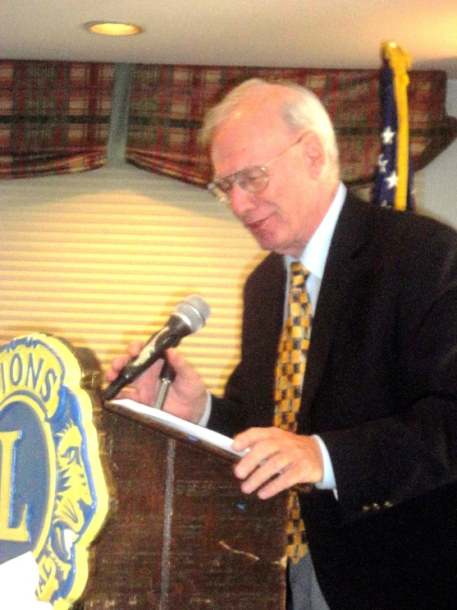
Newly inducted member, Stuart Butler as Guest Speaker, is shown at the luncheon during his presentation.

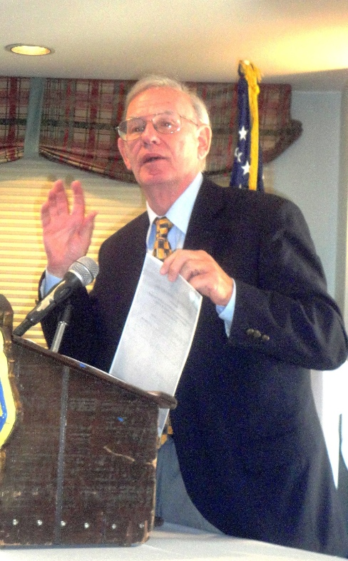
Speaker, Stuart Butler shows a copy of the Declaration of War from the National Archives signed by President James Madison. It was passed around for the luncheon attendees to view.

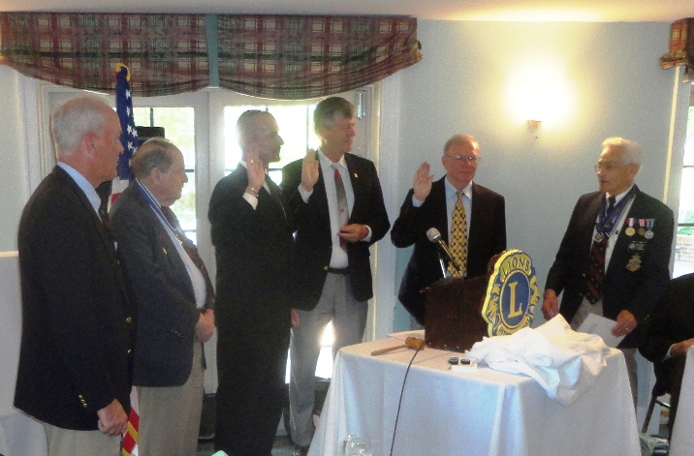
Assistant Historian General, Mike Lyman administers the oath to the new members being
inducted into the Society. Left to Right: Registrar, Henry C. Howells IV, President John C.
(Jack) Maxwell, Jr., new members, David Sutton, Douglas Bowling, and Stuart L. Butler, and Mike Lyman

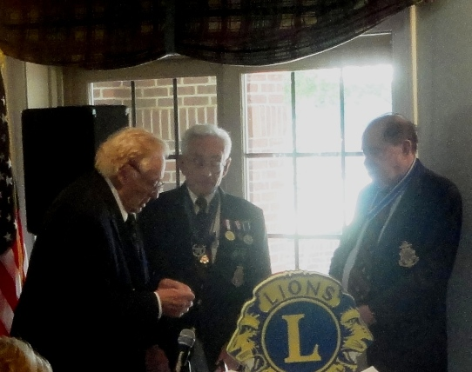

Quartermaster General John N. Dickie presents Mike Lyman, with the General Society’s
Past Presidents Star
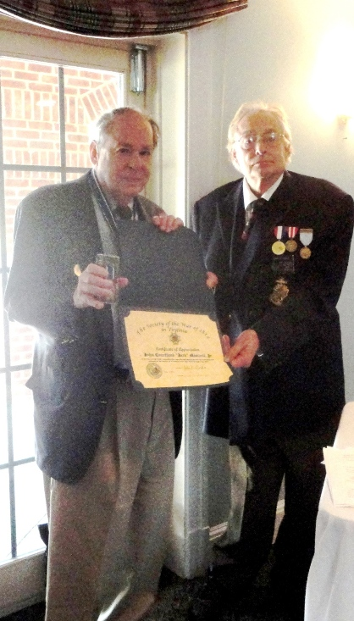
President Jack Maxwell is presented a Certificate of Appreciation for his tenure as President by President Elect Captain (USN Ret) John N. Dickie
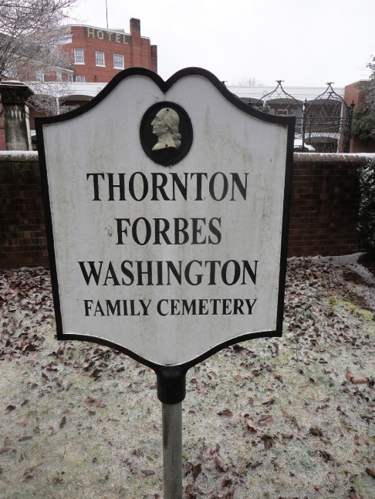
The third part of the Annual Convention of the Society was held at the above cemetery in Fredericksburg
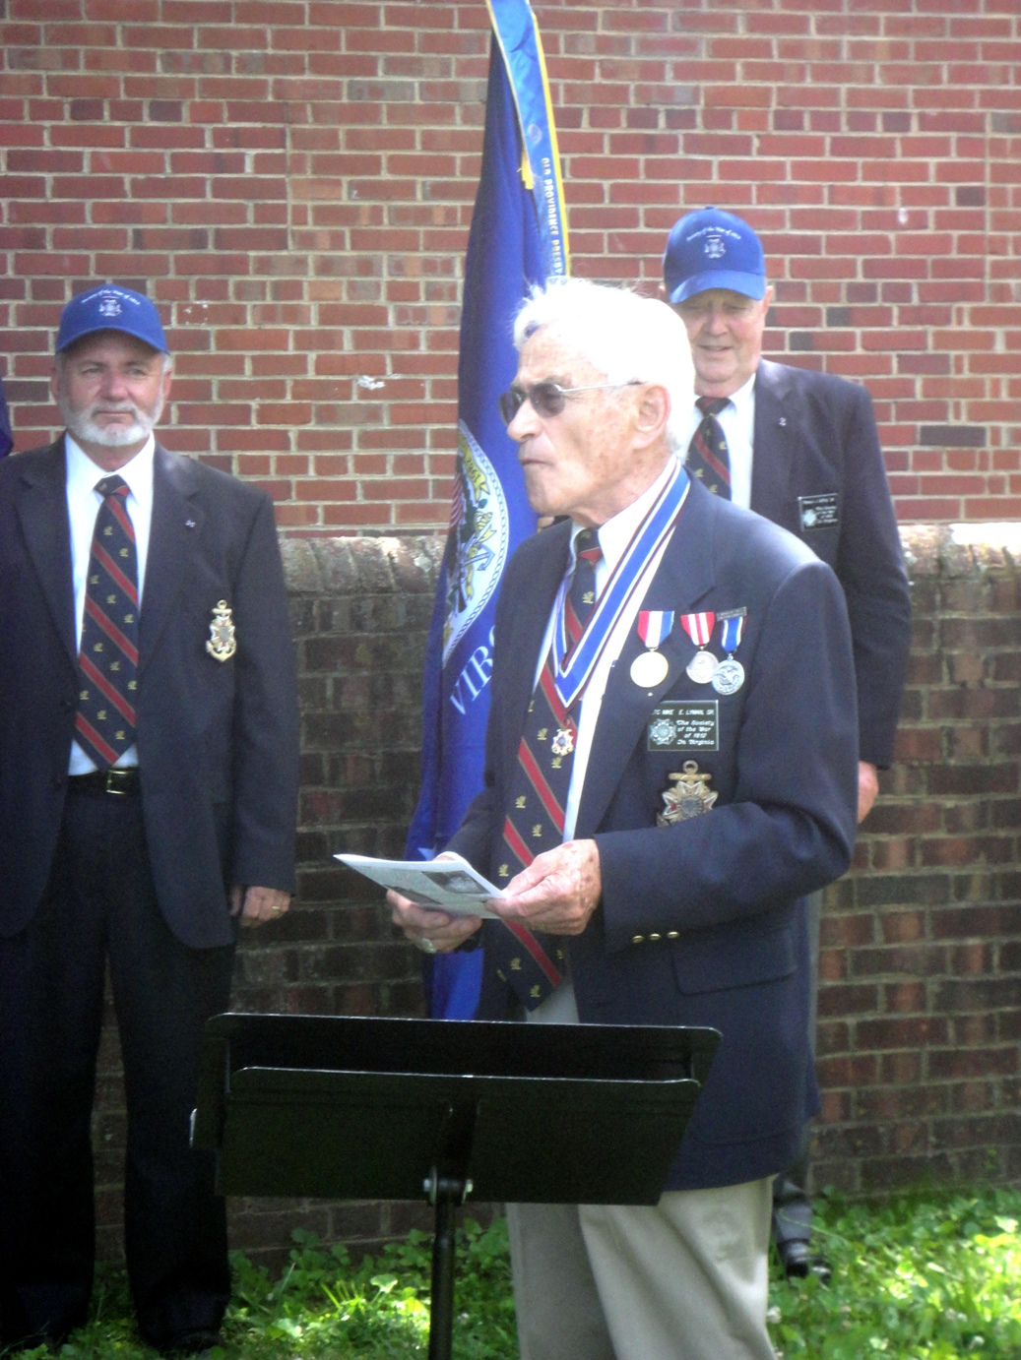
Grave Marking Committee Chairman. Mike Lyman was Master of Ceremonies. On the left behind him and as part of the Color Guard is member James T. Thacker and on the right is member Ronald J Depue holding the VA Society flag
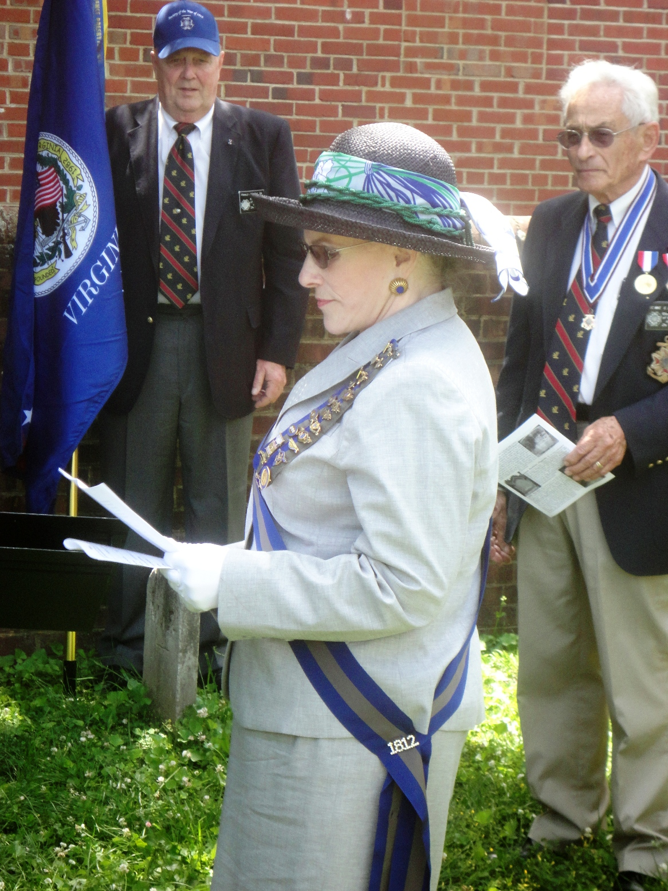
Jodi Cooper Killeen, 1st Vice President, National, U.S. Daughters of 1812 gives greetings and recited information on the cemetery and the veterans being honored.
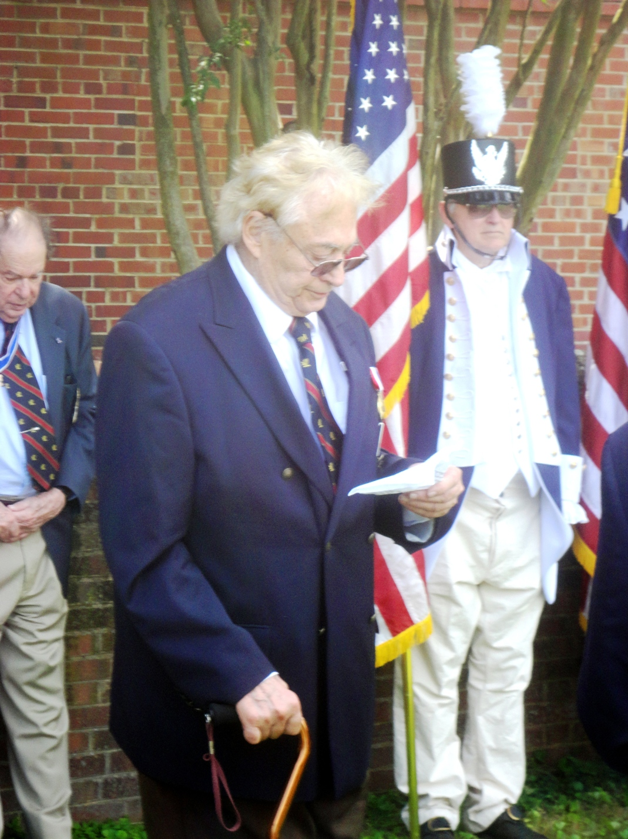
John N. Dickie, President Elect of the Society and Quarter Master General, gives greetings for the General Society War of 1812. Behind him is President Maxwell and 2d Vice President Elect, Dennis Fritts dressed in 1812 attire as leader of the Color Guard
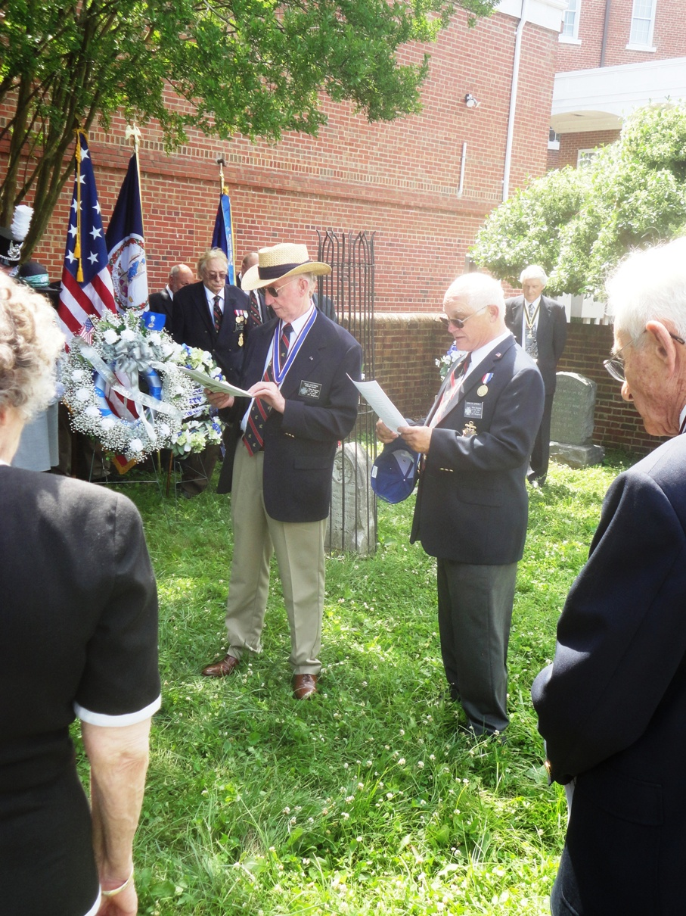
Performing the “Unveiling of Markers Ritual” is Past President Thadeus Hartman and Councilor John Epperly
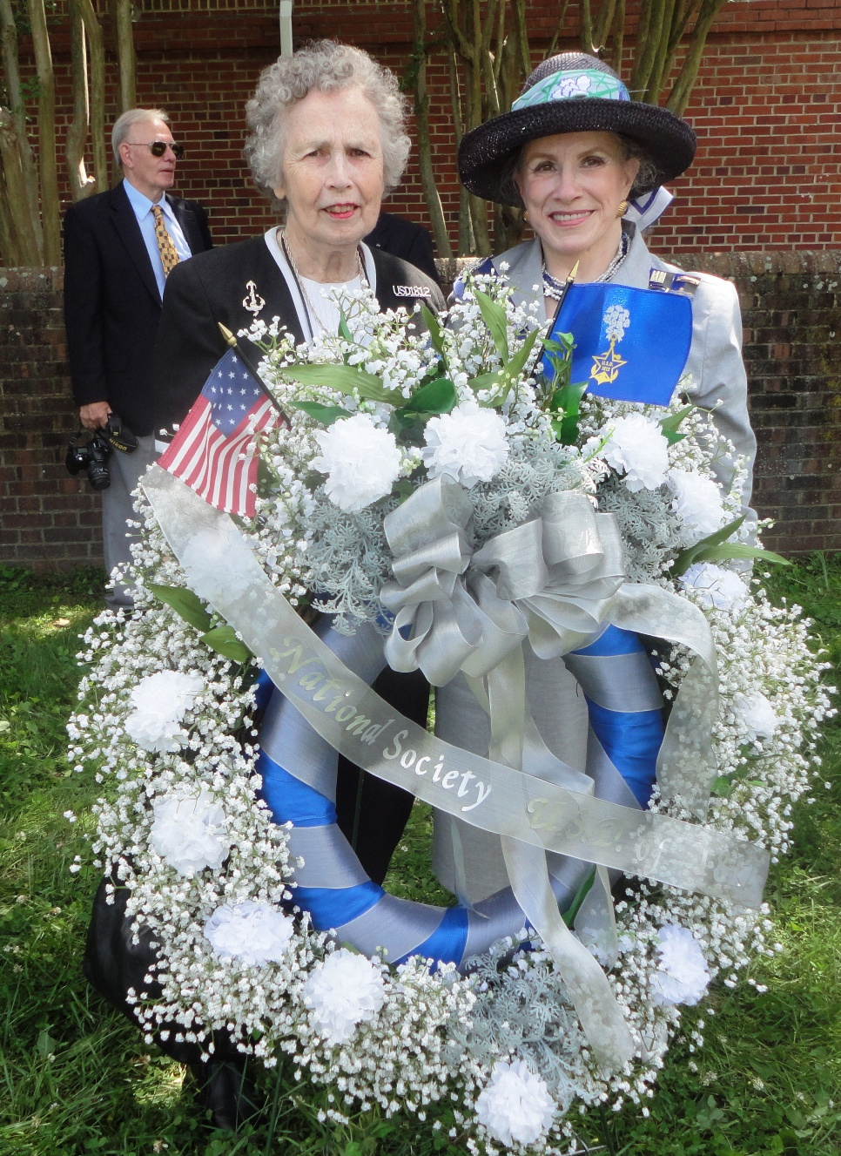
Attending the ceremony from the U.S. Daughters of 1812, is Past VA State Registrar and Past President of the James Monroe Chapter, Marjorie Morse standing behind the wreath thar was presented by Vice President National, Jodi Killeen. Not shown but attending as well from the US Daughters of 1812, VA State Society was Carol Epperly. In the background is member Stuart Butler. Carol is shown in the group photo below
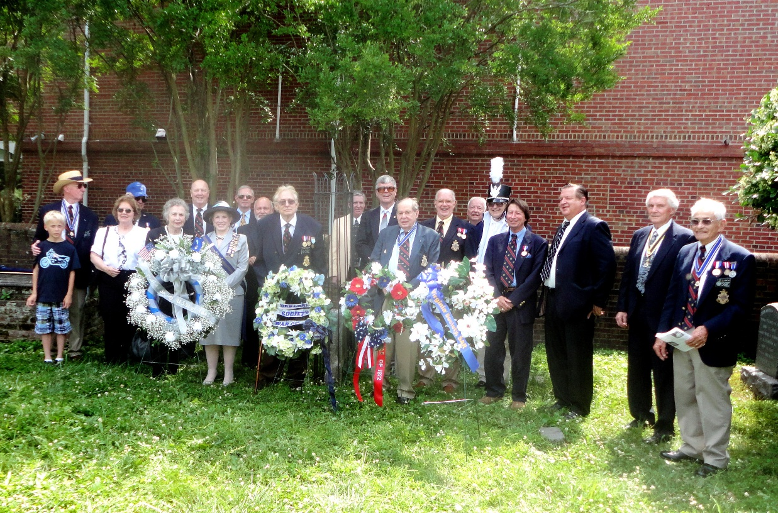
A gathering after the ceremony behind the wreaths presented were some of the attendees

