War of 1812 Society in Virginia’s Annual Conference June 16 2012 held at the
Fredericksburg Country Club & Thornton- Forbes -Washington Cemetery
MEETING AGENDA
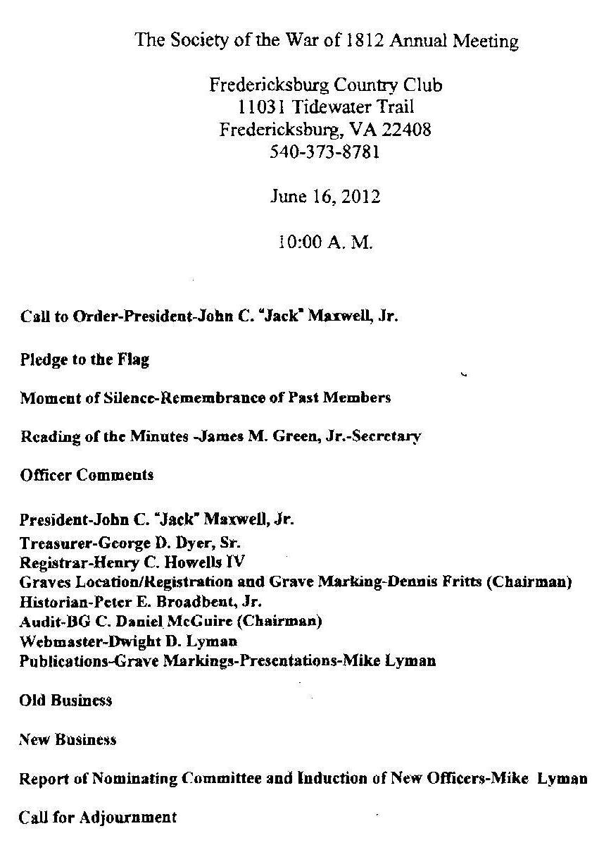

Part III Grave Marking Program

