THE GENERAL SOCIETY FLAG IS DISPLAYED AND A WREATH PRESENTED IN A PLAQUE UNVEILING CEREMONY IN VIRGINIA
The ceremony was conducted jointly by the War of 1812 Society in the Commonwealth of Virginia and the Virginia Society Sons of the American Revolution (VASSAR) at the Fincastle Presbyterian Church in Fincastle, Botetourt County on June 30, 2012
Unveiled were two plaques, one listing 36 Revolutionary War veterans and patriots and one listing 19 War of 1812 veterans interred in the historic church cemetery.
Displaying the General Society flag, presenting the wreath and giving greetings and remarks was Quarter Master General, Capt (USN Ret) John N. Dickie who also the following day became the President of the Virginia Society. Assistant Historian General, LT Col Myron (Mike) E. Lyman. Sr., Past President of the Virginia Society researched the names for each plaque, prepared the program participated in the Color Guard and announced the wreath layers during the ceremony.
This ceremony is one of several joint plaque unveiling ceremonies that the Virginia Society has conducted with VASSAR in the last few years. In 2010 a similar ceremony was conducted honoring patriots from both wars at the Old Providence Presbyterian Church in Augusta County. In 2011 a monument and plaque was installed and dedicated naming the number of Revolutionary War patriots and about 400 War of 1812 veterans buried in the Shockoe Hills cemetery in Richmond. Also in 2011, a similar joint plaque unveiling ceremony was conducted at the St Paul’s Episcopal Church in Norfolk. It is believed that this rubbing of shoulders of the members of the two societies has been beneficial in increasing membership to each.
Carried in the combined Color Guard of VASSAR and the VA Society War of 1812 was the General Society flag carried by Dennis Fritts, First Vice President VA Society; the Star Spangled Banner Flag carried by Mike Lyman, Past President, VA Society and the Virginia Society flag carried by Deputy Councilor, Andy Doss. During the ceremony President Elect, John Dickie and Past president, Lt Colonel Thadeus Hartman unveiled the Virginia society plaque. Deputy Vice President General of the Chesapeake District, Colonel Andrew Johnson, participated in the combined color guard. Several other members of the Virginia society participated in the ceremony as well.
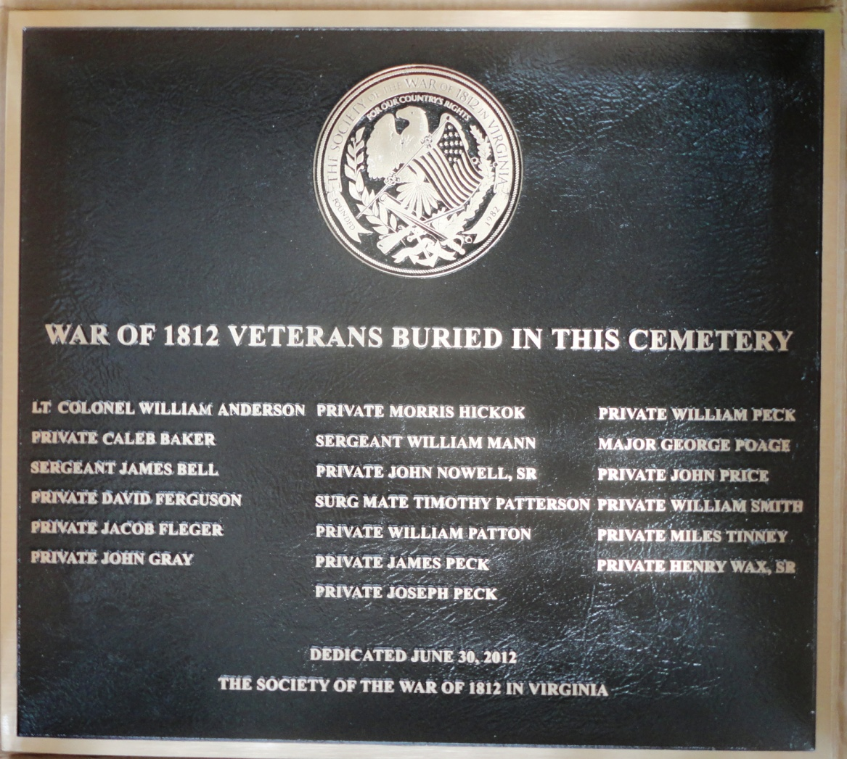
The unveiled War of 1812 Society plaque is shown mounted on the wall of the Fincastle Presbyterian Church, Fincastle, VA
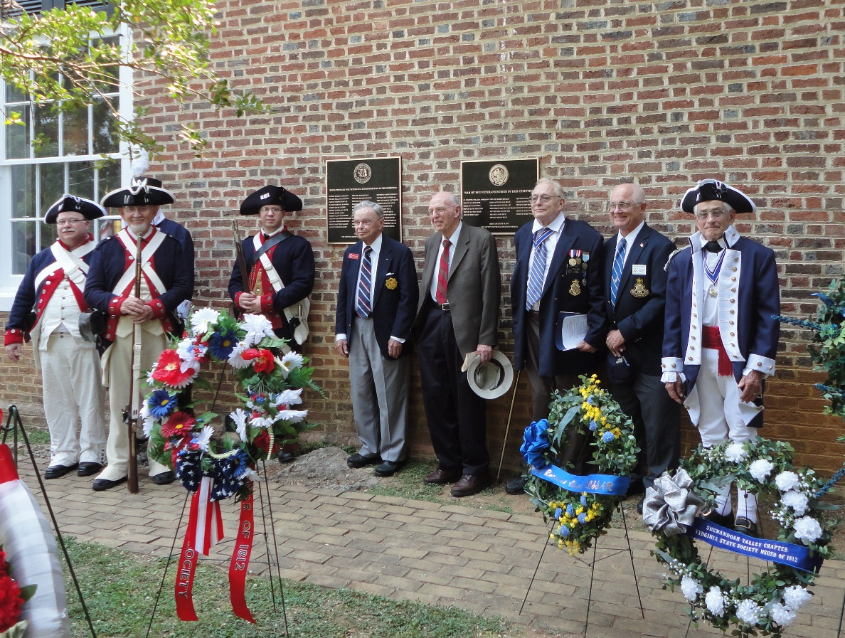
Group photo of 1812 Society members after the ceremony by the unveiled plaques. L/R: member R. Allen Brahin; Deputy President General, Col Andrew M. Johnson; behind him partially visible, Vice President, C. Dennis Fritts; Deputy Councilor, Andrew Doss; Councilor, Cranston Williams, member Professor James Owens; President, John N. Dickie; Councilor, John M. Epperly; and Past President, Mike Lyman. Not shown is Past President Thadeus Hartman.
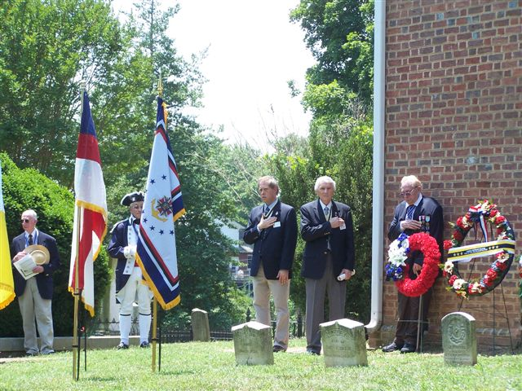
The General Society flag on the right is displayed during the ceremony
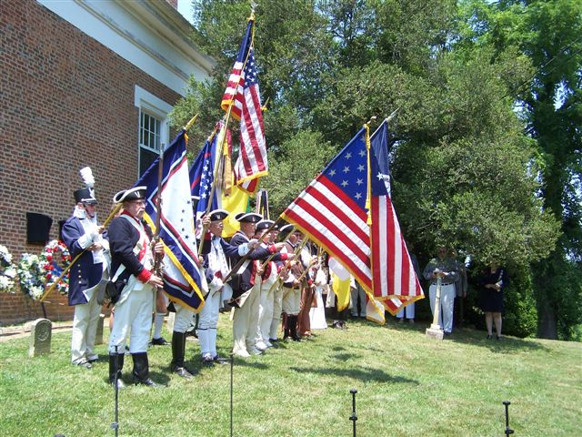
During the Pledge of Allegiance the flags are presented.
Shown are the General Society flag, the Star Spangled Banner flag, and the Virginia Society flag
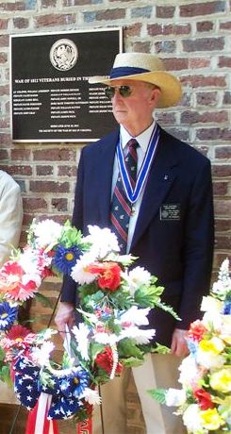
Past President, Thadeus Hartman presented the Virginia Society wreath. The 1812 Society plaque is in the background on the outside wall of the church
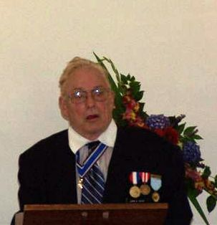
Inside the Church after the ceremony, Quarter Master General, John N. Dickie gave greetings and remarks to the attendees.

