THE WAR OF 1812 IN VIRGINIA
THE BATTLE OF THE LITTLE WHITE HOUSE IN VIRGINIA
TOOK PLACE IN LATE AUGUST 1814
ON GROUND OVERLOOKING THE POTOMAC RIVER WHICH IS
NOW LOCATED IN THE VICINITY OF THE FORT BELVOIR OFFICERS CLUB
The photo below was taken by Mike Lyman from the river which is without the improvements on shore what the British fleet would have seen

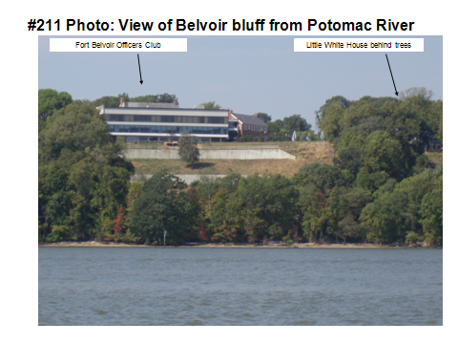
The article below authored by Bertram H. Groene in Volume XVIII, Number 1, Summer 1968 of the Virginia Cavalcade describes the battle in an outstanding manner.
