A JOINT CEREMONY AT THE ARNOLD GROVE CEMETERY, HILLSBORO, LOUDOUN COUNTY, VIRGINIA COMMEMORATING TWENTY TWO INTERRED VETERANS OF THREE WARS, REVOLUTION, WAR OF 1812 AND CIVIL WAR
was conducted at 11 am, May 11, 2013 by the Boy Scouts of America, The Virginia Society, Sons of the American Revolution, The War of 1812 Society in the Commonwealth of Virginia, and the Clinton Hatcher Camp #21, Sons of Confederate Veterans.
General Society of the War of 1812: Attending was Quartermaster General, Captain John M. Dickie, (USN Retired)
Society of the War of 1812 in the Commonwealth of Virginia: Attending was Captain John M. Dickie (above) President of the Society, LT Col Myron (Mike) E. Lyman, Sr. (USA Ret), Past President and Stuart L. Butler, Councilor of the Society
Of the twenty two veterans honored, six were War of 1812 veterans: Ensign Samuel D Leslie; Private Solomon Vanvactor; Private Aaron Scatterday; Private Samuel Clendening; Ensign Andrew Ogden; and Sergeant William Butts.
After the veterans were honored, the War of 1812 members stand behind the wreaths that were presented during the ceremony. They are from left Butler, Dickie and Lyman mentioned above
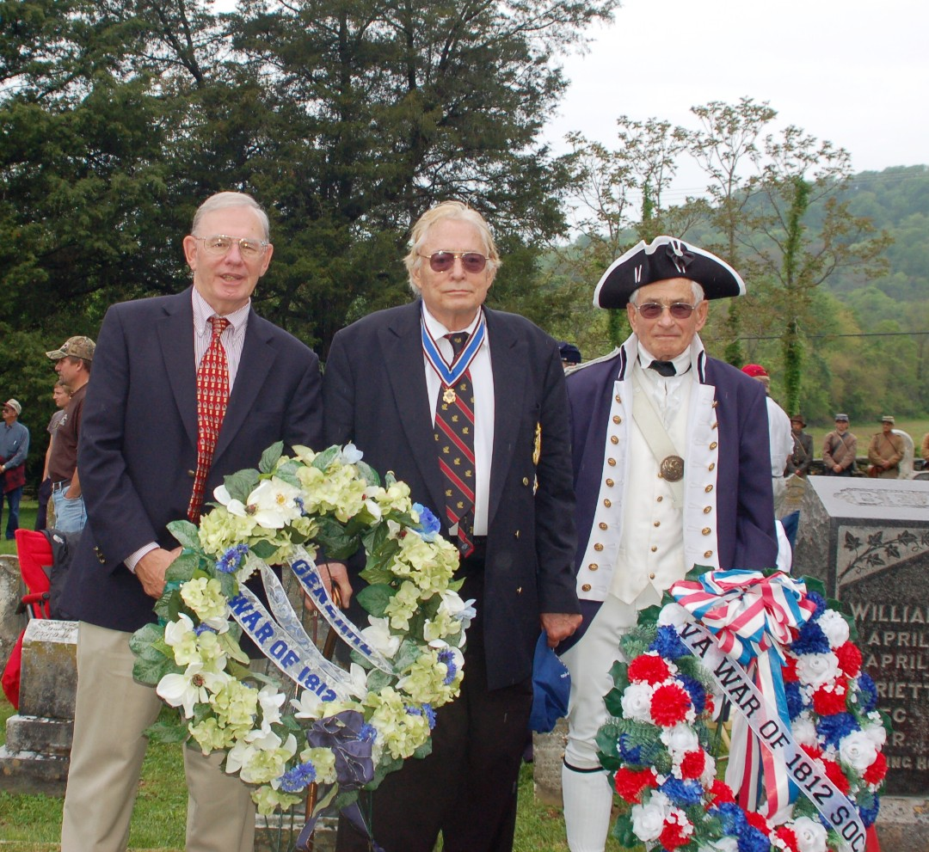

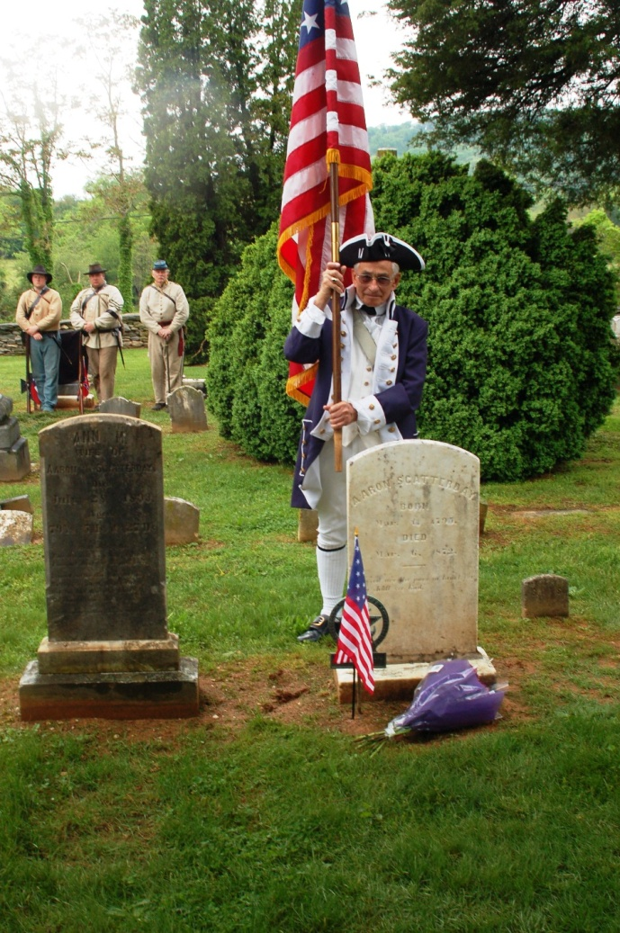
Mike Lyman carried the Star Spangled Banner Flag to each of the six War of 1812 Veteran gravesites where the society grave marker or a U.S. Daughters of 1812 marker was unveiled by the Boy Scouts and/or descendants of the veteran

William Butts, Esq.:
was born about 1791 in Shepardstown, WVA, and died 01 Dec 1871. He served first in Captain Robert Wilson’s Company of the 67th VA Militia Regiment of Berkeley County (now WVA), which was attached to the 6th VA Militia Regiment at Norfolk commanded by Lt Col Thomas Reade, Jr. during the period April to August 1813. He was later a Lieutenant in Captain Van Bennett’s Company of Loudoun County from May to December 1814. This unit marched from Shepardstown to Edward’s Ferry near Baltimore. He married in Apr 1816, Margaret Howsworth. He was awarded bounty land and both he and his wife drew a pension

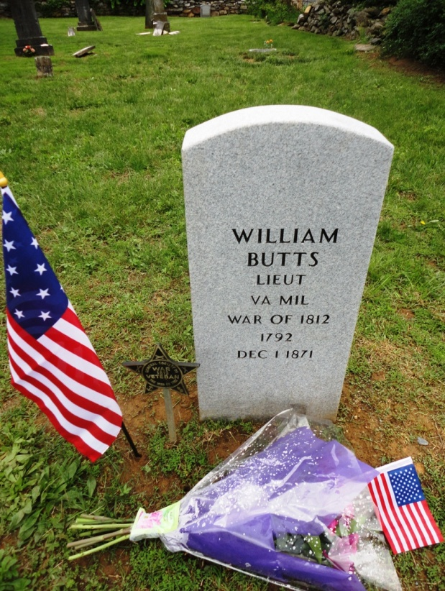
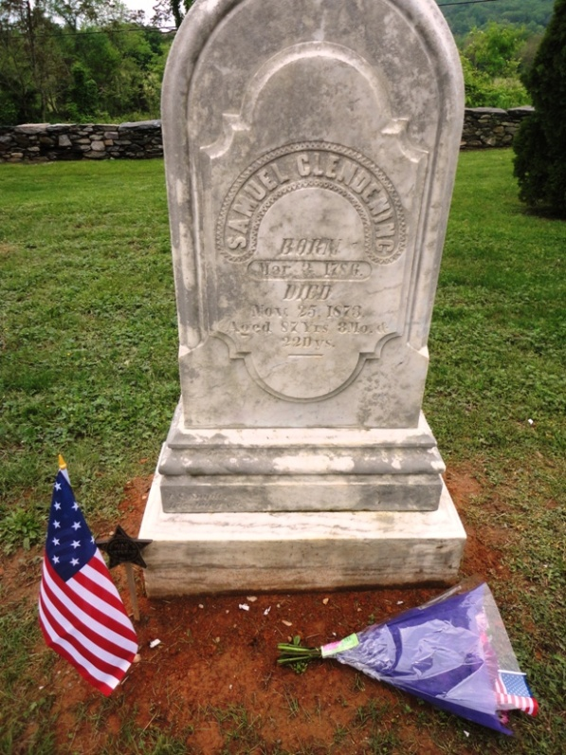
Samuel Clendening:
was born 03 Mar 1786 and died 24 Nov 1873. He was a Private in Lt Colonel John Green's Mounted Infantry Regiment that served in August and September 1814 and was at the battle at the White House where Fort Belvoir is today in Fairfax County. He married Mary (-----), who was born 02 Sep 1775, and died 17 Jun 1859

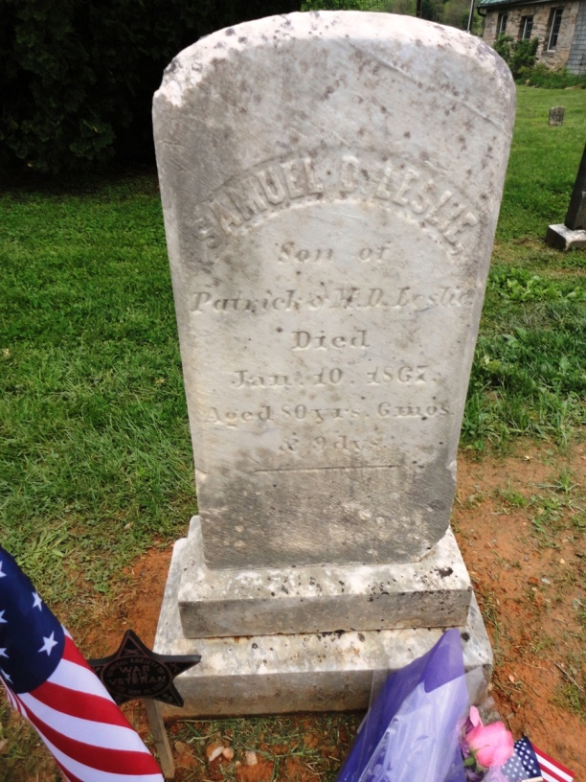

Samuel D. Leslie:
was born in 1786 and died 10 Jan 1867. He was an Ensign in the 56th VA Militia Regiment commanded by Lt Col Timothy Taylor of Loudoun Co

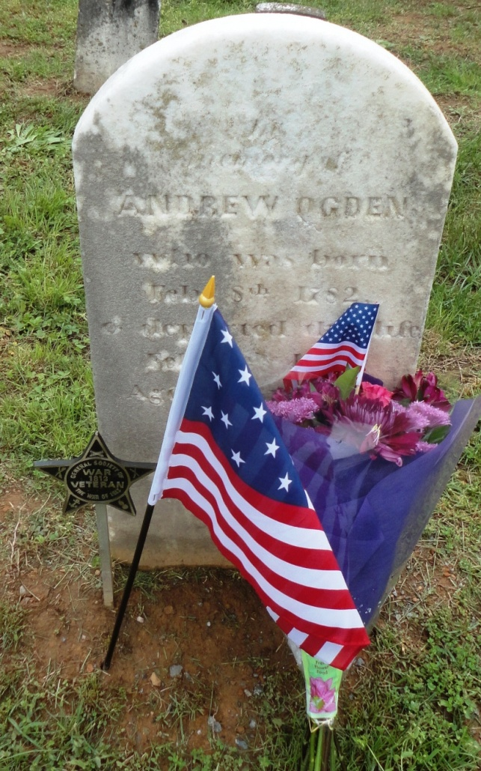
OGDEN, Andrew;
was born 08 Feb 1782 and died 16 Feb 1855. He was an Ensign in Capt John B Stevens’ Company, of the 56th VA Militia Regiment of Loudoun County and was attached to 5th VA Militia Regiment in the defence at Norfolk from May to December 1814. He married 24 Dec 1810 in Loudoun County, Elizabeth Shawen who was born in 1789.

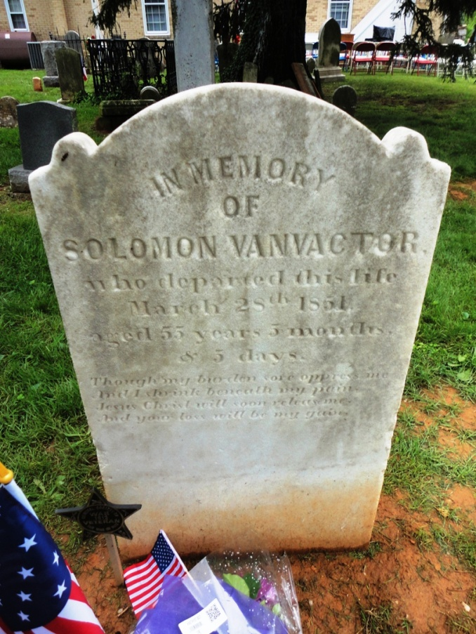
VANVACTOR, Solomon:
date of birth is not determined and he died 23 October 1851. He was a Private in the First VA Militia Regiment commanded by Lt Col Griffin Taylor and served from August to November1814 in the defense of Baltimore. His unit occupied defensive positions along the Ferry Branch southwest of Fort McHenry It was during this period the battle of Baltimore took place

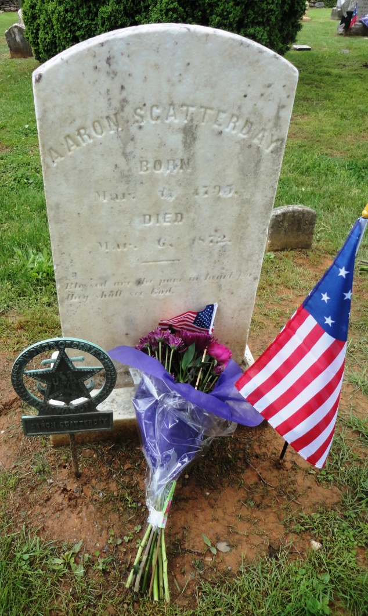
SCATTERDAY, Aaron:
was born 01 Mar 1795 and died 06 Mar 1872. He was a Private in Captain George Blincoe’s Company of thr 57th VA Militia Regiment commanded by Lt Col Armistead Mason of Loudoun County and served in August and September 1814. He married Anna M (-----), who died 28 Jul 1893. He was awarded bounty land and he and Anna both drew a pension.

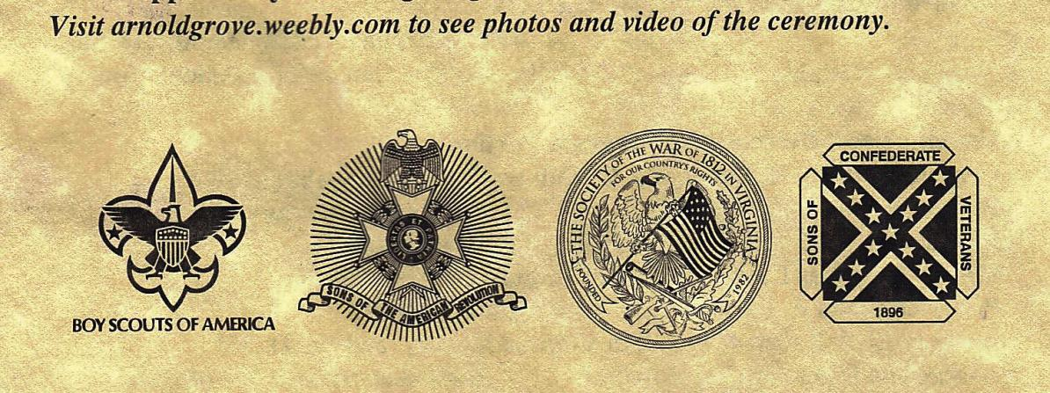
Above are the logos of the four Societies conducting the ceremony

