THE WAR OF 1812 SOCIETY IN THE COMMONWEALTH OF VIGINIA PARTICIPATED IN MEMORIAL DAY SERVICES HONORING FALLEN 1812 VETERANS THAT SERVED DURING THE WAR FROM HALIFAX COUNTY
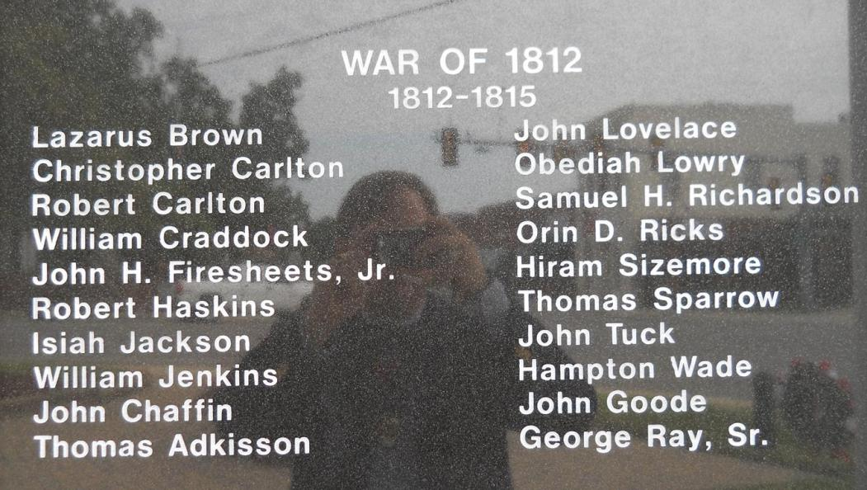
These are the twenty War of 1812 veterans from Halifax County that died during the war period while in service
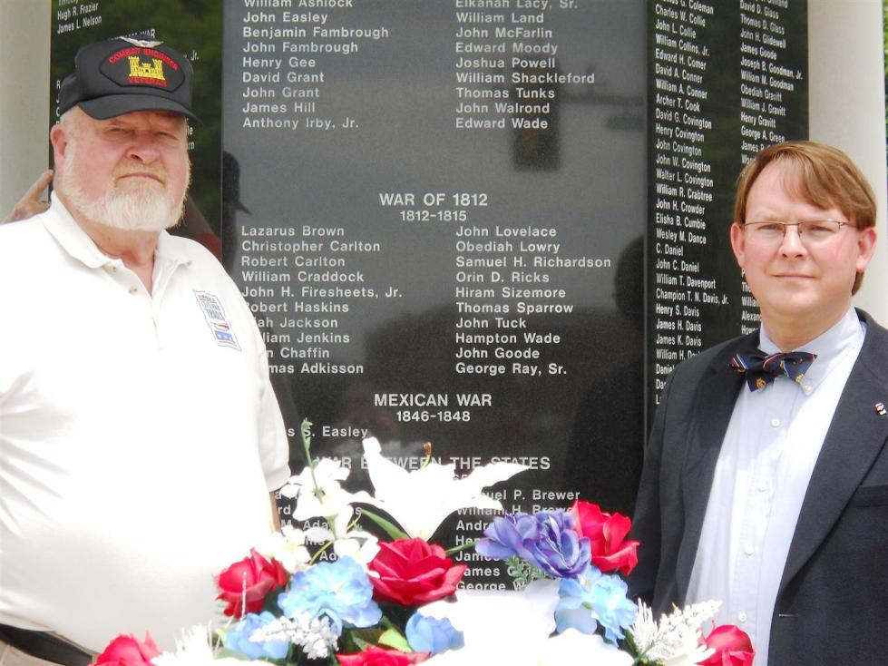
This shows from the left member, Douglas Powell and Secretary, Shane Newcombe
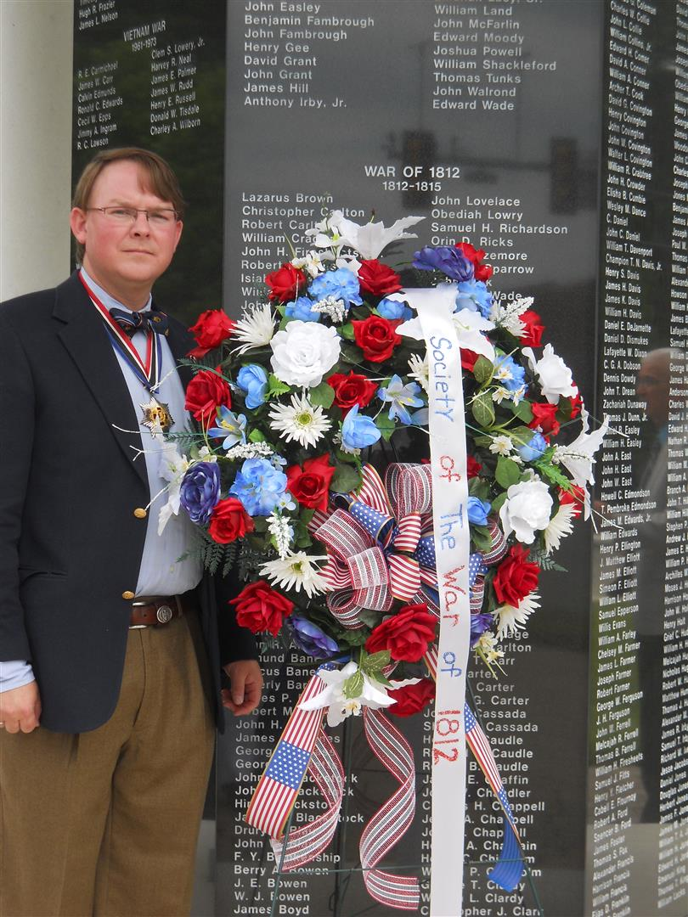
Society Secretary, Shane Newcombe with the Society wreath he presented

