WAR OF 1812 SOCIETY IN THE COMMONWEALTH OF VIRGINIA PARTICIPATES IN A JOINT RECOGNITION OF VETERANS INTERRED IN THE Mt ZION BAPTIST CHURCH CEMETERY MAY 19TH 2013
The society honored, Private Randolph B Phillips, a soldier of the War of 1812 in Virginia His service records from the National Archives, coupled with information from Author Stuart Butler’s, A Guide to Virginia Militia Units in the War of 1812, 2d Edition published 20`11 indicates:
War of 1812 service and information for Randolph B. Phillips
He was born 03 October 1784 and died 01 September 1872 in Buckingham County. While residing in Cumberland County on 27 Dec 1813 he served as a Private in Captain Nicholas Faulkner’s Company of the 17th Virginia Regiment and upon arriving in Norfolk on 13 January 1814 was attached to the 4th Virginia Militia Regiment. His company was stationed to the rear of Fort Norfolk during his tour of duty there and his unit was not involved in any battle with the British. His company commander, Captain Faulkner resigned on 08 February 1814 and he served then under his replacement, Captain Daniel A. Allen to 16 March 1814. He then served there under Captain Hudson M. Wingfield of Hanover County until 11 April 1814. At this time he was paid for eight days travel time to return the distance of 160 miles to come home. Since he served over the minimum of three months he applied for a pension, but it is uncertain if it was received.
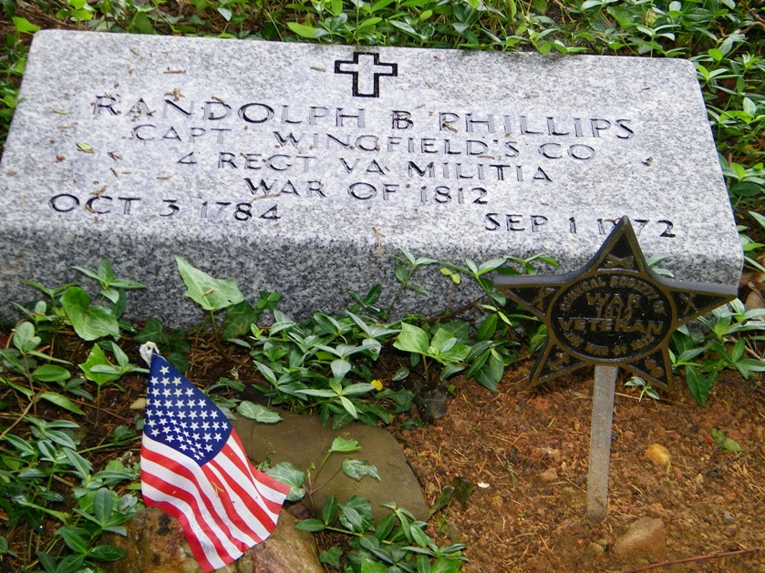
Photo of his Gravestone and the War of 1812 grave marker that was unveiled.
Some photos taken at the ceremony follow

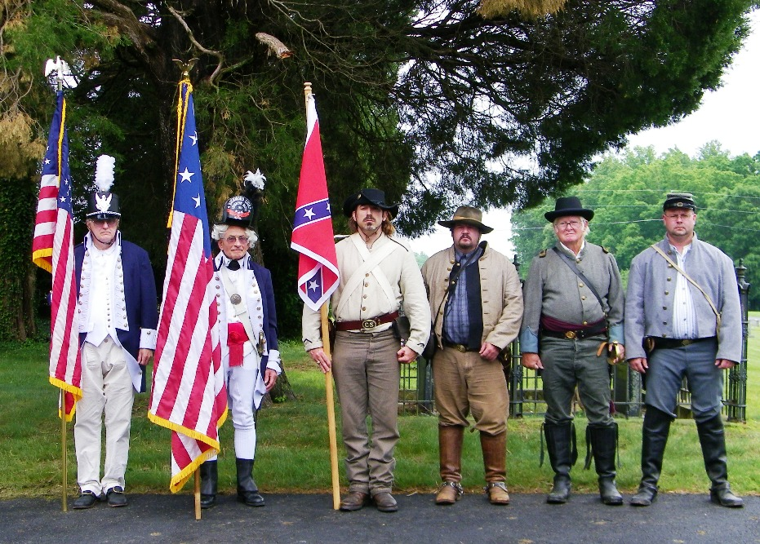
Several Confederate veterans were also interred in the cemetery so a combined Color Guard was assembled. On the left was the U.S. flag carried by First Vice President Dennis Fritts of the War of 1812 Society, next Past President of the Society, Mike Lyman carrying the Star Spangled Banner flag, the flag of the county during the war period; next four members of the local unit of the Sons of confederate Veterans with the Confederate Flag
Because of inclement weather the ceremony was moved into the Church where the rest of the ceremony was conducted and the rest of the photos were taken
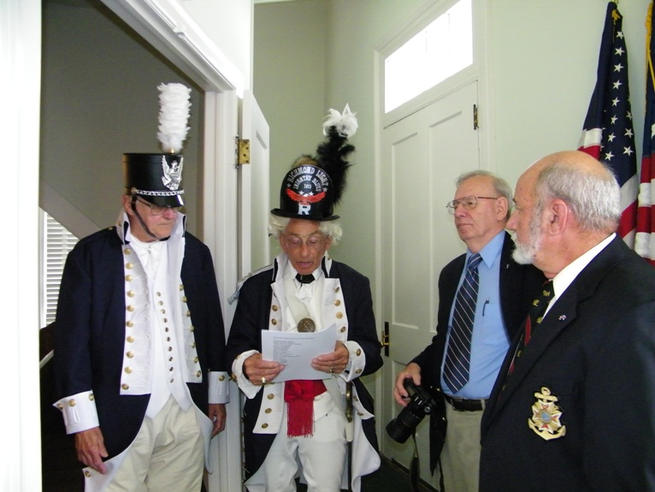
Four members of the society participated and review how the program would be modified for conducting inside the Church. From left: Dennis Fritts, Mike Lyman and society councilors, Stuart Butler and James Thacker
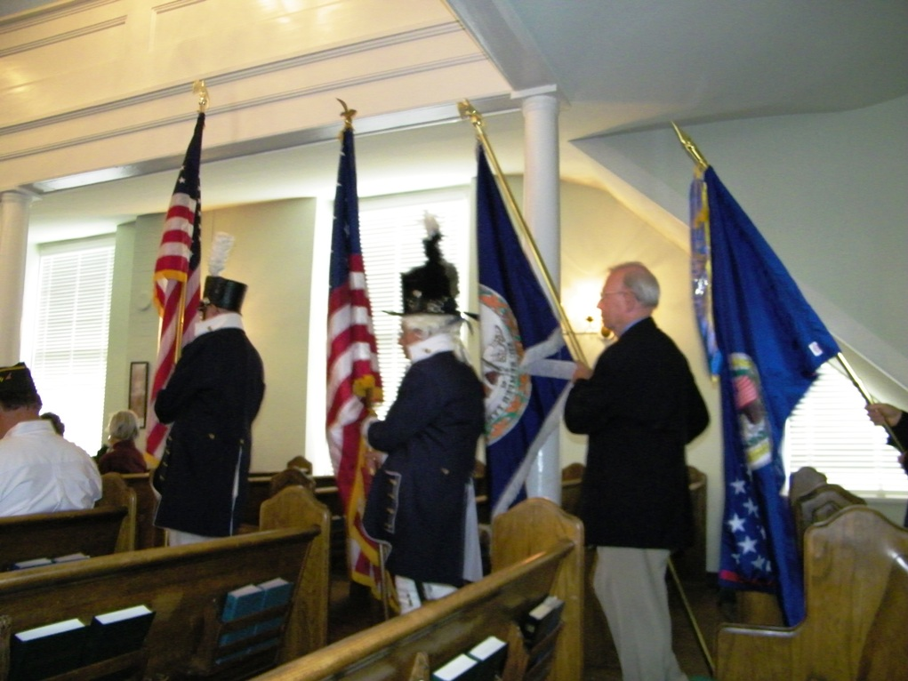
The colors are forwarded

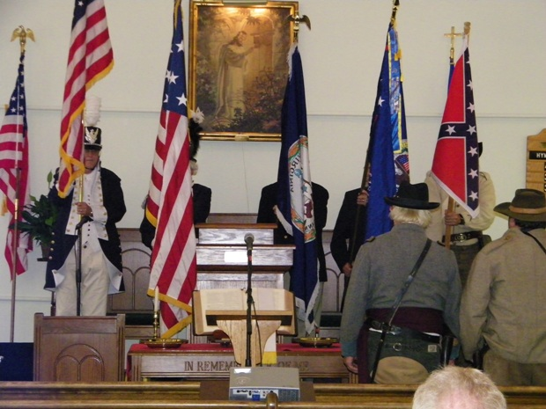

And presented for the Pledge of Allegiance
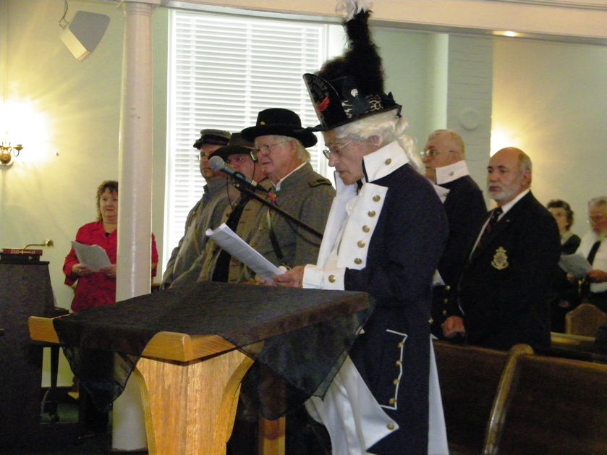

Mike Lyman presides over a portion of the program. He is attired as a Captain of the Richmond Virginia, Light Infantry Blues Company
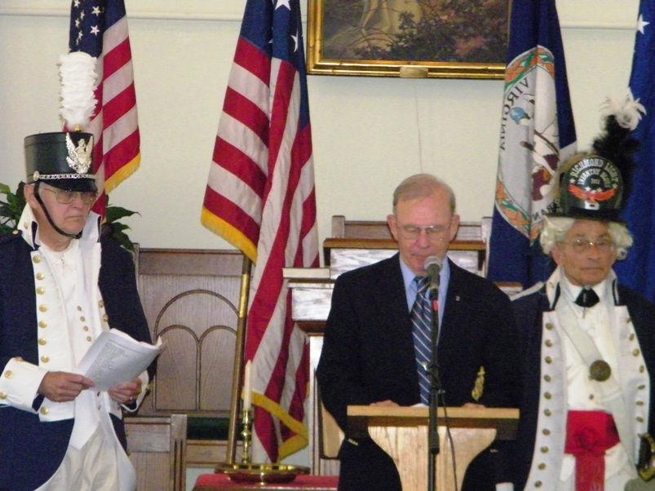

Councilor of the society, Stuart Butler reads the service for the War of 1812 soldier
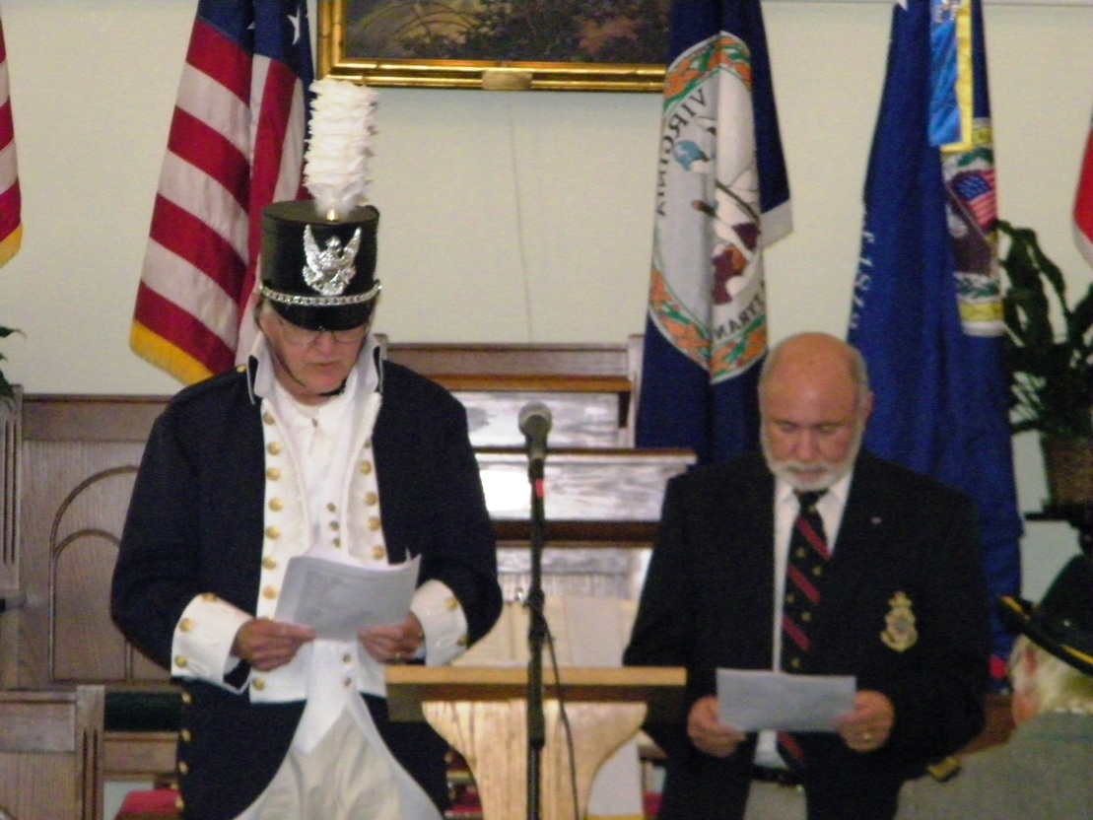
Vice President Dennis Fritts, dressed in War of 1812 attire, and Councilor James Thacker recite the ritual for unveiling a War of 1812 Society grave marker
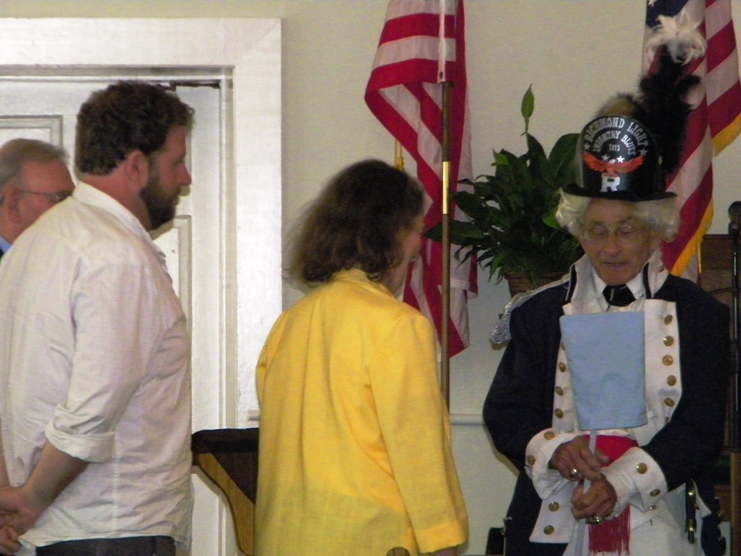
A descendant of the soldier, Diane B George, prepares to unveil a War of 1812 grave marker similar to the one at his gravesite in the cemetery, and below after removing the cover
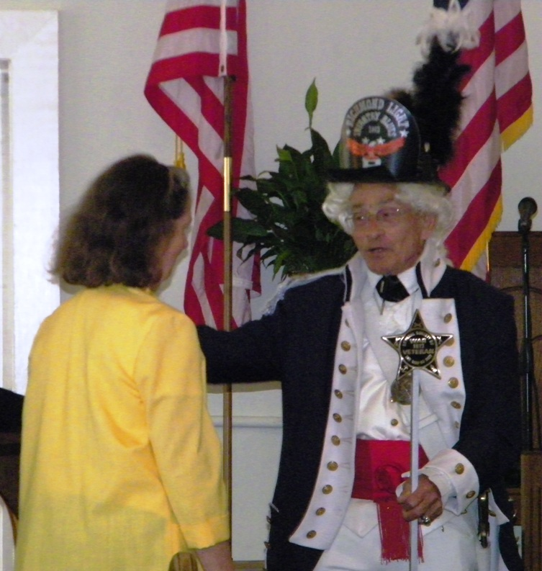
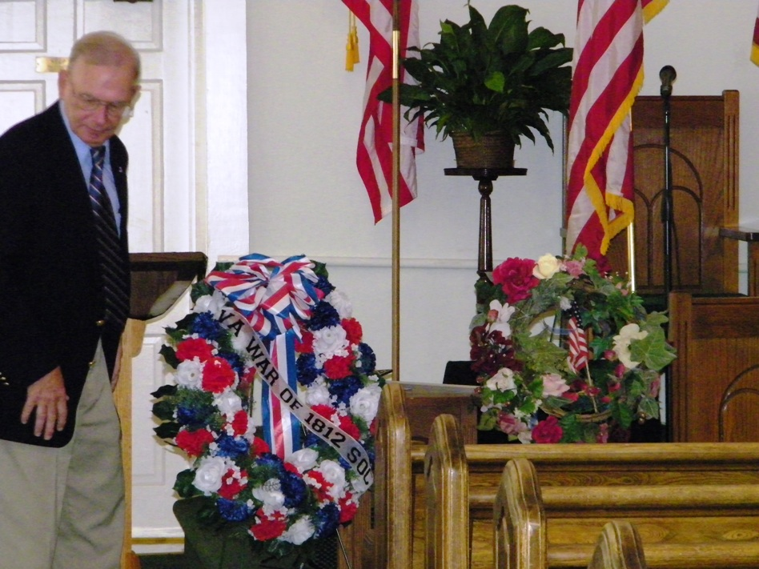
Stuart Butler presents the Society wreath

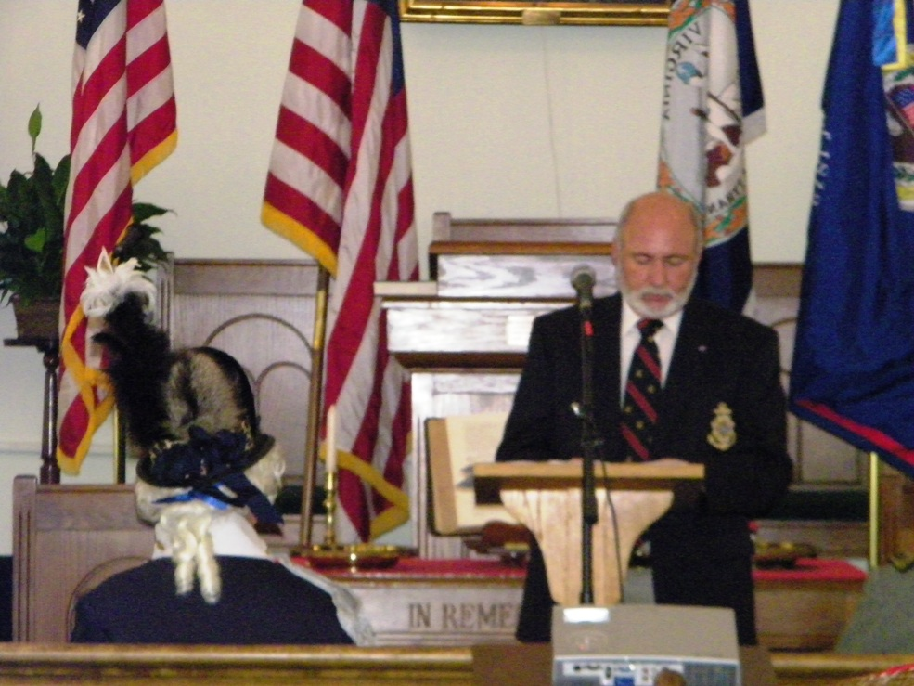
James Thacker reads names of other veterans interred in the cemetery
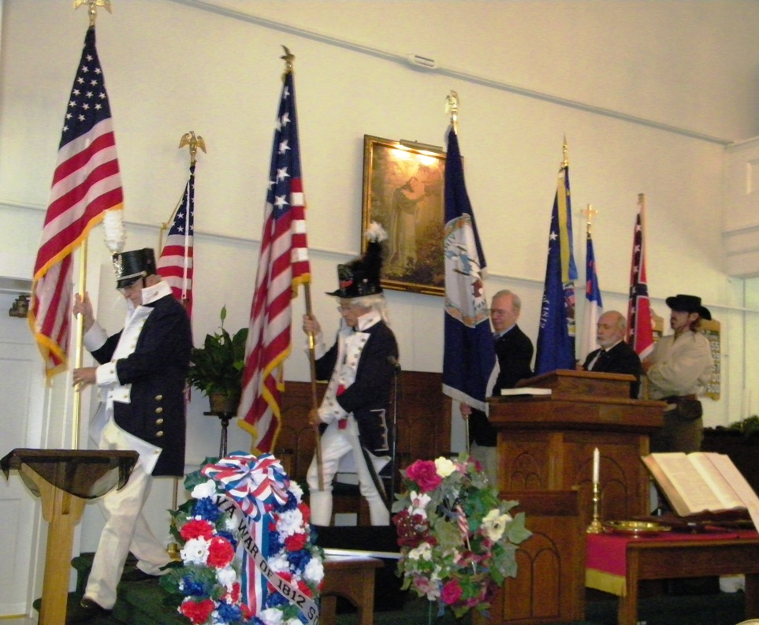
The colors are retired and after the Benediction the ceremony ended.

