The War of 1812 Society in the Commonwealth of Virginia conducts a grave marking ceremony for Corporal Robert H Lee in Newport News, Virginia on May 15, 2013 at the Lee-Davis Cemetery at 51 Curtis Road
A Daily Press newspaper article announced the ceremony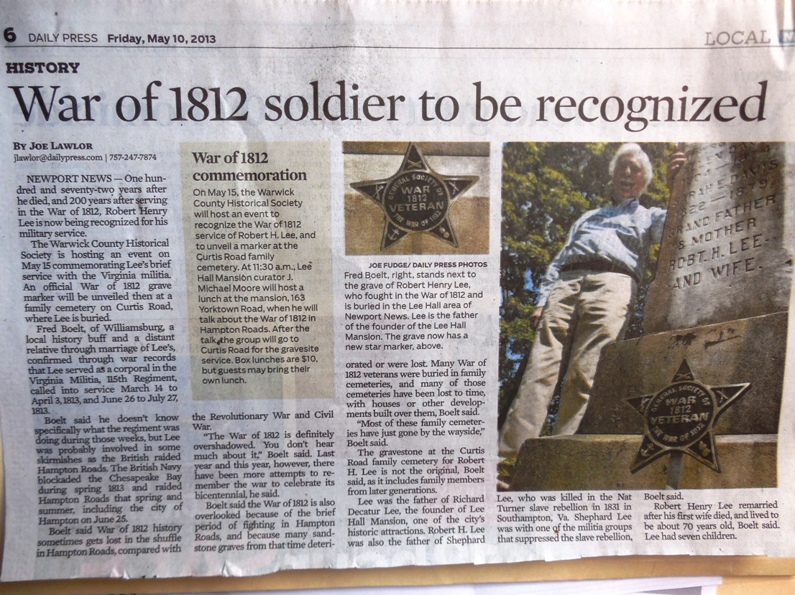
Four members of the Society conducted the ceremony. Mike Lyman, Past President, Councilors of the society, Stuart L. Butler and James T Thacker and member Frederick W, Boelt who appears in the article above

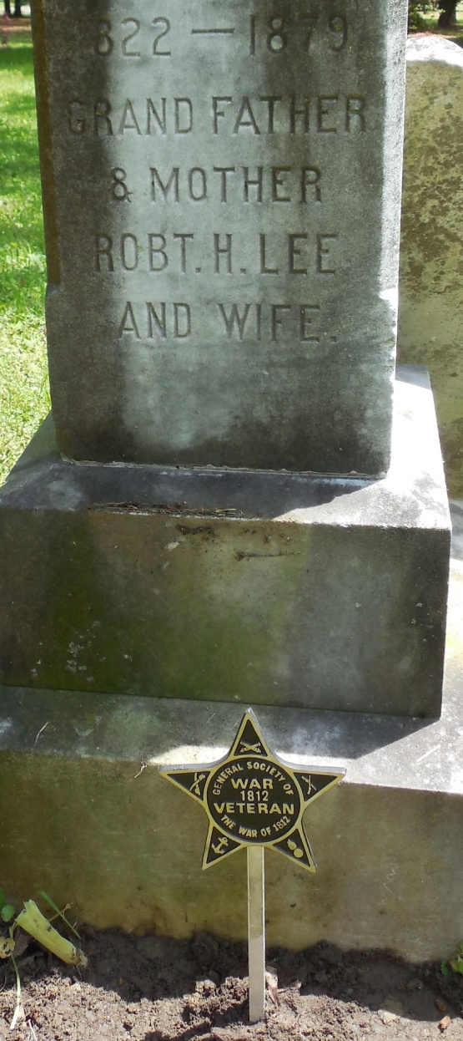
Below is not the original gravestone of Robert H. Lee but he and his wife are memorialized on this stone at his burial site erected by descendants of his family
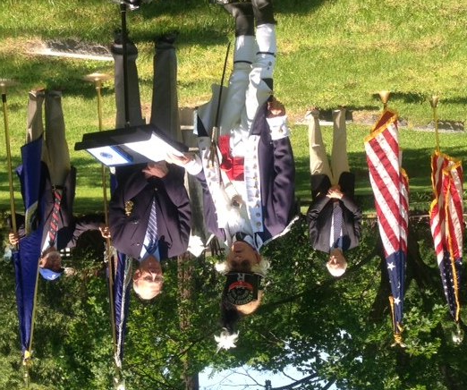

Above Mike Lyman, dressed as a captain of the Richmond Light Infantry Blues of the 19th Virginia militia Regiment during the War of 1812, is shown conducting the ceremony with members of the society mentioned above. Stuart Butler is about to read the information about the veteran while Fred Boelt and James Thacker look on from the posted flags
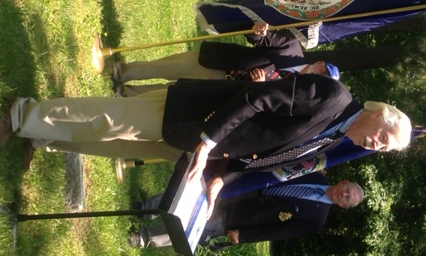
Fred Boelt is a direct descendant of the War of 1812 veteran and he discusses his connection and the family of the veteran. Below he is shown unveiling the War of 1812 Society grave marker
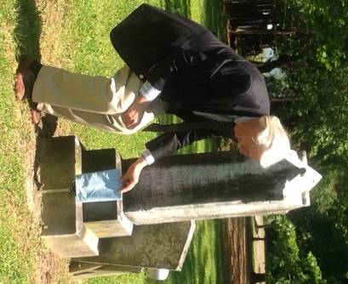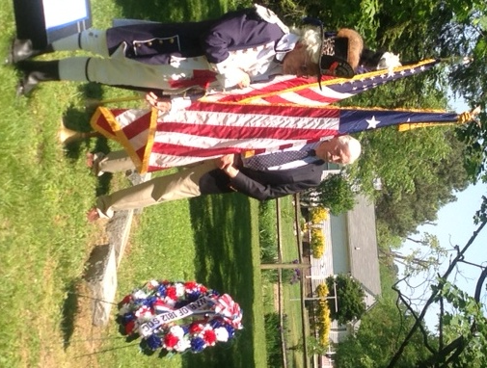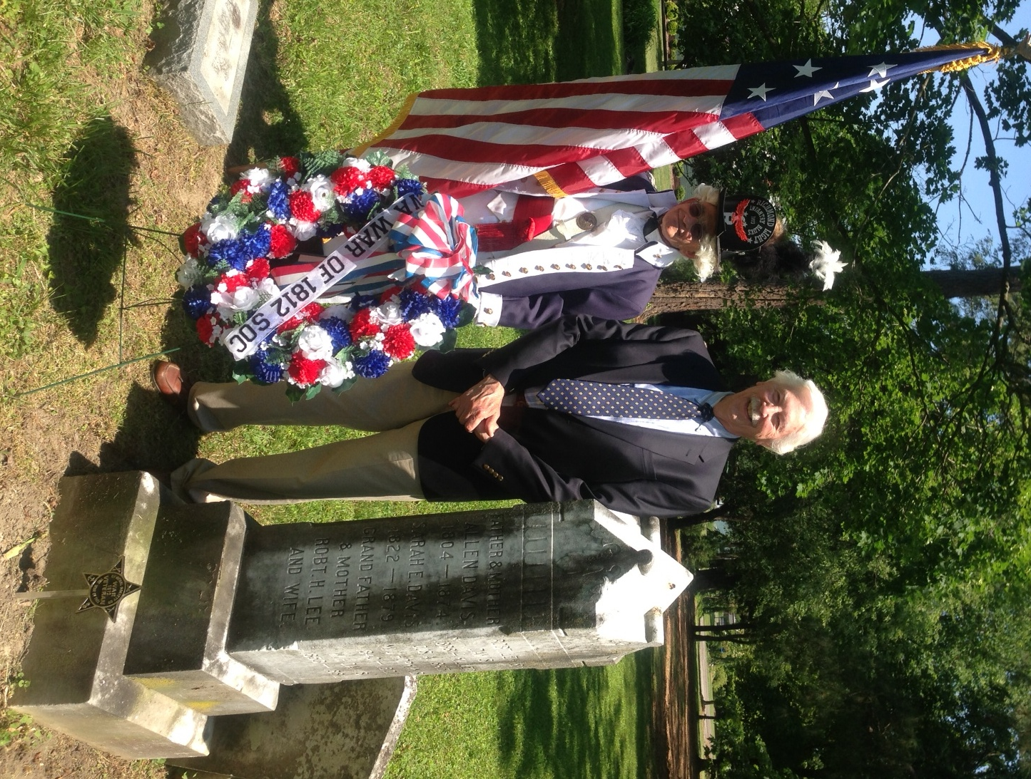
The Star Spangled Banner Flag of 15 stars and 15 stripes, the U.S Flag during the War of 1812 is carried and presented during the ceremony
Also the War of 1812 Society wreath was presented as well

