200TH ANNIVERSITY OF THE BATTLE OF CRANEY ISLAND AT ENTRANCE TO THE ELIZABETH RIVER IS OUTLINED IN NEWSPAPER ARTICLE
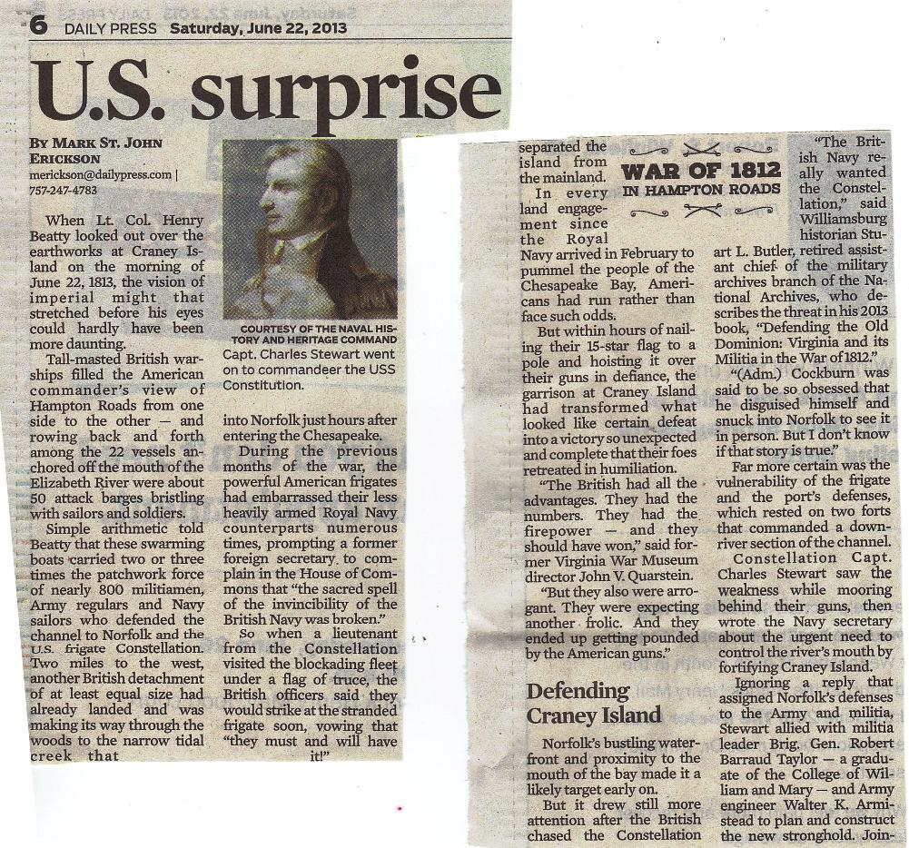
(Continued below)
(CONTINUED,2D COLUMN ON RIGHT)
(CONTINUED IN FIRST COLUMN ON RIGHT)
(CONTINUED IN 2D COLUMN ON LEFT)

