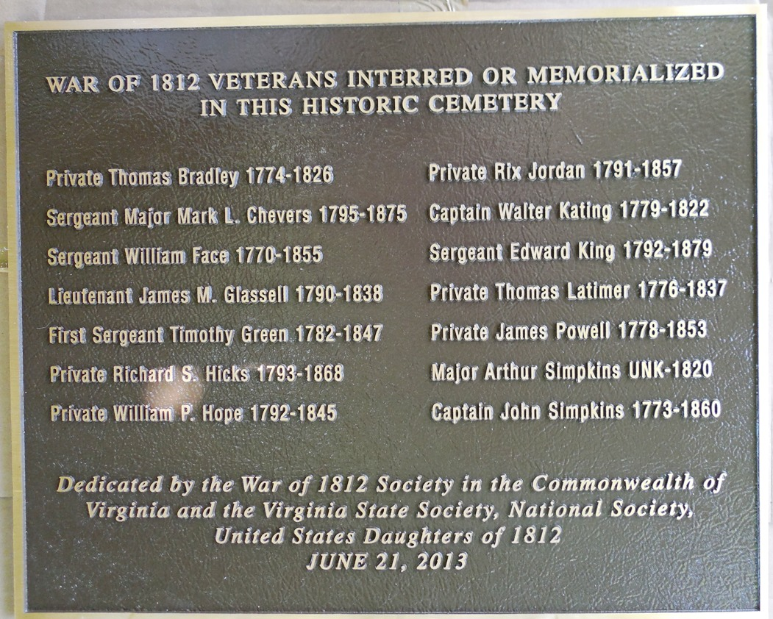
THE SOCIETY UNVEILS A PLAQUE LISTING FOURTEEN WAR OF 1812 VETERANS INTERRED IN THE ST JOHNS CEMETERY IN HAMPTON

Note that the plaque was also jointly financed and presented by the Virginia State Society U.S. Daughters of 1812. The ceremony was conducted following the Annual Muster and Luncheon in Hampton, Virginia on June 21, 2013.
Some information about these veterans are outlined below

WAR OF 1812 VETERANS INTERRED IN THE ST JOHNS EPISCOPAL CHURCH GRAVEYARD, HAMPTON, VIRGINIA
BRADLEY, Thomas H; b 1774; d 09 Jul 1826 ; Private, in Captain David Glass’s Artillery Company, 52nd VMR, New Kent Co, attached to 1st VA Militia Regiment commanded by Lt Col Trueheart,
CHEVERS, Mark L; b 1795; d 13 Sep 1875; Sergeant Major, in 1st Regiment, NY Militia; married Mary D (-----), who d 01 May 1876, at age 71; was a Chaplain at Fort Monroe for 47 years
FACE, William; b 1770; d 1855; Sergeant, 115th VMR, in Capt Richard B Servant’s Company, Elizabeth City County, now city of Hampton, attached to1st VMR commanded by Lt Col James Clarke and probably in the battle at Hampton under Major Stapleton Crutchfield ; married Eliza Presson, who d 1866
GLASSELL, James M; b 1790; d 3 Nov 1838; First Lieutenant, US Army, in Capt Thornton’s Company, commissioned 12 July 1814 and to Adjutant in January 1815. Served in Baltimore. Married Eudora Swartwout
GREEN, Timothy; b 1782, d 23 Dec 1847; First Sergeant, NY Militia, served in Captain McMath’s Volunteer Company. Gravestone styles him “Captain”
HICKS, Richard S; b 1793, Elizabeth City Co; d 18 Mar 1868; Enlisted at Hampton on 7 Jul 1814, discharged at Norfolk 15 Mar 1815. Was a farmer at enlistment. Served as a Private, 35th Infantry, US Army, in Captain F Waller’s Company. Married Mary C (-----), who was b 1800, d 1889
HOPE, William P; b 1792; d 1845; Private, 115th VMR, Elizabeth City County, now city of Hampton, in Captain Miles Cary’s Company; married Maria A (-----) who drew a pension
JORDAN, Rix; b 20 Jun 1791; d 28 Dec 1857; Private, 1st Corps D'Elite commanded by Lt Col Randolph; married Diana G (-----)
KATING, Walter; b 1779; d 01 Oct 1822; Captain, "Maine 1812" is inscribed on tombstone; more specific service not found.
KING, Edward; b 16 Apr 1792; d 29 Apr 1879; Sergeant, in 4th VMR commanded by Lt Col Elisa Boyd; marrried Sarah E (-----), who d 1883
LATIMER, Thomas; b 06 Sep 1776; d 20 Aug 1837; Private, in Captain John Cooper’s, Troop of Cavalry, York County, attached to 1st VMR commanded by Lt Col James Clarke and probably in the battle at Hampton under Major Stapleton Crutchfield,
POWELL, James; b 28 Feb 1778; d 11 Dec 1853; Private, Capt Charles M Collier’s Company, 115th VMR and probably in the battle at Hampton under Major Stapleton Crutchfield: married Alice Wilson who received an Old War pension. This type usually given to veterans wounded or disabled during service.
SIMPKINS, Arthur; b date unknown; d 16 Apr 1820; Major, Staff Officer, 27th VMR of Northampton County commanded by Lt Colonel Major S. Pitts
SIMPKINS, John; b 21 Jan 1773; d 07 Nov 1860; Captain of a Troop of Cavalry, 27th VMR, Northampton County
Some photos taken during the ceremony are shown below. Most were taken by Shane Newcombe, Secretary of the Society and others by member, Floyd Brown
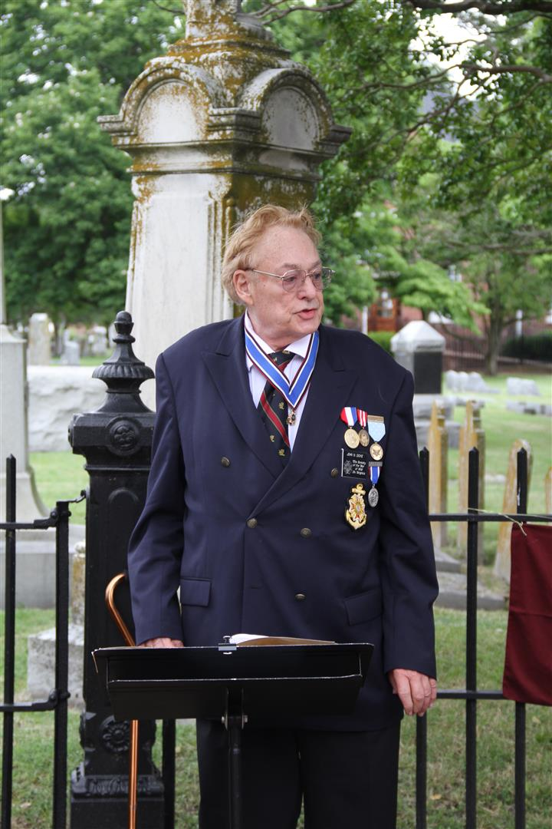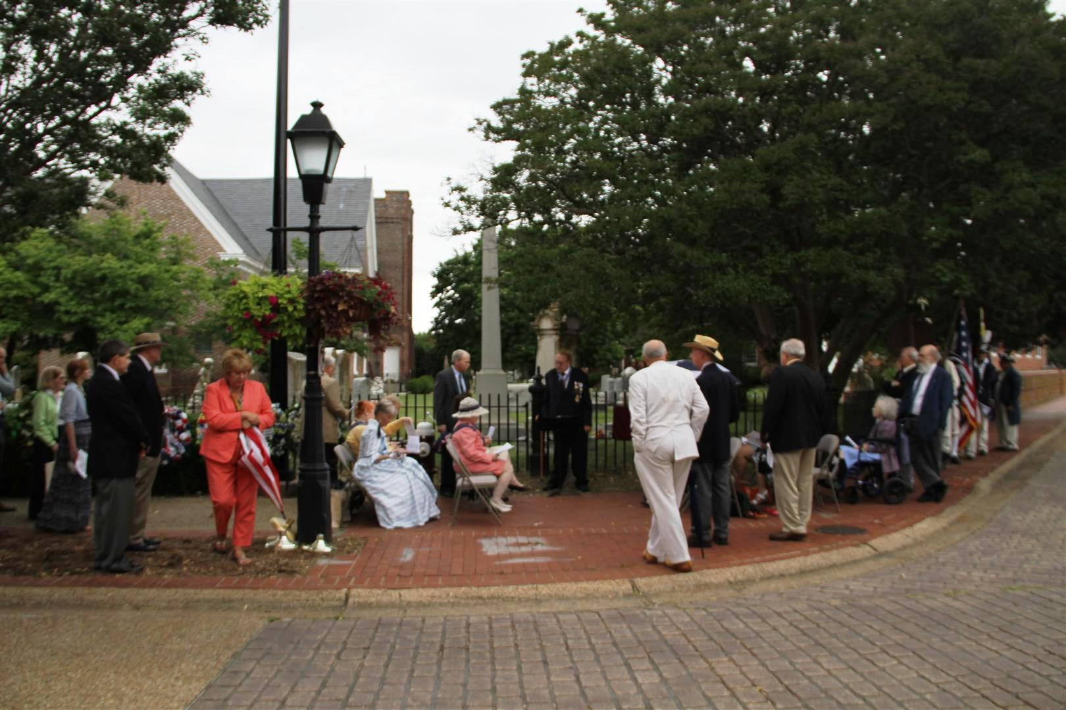
President John N. Dickie, Captain USN Ret conducted the ceremony
The attendees gather
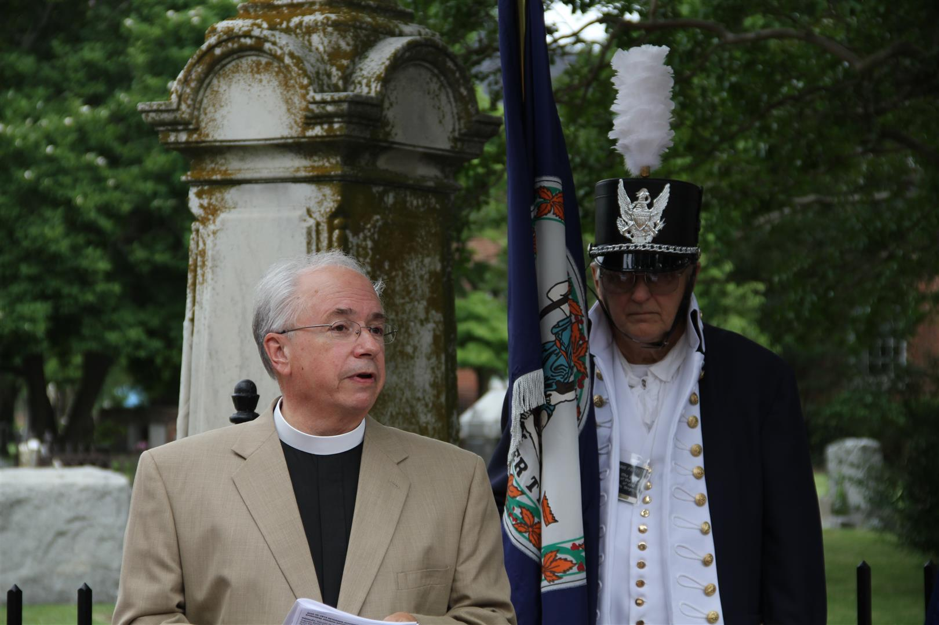
Interim Rector, Reverend Peter Hogg gave the invocation and the greetings from the church
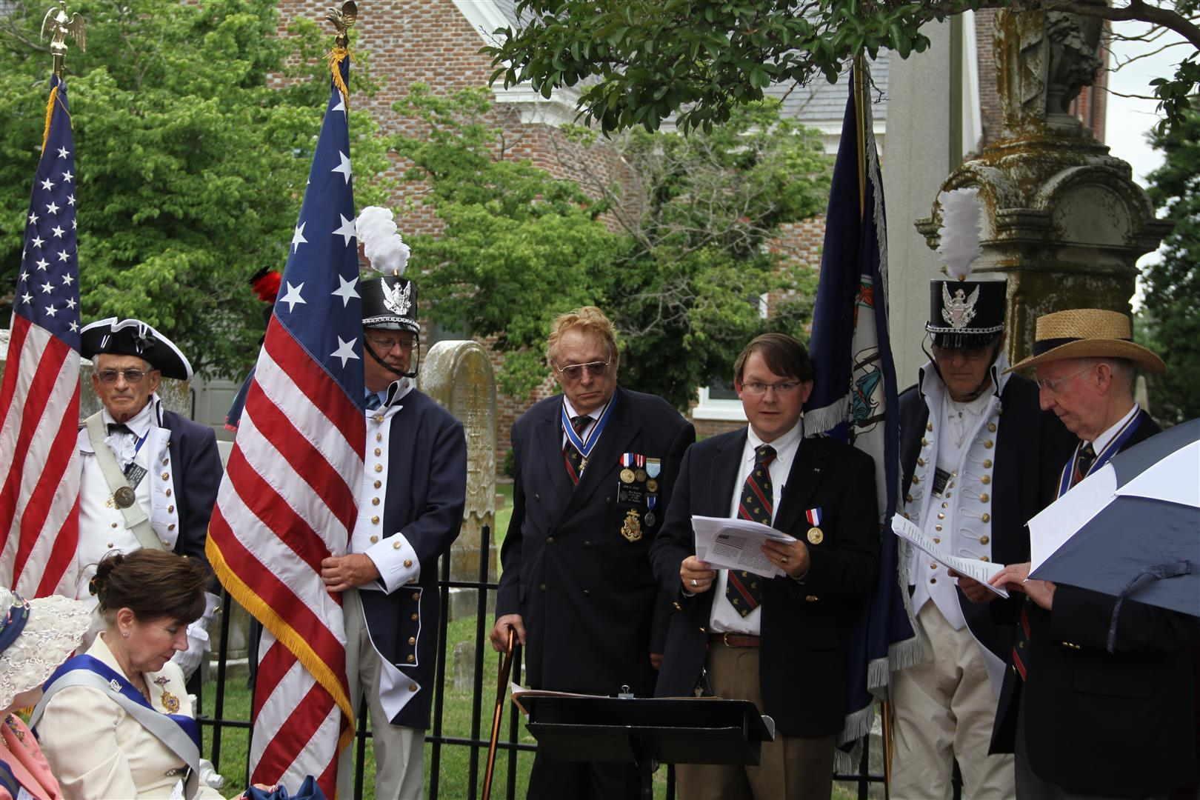
The unveiling ritual is presented by Secretary Newcombe and Past President Hartman
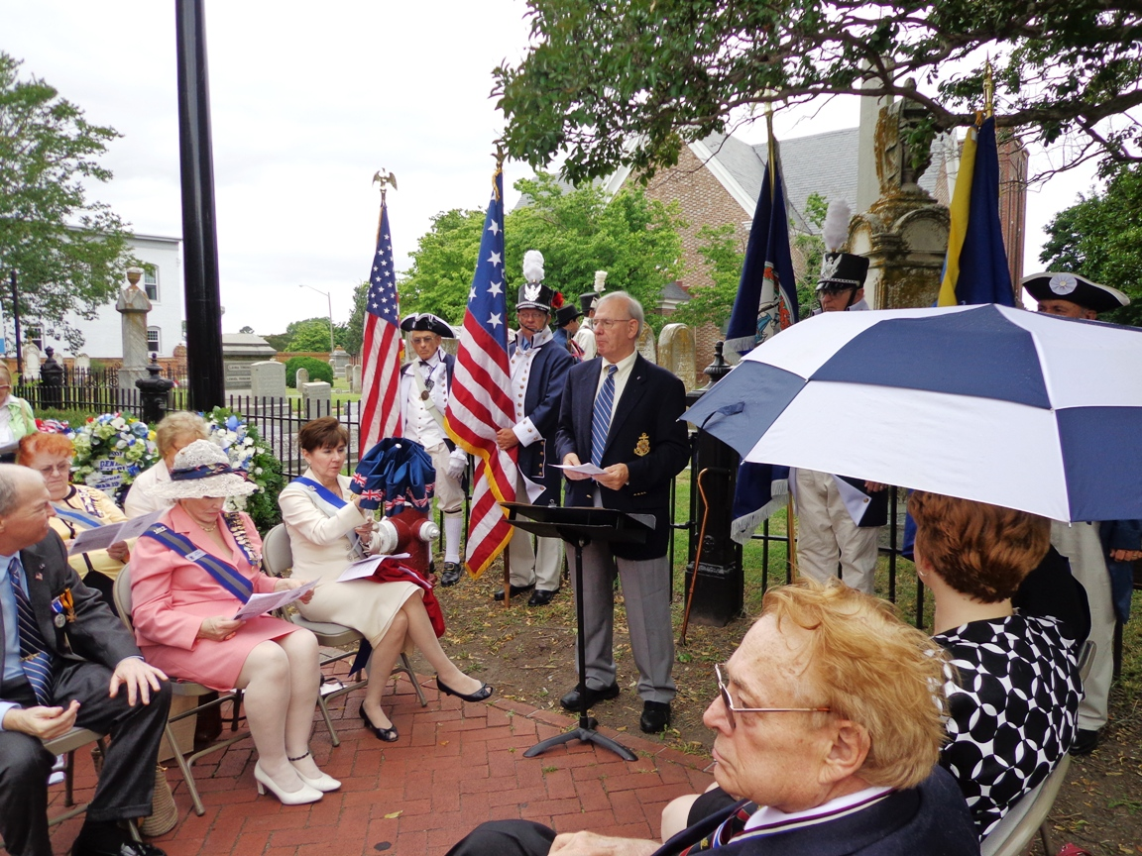
Councilor of the Society, Stuart Butler, presented information about the veterans
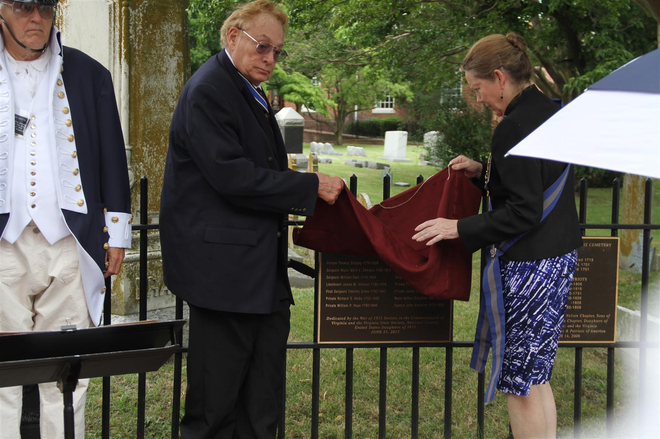
The plaque is unveiled by President Dickie and VA State President U.S. Daughters of 1812, Jacque-Lynne Schulman
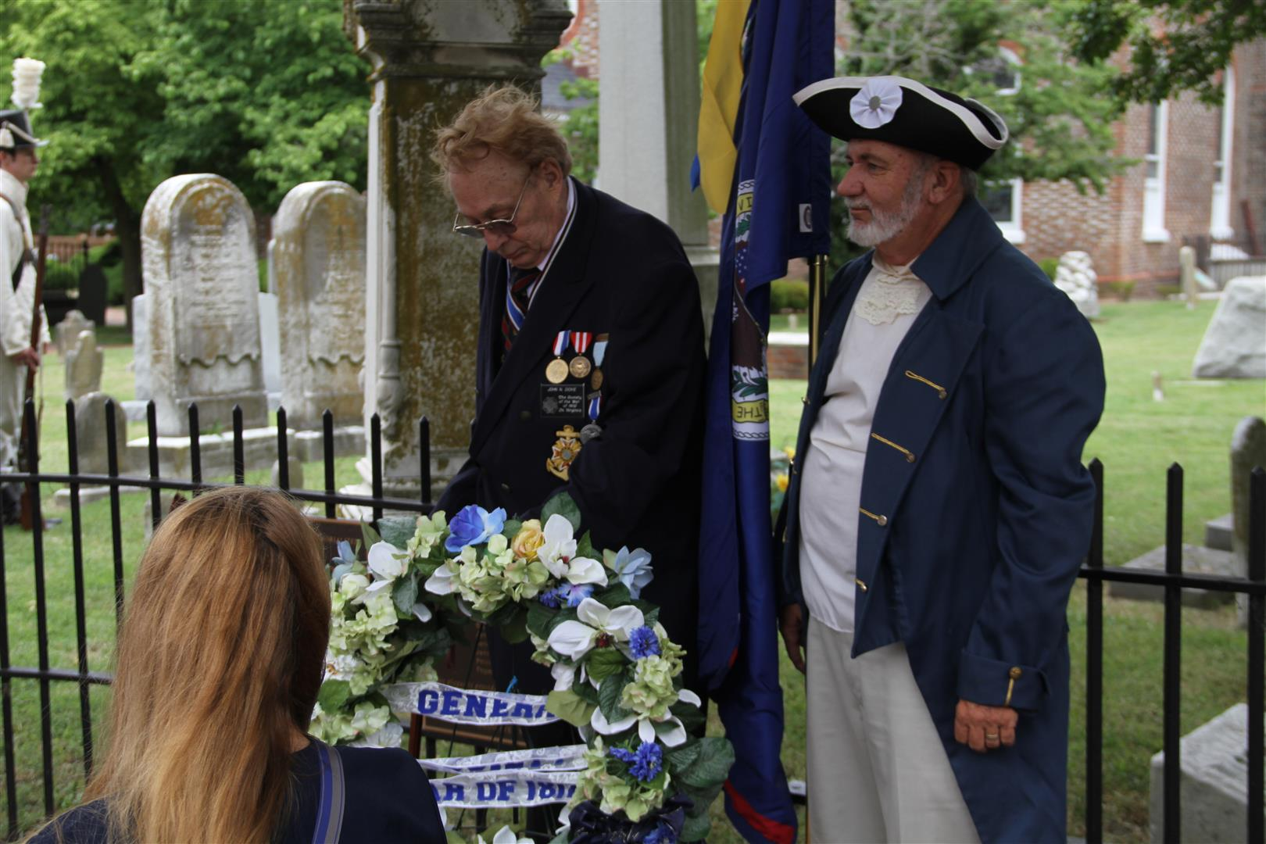
A wreath is presented by President Dickie for The General Society War of 1812 as the Quarter Master General
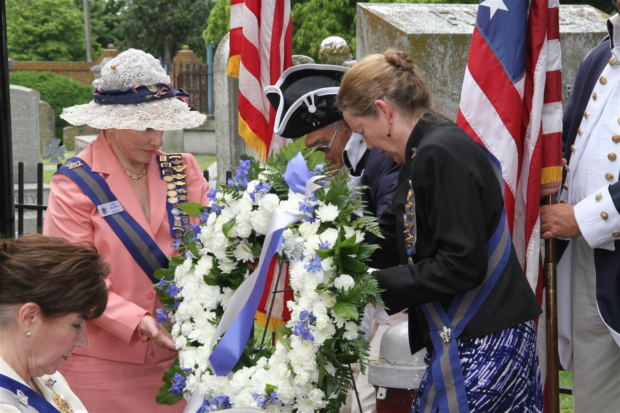
The U.S. Daughters of 1812 Virginia State Society wreath is presented by past President, Jodi Killeen and current President, Schulman. Then Bill Nash presented the VA Society wreath.
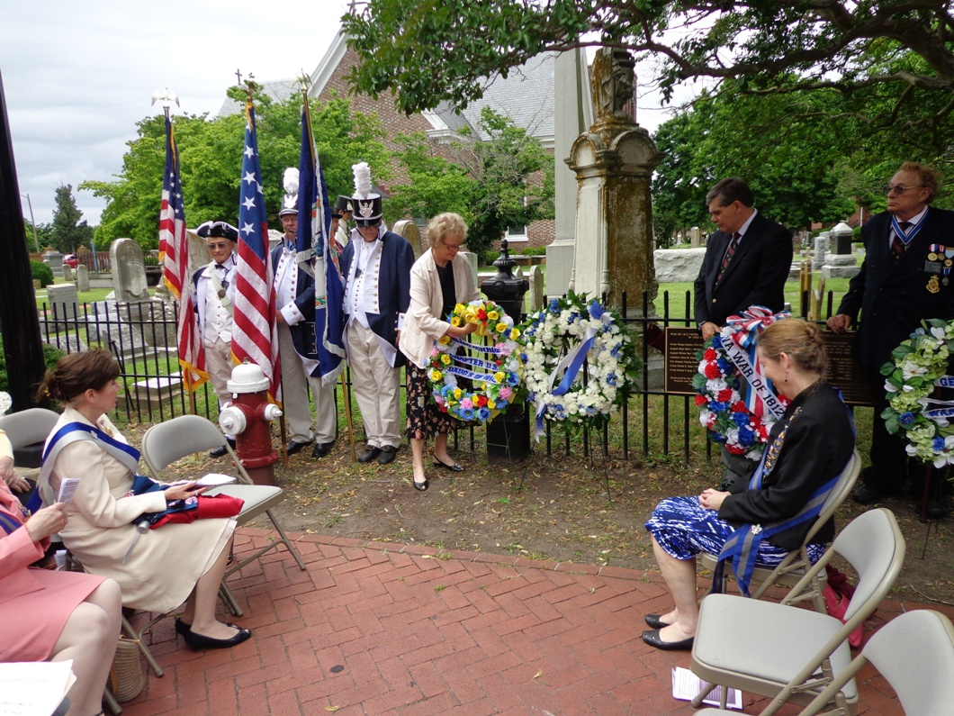
The Eliza Monroe chapter wreath is presented by Anita Brown
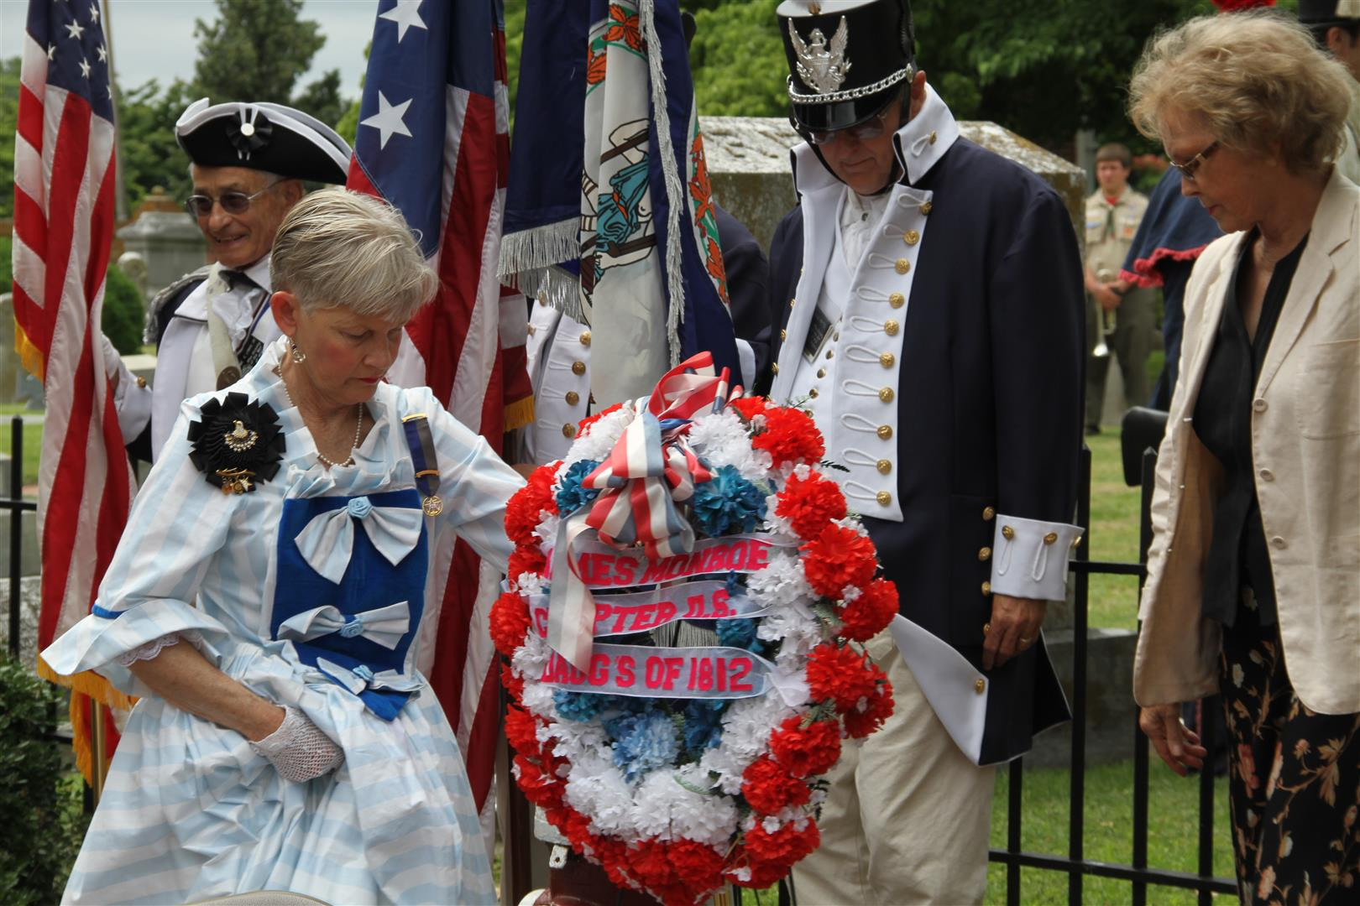
Dr Cheryl Davis presented the James Monroe Chapter wreath
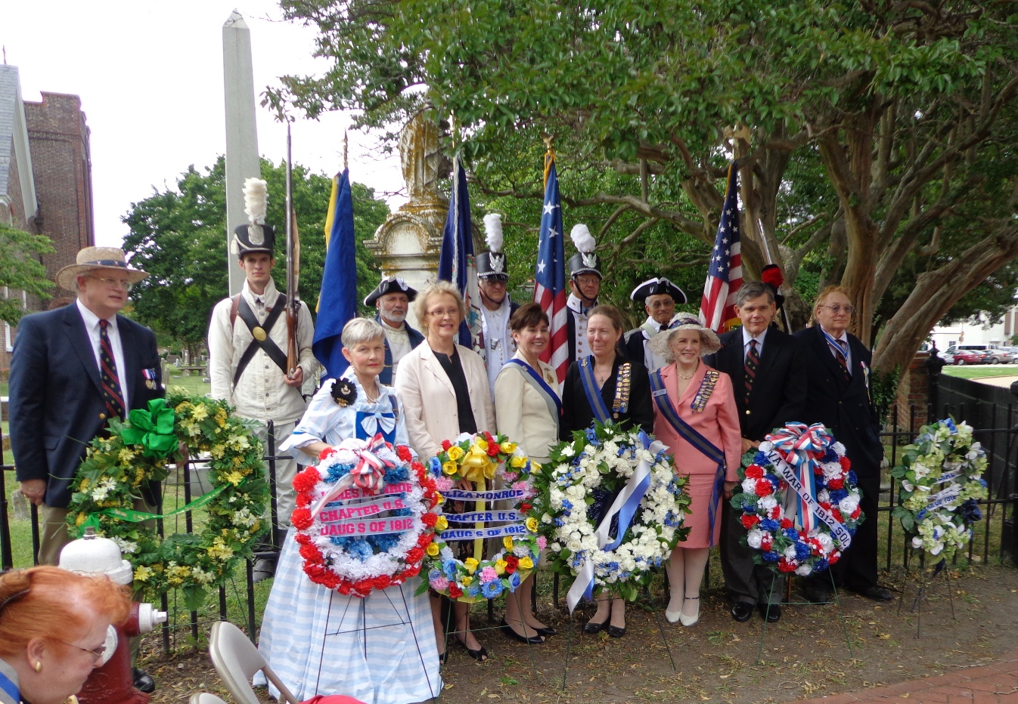
On the left, Peter Broadbent, representing the VA Bicentennial Commission stands behind the wreath he presented. Other presenters stand behind their wreaths
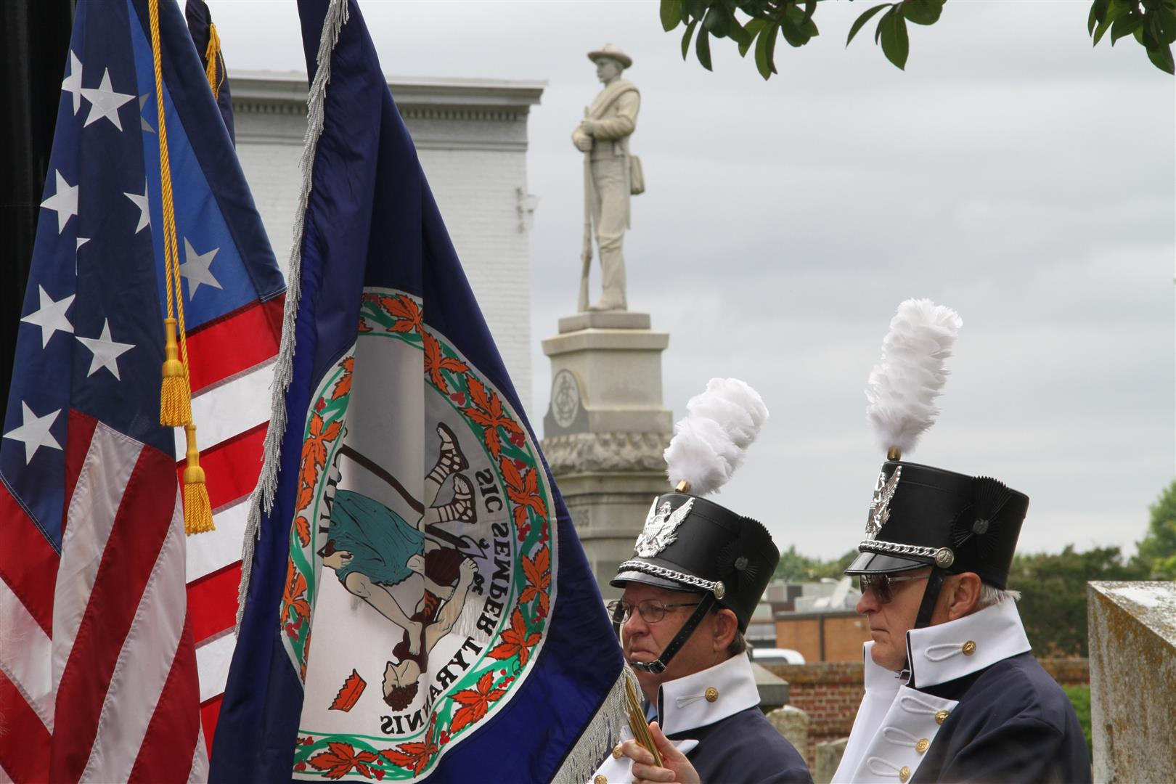
Colors are then presented. Holding the star Spangled banner Flag is member, Charles Belfield, and the Virginia state flag by First Vice President, Dennis Fritts
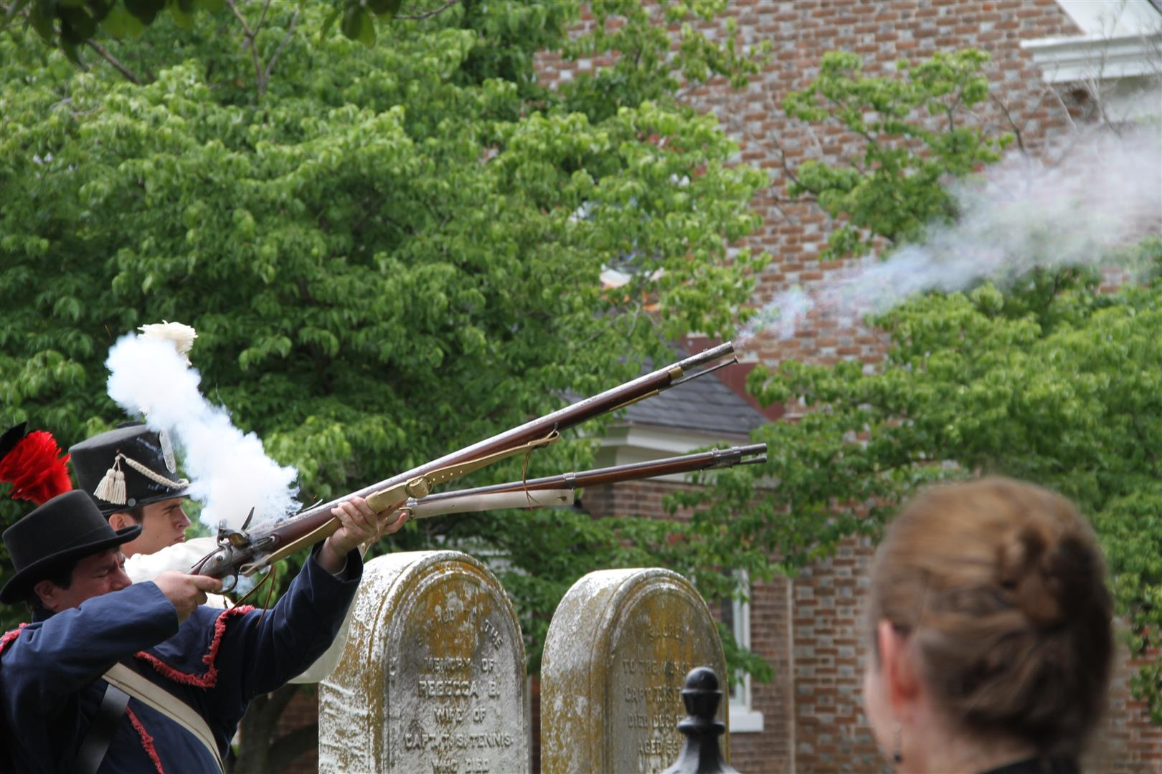
Muskets are then fired by Stephen Forrest and John Forrest
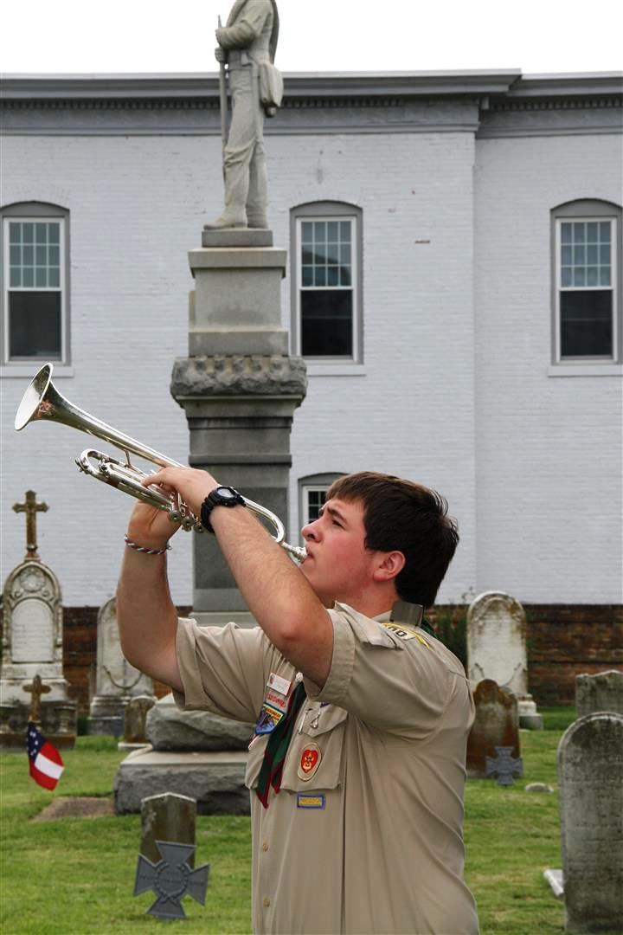
Taps is played by Dillon Wilbert, Life scout, Boy Scouts of America
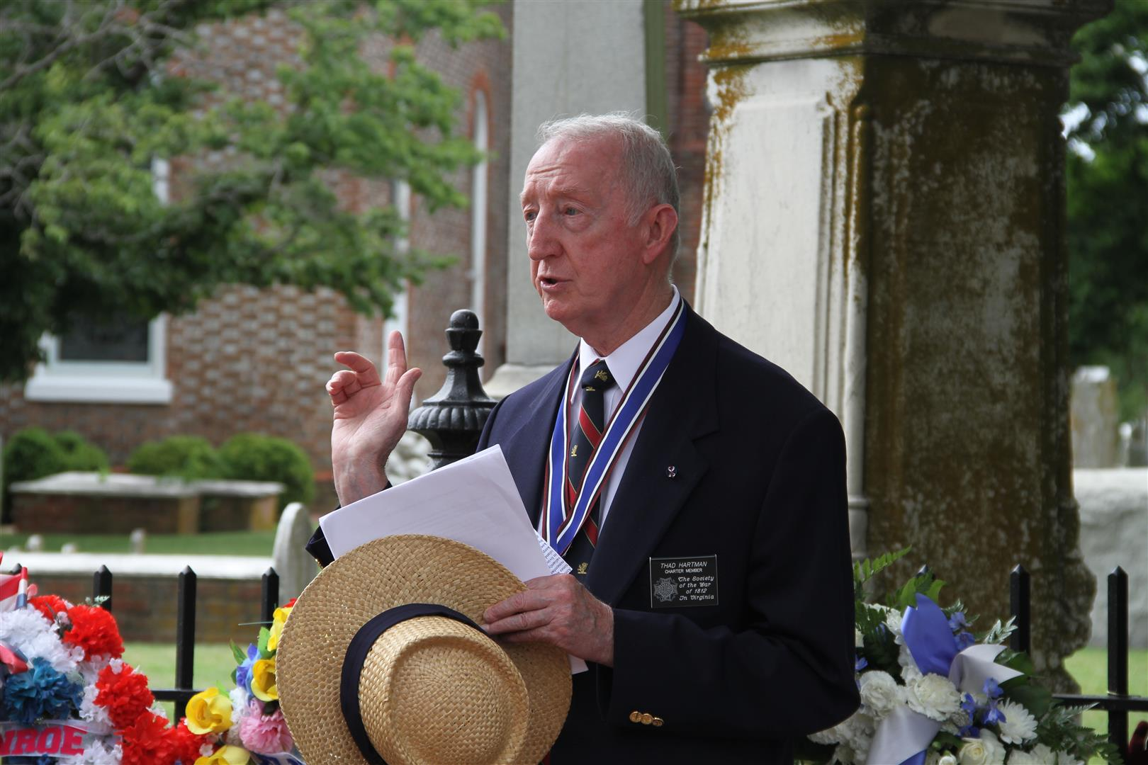
Past President of the society, Thadeus Hartman gives the benediction
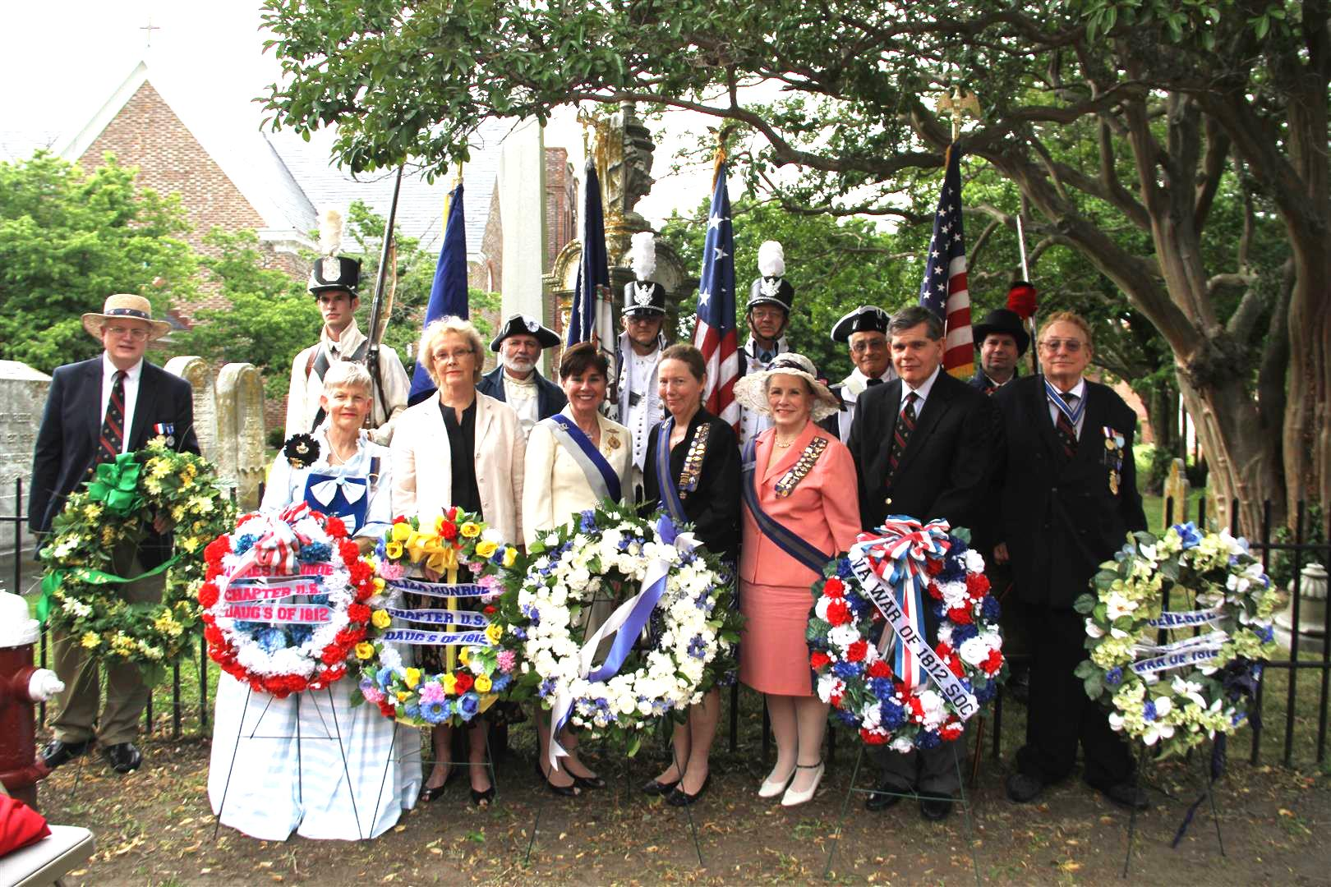
A group photo of the participants ends the ceremony

