The Society Conducts a Remembrance Ceremony for War of 1812 veterans interred in the St Paul’s Episcopal Church graveyard in Norfolk. Jun23, 2013
The first portion of the ceremony was inside the church
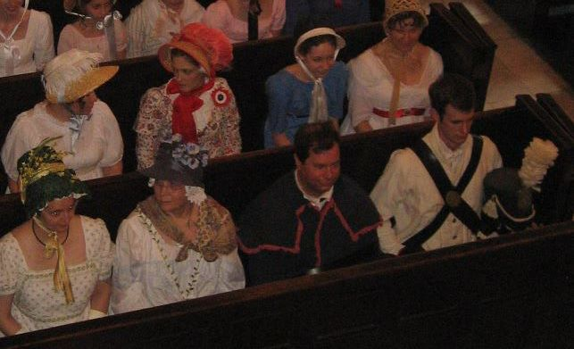
In front on the right is Stephen and John Forrest in War of 1812 attire

WAR of 1812
VETERAN NAMES ON THE PLAQUE AT ST PAULS EPISCOPAL CHURCH IN NORFOLK
Private James R. Barnett
Private John L. Billups
Private John Davie
Private Charles Donaldson
Lieutenant Glenn Drayton
Private Alexander Guthrie
Midshipman William C. Hall
Private Daniel C. Henop
Midshipman John F. Howell
Lieutenant William Hungerford
Surgeon's Mate Robert Barron Hunter
Ensign William F. Hunter
Captain John Maxwell
Sergeant William T. Nivison Obit
Surgeon's Mate George Raine
Lieutenant James Saunders
Sergeant George Shuster
Q. M. Sergeant Edwin Stark
Major Lewis Littlepage Taylor
Private Charles Tyler
Private John Benign Vaché

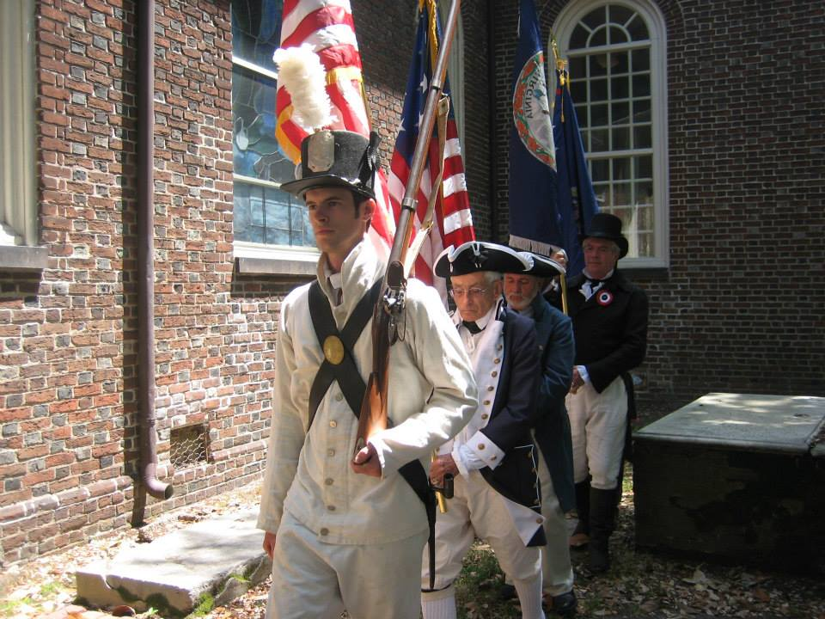
The Color Guard comes forward
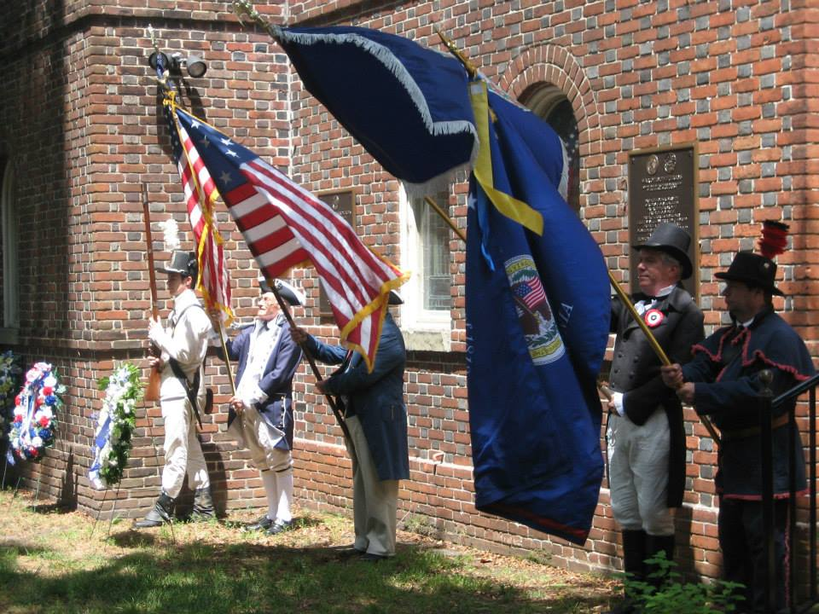
The Color Guard Presents the Colors
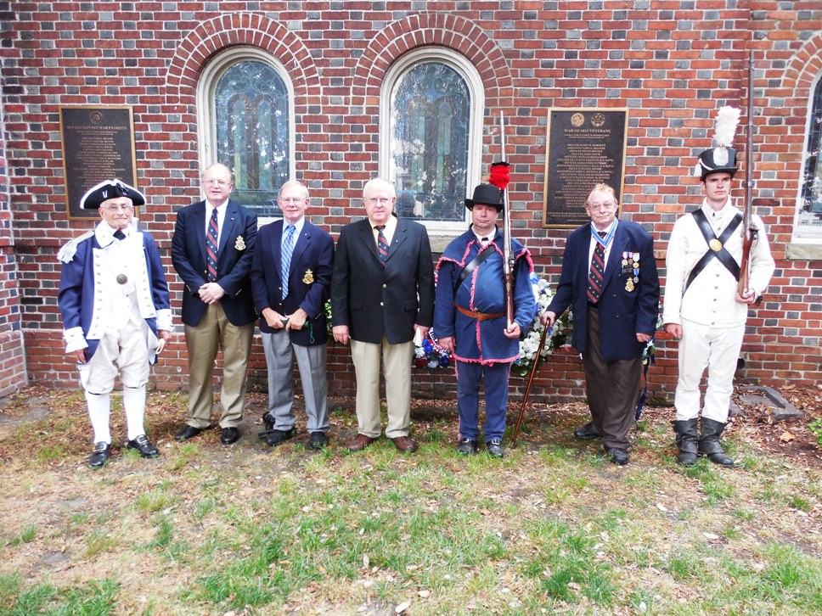
Members of the War of 1812 Society that participated are shown after the ceremony
Behind them on the right is the War of 1812 plaque listing twenty two veterans interred or memorialized in the cemetery
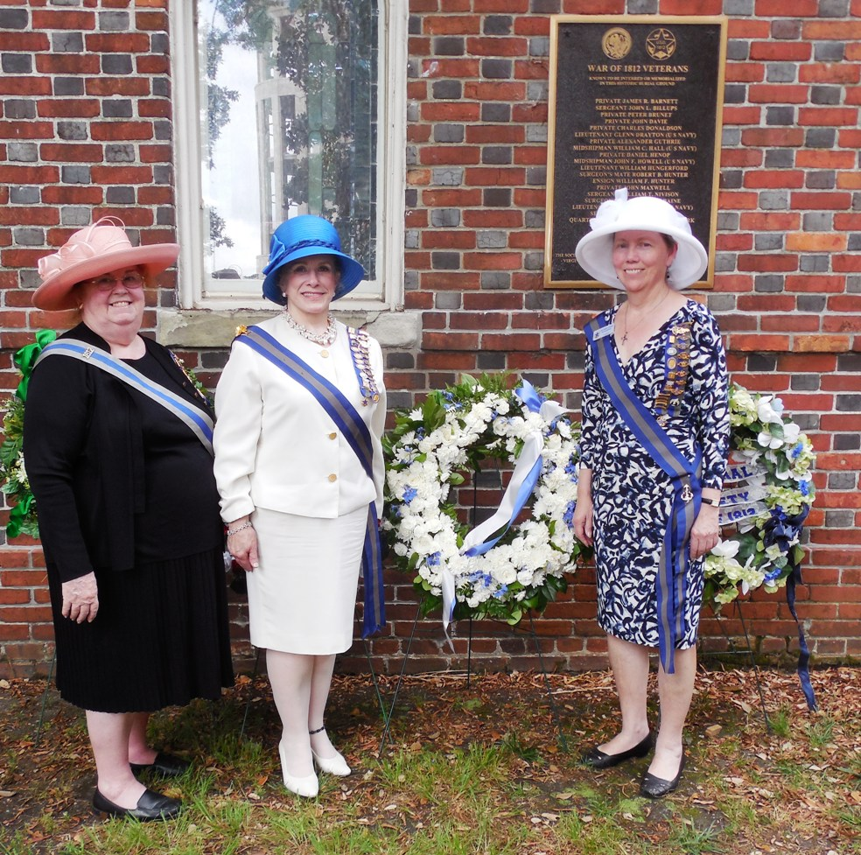
The officers of the U.S. Daughters of 1812 that participated pose in front of the plaque

