The Society of the War of 1812 in the Commonwealth of Virginia conducts their Annual Muster 21 June 2013 at the Hampton History Museum and at the St John’s Episcopal Church Graveyard.
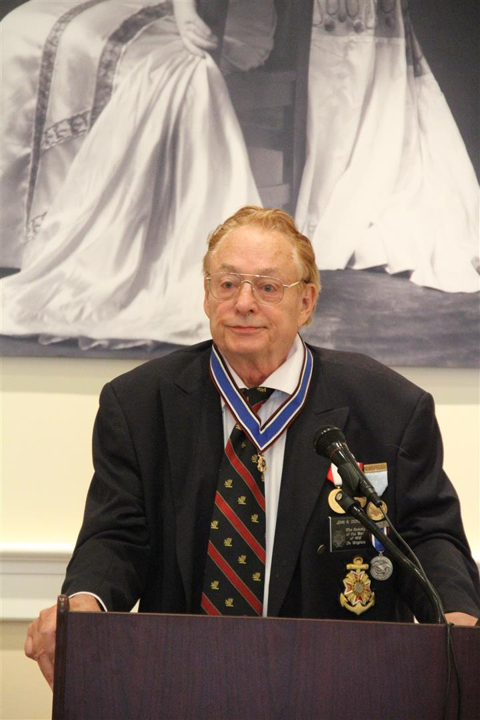
President John N. Dickie, Captain USN Ret presides
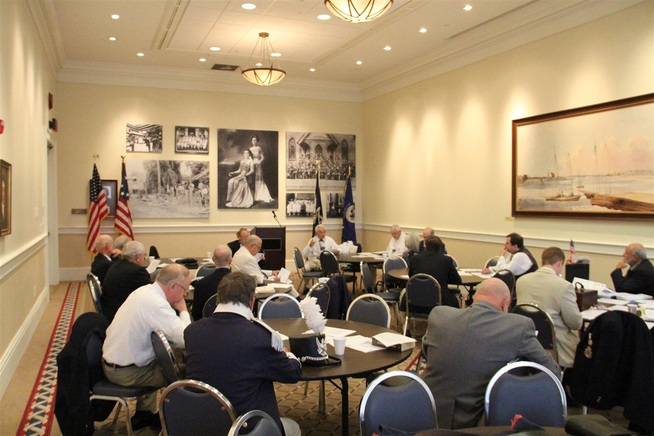
Attendees reviewing annual reports

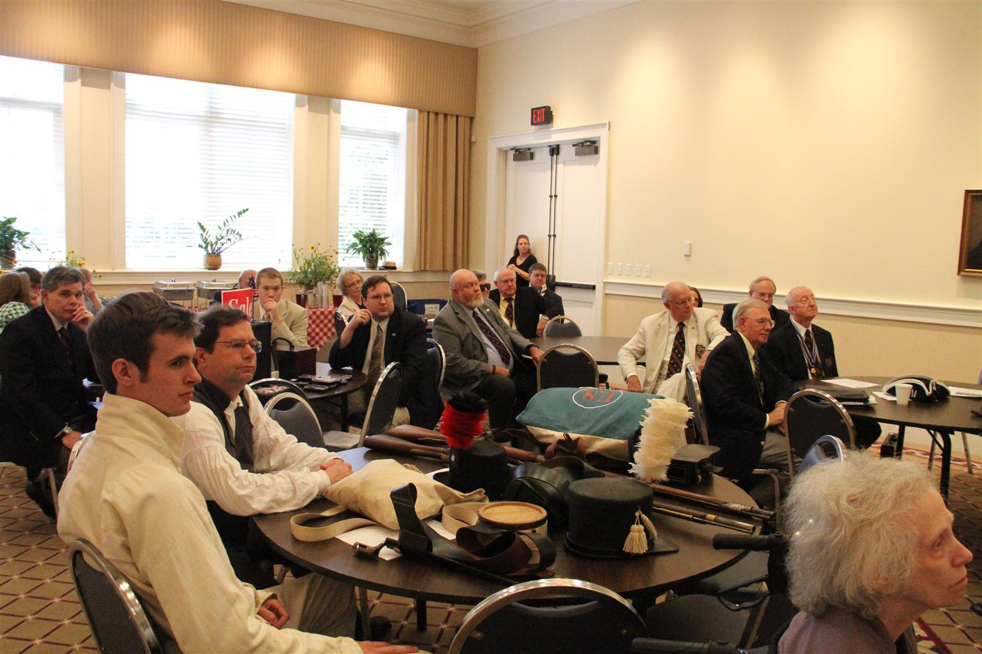
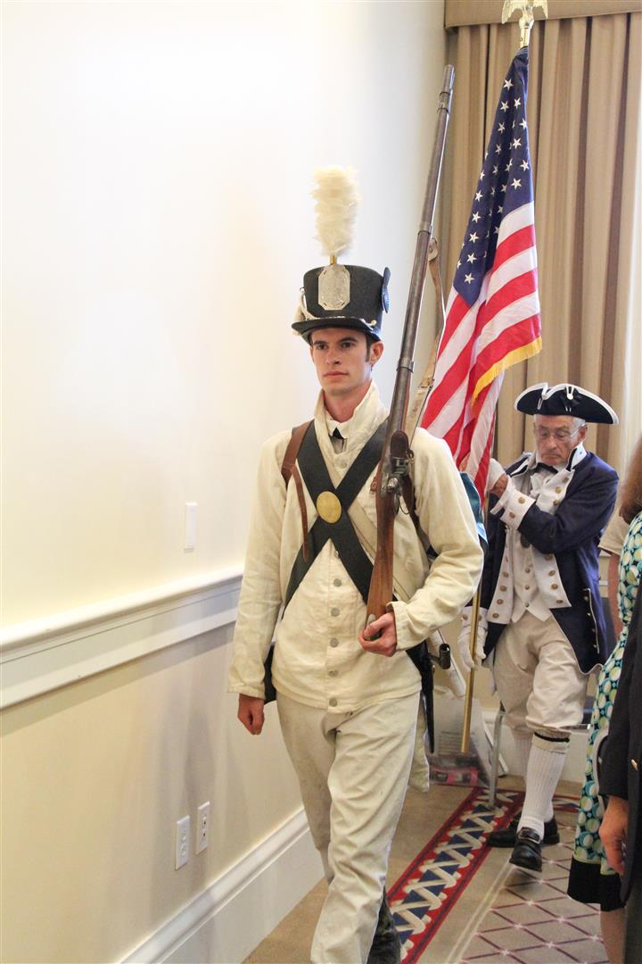
The colors are brought forward at the beginning of the meeting, then presented and posted
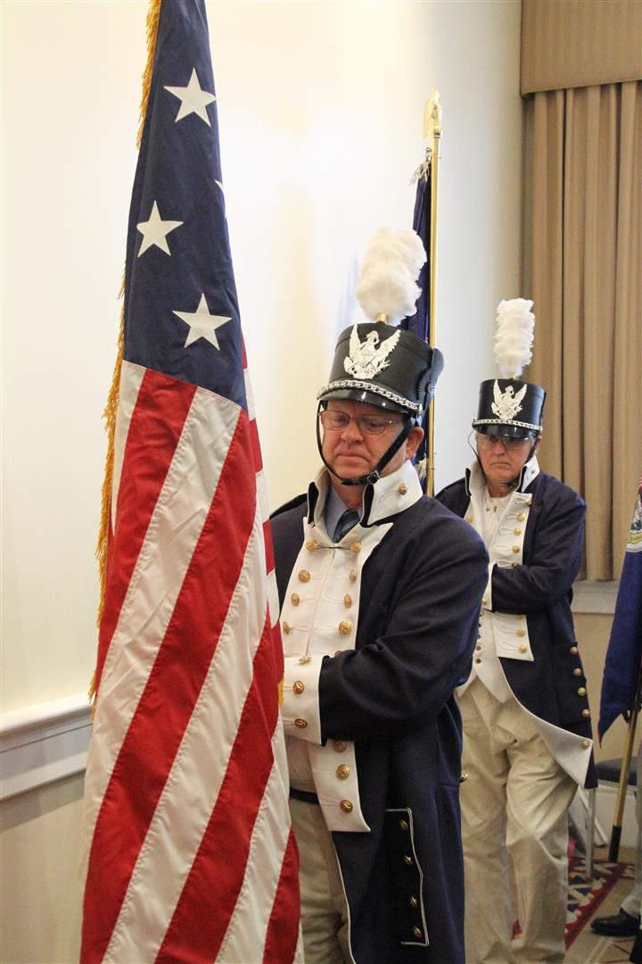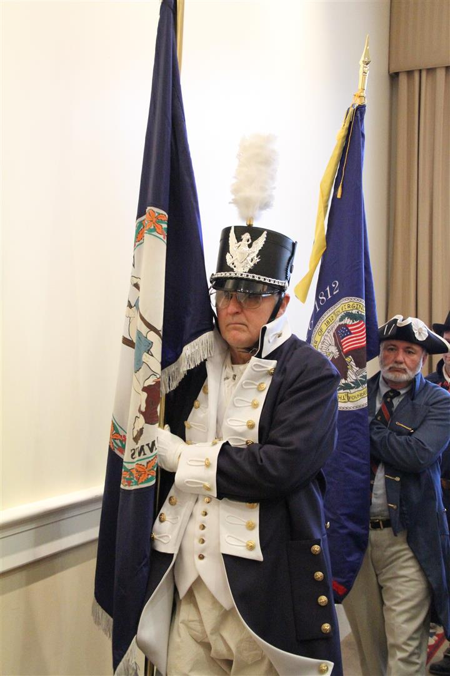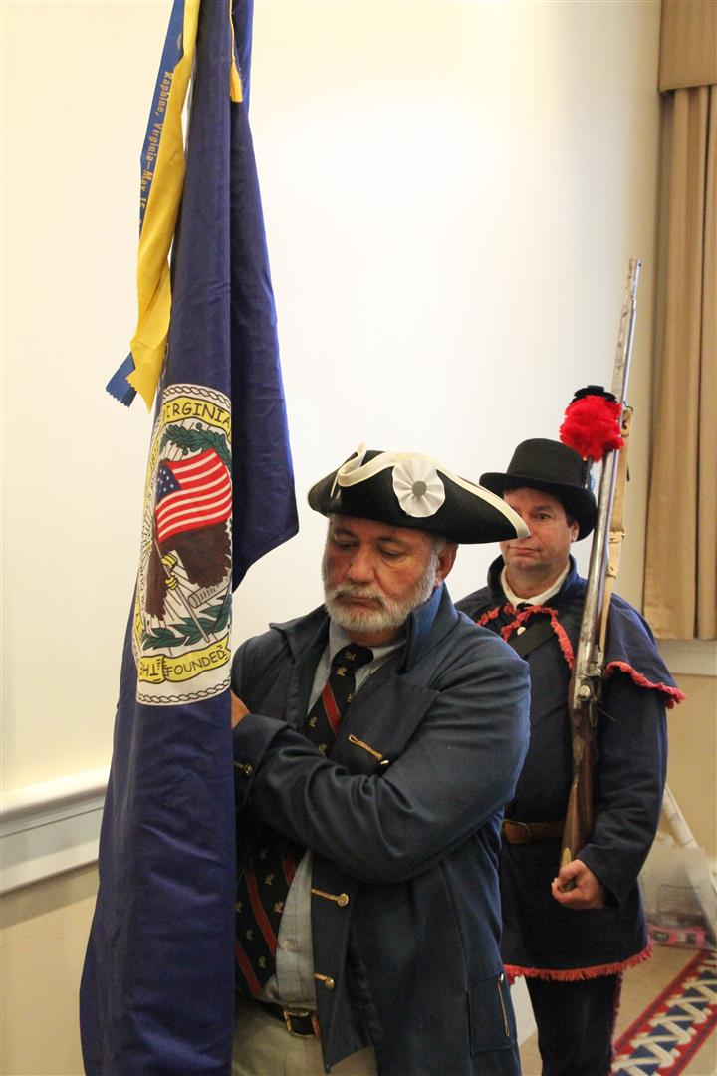
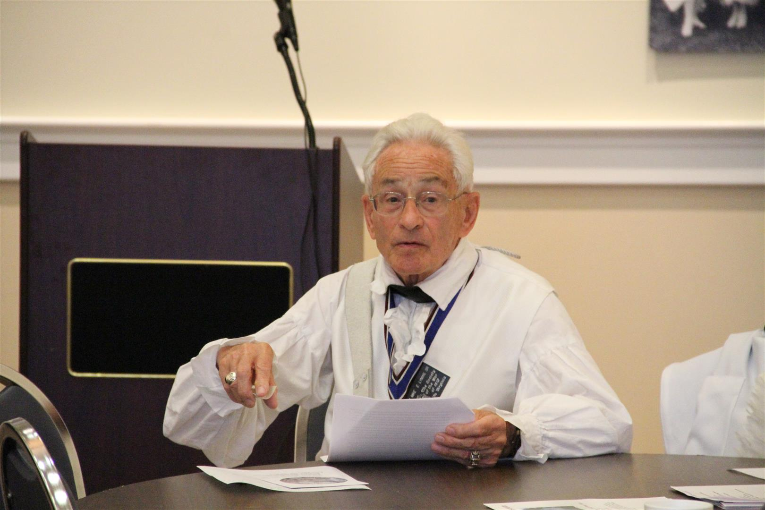
Mike Lyman is shown presenting his reports
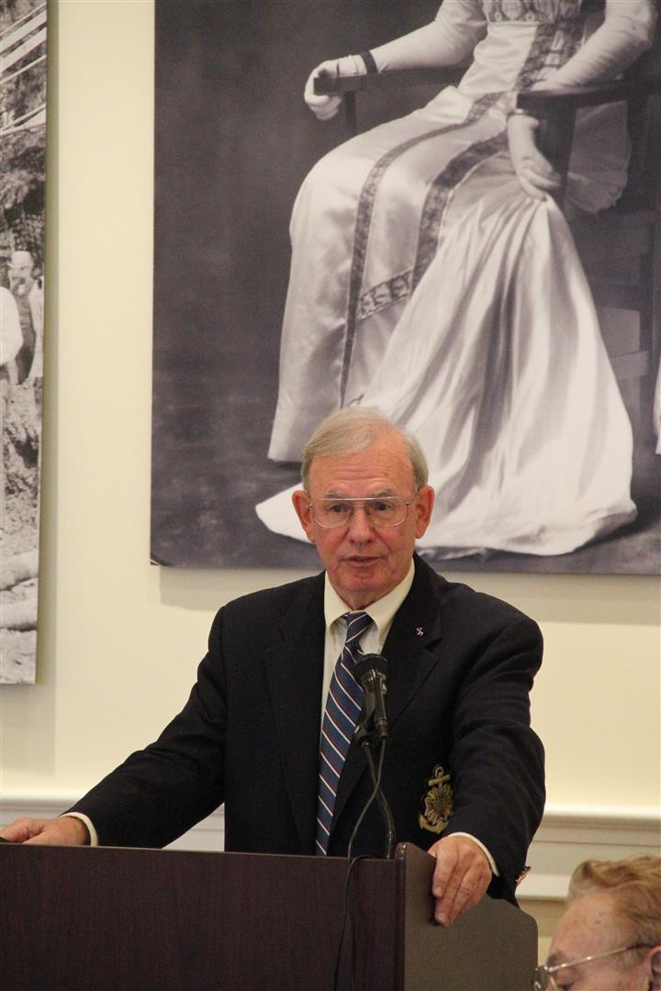
Stuart Butler is shown as guest speaker giving his presentation on the “Battle of Hampton”

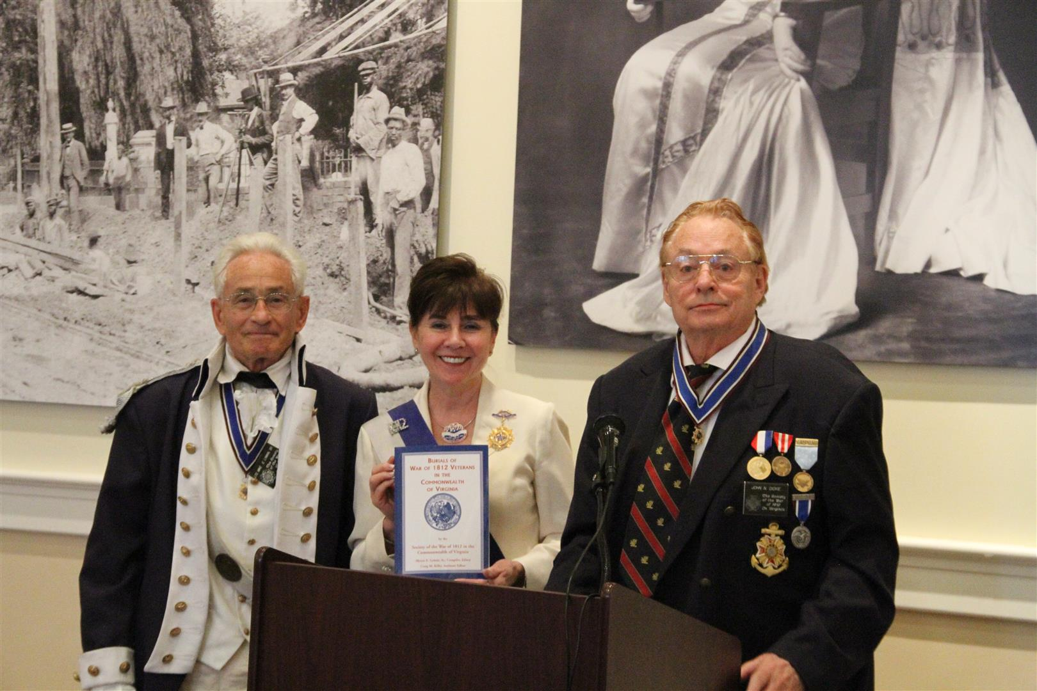
The President National of the U.S. Daughters of 1818 after her greetings is presented a Society publication “The Burials of War of 1812 Veteran Burials in Virginia”
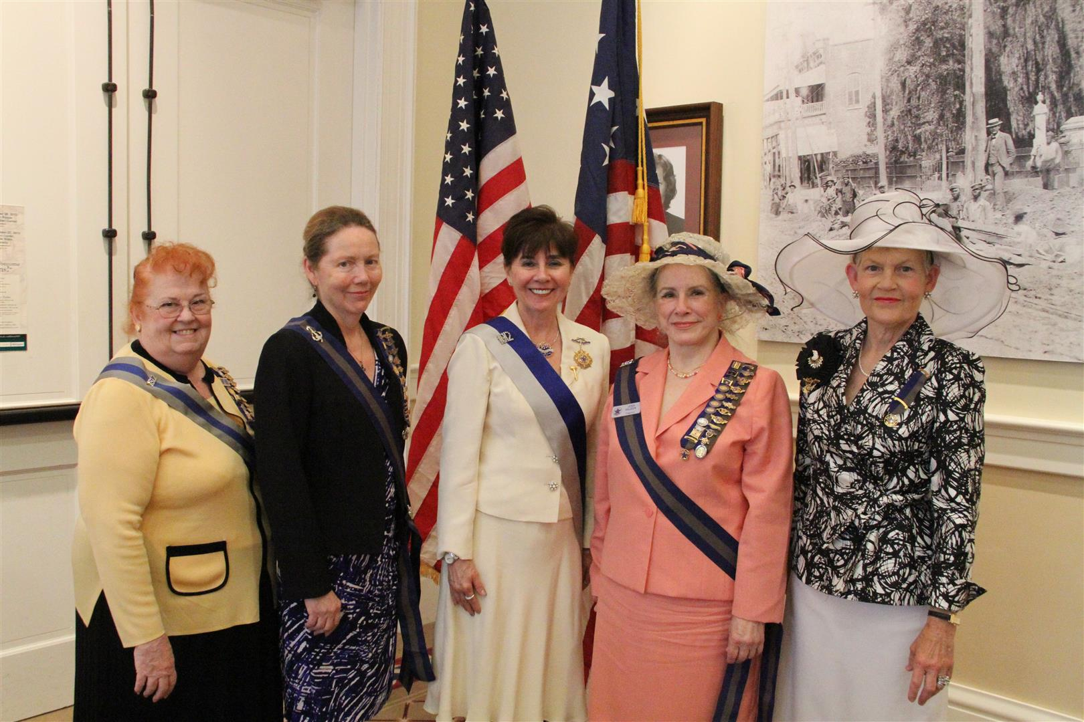
Five members of the U.S. Daughters of 1812 attended the luncheon
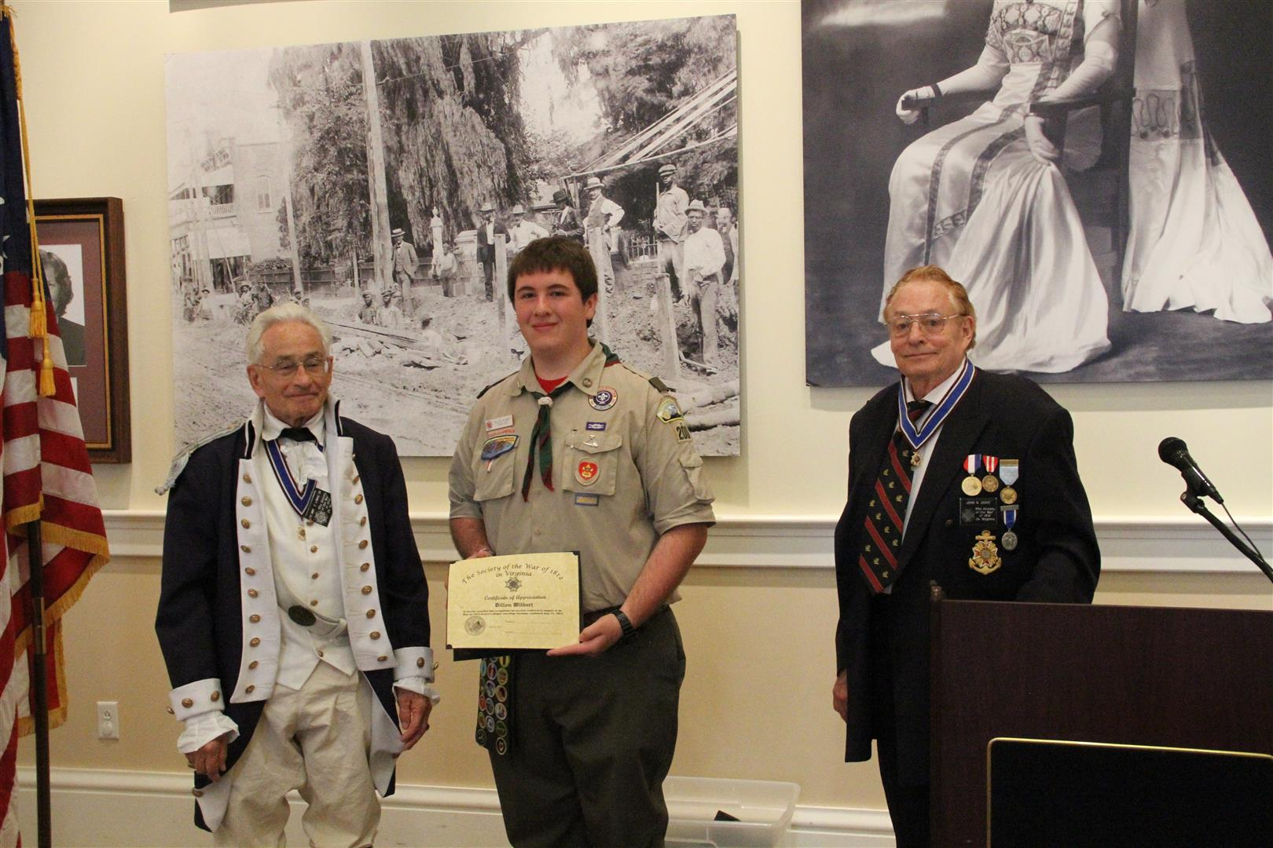
The Boy Scout Bugler, for the plaque unveiling ceremony that followed, is given a Certificate of appreciation
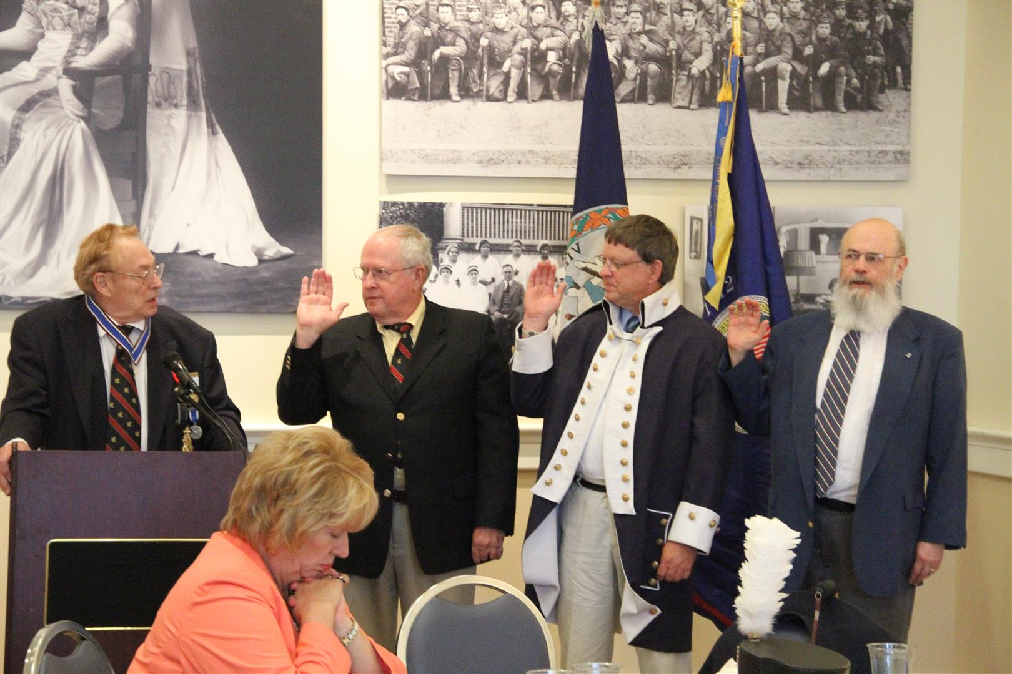
Three of eight new members are inducted into the Society
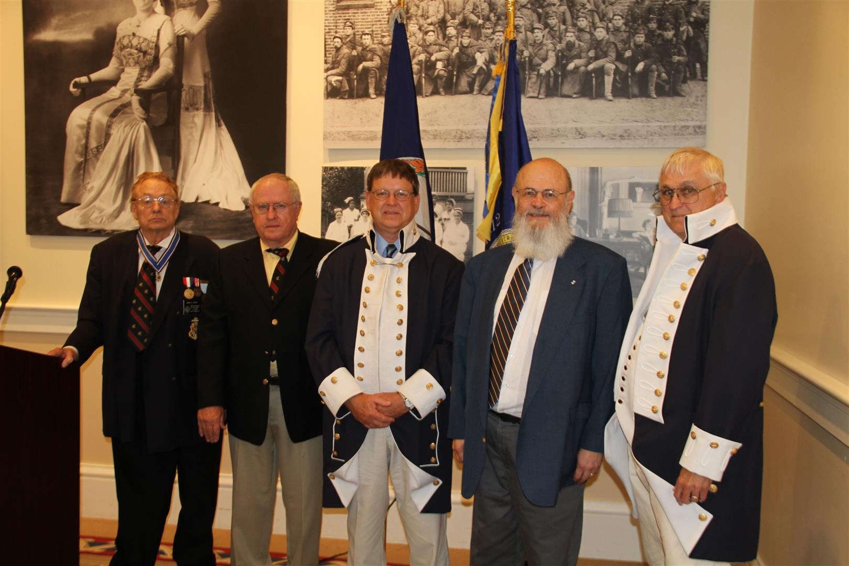
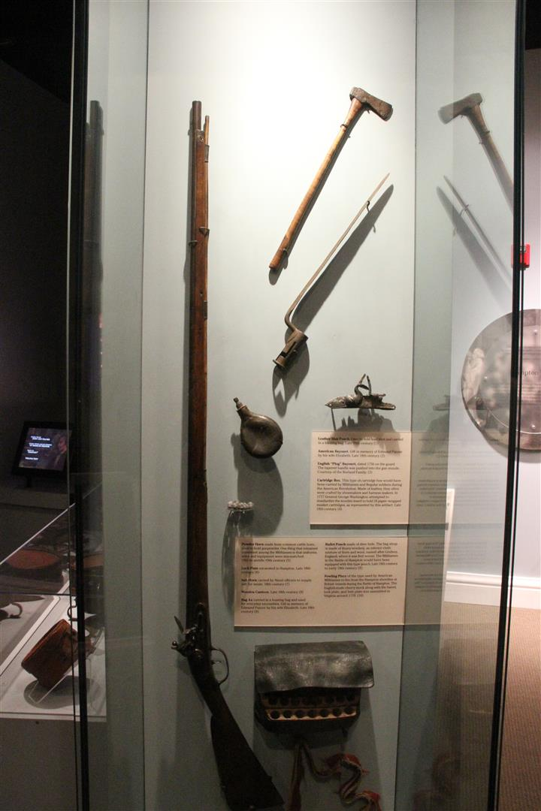
A tour of the Hampton History Museum was conducted after the meeting.
A rifled musket and other War of 1812 artifacts are displayed

