WAR OF 1812 & REVOLUTIONARY WAR VETS HONORED IN A CEREMONY OCTOBER 5TH 2013 IN DUMFRIES, PRINCE WILLIAM COUNTY, VIRGINIA
A joint ceremony between the Col Wlliam Grayson Chapter, VASSAR and the War of 1812 Society in VA took place in Dumfries, Prince William County on October 5th at the Tebbsdale Cemetery on Possum Point Road. Some photos and scans are attached
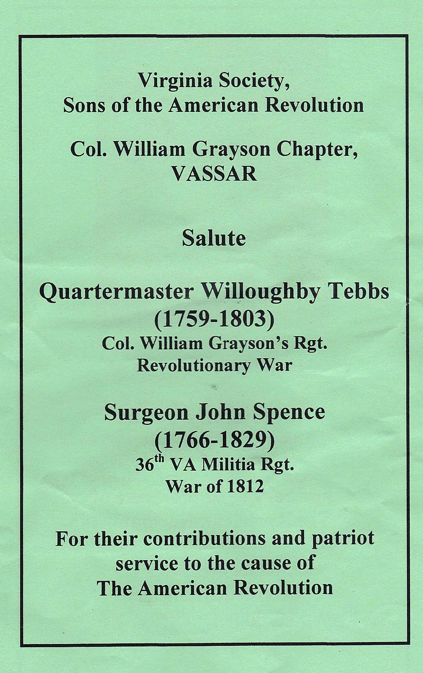
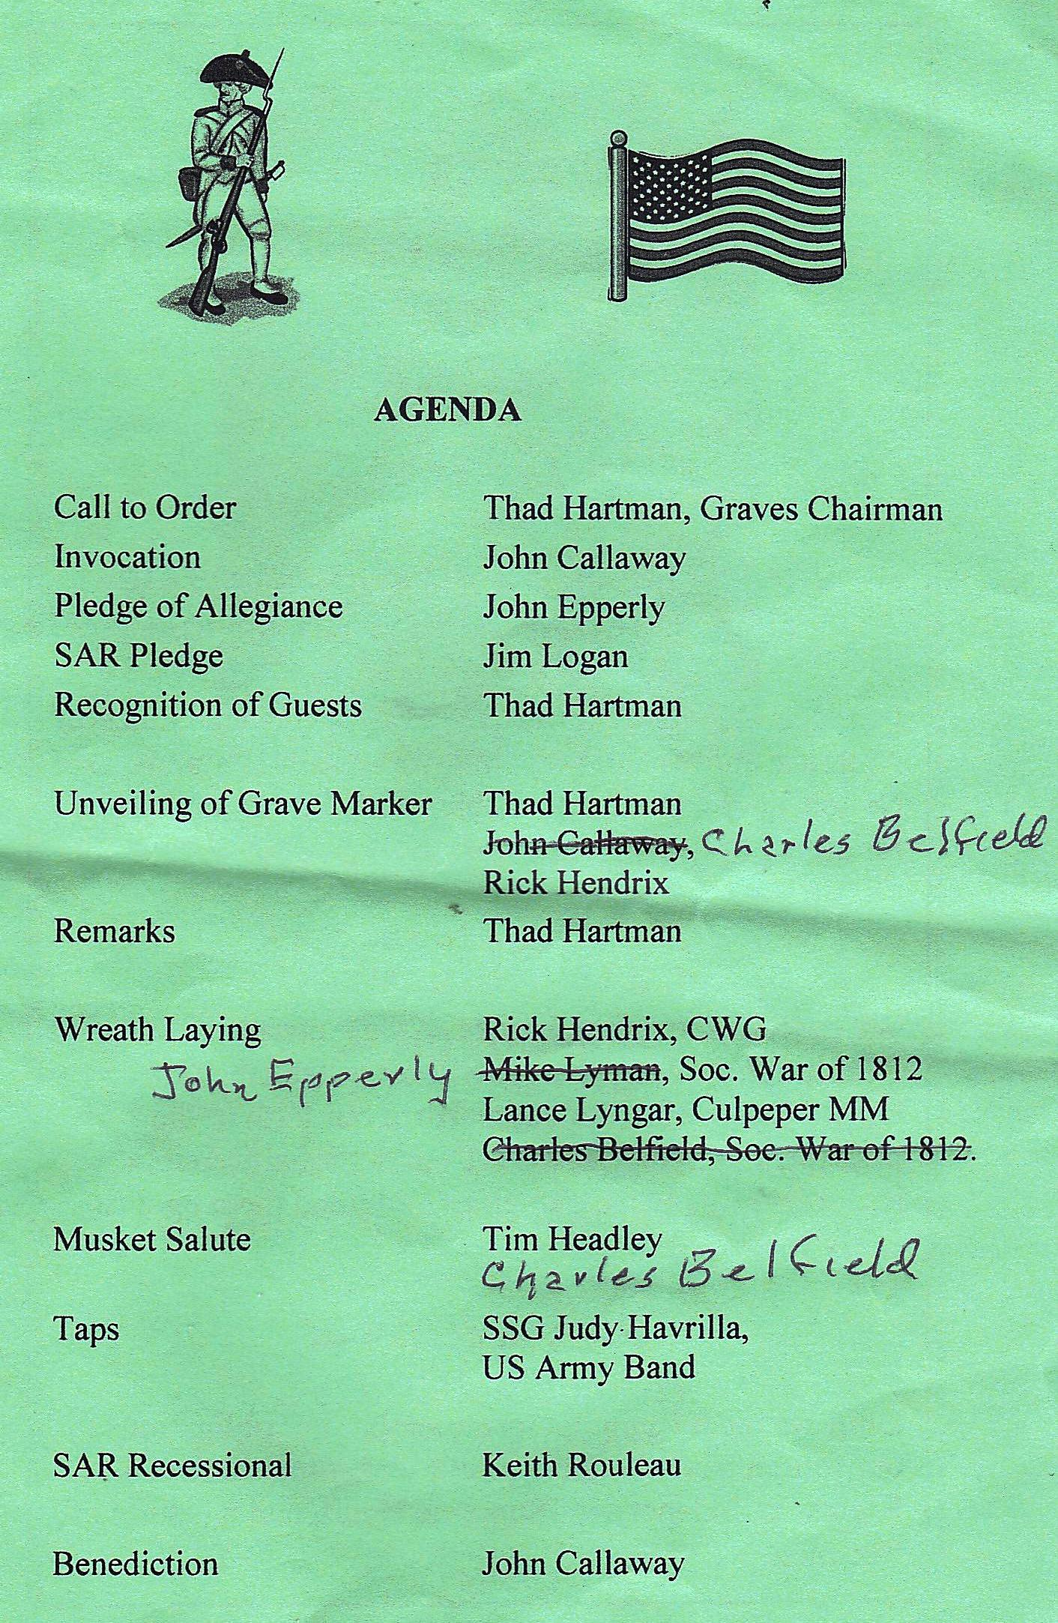
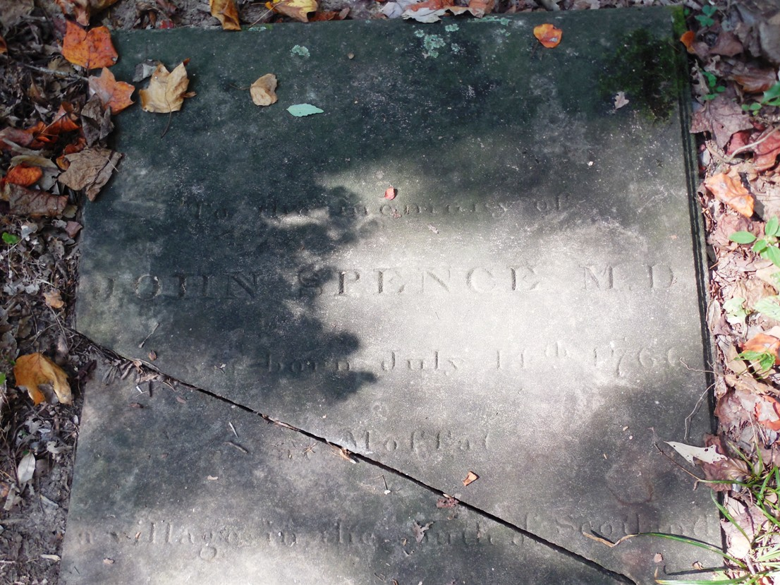
Gravestone of John Spence. Below shows grave marker unveiled in the ceremony
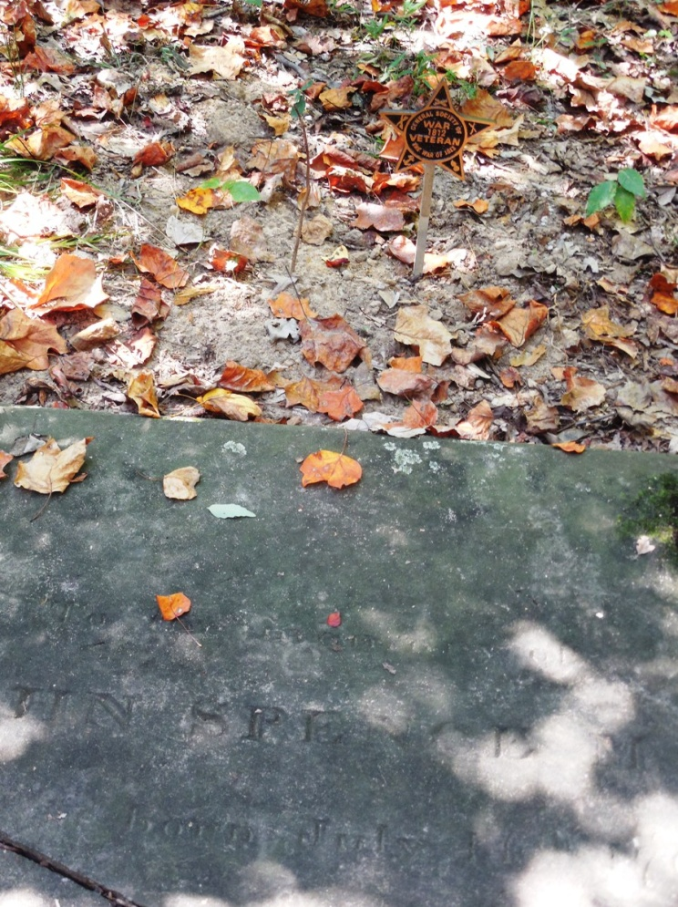
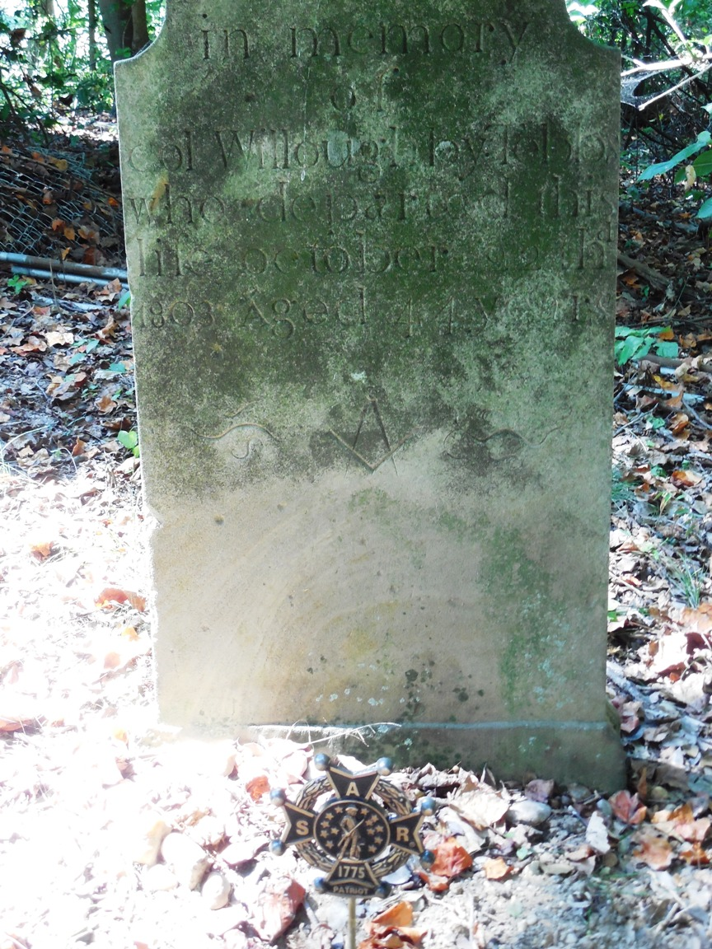
Gravestone of Willoughby Tebbs with SAR grave marker unveiled in the ceremony
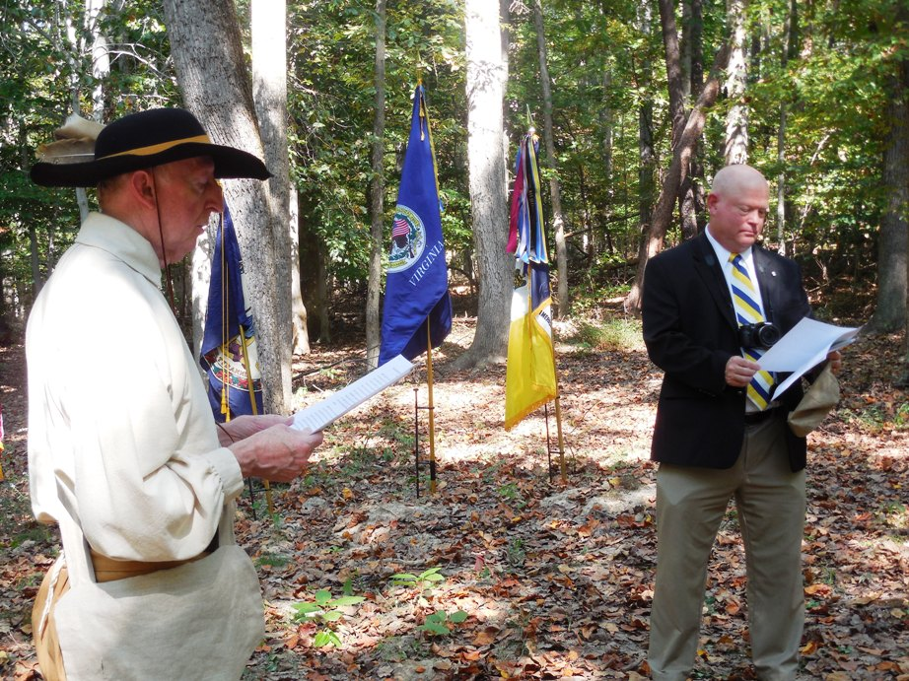
During the ceremony information about the veterans is given and below the SAR maker is unveiled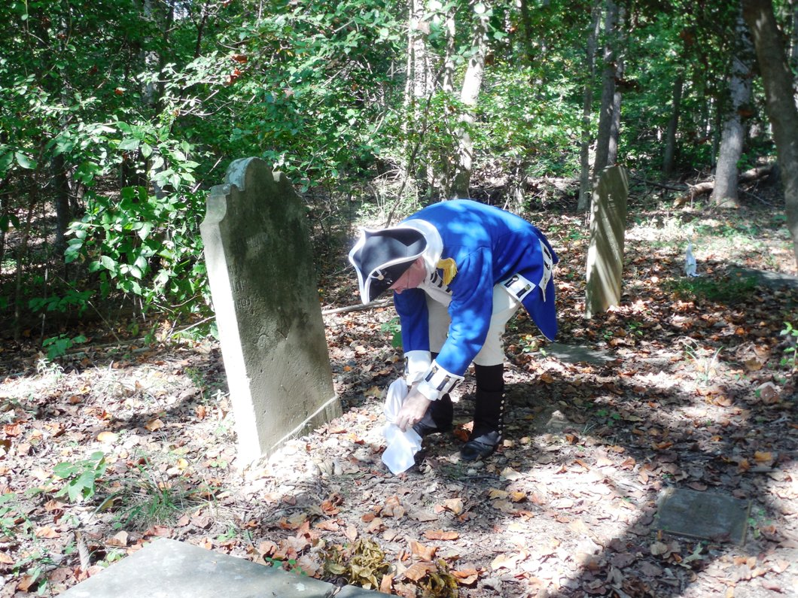
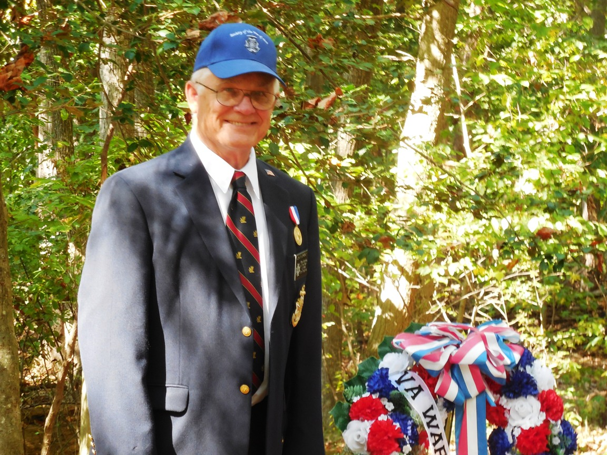
And wreaths are presented
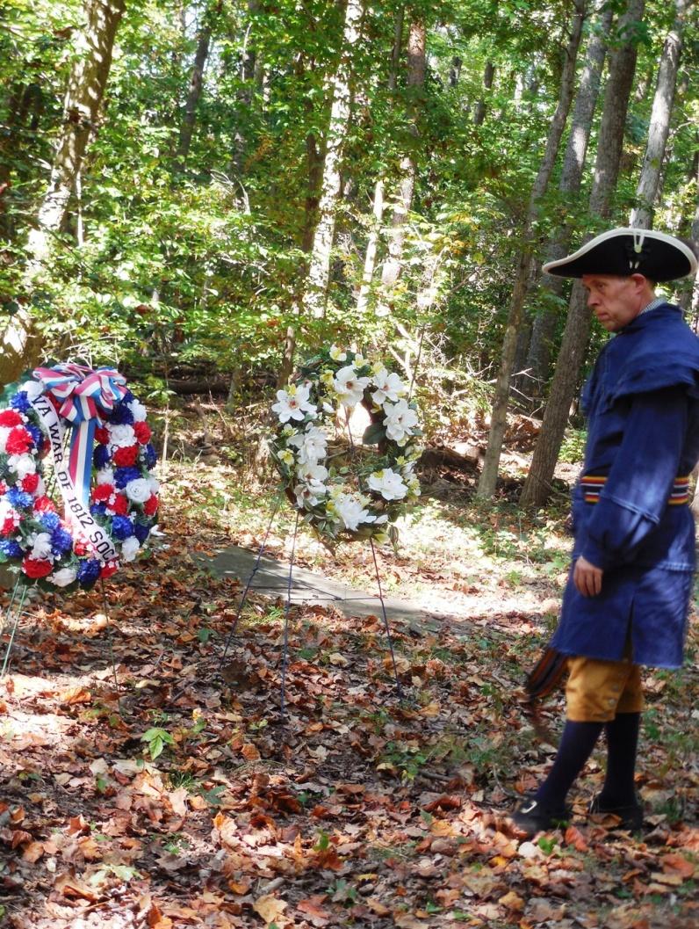
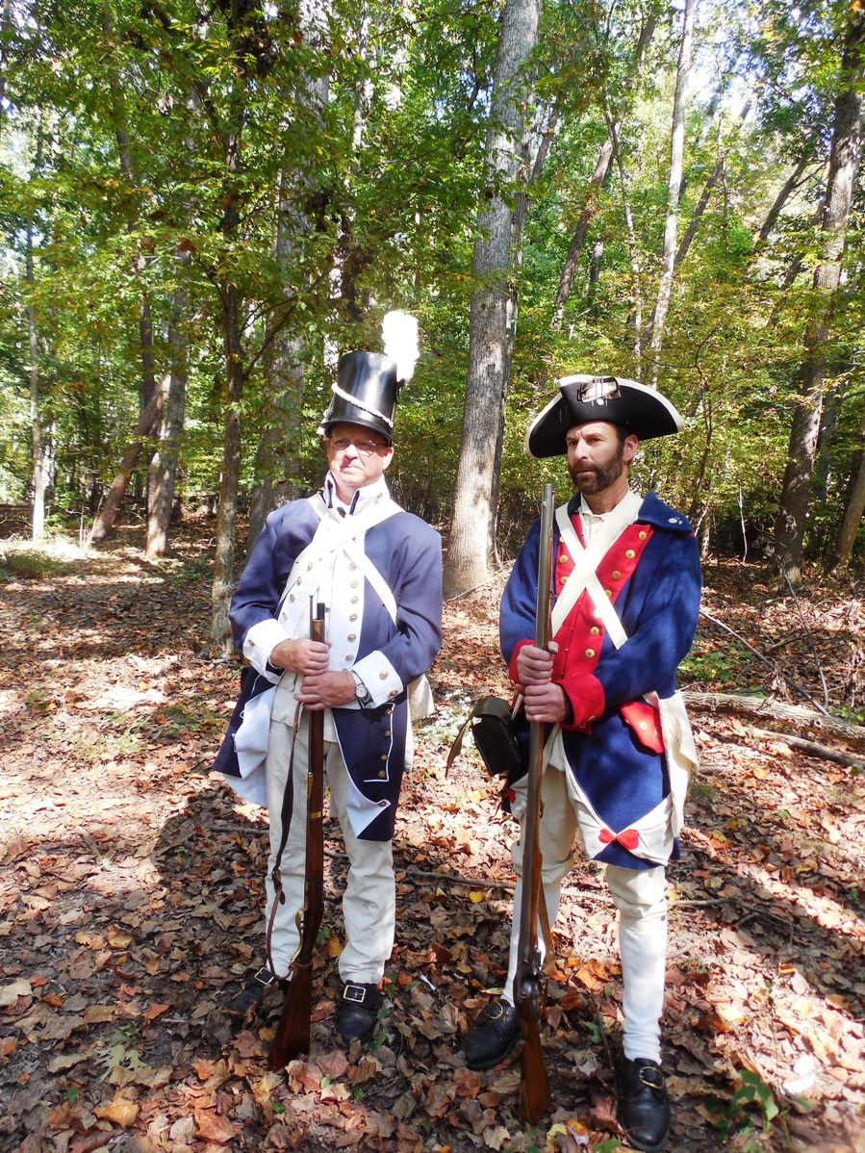
A musket salute is given by musket firers from each society
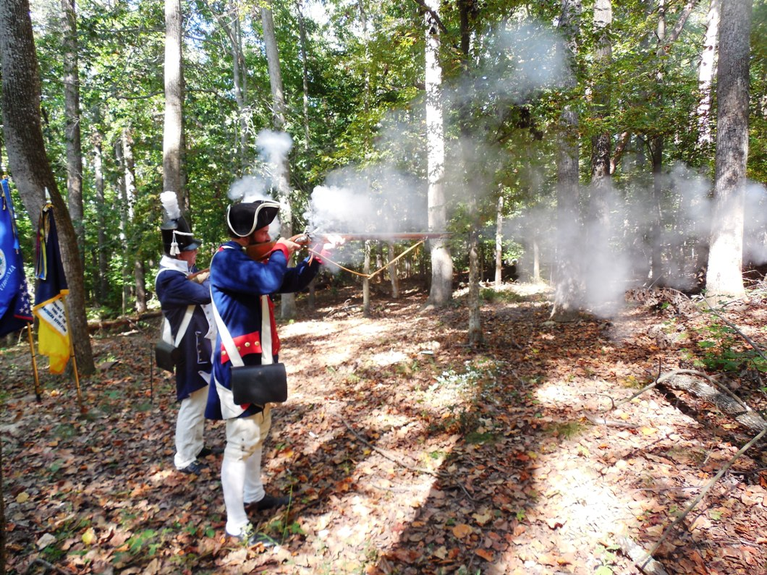
Below some of the attendees form for a group photo
