A NEW WAR OF 1812 HISTORICAL ROAD SIGN HAS BEEN UNVEILED IN LANCASTER COUNTY, VIRGINIA
The ceremony was on December 3rd 2013 at a restaurant on the Rappahannock River where the river battle took place on April 4th 1813. Below is the program and some photographs taken during the ceremony as well as some news releases
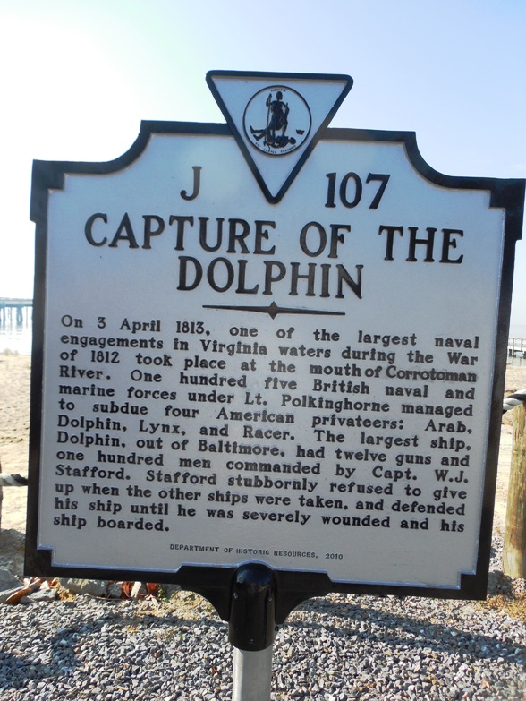
This top portion of the sign was placed in the parking lot of the restaurant for this photo, but afterwards has been installed on route 3 as one crossed the Rappahannock River Bridge entering the county.
The reverse side of the sign shows general information about the war in the area as shown below
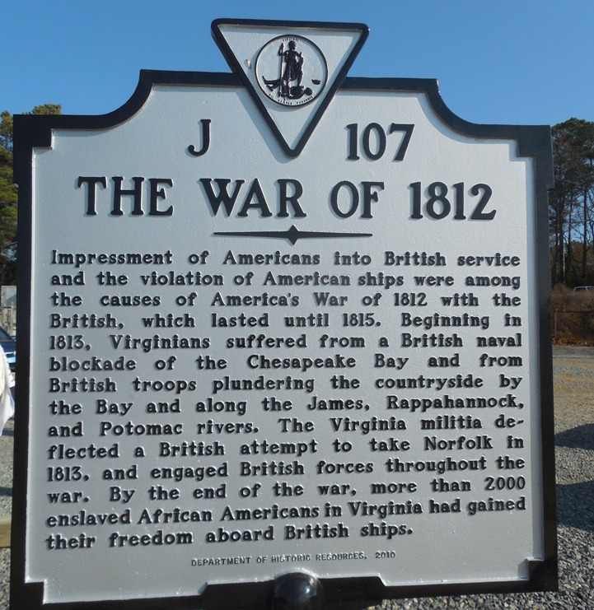
The ceremony was sponsored by the Society of the War of 1812 in the Commonwealth of Virginia, The Northern Neck of Virginia Historical Society and the Mary Ball Washington Museum and Library. Financing of the sign was by the Virginia Bicentennial of the American War of 1812 Commission and the Virginia Department of Historical Resources
The program follows:
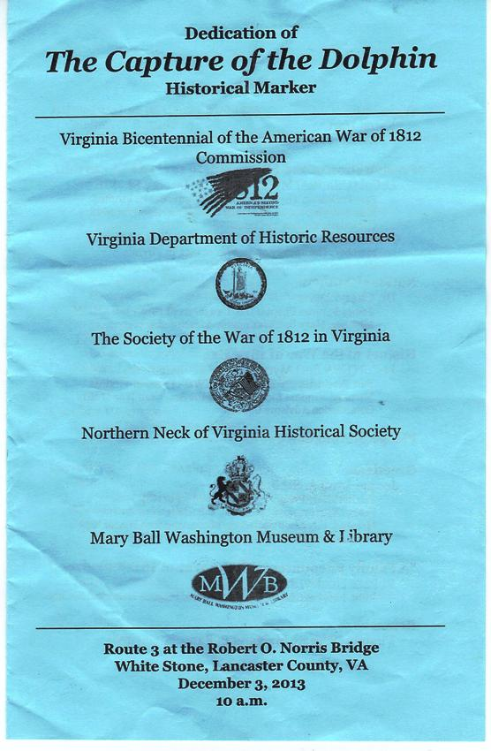
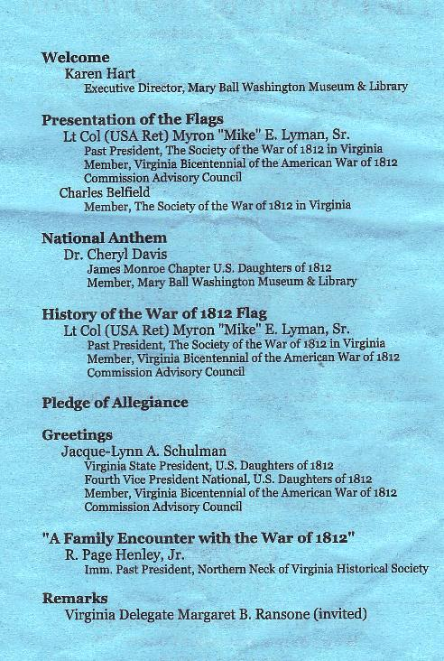
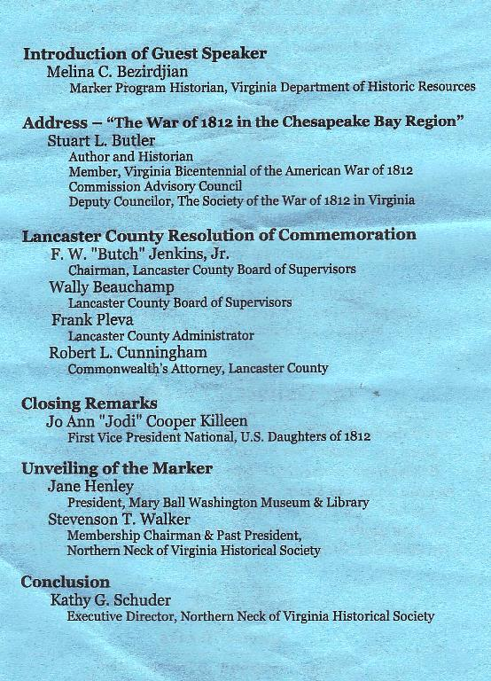
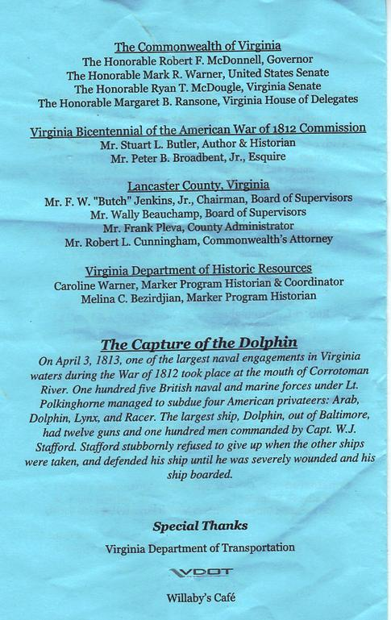
Some photos follow
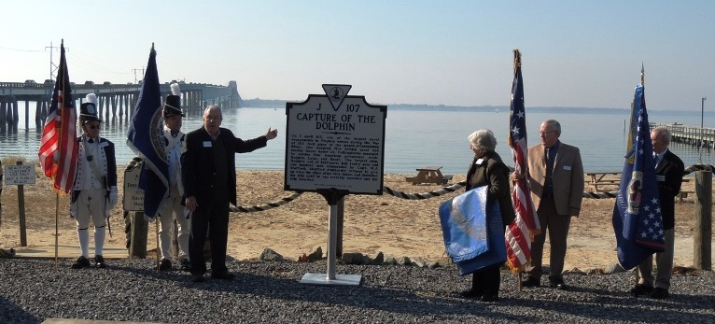
Above Stevenson T. Walker (hand pointing to the sign), Past President of the Northern Neck of Virginia Historical Society and Jane Henley, President of the Mary Ball Washington Museum and Library unveil the sign. Four members of the War of 1812 Society in the Commonwealth of Virginia carry the colors L/R: Mike Lyman, Charles Belfield, Floyd Brown and Stuart Butler. In the background is the Rappahannock River and in the vicinity of the bridge shown, the American Schooner Dolphin fired the first cannon shot of the War in the Northern Neck of Virginia at the approaching British vessels. Below is a group photo of participants:
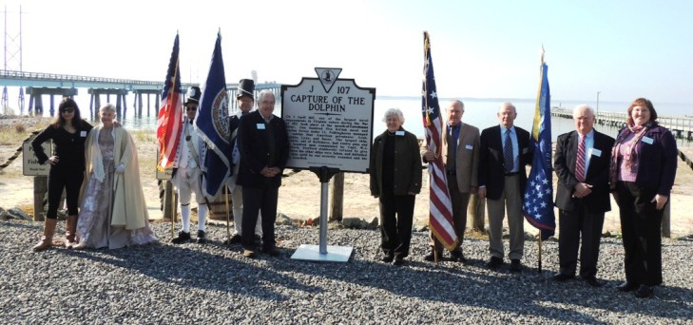
L/R Melinda Bezirdjian, representing the VA Department of Historic Resources; Dr Cheryl Davis of the U.S. Daughters of 1812 who sang the National Anthem in the inside portion of the ceremony; Mike Lyman, holding the U.S. flag; Charles belfield with the Virginia flag; Stevenson Walker and Jane Henley, previously mentioned, Floyd Brown holding the Star Spangled Banner flag; Stuart Butler, who gave the address during the ceremony holding the Virginia Society War of 1812 flag; Page Henley. Past President Northern Neck of Virginia Historical Society; and Karen Hart, Executive Director. Mary Ball Washington Museum & Library

The reverse side of the sign is shown below:
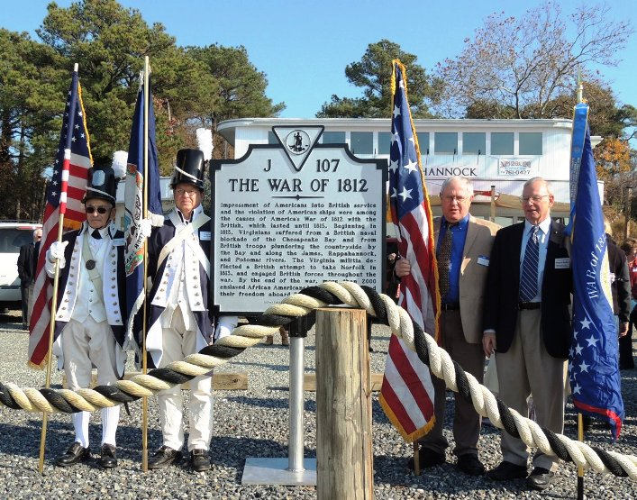
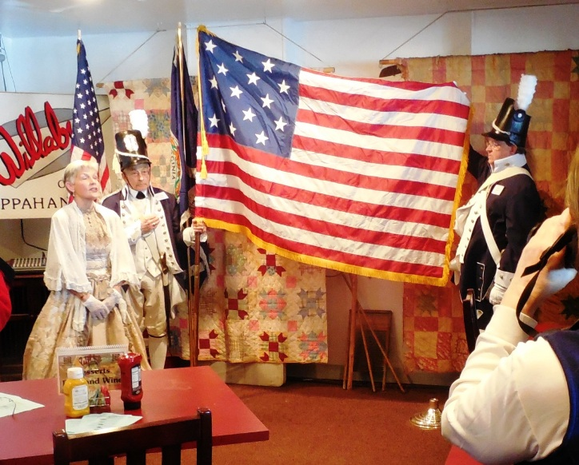
Above the Star Spangled Banner flag to held as Dr Cheryl Davis sings the words about it in the National Anthem
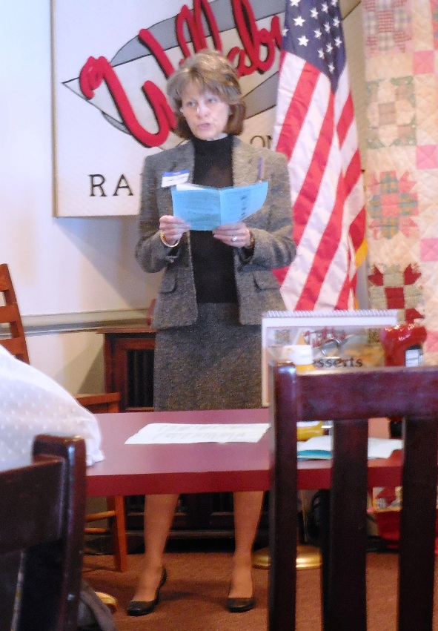
Above Jude Degan of the James Monroe Chapter, gives greetings from the U.S. Daughters of 1812
Below Melinda Bezirdjian, representing the VA Department of Historic Resources gives remarks
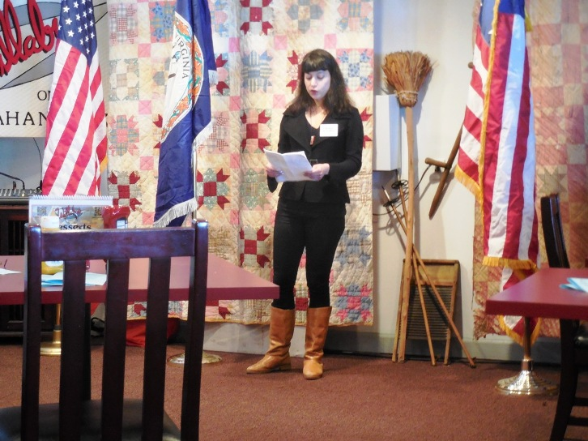
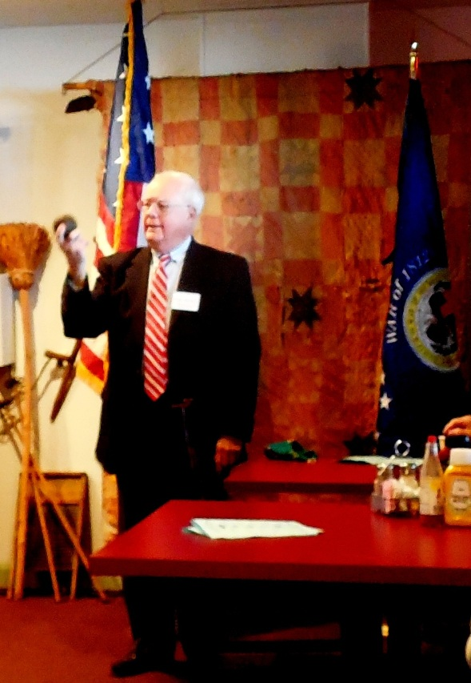
Above Page Henley, Past President Northern Neck of Virginia Historical Society shows a cannon ball fired from a British launch during the War on the Northern Neck, similar to the launches that fired to capture the Dolphin. Below, Stuart Butler, the author of the book, Defending the Old Dominion: Virginia and Its Militia In the War of 1812 that contains the details about the capture of the Dolphin is shown by the sign. He gave the address containing the details about the battle. He also represented the VA Bicentennial Commission.

