Members of the War of 1812 Society Honor President James Monroe April 28, 2014

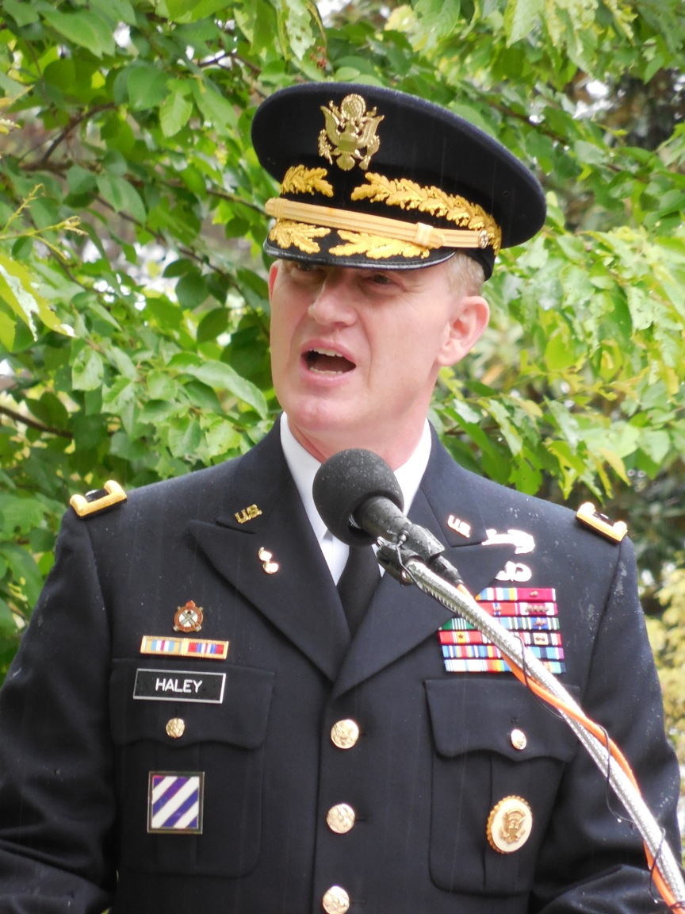
Brigadier General Haley from Fort Lee, VA does the honors for presenting the United States Presidential Wreath for President Obama at Hollywood Cemetery in Richmond on occasion of his birthday
Shown below is a photo of the wreath presented
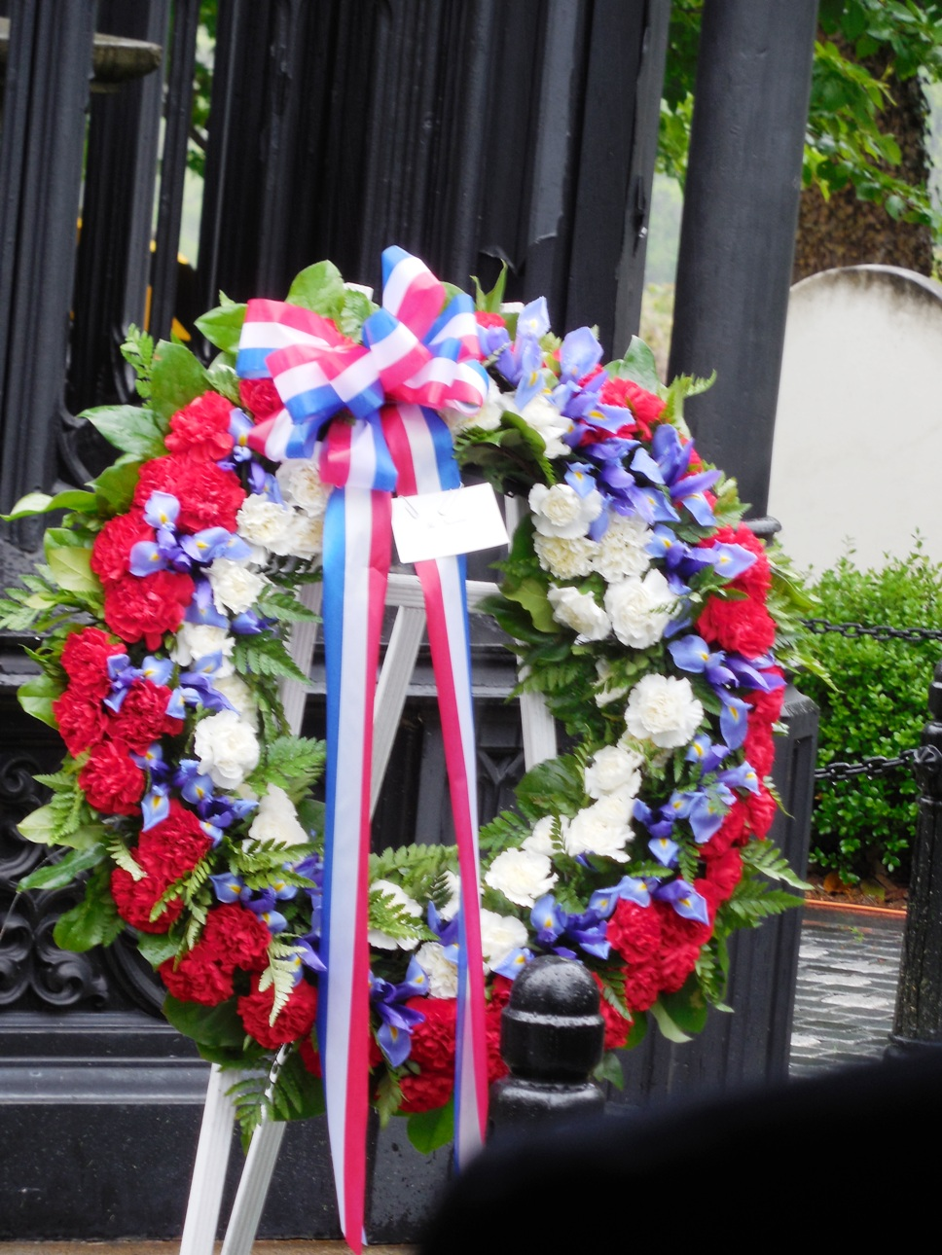

Following this U.S. Army’s portion of the ceremony the James Monroe Memorial Foundation performed their part of the celebration. The President of the Foundation, Bill Thomas presided. It was raining hard so the attendees as much as possible were under a tent
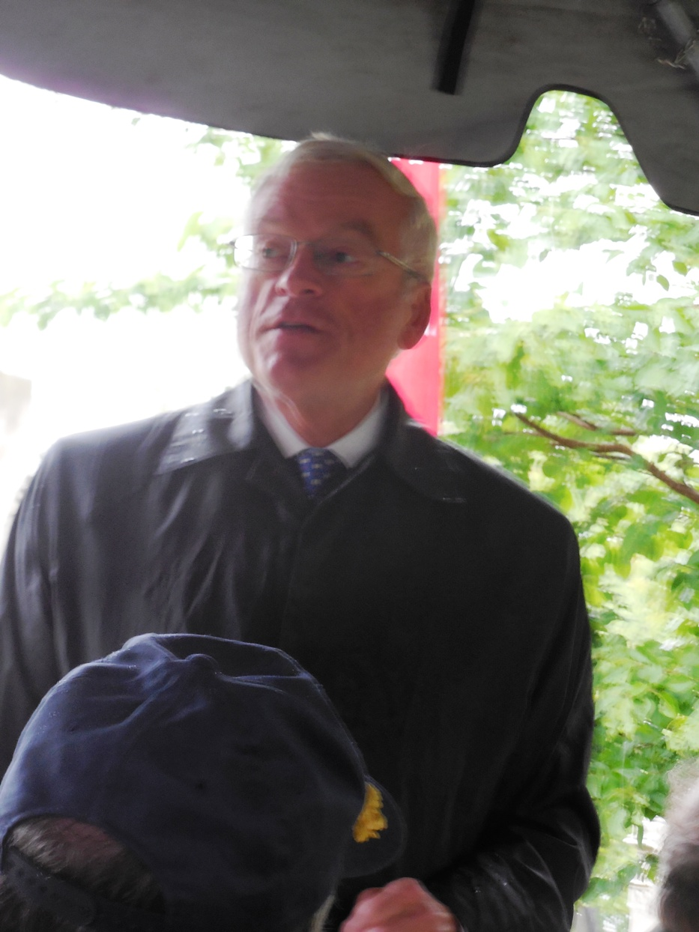
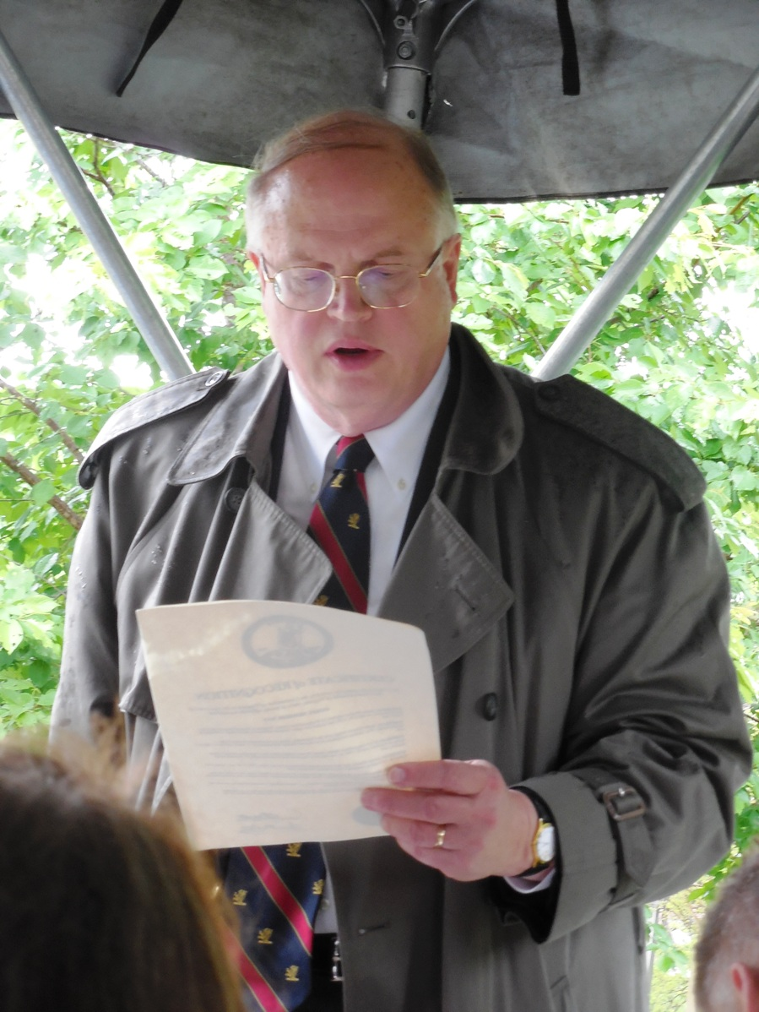
Peter E Broadbent, Jr., Esquire, Historian of the War of 1812 Society in the Commonwealth of Virginia read the Proclamation from Virginia Governor, Terry McAuliffe that proclaimed April 28th 2014 as James Monroe Day in Virginia
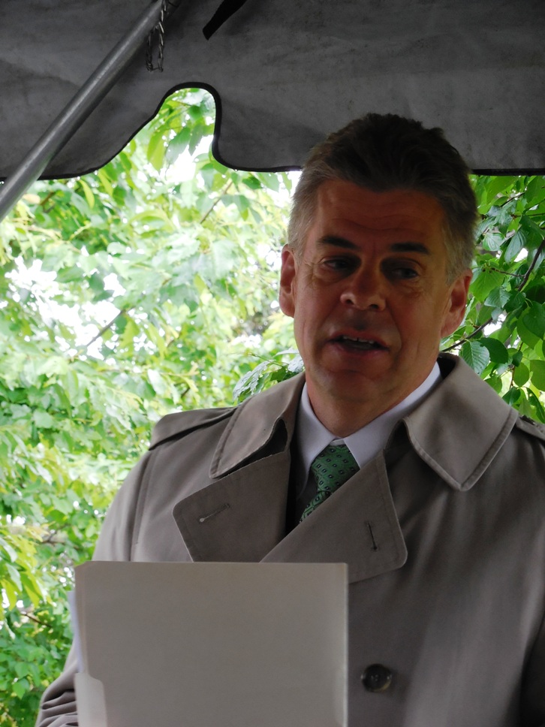
The Honorable Marvin Kirkland "Kirk" Cox, Virginia Delegate, as Chairman of the Virginia War of 1812 Commission gave greetings and remarks and presented a wreath.
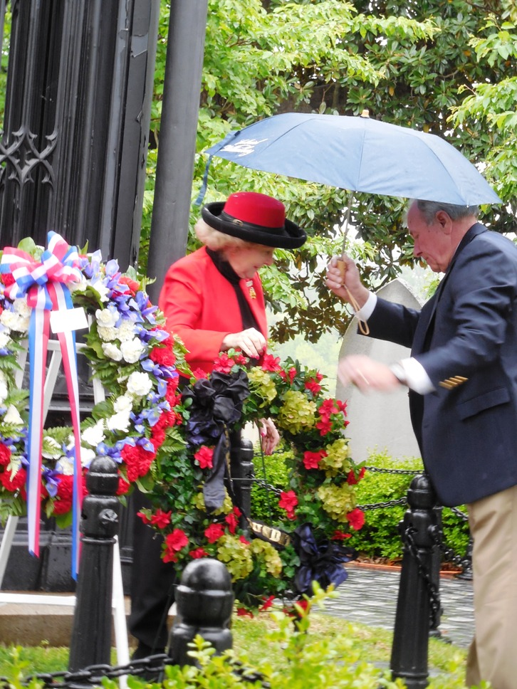
The Honorable Helen Marie Taylor, a direct descendant of James Monroe, gave greetings and remarks and is shown presenting a wreath
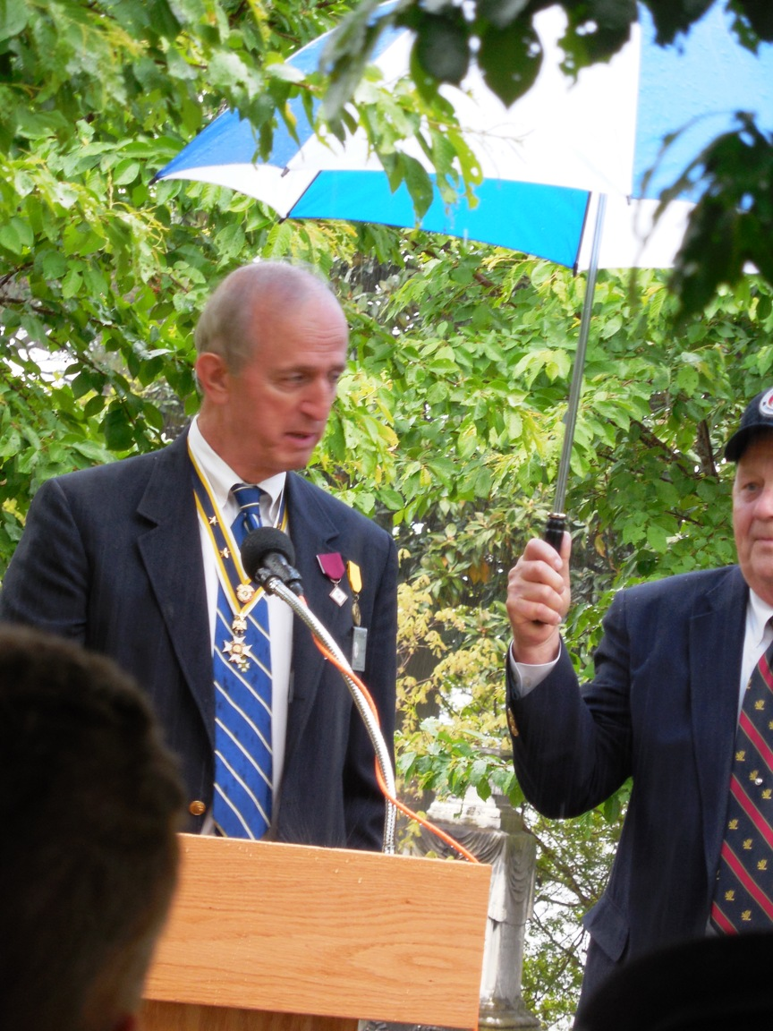
Edward W Truslow, a new member of the 1812 Society is shown giving remarks following his presenting an SAR wreath. Holding the umbrella for him and partially shown is Ronald J Depue a member of the 1812 Society
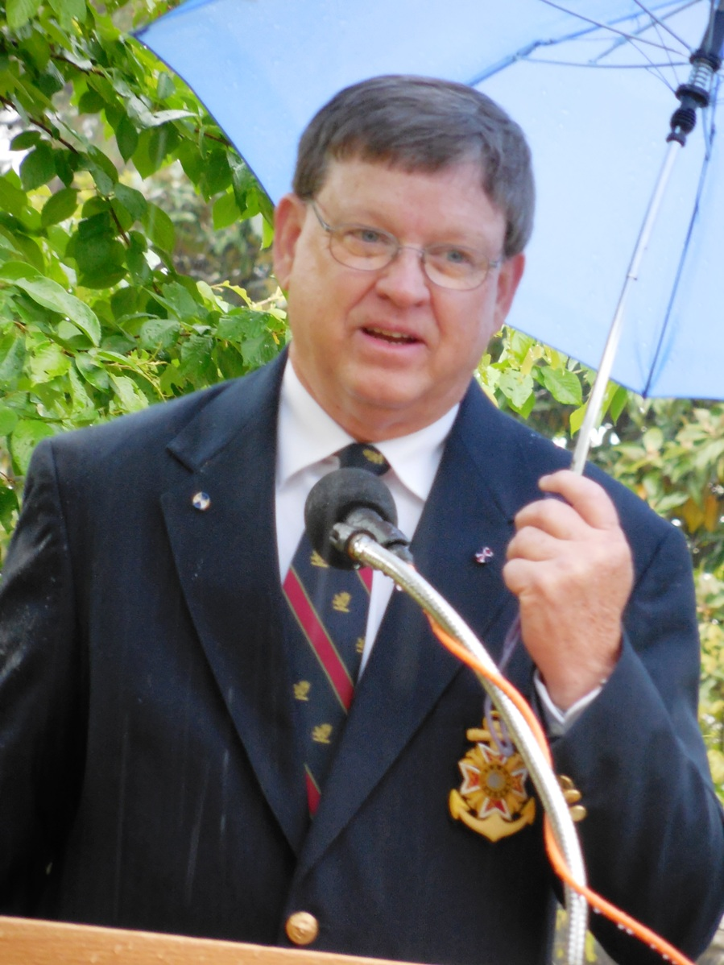
Charles Belfield, a member of the War of 1812 Society in Virginia is shown giving remarks after presenting the Society’s wreath
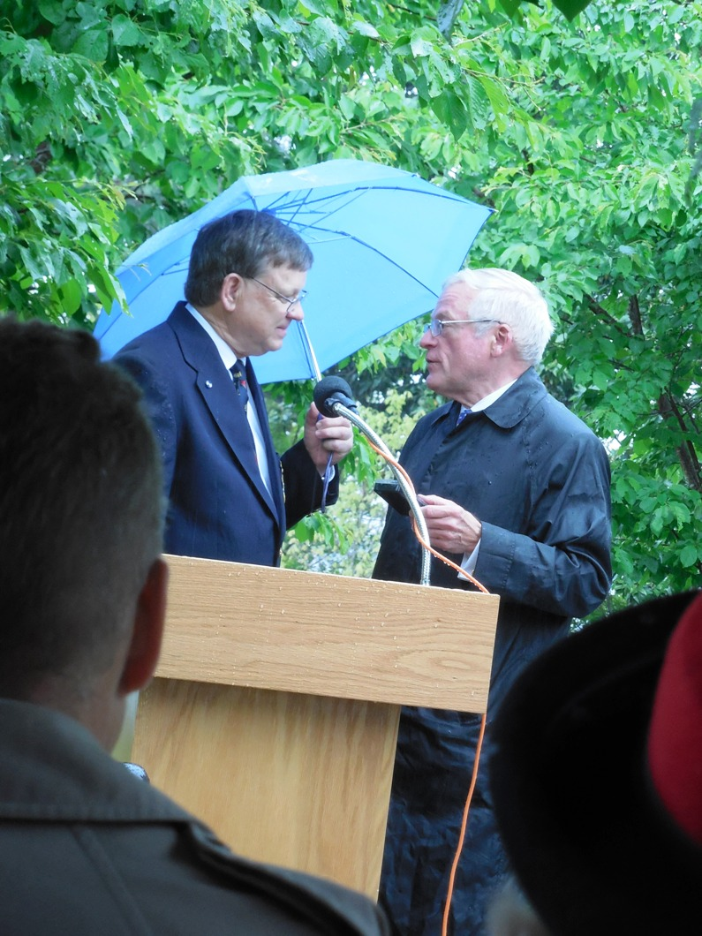
Charles Belfield is shown presenting Bill Thomas, President of the James Monroe Memorial Foundation a War of 1812 Society Bicentennial Medal for exhibiting at the James Monroe Birthplace Museum

