The Society Participates in the James Monroe Birthplace Ceremony April 26 2014
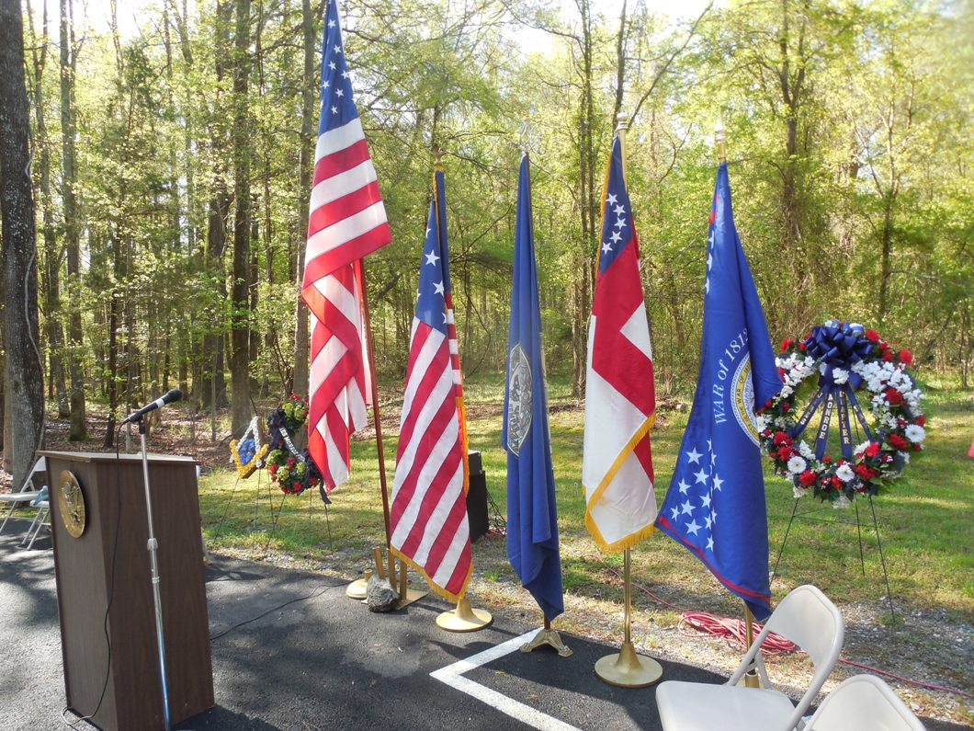
The Virginia Society War of 1812 flag on the right is posted before the ceremony behind the podium. Also, the society posted its Star Spangled Banner flag there as well, as James Monroe was Secretary of War and State in 1814
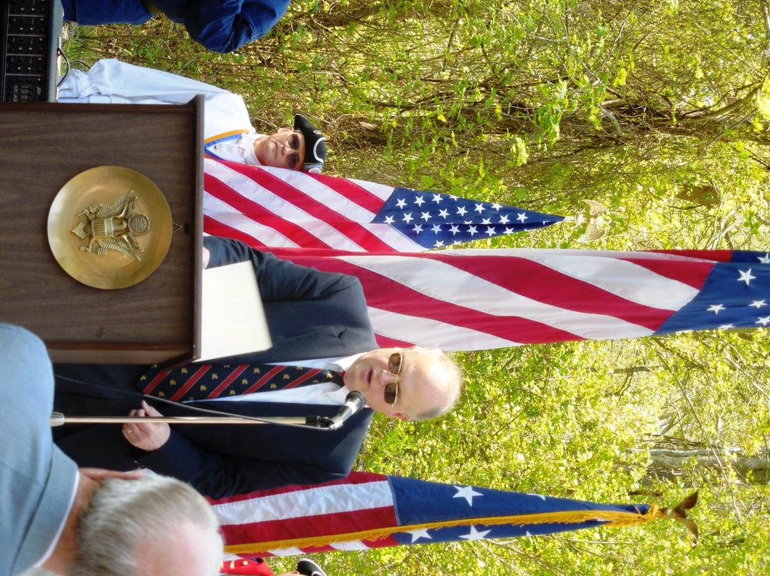
Peter Broadbent, Esq the Historian for the Society, is shown reading the proclamation from Virginia Governor, Terry McAuliffe
Below the five members of the society that attended are shown behind the society’s wreath
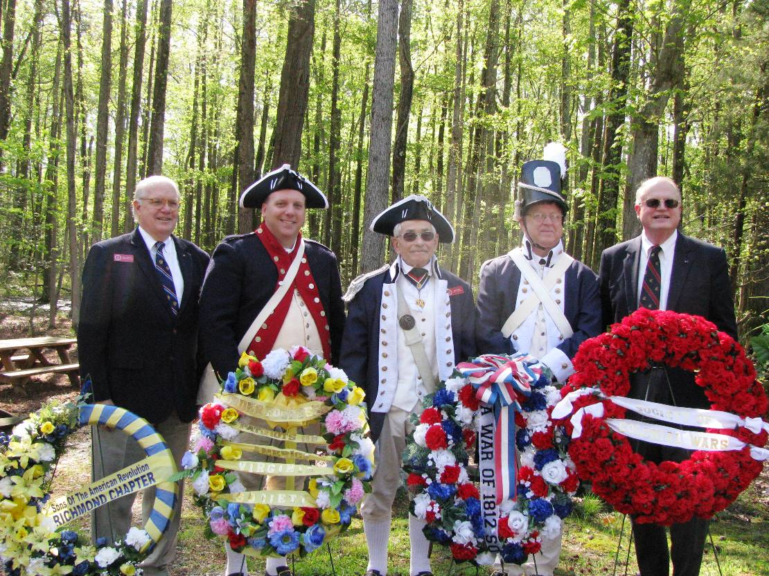
From the left is second Vice President, Walter Sheffield, Esq, member Mike Elston, Past President, Mike Lyman; member Charles Belfield and Society Historian, Peter Broadbent, Esq who is also the society’s representative to the Virginia Bicentennial Commission
Below Mike Lyman and Charles Belfield show and talk about the Star Spangled Banner Flag
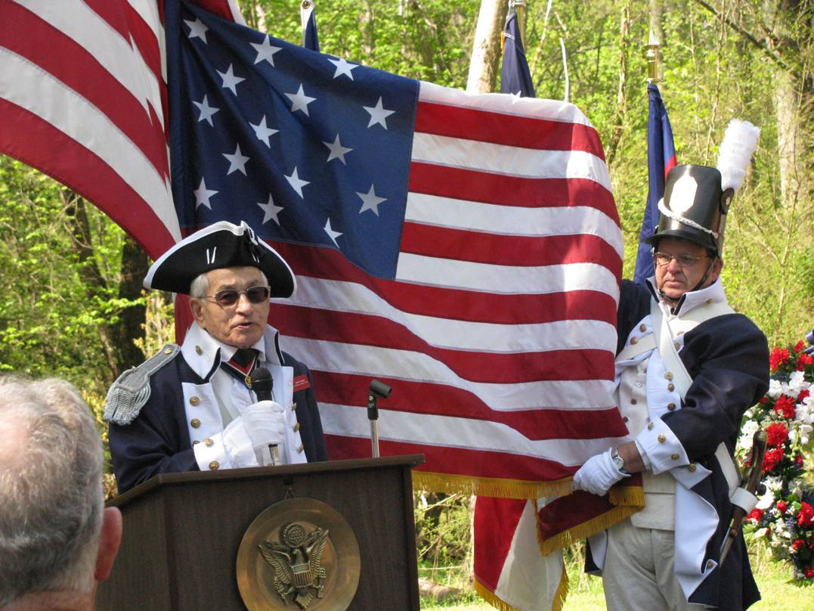
Below is Charles Belfield who presented the Society’s wreath
