The War of 1812 Society in the Commonwealth of Virginia Participates in Lancaster County, Virginia Court Day Ceremony April 12, 2014
Two members of the society, Charles Belfield and Mike Lyman dressed in War of 1812 attire hold up the Star Spangled Banner flag during the portion of the ceremony that honored the 200th anniversary of the wording of our National Anthem penned by Francis Scott Key. Members Floyd Brown and Hugh Markham also attended the event.
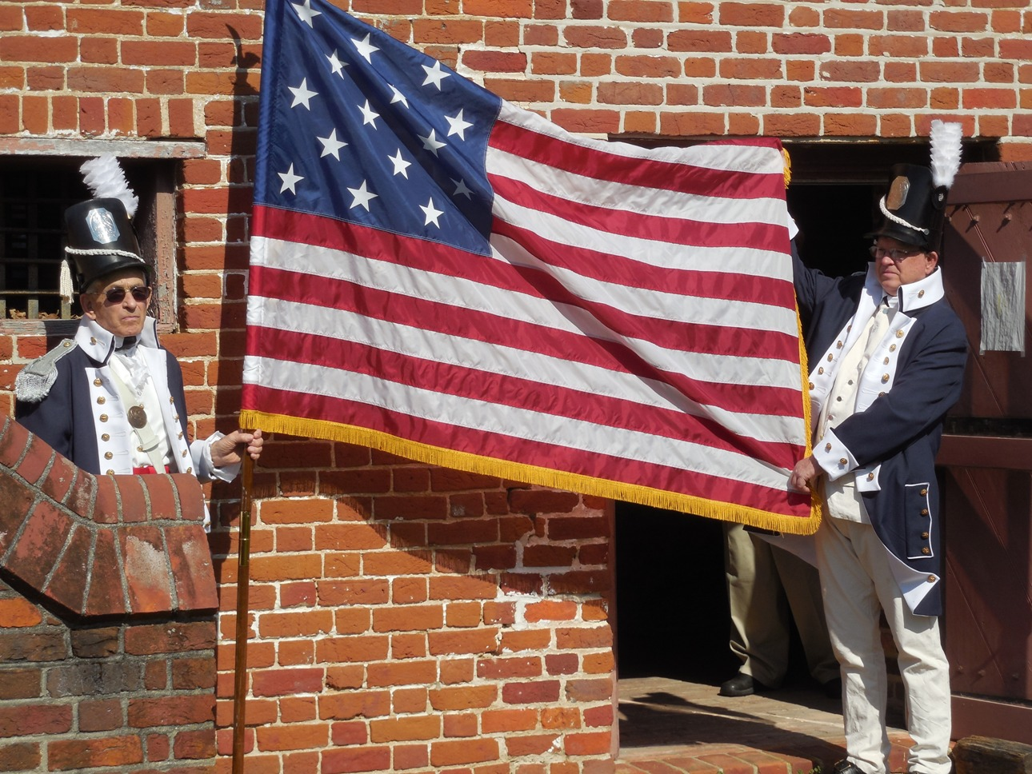
The ceremony was conducted in front of the Old Jail House on Court House Square in Lancaster
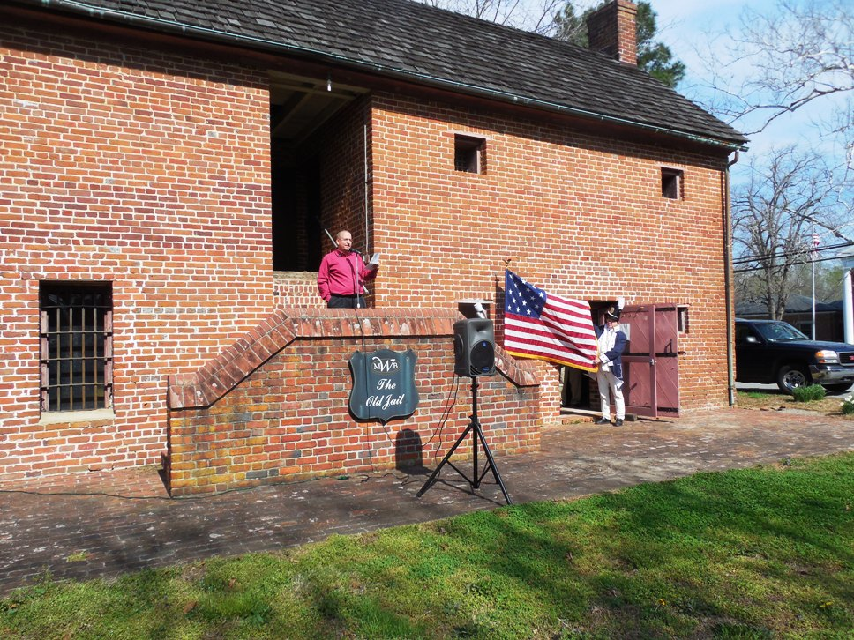
The Society also displayed materials pertaining to the War at one of the many vendor booths visited hundreds of attendees. See the photos below:
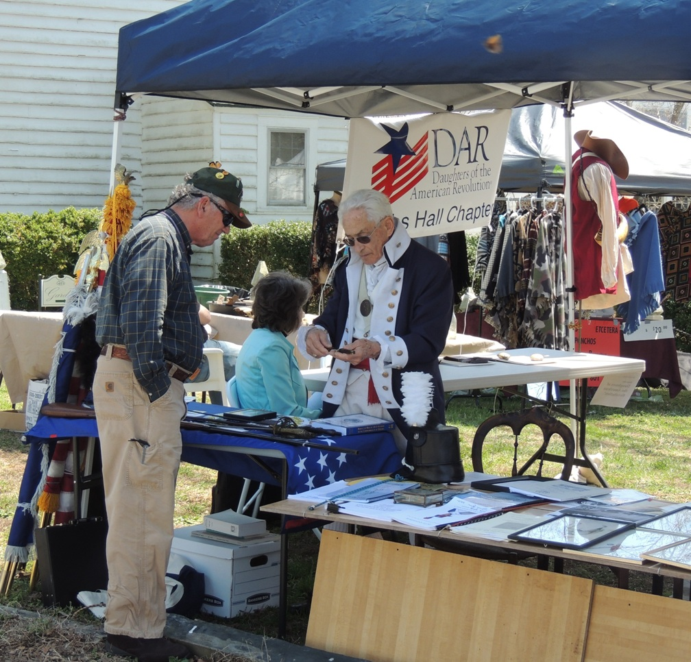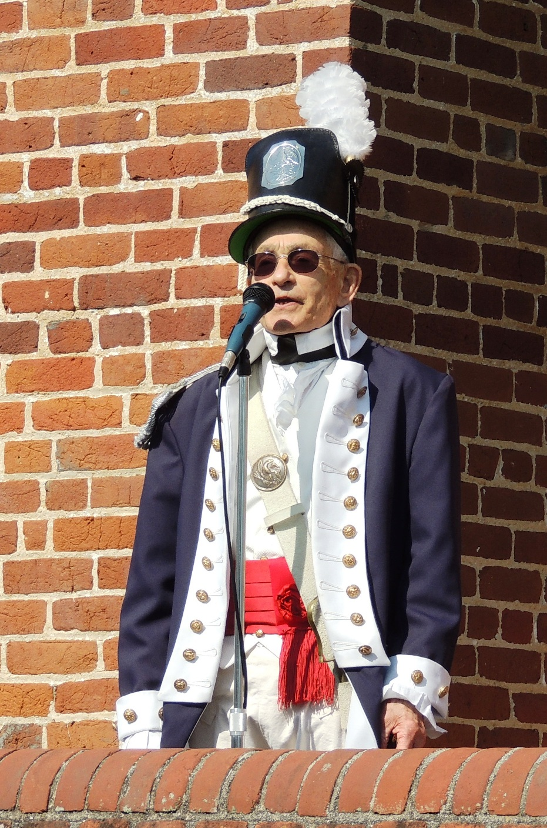
Mike Lyman provides additional information about the flag
