The War of 1812 Society in the Commonwealth of Virginia participates in the John Tyler Birthday Celebration in the Hollywood Cemetery on March 29 2014 in Richmond Virginia
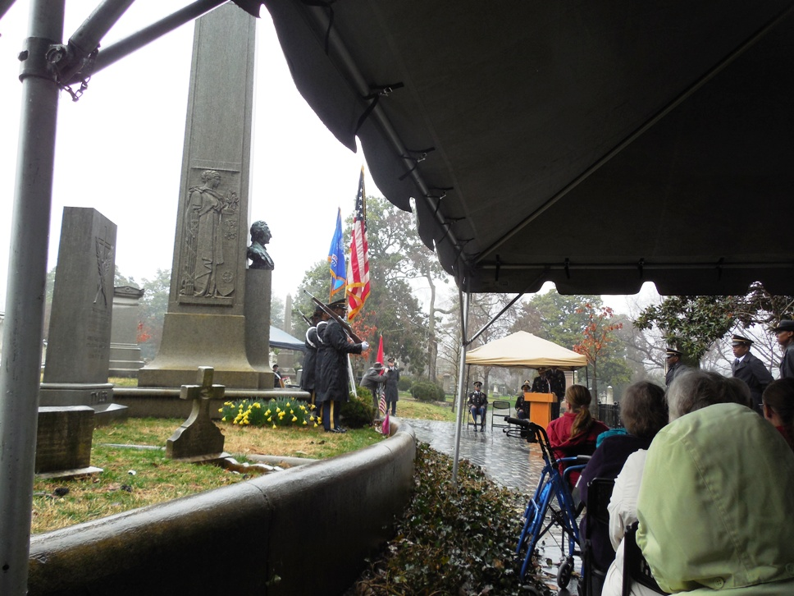
The ceremony is conducted on a rainy day by the U.S. Army at Fort Lee.
Shown are some of the attendees and their Color Guard in front of President Tyler’s monument. Below the Presidential wreath is presented

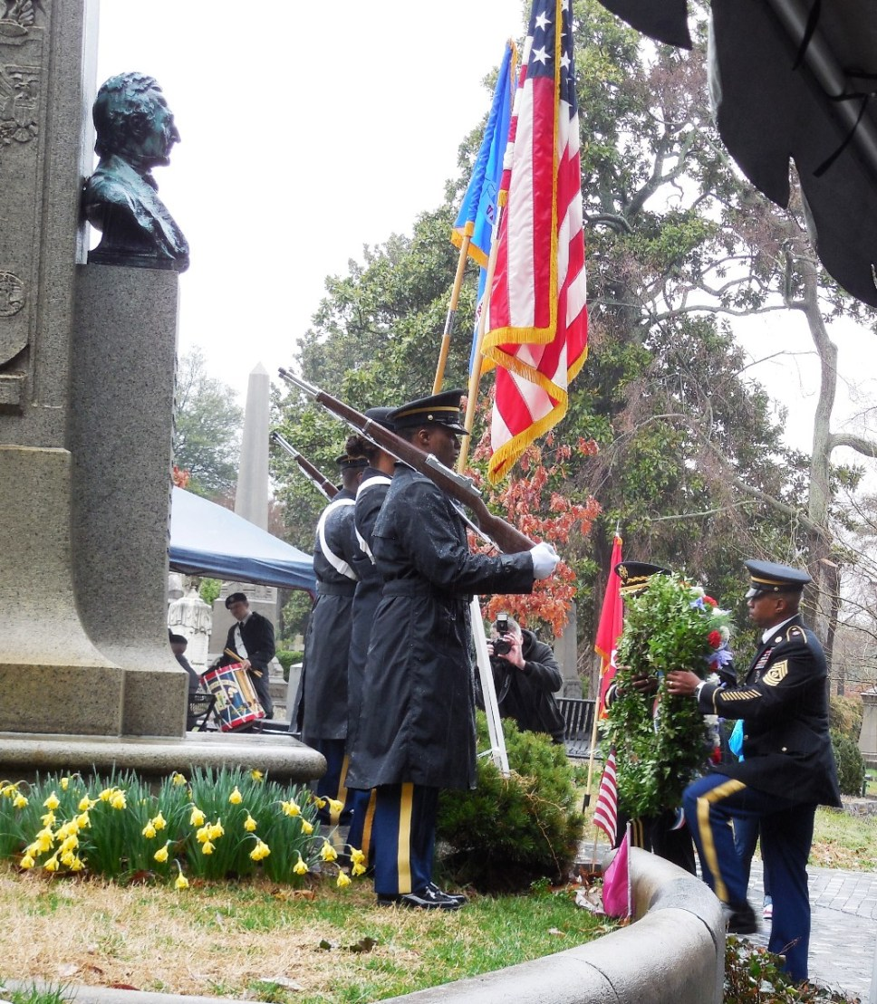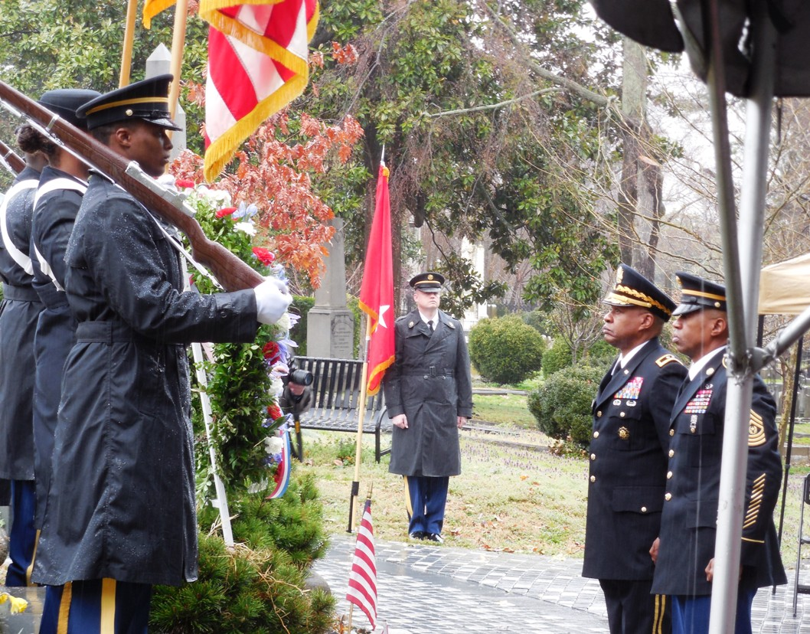
Below the Virginia War of 1812 Bicentennial Commission wreath is presented by the War of 1812 Society’s Advisory Council member, Stuart L Butler
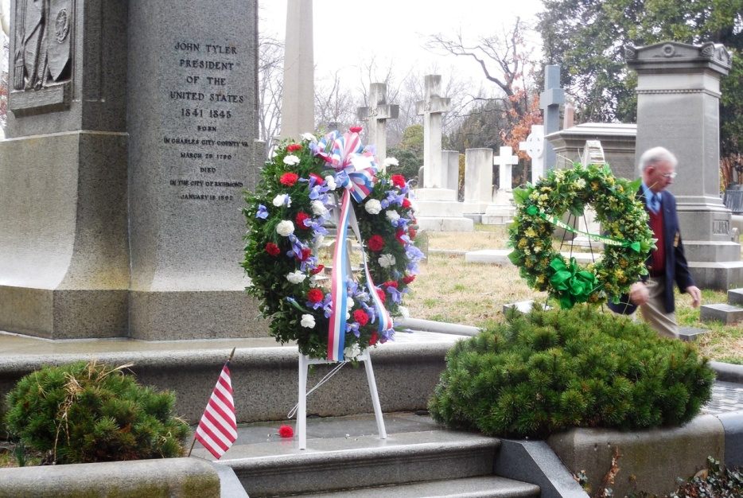
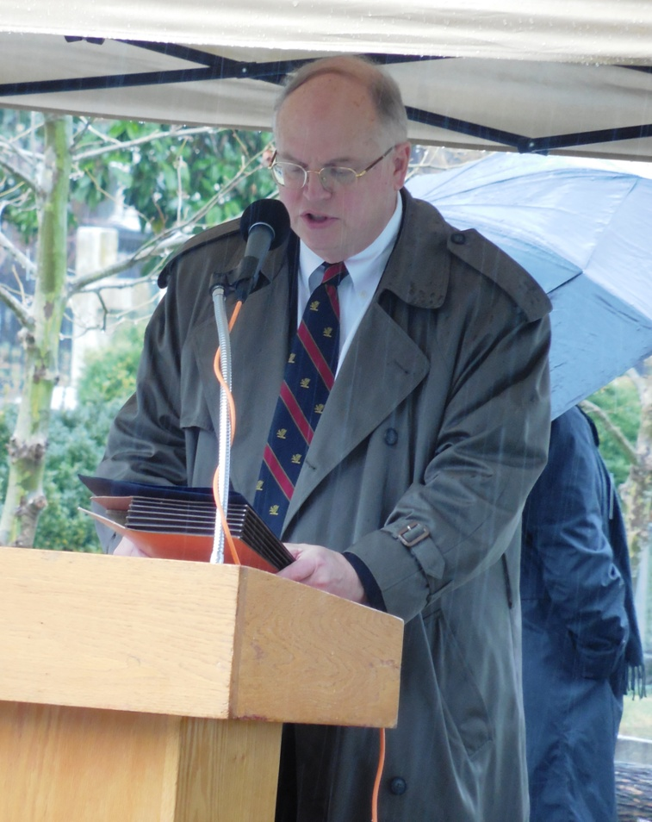
Above the Society’s representative to the Virginia Bicentennial Commission, Peter E Broadbent, Jr, Esq. reads the Society’s proclamation containing the following information about John Tyler who was a Captain during the War of 1812 in Virginia
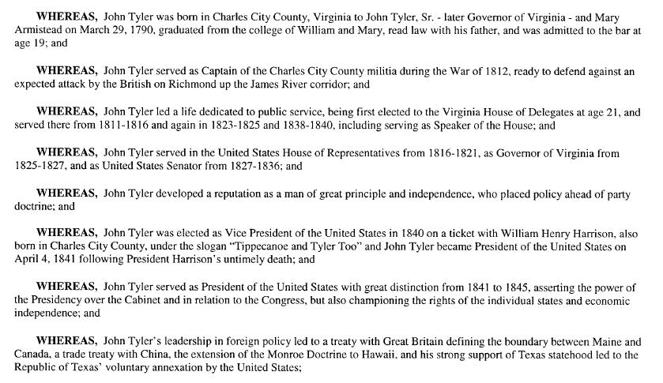

Past President of the Society, Mike Lyman presented the society’s wreath which is shown on the right in the photograph below. In the center is the Presidential wreath and on the right is the Commission’s wreath
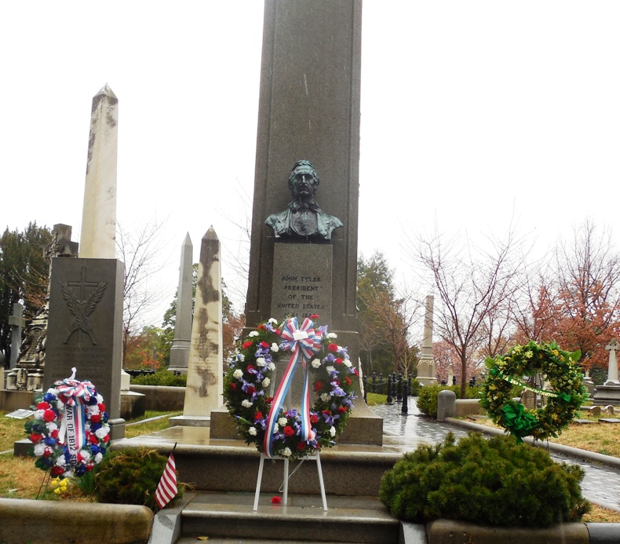

After the ceremony the five members of the society that attended the ceremony pose in front of the monument. From the right is Mike Lyman, Peter Broadbent, Hugh Markham, Stuart Butler and Charles Belfield.

