THE SOCIETY PARTICIPATES IN THE FAUQUIER COUNTY WAR OF 1812 COMMEMORATION ON MAY 10TH 2014
Author and Councilor, Stuart L Butler and Past President, Mike Lyman of the War of 1812 Society in the Commonwealth of Virginia participated by giving presentations, cutting ribbons and by setting up displays at the event. Below is the program in two parts:
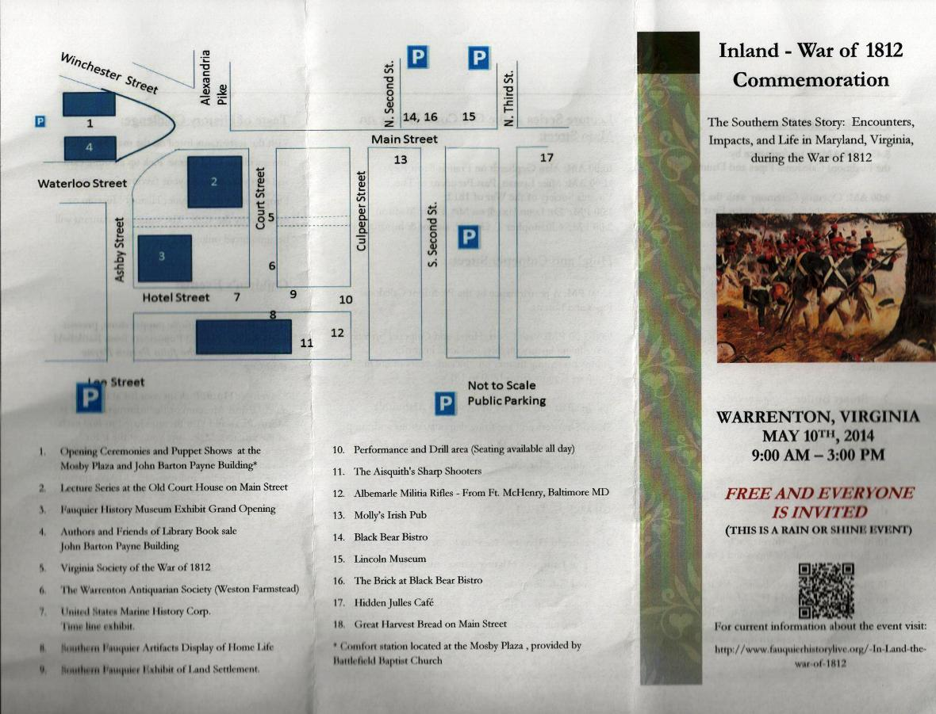
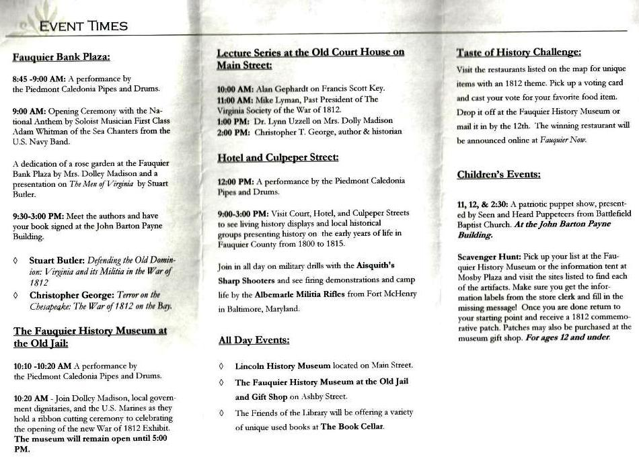
Stuart Butler of the Society is shown talking about the War of 1812 in Virginia

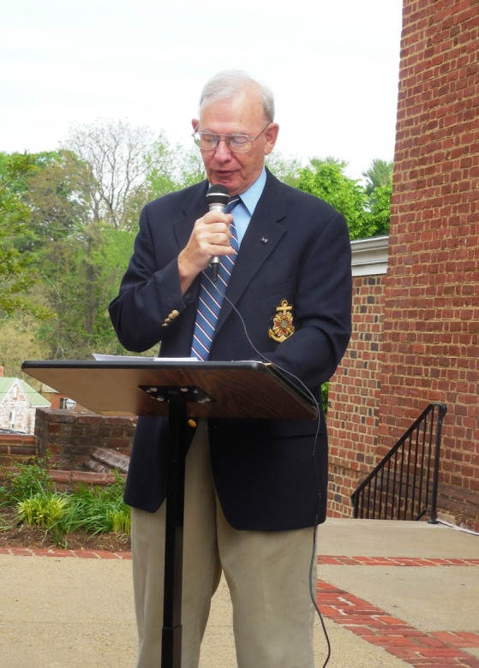
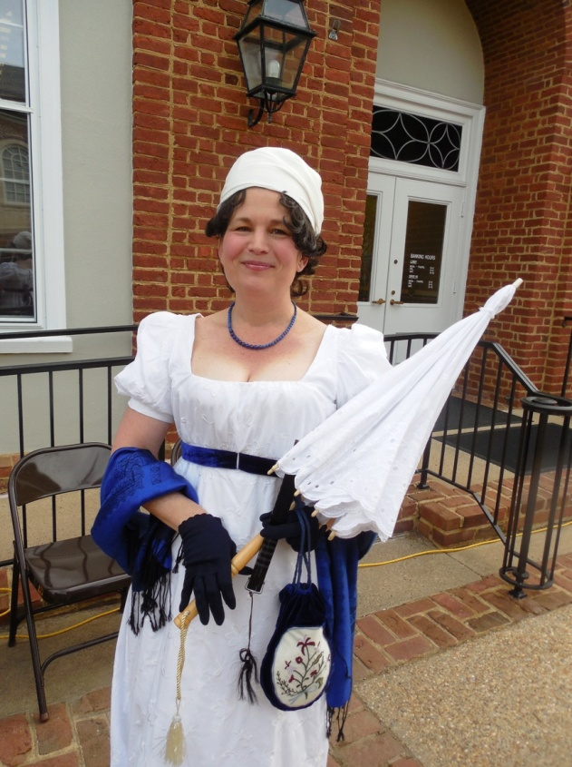
A representative of Dolly Madison, by Dr Lynn Uzzell also spoke
Below Mike Lyman and Dolly cut a ribbon to the new War of 1812 display in Warrenton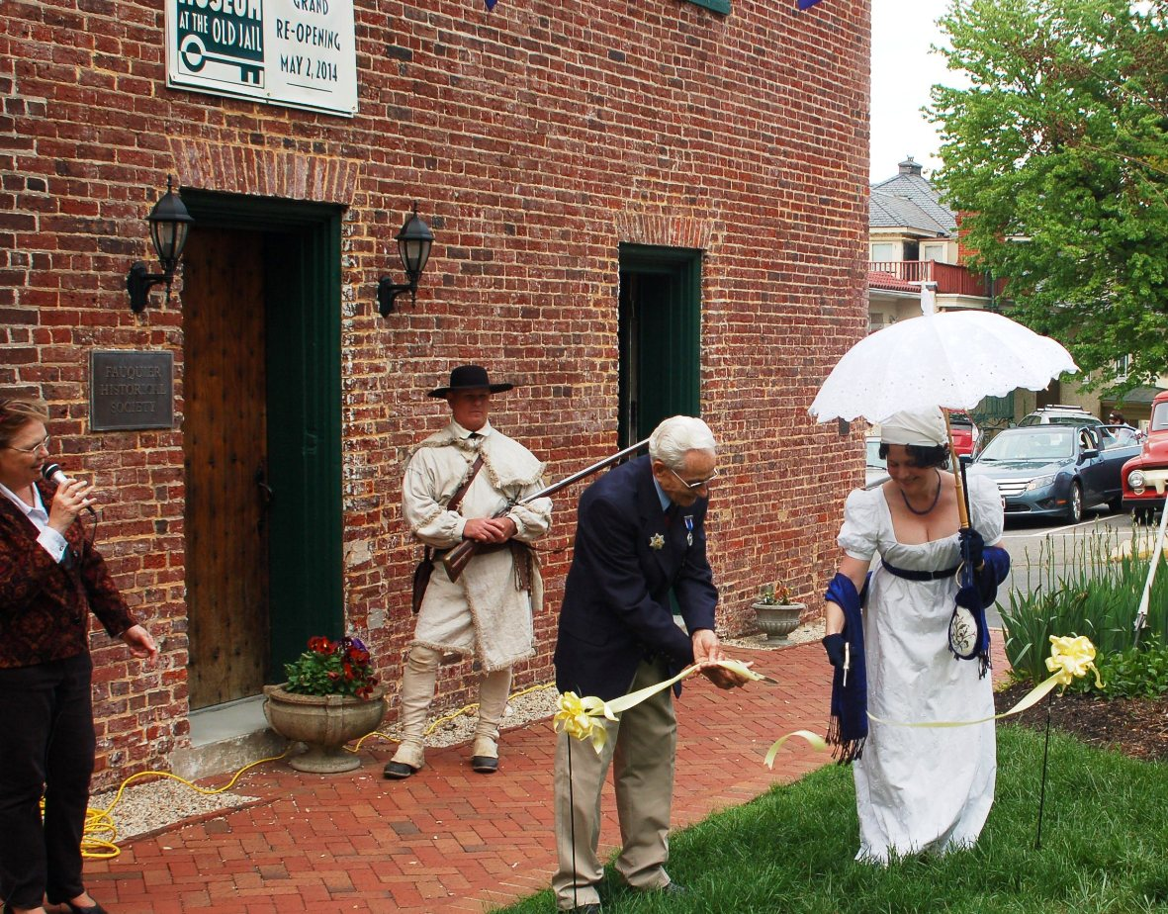
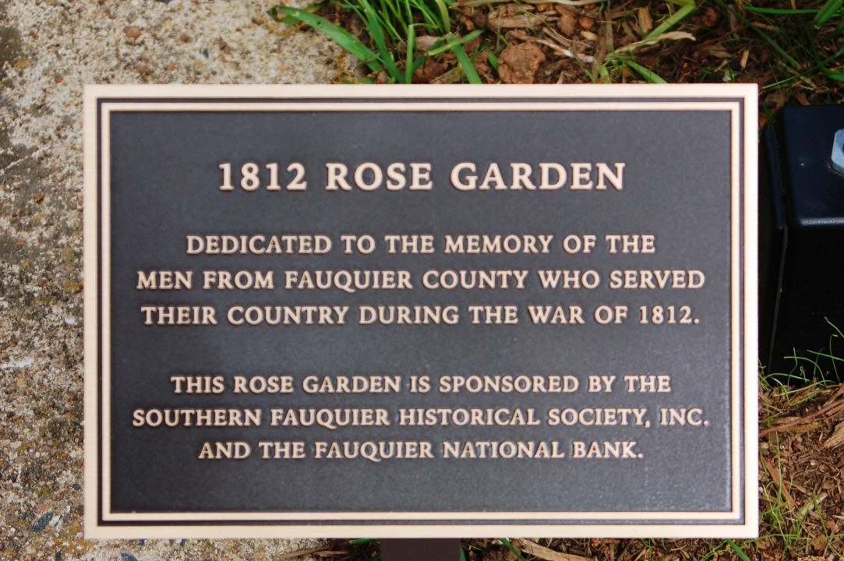
Mike Lyman and Stuart Butler are shown in the War of 1812 display booth
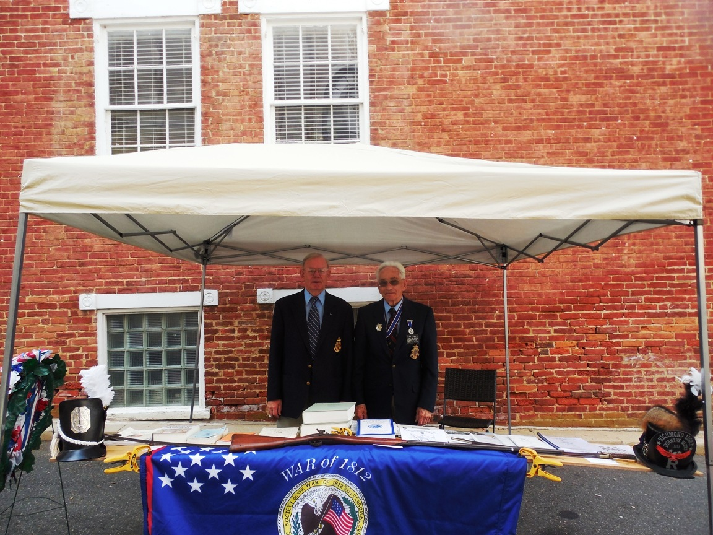

Mike Lyman gave a presentation on how Fauquier County was involved in the war. Shown is a handout he provided that gave details and rosters
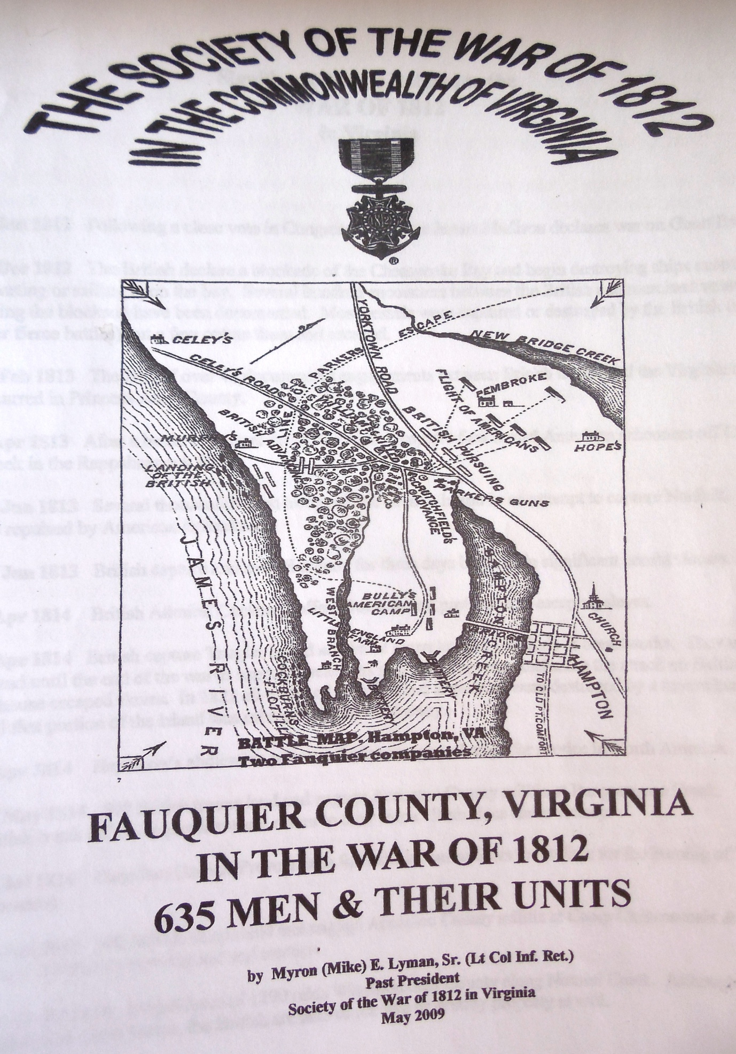

The Alaquich’s Sharp Shooters in War of 1812 attire are shown that gave a firing demonstration