Society of the War of 1812 in the Commonwealth of Virginia has developed an on-line store for purchase of merchandise for members
This from our Society Quartermaster:
I am pleased to announce that I have (with the assistance of my secretaries) a very nice and easy to use online store for the Society of the War of 1812 in Virginia. These items are sold only to members

https://squareup.com/market/society-of-the-war-of-1812-in-virginia

You will see an array of items that I sell as Quartermaster for the Virginia Society. It currently takes Credit Cards, but as always, you can “snail mail” an order by visiting the Society’s website or in the newsletter.

Please take a look. All of these items will be available for purchase at the Annual Muster on June 7th 2014 in Petersburg, VA. Mike Lyman will have the Quartermaster merchandise shown on the link above there for your direct purchase with cash or check.

In the future, this system will enable me to accept credit card payments – mobile – meaning at future Exe. Meetings, and Annual Musters!

Completely versatile, mobile, and above all a great way to get your needed items.

Shane

J. Shane Newcombe

Bicentennial Merchandise
- 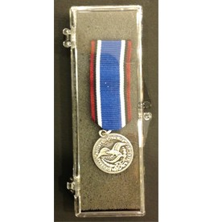
Bicentennial Medal-Mini
$30.00

- 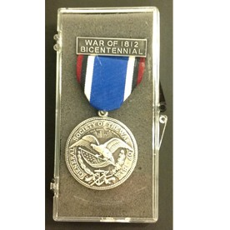
Bicentennial Medal-Regular
$50.00

- 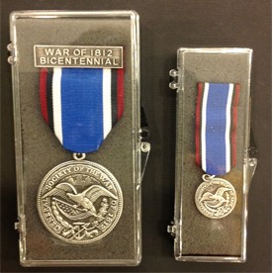
Bicentennial Medals-Regular and Mini
$75.00

National Insignia Merchandise
- 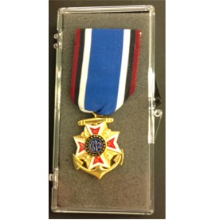
Bronze Mini Insignia
$72.00

- 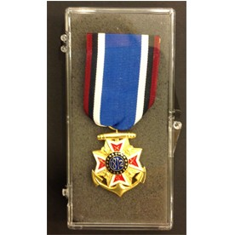
Bronze Regular Insignia
$135.00

- 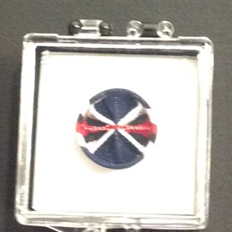
Rosette
$15.00

Virginia Merchandise
- 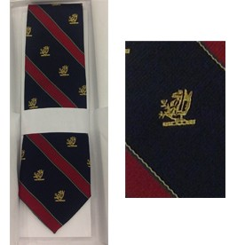
Official Virginia Society Tie (The James Monroe tie)
$30.00

Rosette
$15.00

- 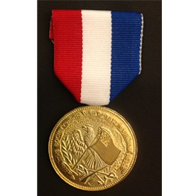
Virgnia Society Medal
$25.00

CONTACT US
434-547-9597
1812va.org

