Three Members of the Society Attend or Participate in the Virginia Bicentennial Commission’s “Legacy Symposium” on June 20-21 2014 at the Hampton University
Peter E Broadbent, Jr, Esq. as the Society of the War of 1812 in the Commonwealth of Virginia representative to the Virginia Bicentennial Commission’s “Legacy Symposium” gave remarks and attended and Councilor Stuart L. Butler was a selected panelist and speaker who provided information about the War in Virginia. Legal Councilor, Carter B.S. Furr also attended. Some photos taken during the event are below:
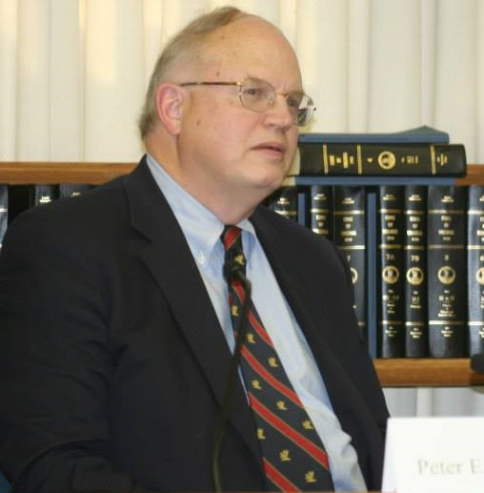
Society Representative to the Commission, Peter E. Broadbent, Jr., Esq.
Below he is with Virginia Senator Barker
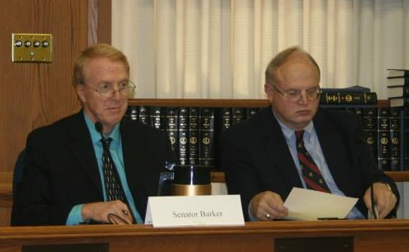
Several photos of panelist and speaker Stuart L. Butler with others follow: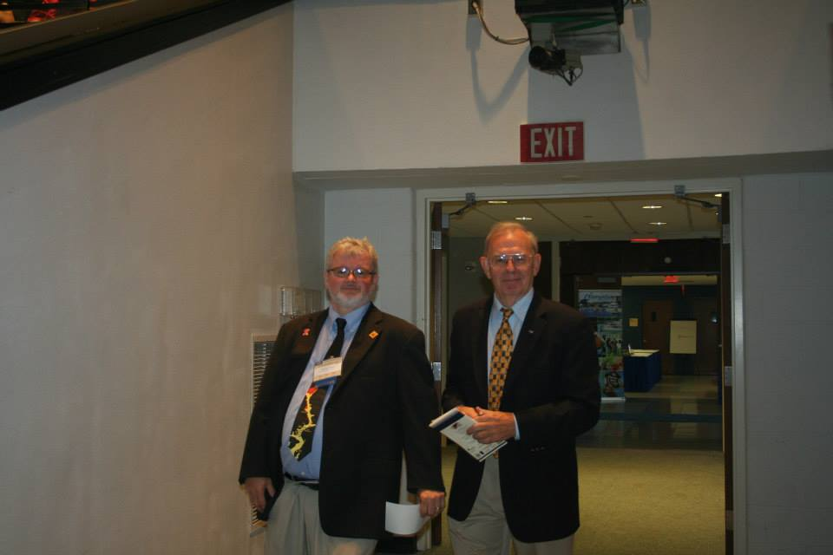

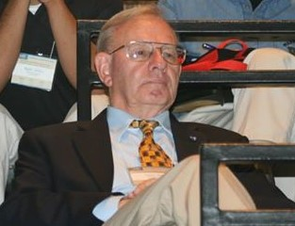
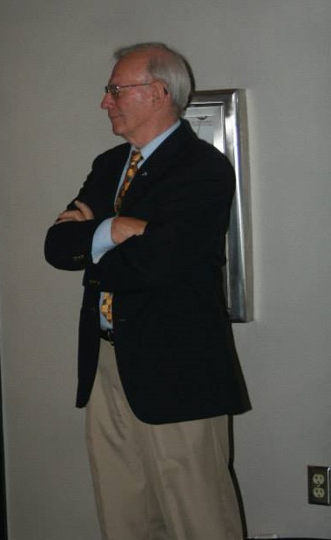
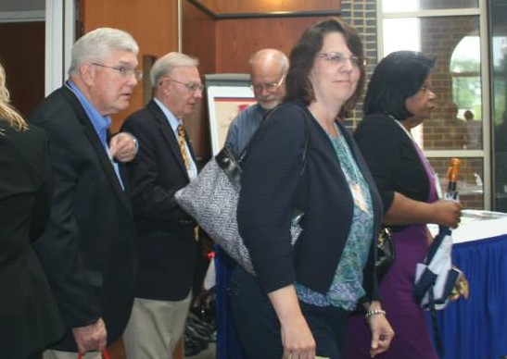
And Society Councilor Carter Furr
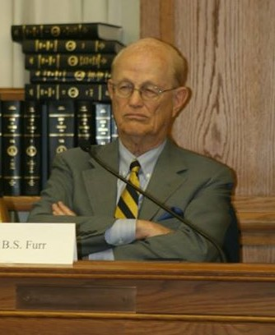
The building at the Hampton University where the event occurred
