Stuart Butler is Speaker at Admiral Cockburn Road Sign Unveiling June 28, 2014
Councilor Stuart L Butler of the Society of the War of 1812 in the Commonwealth of Virginia was the Special Guest Speaker at the unveiling of a Virginia Historical Road Sign in Hampton, Virginia for Admiral Sir George Cockburn. He is the author of several books pertaining to the war in Virginia to include Defending the Old Dominion; Virginia And Its Militia in the War of 1812, published 2013 by the University Press of America, Inc. of Lanham, MD
See the program below:
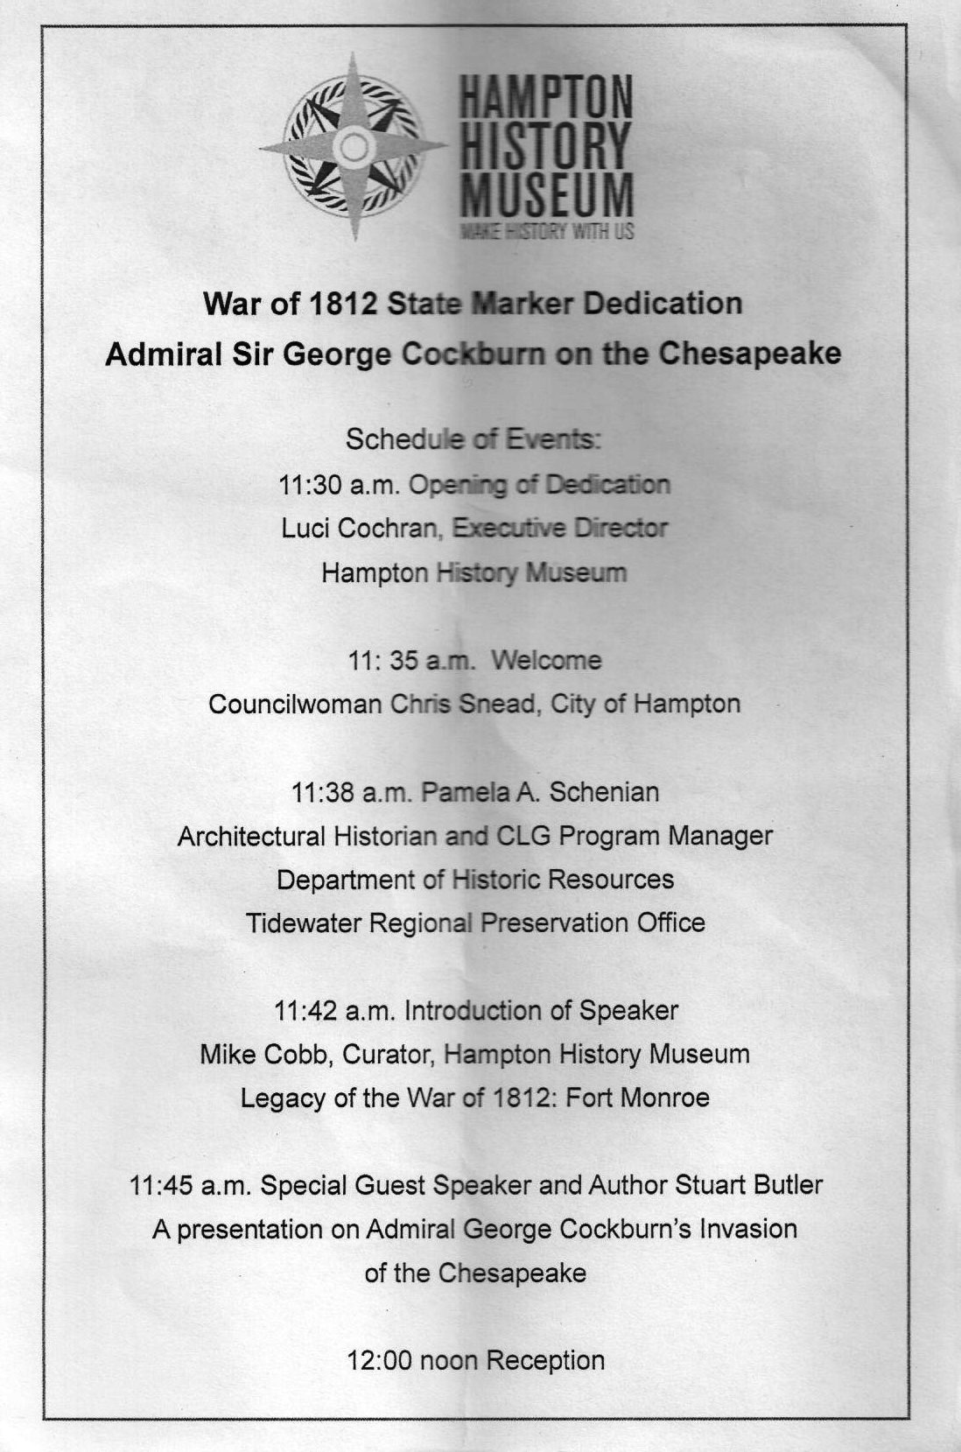
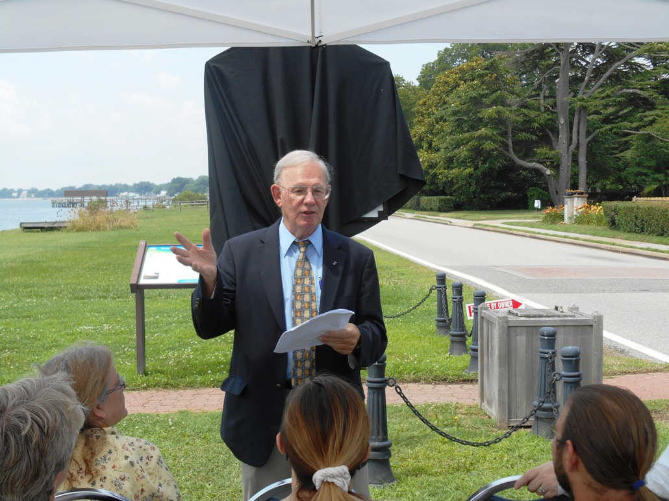
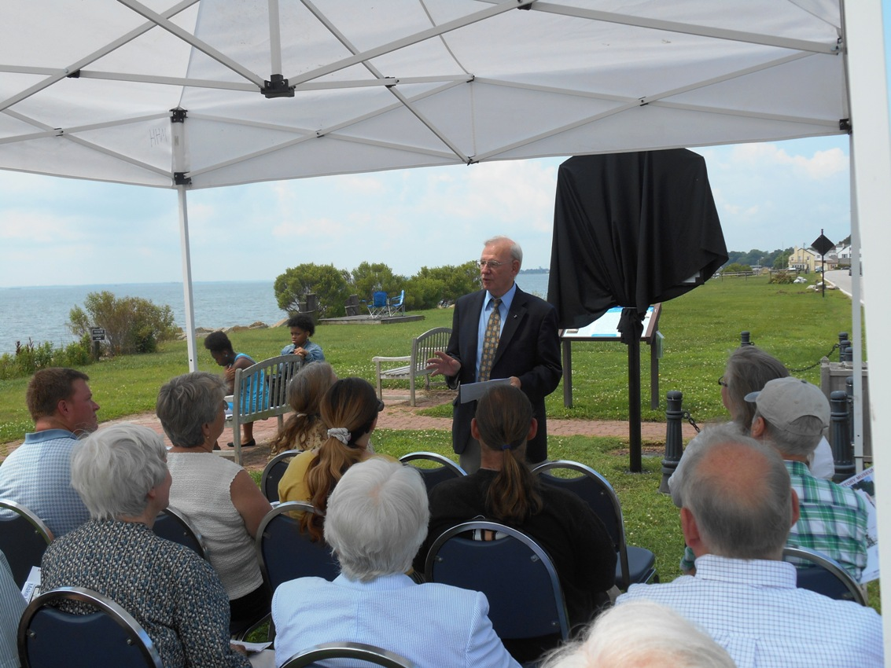
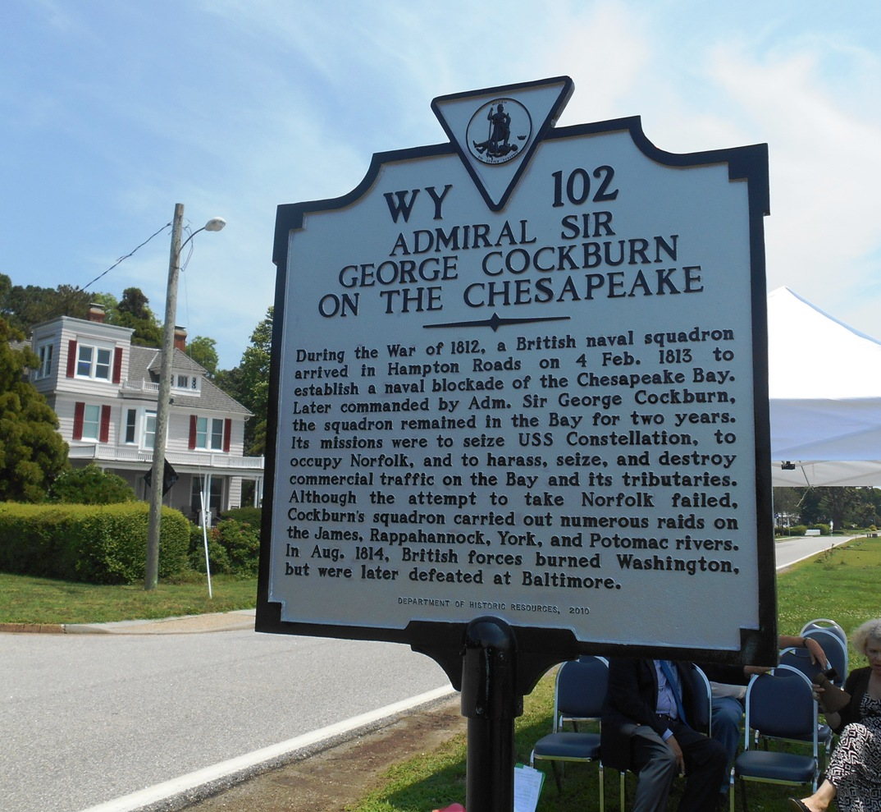
Above the unveiled sign
After the ceremony he is shown below with the Curator of the Hampton History Museum, Mike Cobb with some of the attendees in the background
The sign is erected at the intersection of Alleghany Road and Chesapeake Avenue in Hampton, right on the waterfront.

