Grave Marking Ceremony For Rezin Willcoxon, 3pm 20 September 2014, Fairfax, VA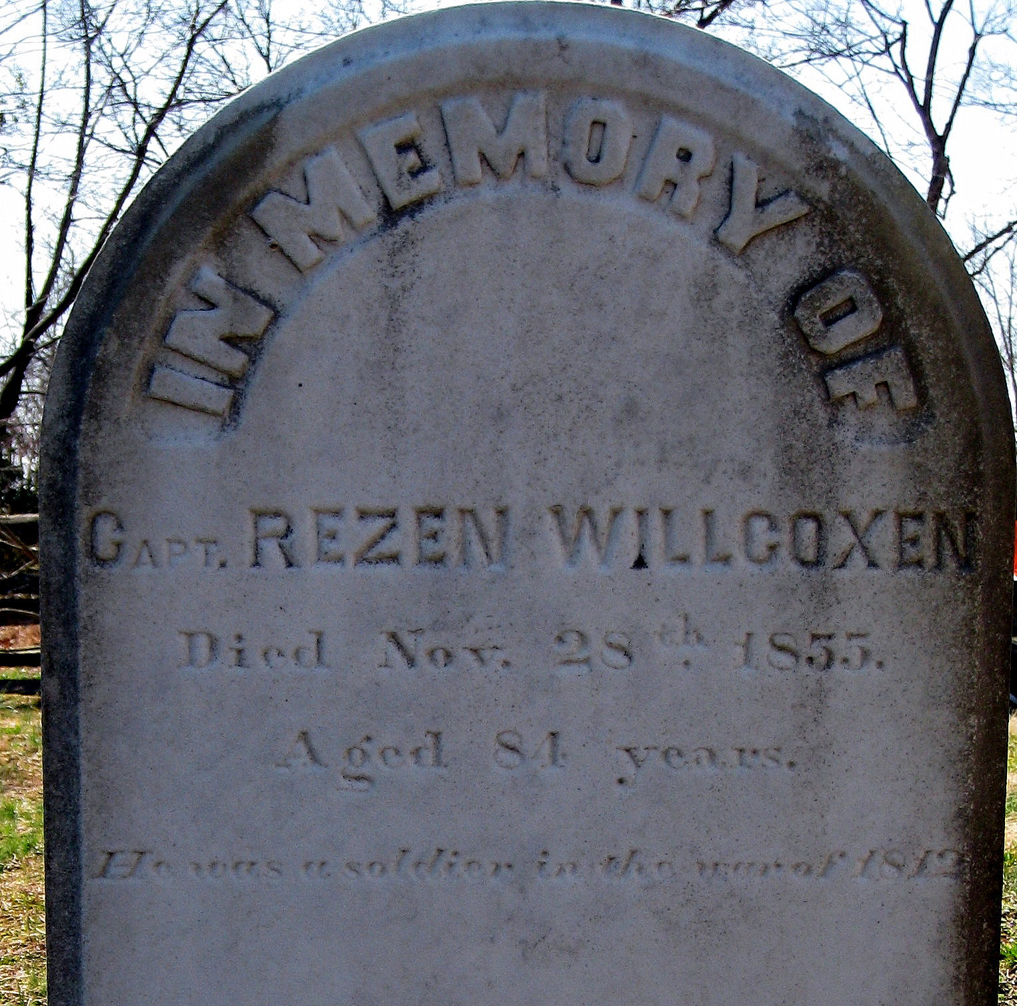
Information about him: He served as the captain of a troop of calvary, one two 60th Virginia Cavalry troops who were sent to Washington, DC. But they arrived too late to be sent to Bladensburg to stop the British advance to the District of Columbia. They did however proceed to Baltimore as part of the Virginia’s 6th Brigade. His federal service was from August 23-31, 1814.

The City of Fairfax Bicentennial Event begins at 11am. Details may be obtained from Andrea J Loewenwarter, tel (703) 571-6728 or e-mail Andrea.Loewenwarter@fairfaxva.gov The War of 1812 Society in Virginia grave marking ceremony commences at 3 pm. The cemetery is in the front yard right next to the main artery, Old Lee highway. Mayor and City Council members from Fairfax and Willcoxon descendants are planning on attending. The grave marking event is open to the public and welcomes War of 1812 society members and their guests.

