War of 1812 Society Members Plan Family Ceremonies for their Ancestors
War of 1812 Member Ken Williamson Family Ceremony September 6 2014
John Walter Harbin and his brother Rezin Harbin fought in the Maryland Militia in Southern Maryland during the War of 1812, protecting the geographical area where many of our family currently reside.
On Saturday, September 6, 2014, at 1:00 pm you are invited to attend the War of 1812 grave marking ceremony event for these two defenders of our United States. We will be marking the graves of our two ancestors who served during the War of 1812 in the First Regiment, Maryland Militia. Their graves will be marked with grave markers from the General Society of the War of 1812 (see picture below). Family members, members of the General Society of the War of 1812 and the Society of the US Daughters of 1812 will be in attendance.
Please come and participate in this memorable once-in-a-lifetime family event. After the ceremony, we will meet at Susan and Bruce’s house for a small gathering with some light refreshments. Thank you for forwarding this notice to anyone you think would be interested in attending this event. If you believe you will be attending and coming to the gathering at Susan and Bruce's house, it would be appreciated if you would send an email response. Casual dress is appropriate.
The church location is:
St. Mary's Catholic Church Cemetery
13715 Notre Dame Place, Bryantown, Charles County, MD, 20617
St. Mary's Catholic Church Cemetery Link
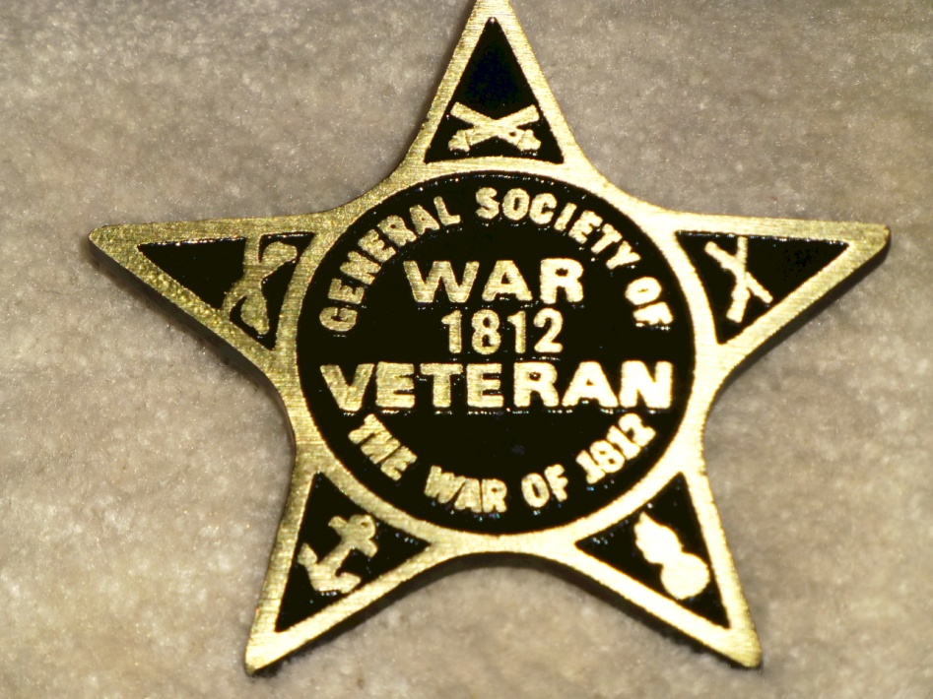

War of 1812 Member, Charles Belfield Family Ceremony October 5 2013

Seven veterans of the Belfield family of Richmond County will be honored. The grave marking ceremony will honor John, Thomas, John Jr., and Sydnor Belfield who fought in the Revolutionary War. Also, John Wright, Joseph and Thomas M. Belfield, soldiers in the War of 1812 will be honored.

Family and service Information about each of these veterans will be presented

Government gravestones have been procured and mounted for all of the above. Sons of the American Revolution (SAR) and War of 1812 Society grave markers will be unveiled along with the new gravestones.

The ceremony will be held at the Belfield Memorial Cemetery on 2804 County Bridge Rd. Warsaw, Richmond County, VA. For information to include directions please contact Charles Belfield at 804 333-5270 belmo@yahoo.com

War of 1812 Member Floyd Brown plans to honor his ancestor, William Brown October 7 2014
Private William Brown was wounded in the battle of the Northumberland County Court House on Oct 4 1814 and died as a result of his wounds of his wounds on October 7 2014. The planned ceremony will be the 200th anniversary of his death. Floyd and his twin sister Anita Brown have procured a gravestone for him and have installed a War of 1812 grave marker to be unveiled in the ceremony. The public is invited. The location is at a Brown family ceremony in Reedville, Northumberland County, Directions and information about the ceremony may be obtained from Floyd at 252 725-2953 or from his sister, Anita Brown at e-mail arbarl2014@gmail.com

