WAR OF 1812 MEMBER CHARLES BELFIELD PRESENTS INFORMATION ABOUT THE BELFIELDS OF RICHMOND COUNTY TO THE JAMES MONROE CHAPTER, SONS OF THE AMERICAN REVOLUTION SOCIETY ON AUGUST 8 2014
In his talk he plays the part of six generations of the Belfield family, dresses separately for each period and speaks of the history of that era and how his family was involved. In one of these he plays the part of Joseph Belfield, the 1812 soldier while dressed in his 1812 uniform. He also gave a 10 minute talk about the 1812 war on the Northern Neck.
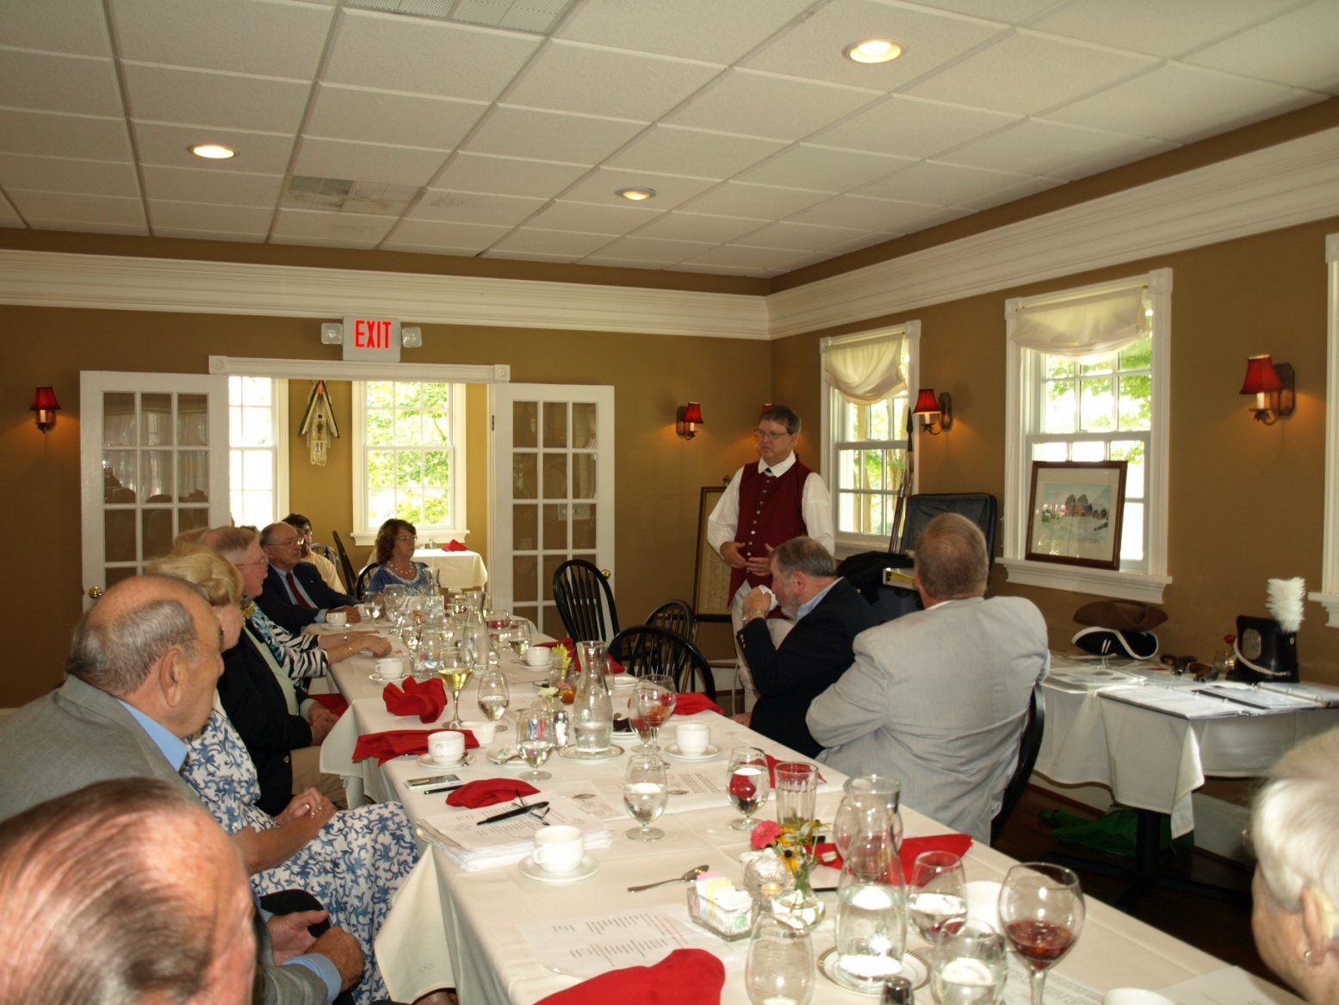
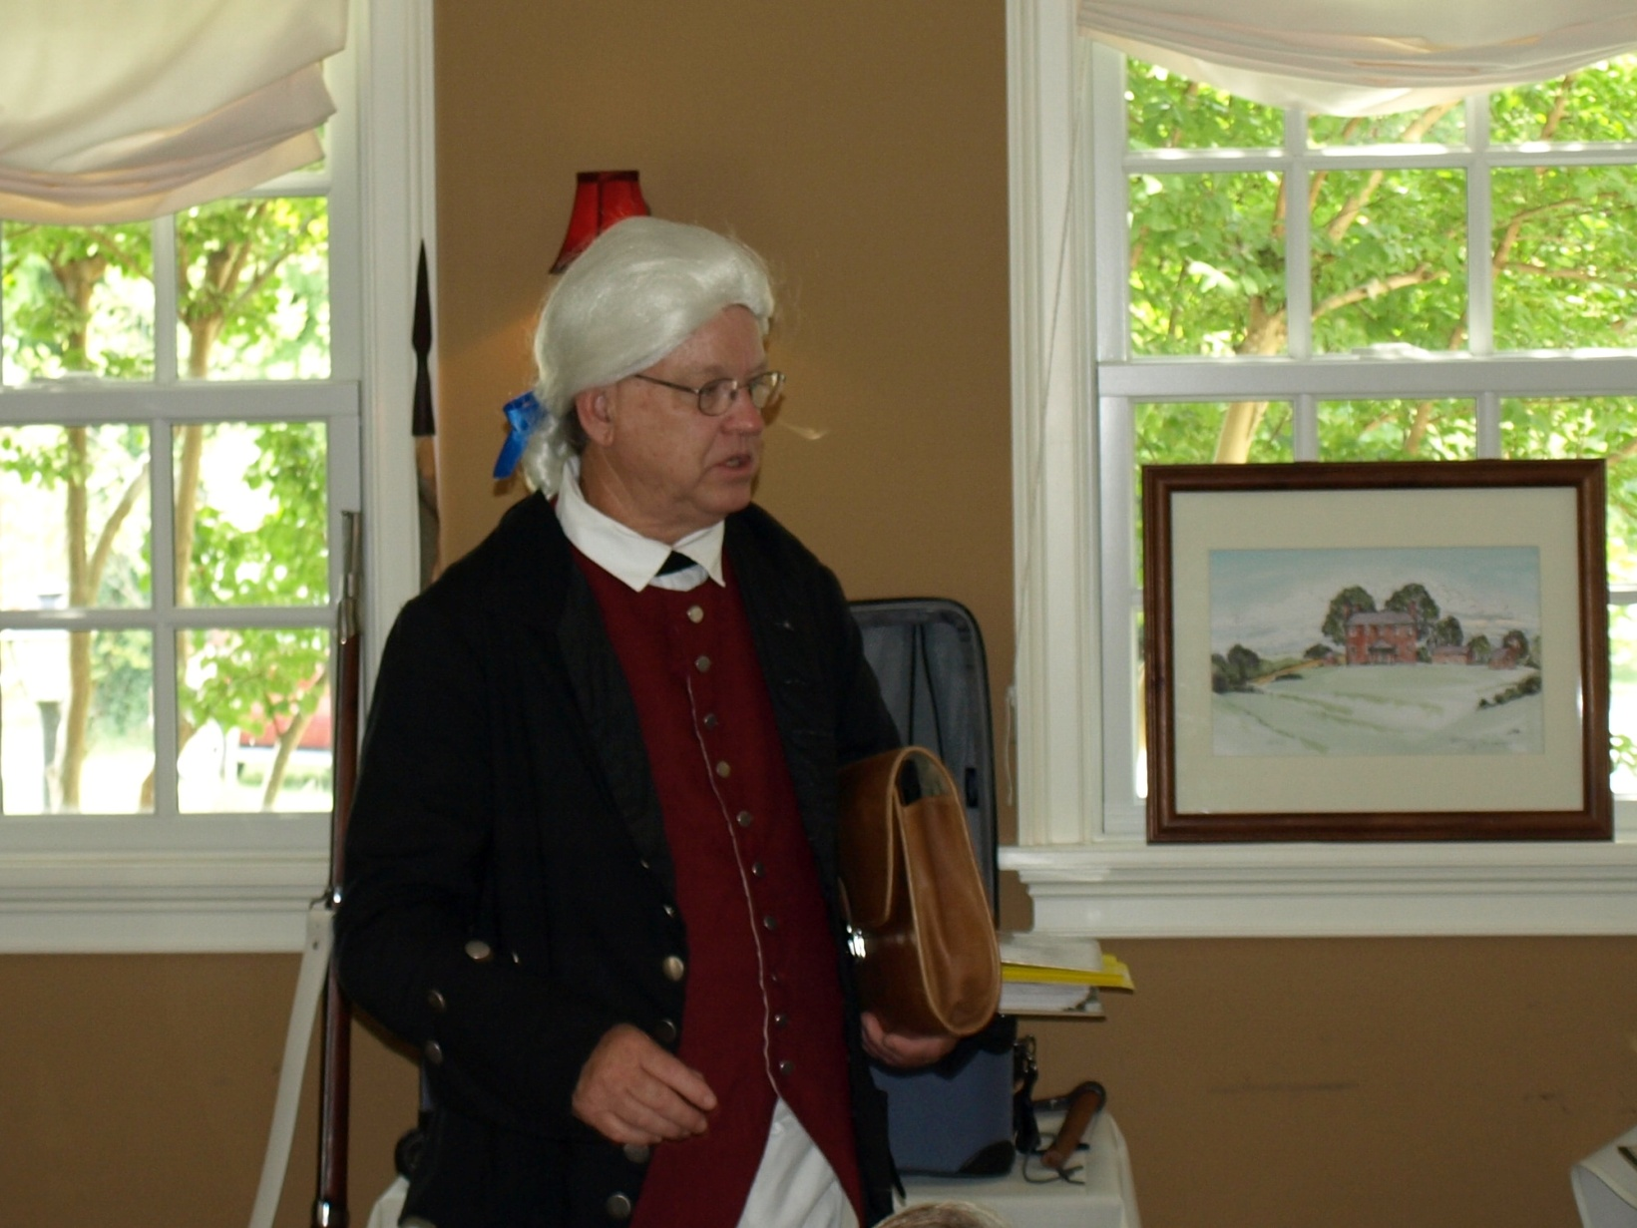
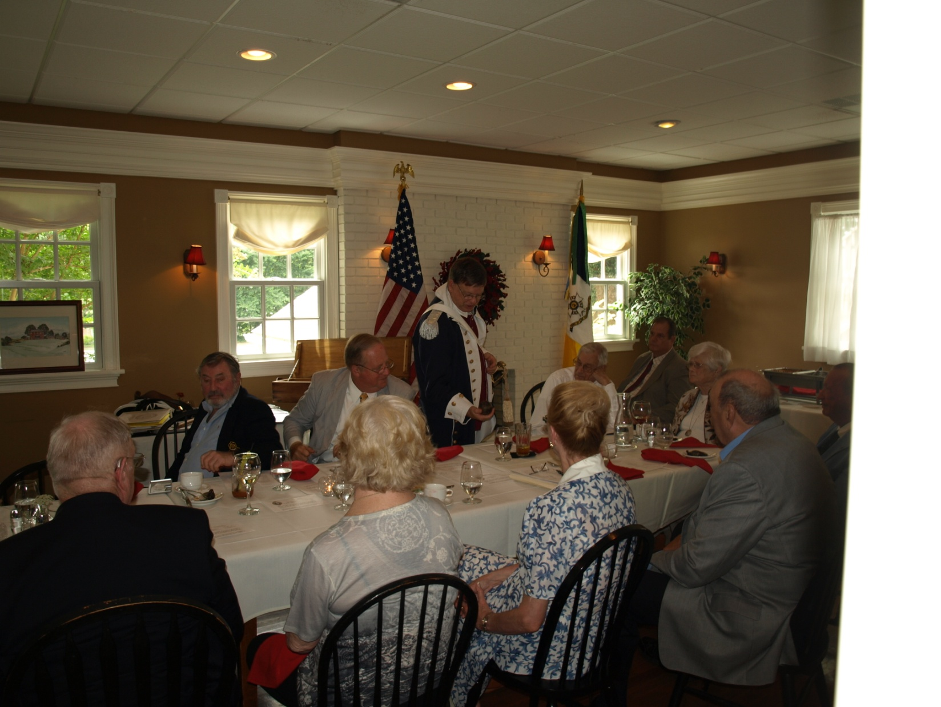
Above he is shown with a cannon ball from the War of 1812 found in the yard of his ancestors home that was burned by the British in December 1814
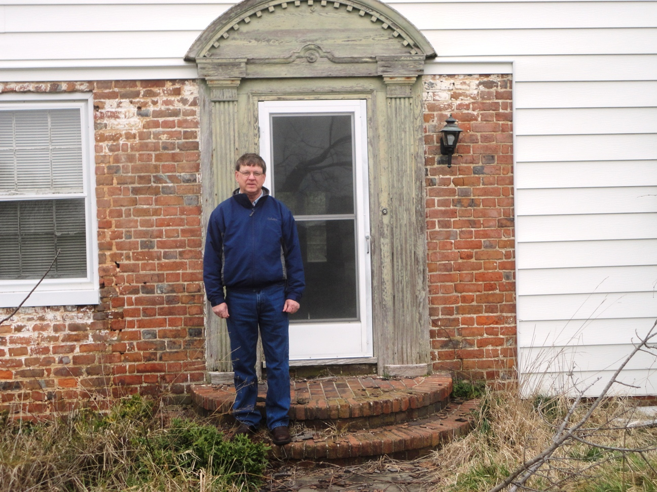
The above photo shows him in front of the entrance portion of the original Bellemont home of his War of 1812 ancestor. Only that portion remained with the bricks after the British burned the house in the first few days of December 1814

