War of 1812 Society in Virginia Conducts a Grave Marking Ceremony Sep 20, 2014As a part of the Fairfax City’s Commemoration of the Bicentennial of the War of 1812 the Society conducts a grave marking ceremony for Captain Rezin Willcoxon at the Historic Blenheim House in Fairfax. A program and photos follow.

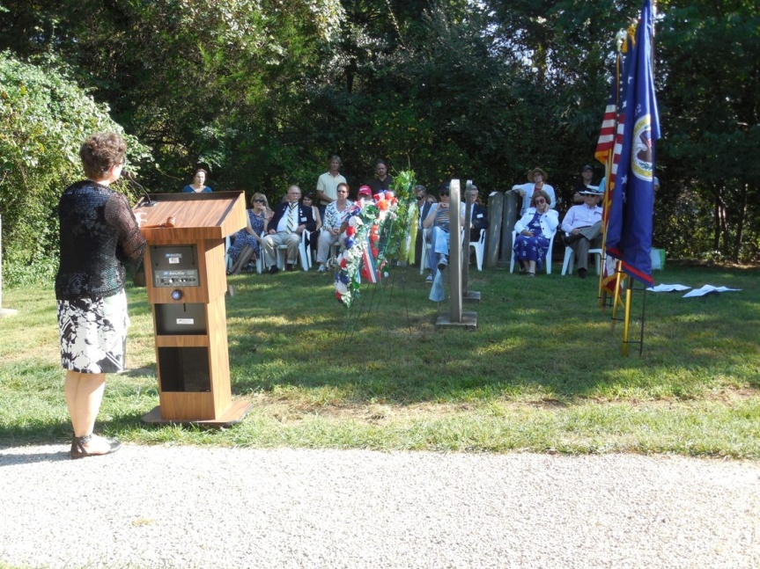
Above Andrea J Loewenwarter talks about Captain Willcoxon. Her remarks follow the photos taken:
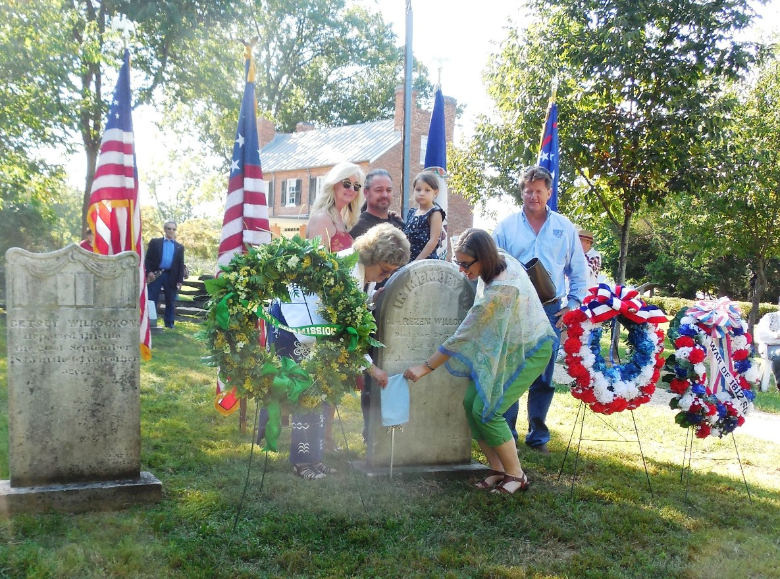
Descendants of the veteran unveil the War of 1812 grave marker. Note the veteran’s house in the background. Below the front and back of the house are shown
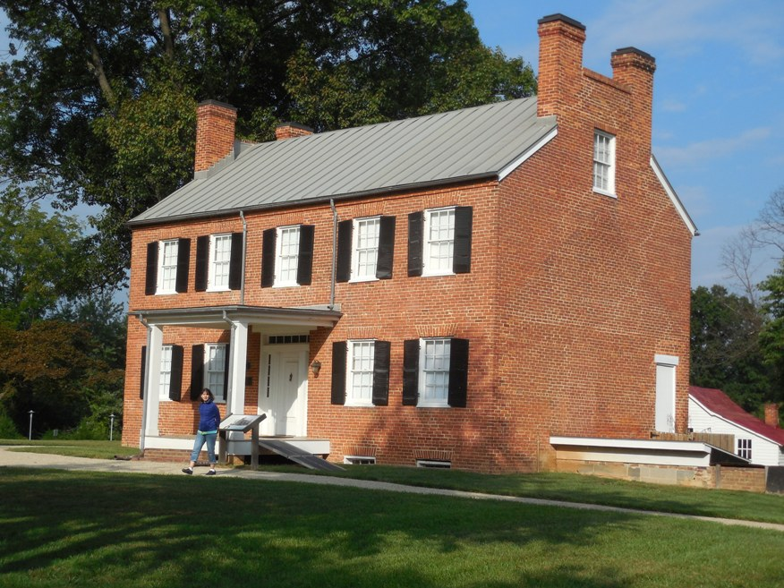
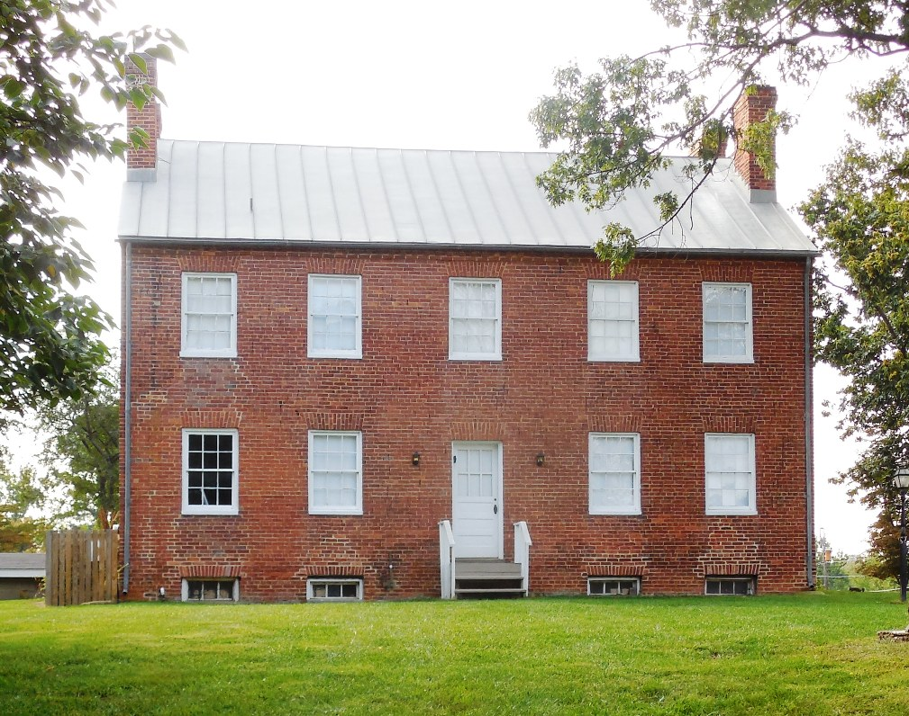
Below the unveiled War of 1812 Society grave marker is shown by his gravestone
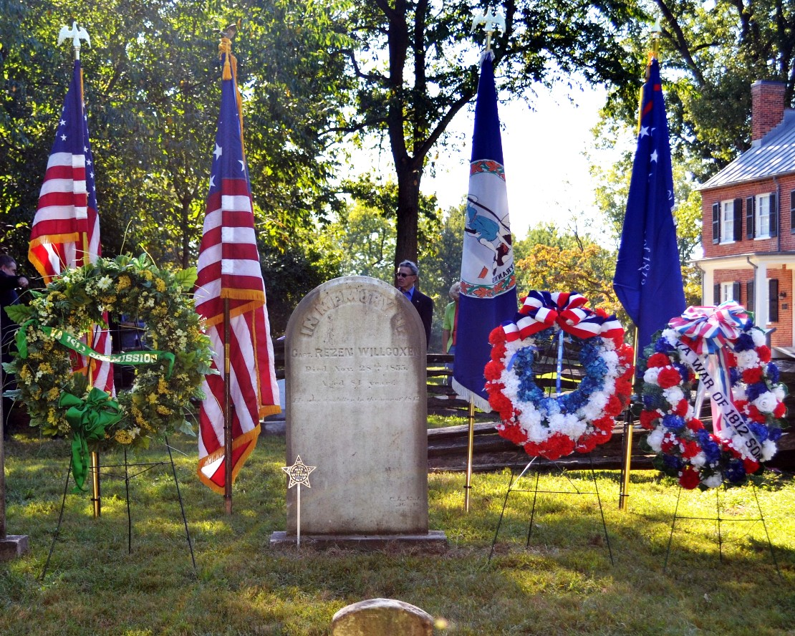
Above are the posted flags and some of the wreaths that were presented. Below Mike Lyman, John Epperly and Cranston Williams present the colors for the musket salute and the playing of taps
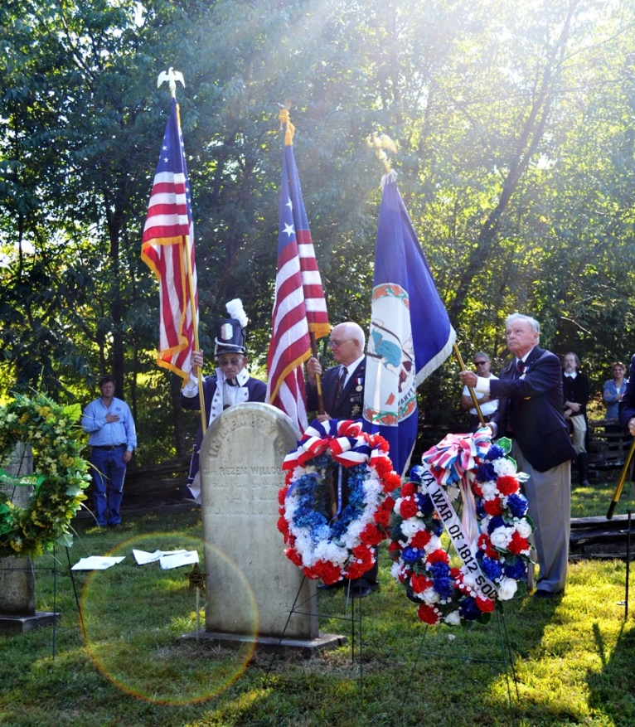
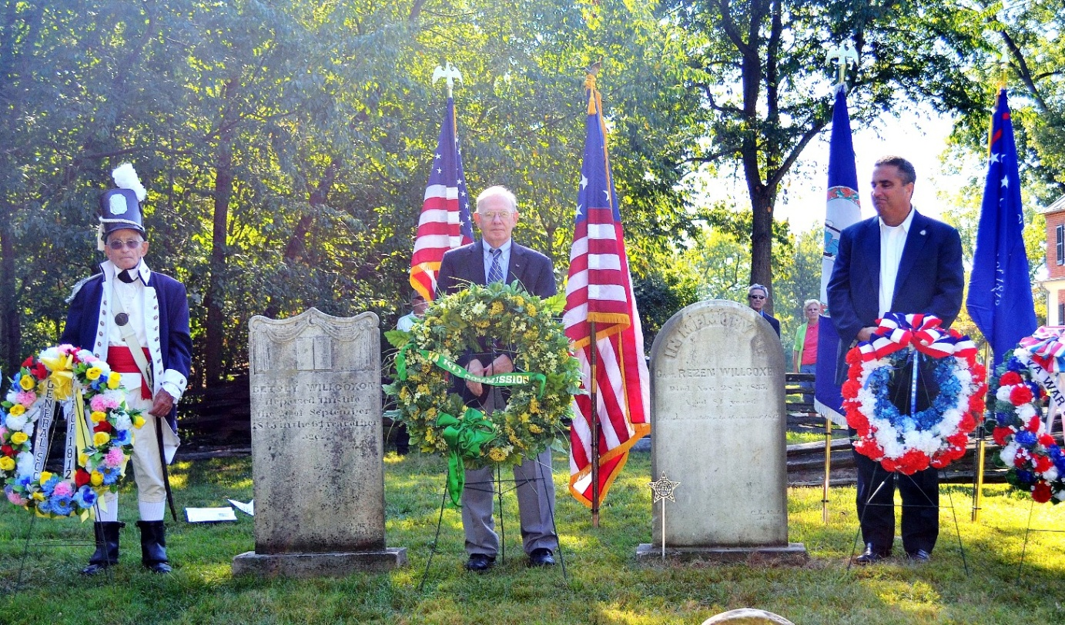
Above left to right is Mike Lyman in War of 1812 attire that presented the General Society War of 1812 wreath, Councilor and War of 1812 historian, Stuart L Butler that presented the Virginia Bicentennial Commission’s wreath and The Honorable R. Scott Silverthorne, Mayor of the City of Fairfax behind the wreath he presented. Not pictured is President C. Dennis Fritts who presented the War of 1812 Society in Virginia wreath

