War of 1812 Society in VA attend James Madison Ceremony at Montpelier Mar 16, 2015
The 264th Anniversary of the birth of President James Madison, who was Commander-in-Chief of our country during the War of 1812, was celebrated in the Madison Graveyard at Montpelier, his home in Orange County on March 16, 2015
It was attended by at least eight members of the society and the wreath was presented by President, Dennis Fritts. The program and photos taken follow.
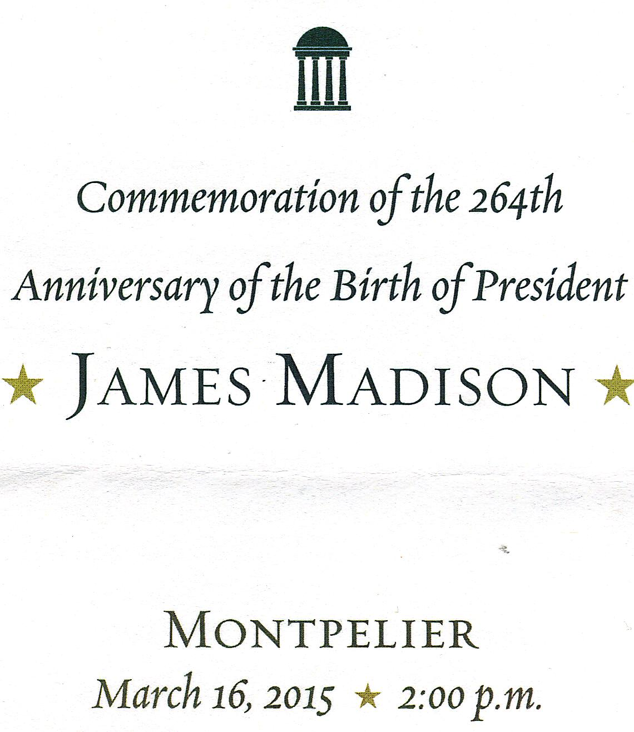
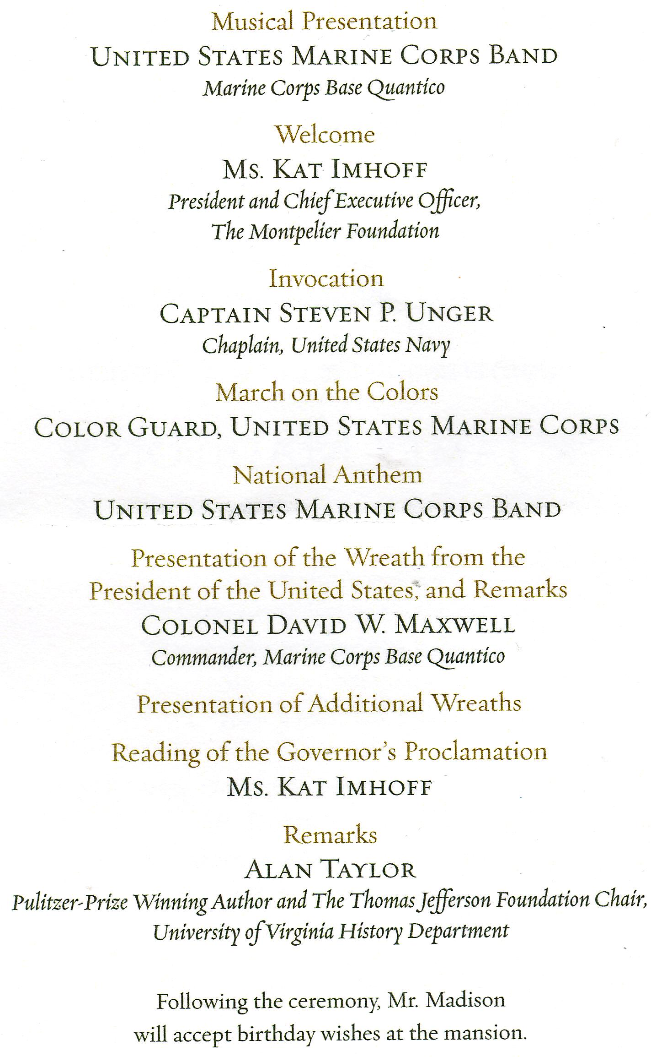
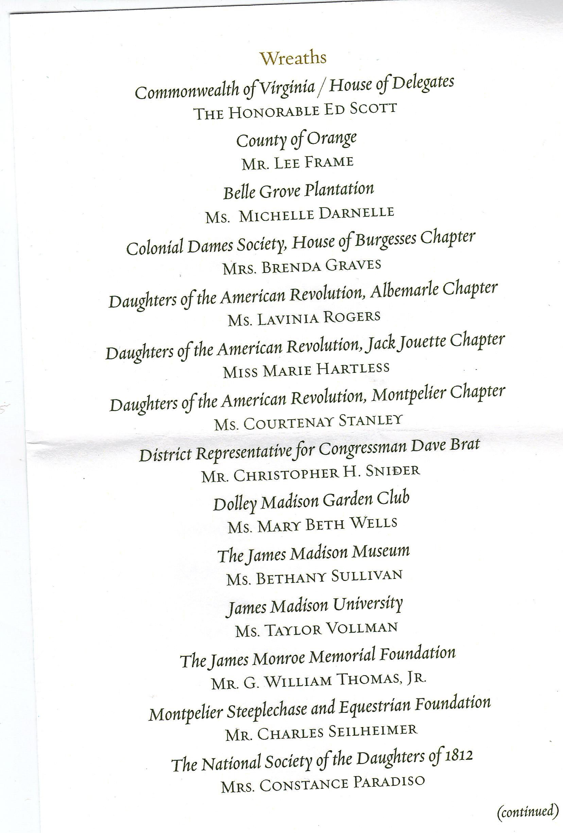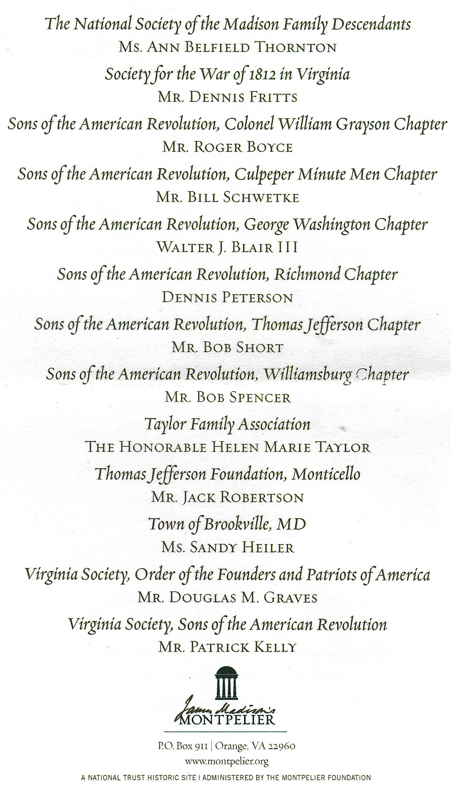
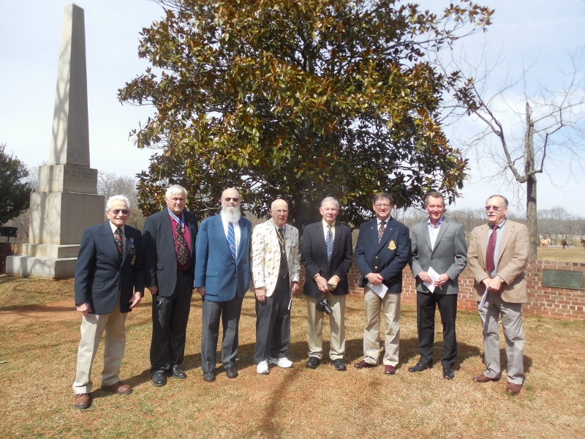
After the ceremony with the Madison Obelisk in the background are from left:
Mike Lyman, Past President, Dennis Fritts, President, Chuck Poland, Registrar, Bob Spencer, Member; Stuart Butler, Councilor; Charles Belfield, Color Guard Chairman, Un-identified member and Hugh Markham, Member
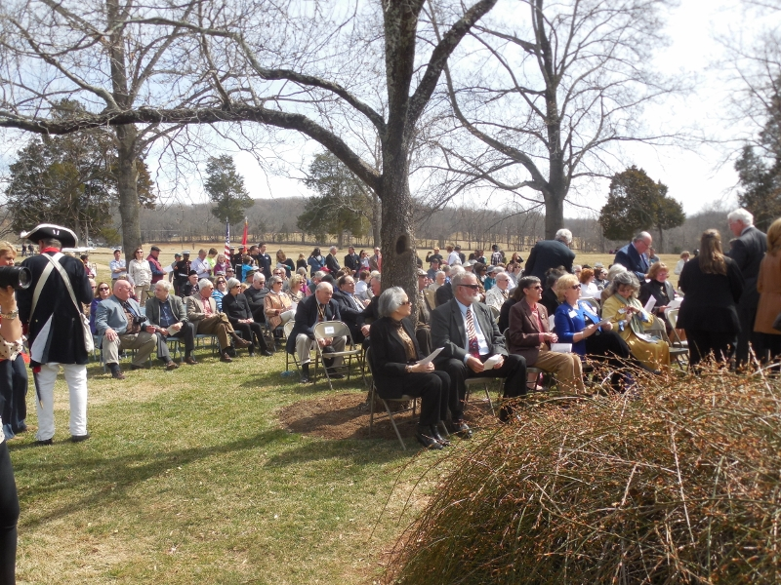
The photo shows some of the attendees outside of the cemetery
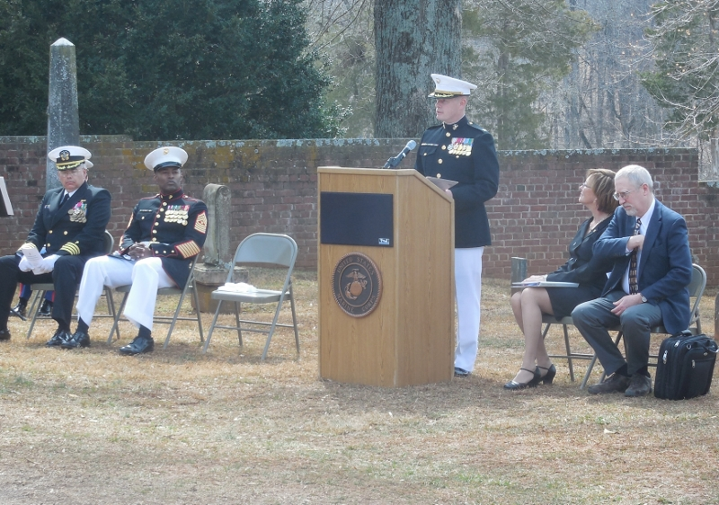
Above is Colonel David W Maxwell, Chief of Staff, Marine Corps Base Quantico, who gave remarks and who presented the wreath for President Obama as shown in the photos below
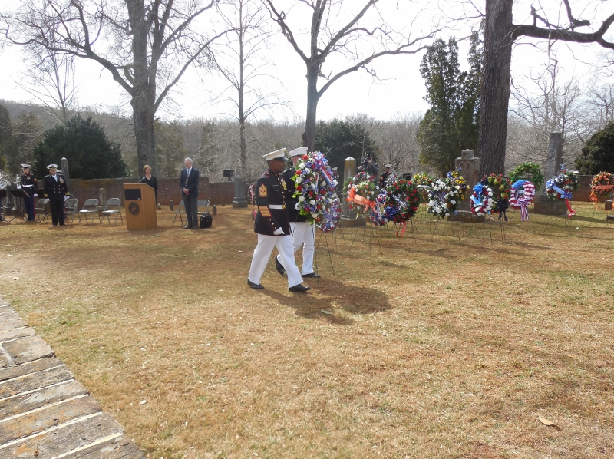
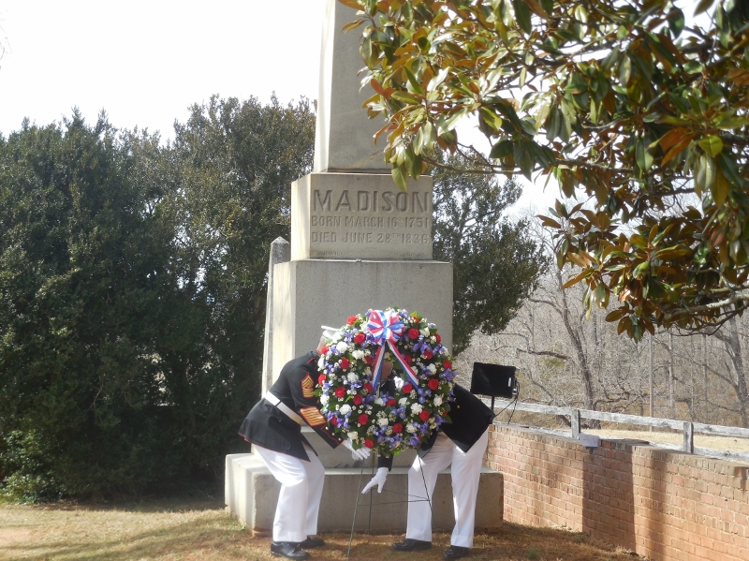
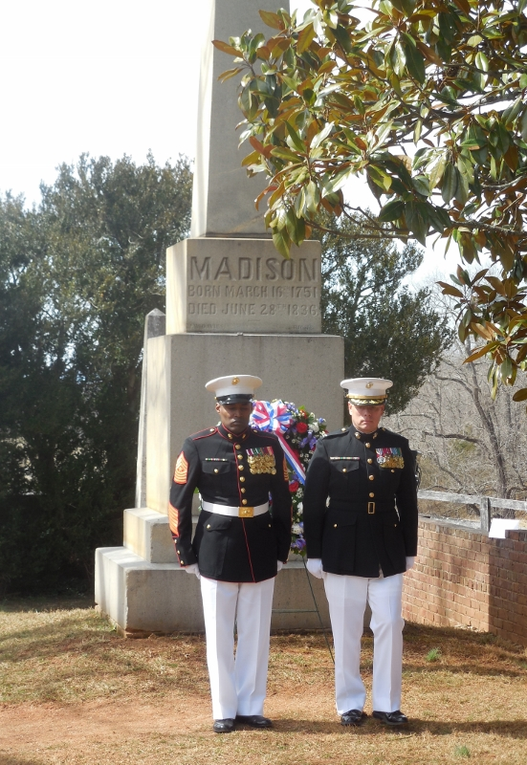
President Fritts is announced and comes forward to stand behind the society wreath
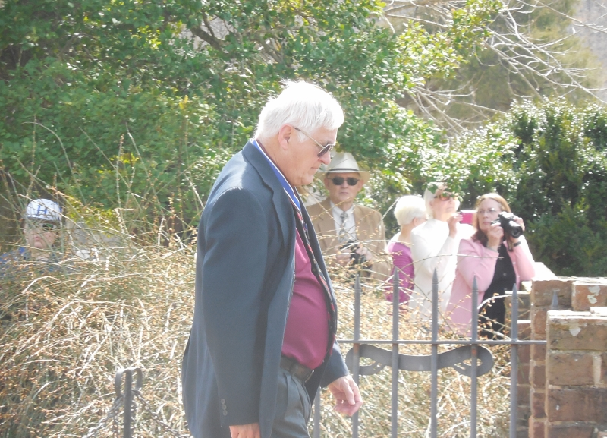
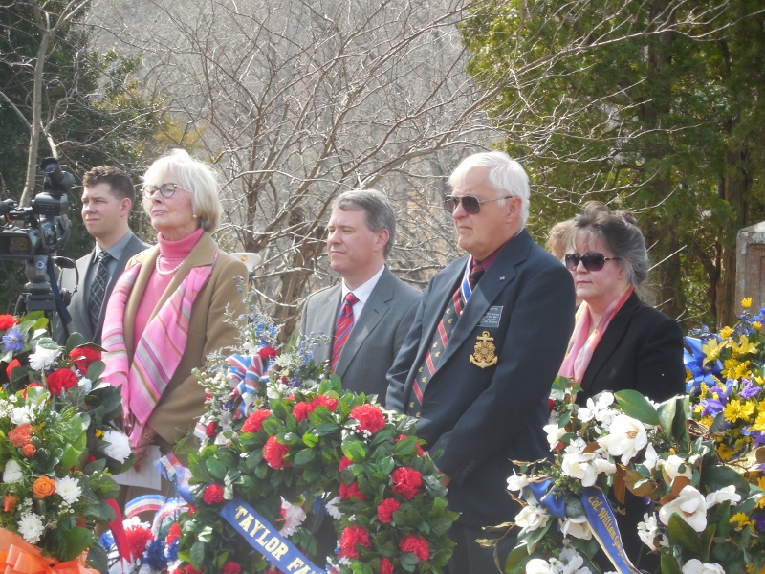
Although not on the program, the Virginia Bicentennial Commission for the War of 1812 wreath was presented. After the ceremony, Advisory Council members to the Bicentennial Commission, Stuart Butler and Mike Lyman stand by the wreath
