A Virginia Historical Road Sign is erected and dedicated to a British War of 1812 Fort
A news story on Governor McAuliffe's dedication of two historical markers on Tangier Island--one for the British FORT ALBION erected during the War of 1812 was conducted on June 4, 2015
By TEE CLARKSON Special correspondent To the Richmond Times Dispatch
TANGIER — Outside, the wind whipped the Bay into a frenzy as a driving rain fell sideways on the tiny island of Tangier, located in the middle of the Chesapeake Bay.
The weather, however, did little to dampen the celebration inside the only school on the island, which hosts students from kindergarten through 12th grade.
While the weather may not have been out of ordinary for the residents of Tangier, one couldn’t say the same for the crowd in attendance, which included Gov. Terry McAuliffe and family, Secretary of Natural Resources Molly Ward, Director of the Virginia Department of Historic Resources Julie Langan and Director of the National Park Service John Jarvis.
The group was there to celebrate the dedication of two historical markers on the island and the donation of a neighboring island known as The Uppards to the town of Tangier.
“This is a celebration of what makes Tangier so special and distinctive,” said Langan.
Tangier is listed as a historic district on the Virginia Landmarks Register and is included on the National Register of Historic Places.
“The history here is unlike anywhere else in Virginia,” Langan said. “We wanted to call attention to the significance of the island and also create a permanent record.”
The settlement of Tangier and its history is long and storied, dating back to 1608. It includes the likes of Captain John Smith, a time when the island served as a military base for the British during the War of 1812, and a history of providing safe haven for slaves fleeing to freedom in the North.
One of the two historic markers dedicated Thursday calls attention to the time when British forces commanded by Adm. Sir George Cockburn established Fort Albion on Tangier Island during the War of 1812. The British launched raids from Tangier up and down the Chesapeake Bay, including Washington and Baltimore.

- 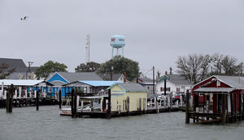
- 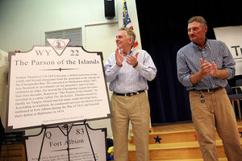
- 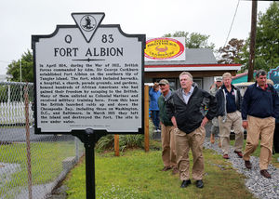

The inscription reads:

“In April 1814, during the War of 1812. British forces commanded by Adm Sir George Cockburn established Fort Albion on the southern tip of Tangier Island. The fort, which included barracks, a hospital, a church, parade grounds, and gardens, housed hundreds of African Americans who had gained their freedom by escaping to the British. Many of them enlisted as Colonial Marines and received military training here. From this island the British launched raids up and down the Chesapeake Bay, including those on Washington, D.C., and Baltimore. In March 1815 they left the island and destroyed the fort. The site is now under water.”

Gov. Terry McAuliffe and other dignitaries helped celebrate the dedication of two historical markers on the island and the donation of a neigh…

The second marker provides the history of Joshua Thomas, who raised his family on Tangier. Born at the beginning of the Revolutionary War, Thomas, a waterman early in his life, was later ordained an elder in the Methodist Church. He became known as the “Parson of the Islands,” ferrying clergymen from the mainland to the islands of the Chesapeake Bay in his canoe known as “The Methodist.”
“The key here is to recognize the many layers of history in one place,” said Jarvis. “Tangier is not only important to Virginia, but important nationally, and internationally.”
“I always wanted to come to Tangier,” said McAuliffe, who made his first visit to the island Thursday. “I have heard about some of the issues here.”
Those issues include sea level rise and erosion that has washed grave sites on the Uppards, the 175-acre island to the north, into the Bay. The site where Fort Albion was once located is now under water.
“Sea level is rising,” said McAuliffe, who initiated a Climate Commission early in his tenure to study such issues.
“We want to take a leadership role,” he said. “We are raising issues on climate change and sea level rise and its effect on Virginia’s resources.”
Tangier Island is one of those resources that is already feeling the effects of sea level rise. The donation of the Uppards to the town should help as they will be able to restore beaches and wetlands.
“The Uppards provides protection from the annual Nor’easters, Nor’westers, and sea ice that frequent the Chesapeake during the harsh bay winters,” McAuliffe told those in attendance.
Harry Dutson, John Daniels and Steven L. Duckett purchased the island in 1993 and visited it periodically over the years. Once home to Native American fishing villages as well as Canaan and Rubentown settlements, The Uppards contains the ruins and archeological relics from the times when people lived there and reaped the bounties of the bay. It is home to present-day colonies of endangered shorebirds as well as thousands of migrating waterfowl each winter.
Duckett died in 2003, and Dutson and Daniels visited less and less, ultimately deciding to donate the island back to Tangier with the help of Jamie Craig and Beechtree Group out of Falls Church.
“We are excited to donate it,” Dutson said. “If it can help the people of Tangier then that is just gravy on the whole thing.”
The donation of the Uppards was made in Duckett’s name and is now included on the list of “Virginia’s Treasures.”
“Our goal is to protect a thousand treasures during the governor’s term,” Ward said. These might be historic places, boat ramps, archaeological sites or other important protected structures and lands of varying sizes.”
“It’s huge,” Tangier Mayor James “Ooker” Eskridge said of the donation. “It’s part of Tangier. People on the island grew up there.”
Eskridge, a commercial waterman, grew up in a house that was moved to Tangier from The Uppards in the 1930s.
“There is so much history here,” Eskridge said. “It’s wonderful that we are being recognized for it.”
“These are hardy individuals,” McAuliffe said. “They get up at two or three in the morning, work until three or four. Go home, get a little rest, then go back out and work until eight.”
The weather finally subsided a bit as those in attendance spilled out into the streets of Tangier following the dedication ceremonies and lunch of freshly caught crab .

