Society Holds Board Meeting in Roanoke September 18 2015
The Society of the War of 1812 in the Commonwealth of Virginia held a Board of Direction meeting at the Hilton Garden Inn in Roanoke on 18 September 2015. Twelve members attended. The agenda and photos follow.
Board of Directors
18 September 2015
1 PM – Hilton Garden Inn
4500 South Peak Boulevard
Roanoke, Va. 24018
1. Call to Order
2. Invocation
3. Pledge of Allegiance
4. Reading of Minutes Jun. 2015
5. Officer Reports
6. Committee Reports
7. Old Business
New member recruitment
Meetings (rotate annual meeting or specific location every year/ date)/ Muster/BOD
Publicity (General Society/Virginia)
Dues/Late dues
Investments
8. New Business
Donations/Kroger Card/Amazon
Amendment to Bylaws
Historical/Genealogy Societies http://www.lva.virginia.gov/public/historical.asp
Regional Grave Markings
Nominating Committee
9. Adjournment
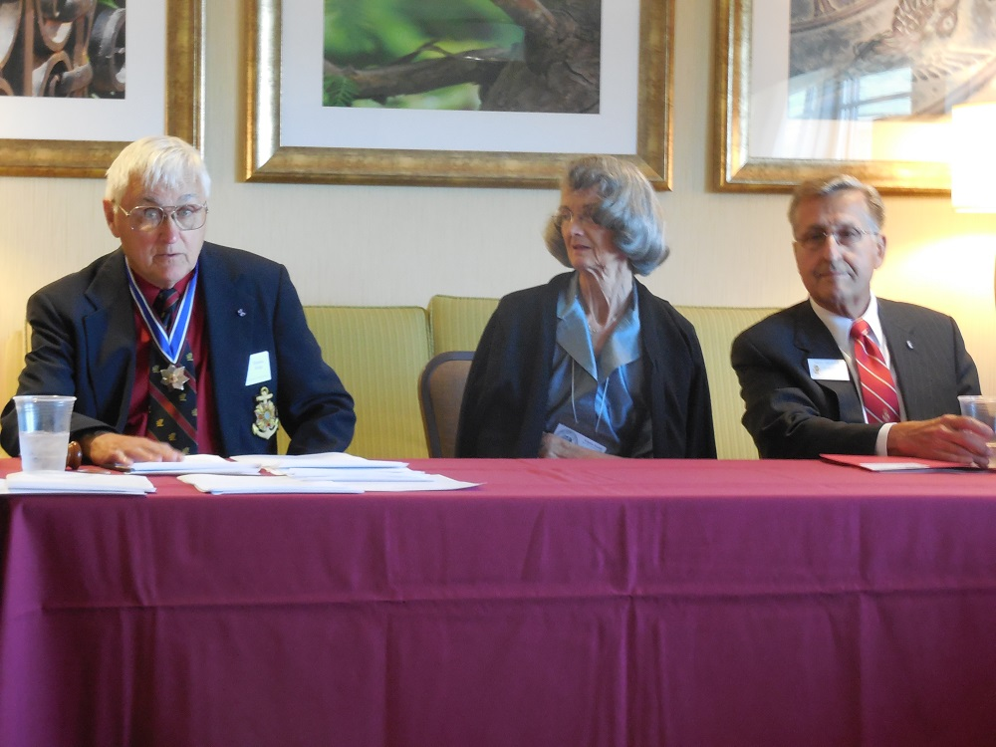
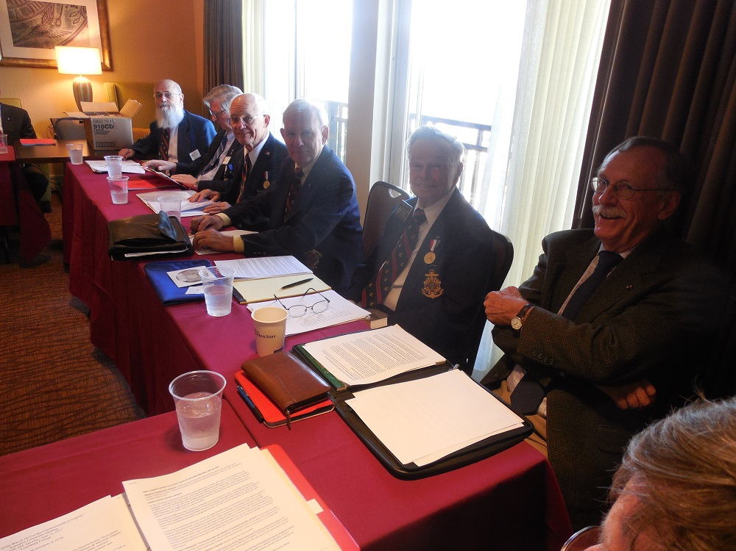
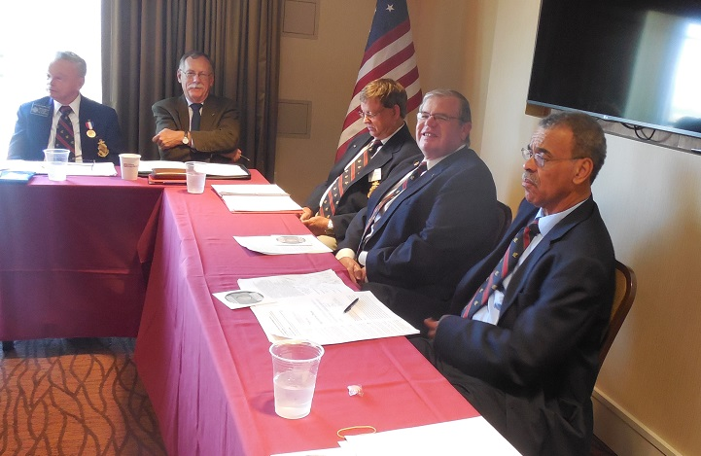
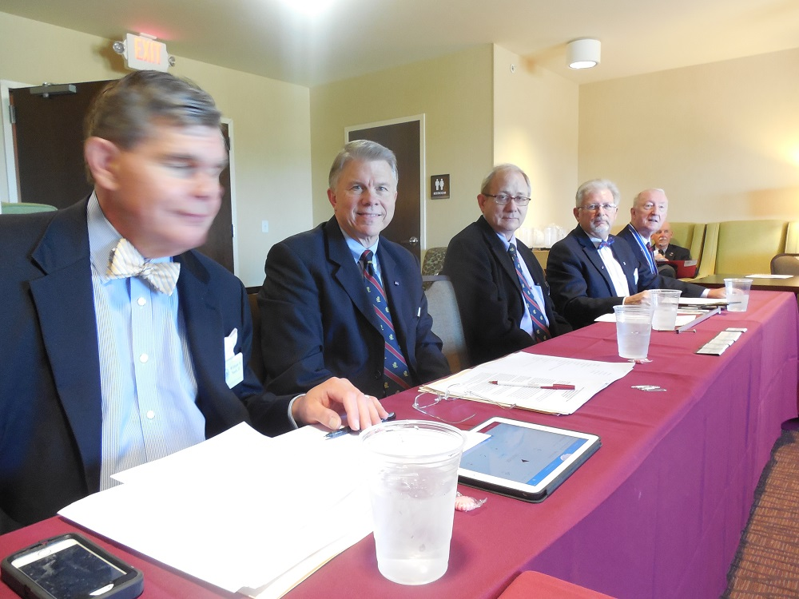
Following the meeting members and their wives enjoyed a dinner at a local restaurant
