Two members of the Color Guard of the War of 1812 Society in the Commonwealth of Virginia participated in the ceremony at the University of Mary Washington campus in Fredericksburg on March 4th 2017. They were Charles Belfield and George Beckham. They are shown in some of the photos below

This from their website: The James Monroe Inauguration Bicentennial Celebration was a resounding success! Thank you to all who participated, and to all who attended! If you were unable to join us an unedited version of the event is available to view here. Please note, the program begins at about 14 minutes into the recording. A photo album of the event is available on Facebook.

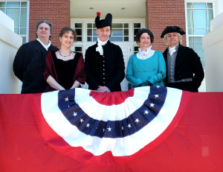

The James Monroe Museum and Memorial Library, located in historic downtown Fredericksburg, Virginia, is the largest repository in the country for artifacts and documents related to the fifth president of the United States. The museum was first opened in 1927 by Monroe descendants as a place to house their own personal collections, which had been handed down through generations of the family. Eventually, the museum and its extensive collections were turned over to the Commonwealth of Virginia, and the museum is now administered by the University of Mary Washington.
The museum belongs to the American Association of Museums, the American Association for State and Local History, and the Virginia Association of Museums. It is also on the National Register of Historic Places.

It is located on the lot where Monroe practiced law in Fredericksburg, VA, we are dedicated to the study and interpretation of the life and times of the 5th President and his family.
