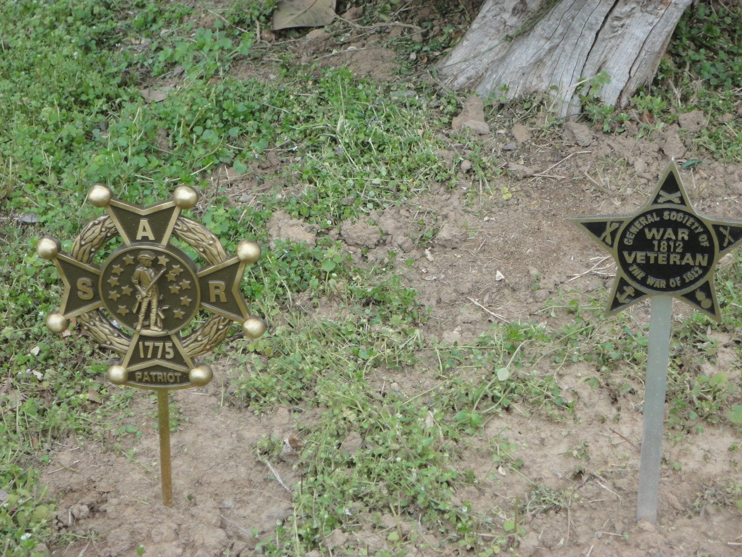
SAR & WAR OF 1812 SOCIETY GRAVE MARKERS ARE INSTALLED FOR CAPTAIN CHARLES CARTER & MIDSHIPMAN HILL CARTER
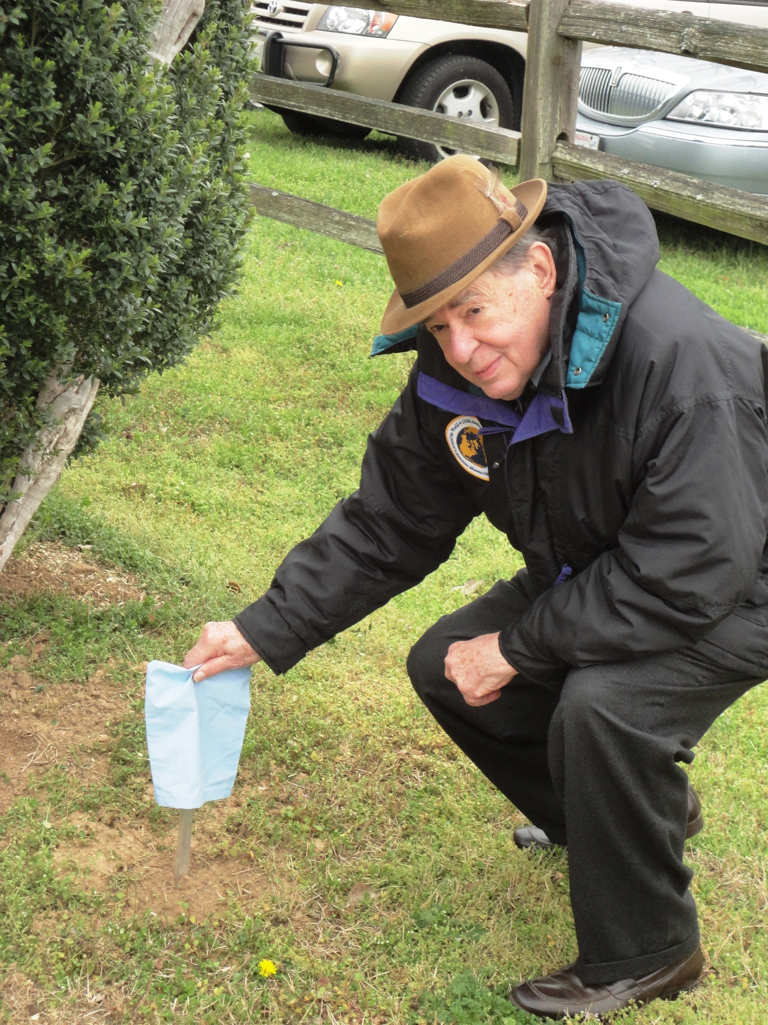
PRESIDENT MAXWELL OF THE VA 1812 SOCIETY PREPARES TO UNVEIL THE 1812 GRAVEMARKER FOR MIDSHIPMAN HILL CARTER

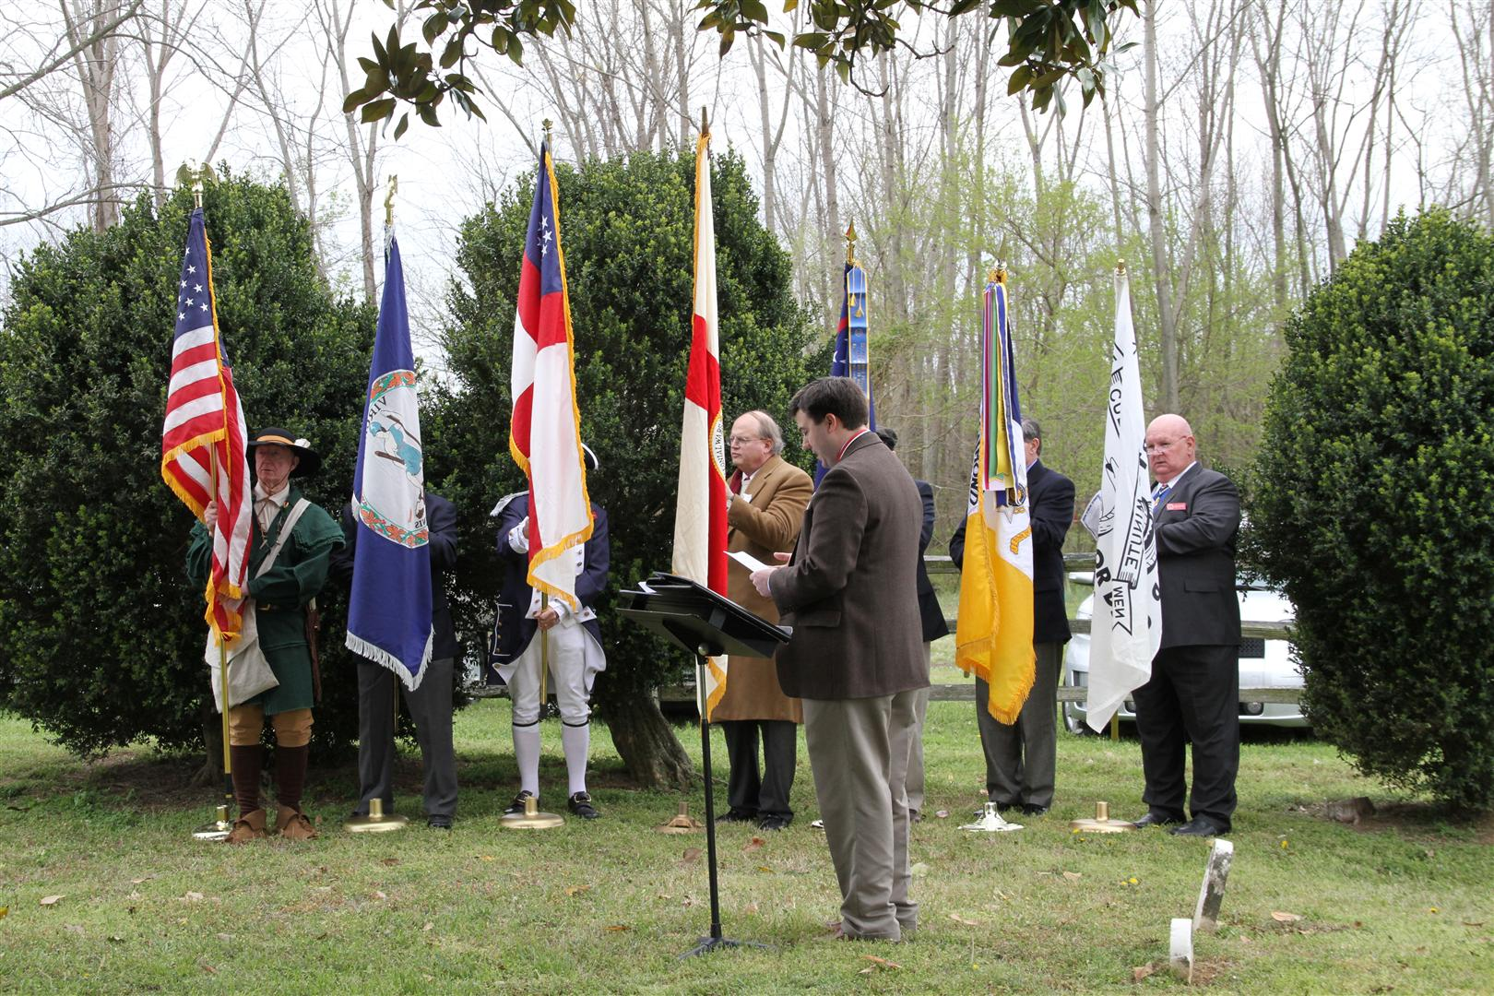

THE COLORS ARE BROUGHT FORWARD L/R they are: US, VA, VA Order of Founders & Patriots of America, Society of Colonial Wars in VA, Society of War of 1812 in VA, Richmond Chapter, VA Society Sons of the American Revolution, and The Culpeper Minute Men Battalion "Don't Tread on Me" flag.

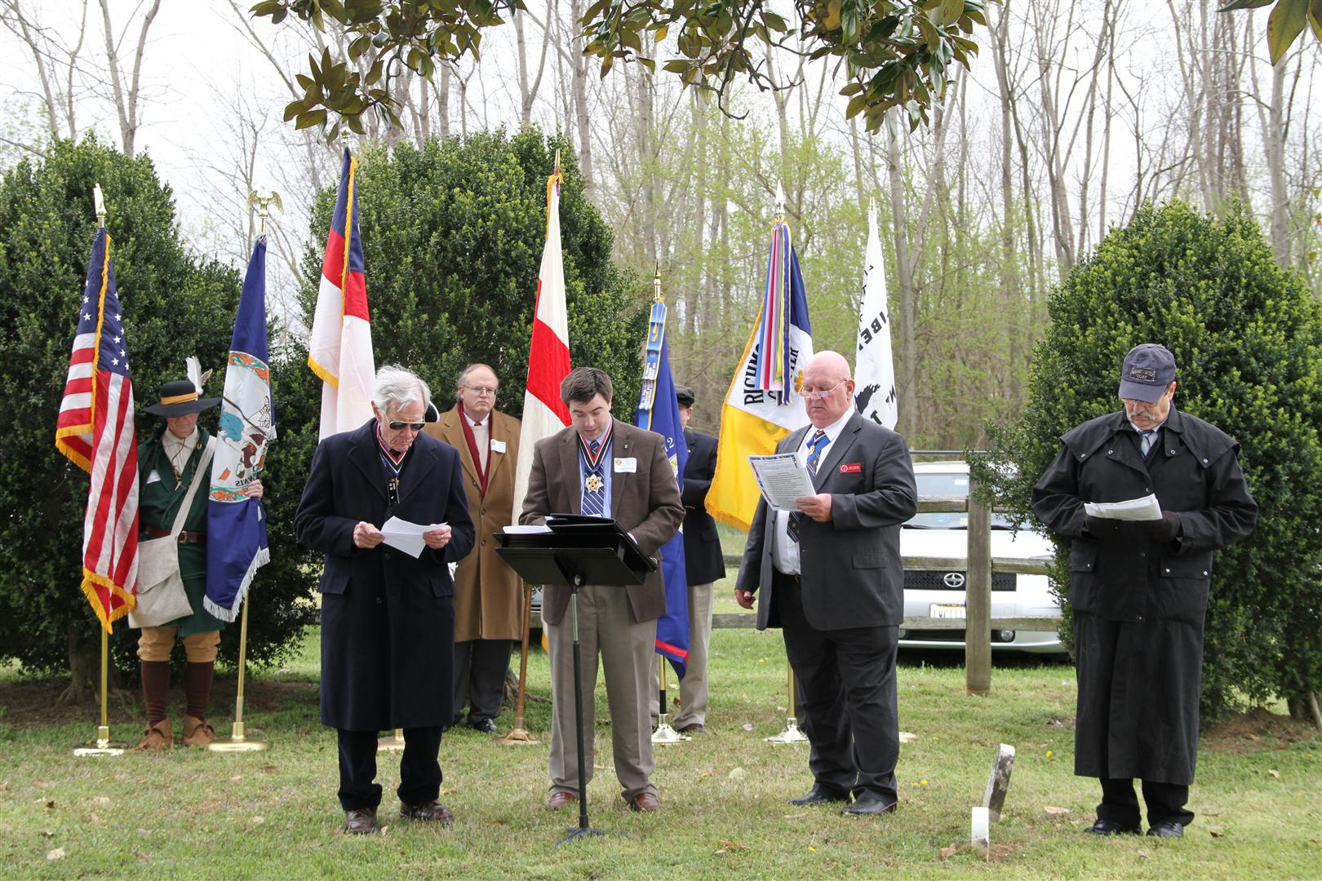

The unveiling ritual is recited.

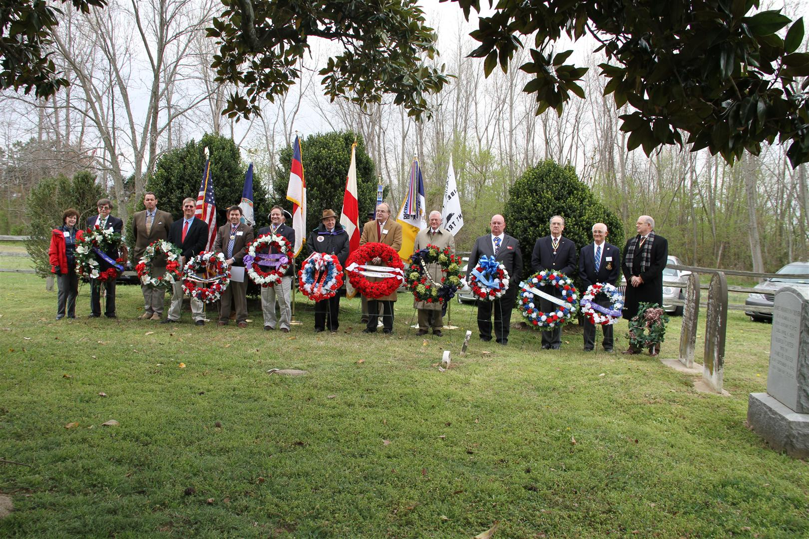
Wreaths are presented by eleven societies to honor the VA founder, the Revolutionary War veteran and the War of 1812 veteran

Left to right the wreaths presented above are: 1) The Carter Family Association, 2) The Carter Brothers, Charles & Randolph, owners of Shirley Plantation, 3) The VA Order of Founders & Patriots of America, 4) The VA Society Sons of the American Revolution (SAR), 5) The VA Society War of 1812, 6) The VA Society of Colonial Wars, 7) The James Monroe Memorial Foundation, 8) The Culpeper Minute Men Chapter, SAR, 9) The Richmond Chapter, SAR, 10) The Colonel William Grayson Chapter, SAR, and 11) the Colonel Fielding Lewis Chapter, SAR. Below some certificates are presented.

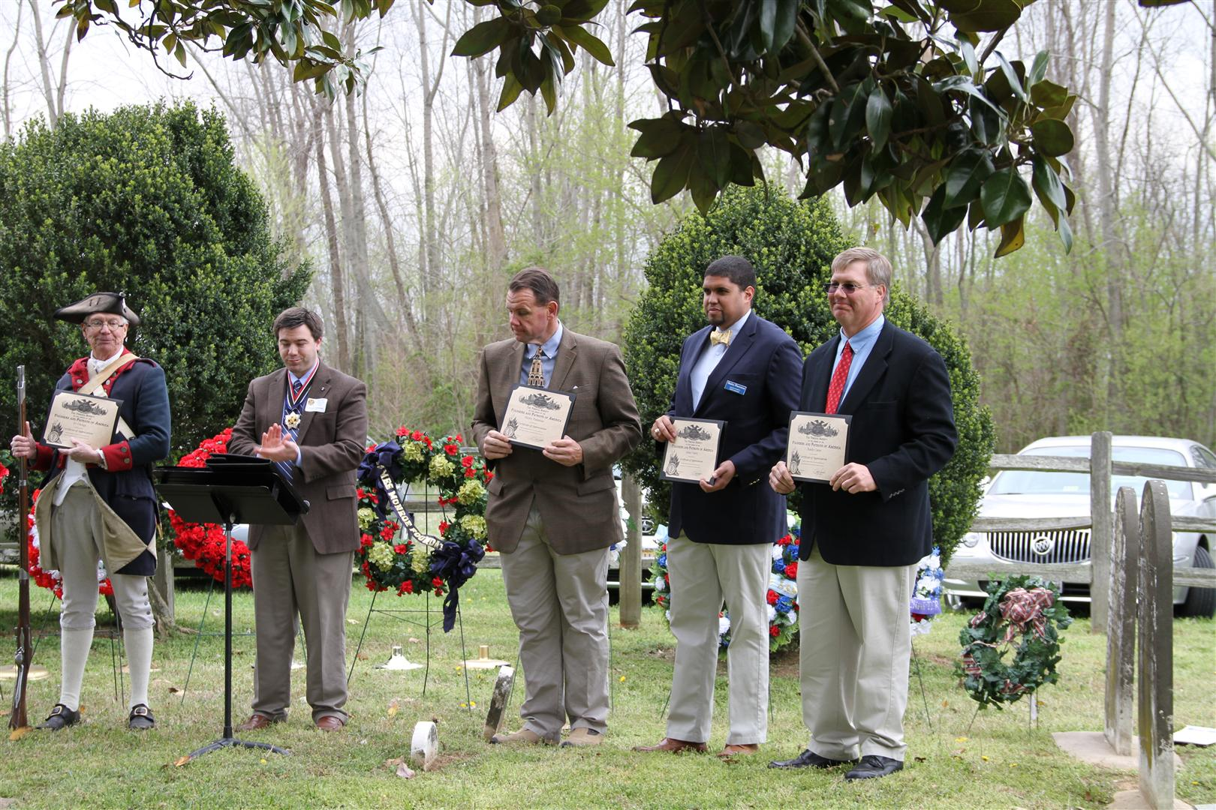
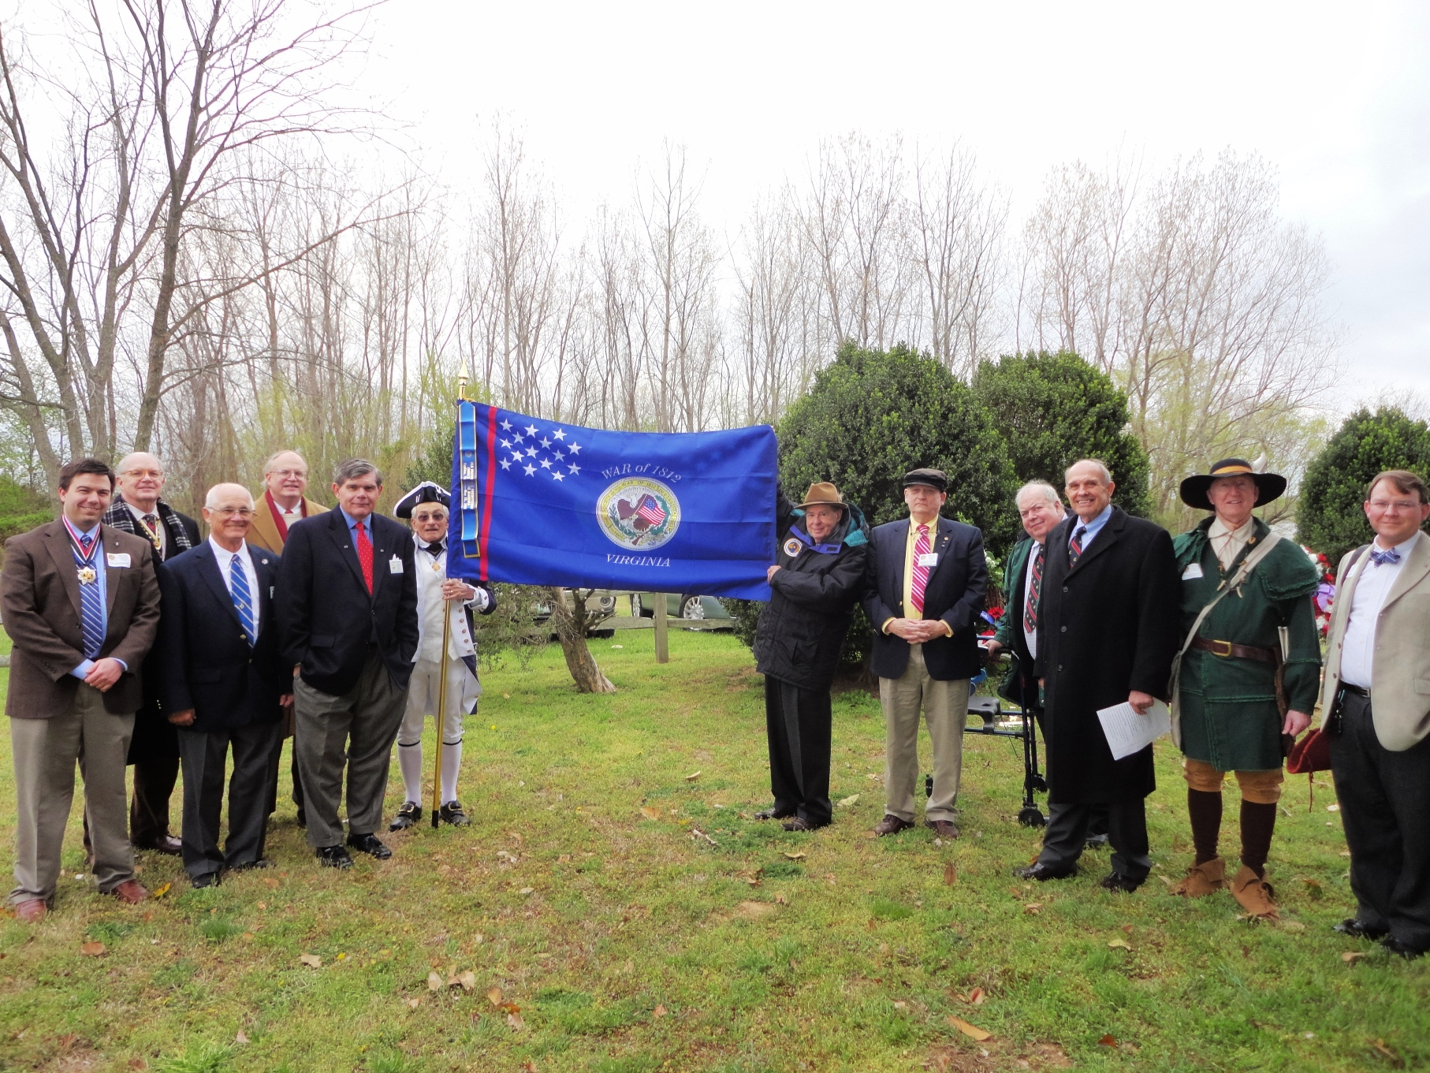

Twelve members of the Society of the War of 1812 in the Commonwealth of Virginia attended the ceremony and are shown with the new Society flag

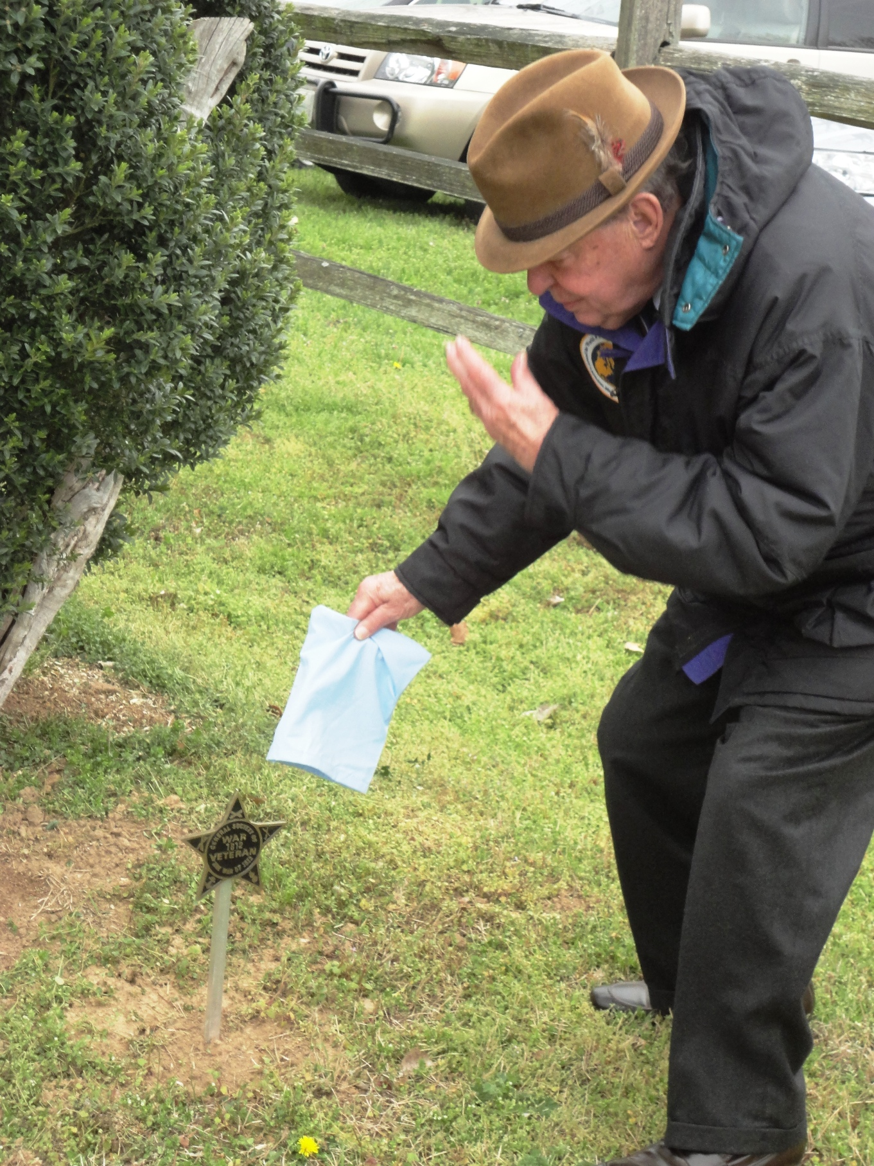
Midshipman Hill Carter's marker is unveiled. He has been appropriately honored.

