THE WAR OF 1812 SOCIETY WAS REPRESENTED IN THE JAMES MONROE BIRTHPLACE CELEBRATION APRIL 30. 2011 AND PROVIDED THE STAR SPANGLED BANNER AND SOCIETY FLAGS FOR THE SPEAKER'S STAND.

Past President of the Society, Mike Lyman presented a wreath and gave remarks at the ceremony.
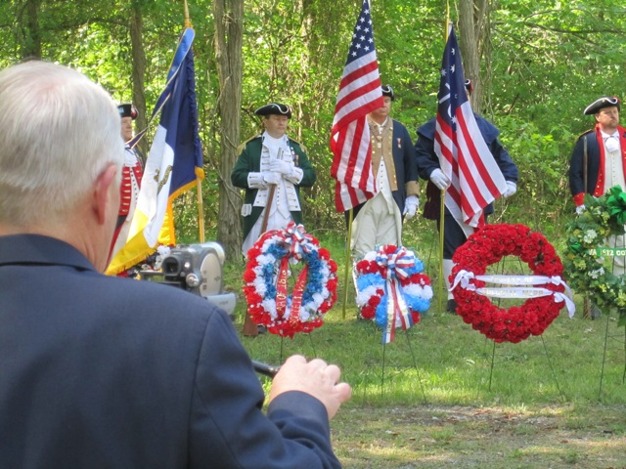

The society wreath that was presented is on the left above.

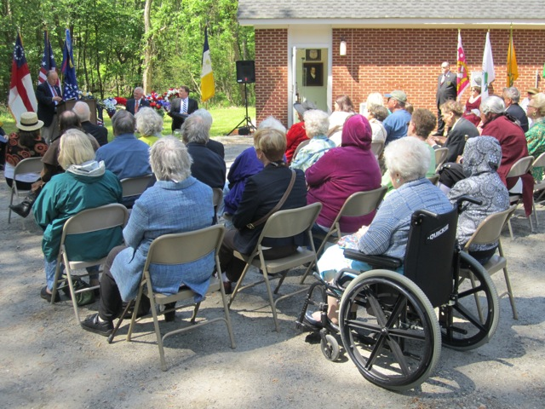
Some of the attendees at the ceremony
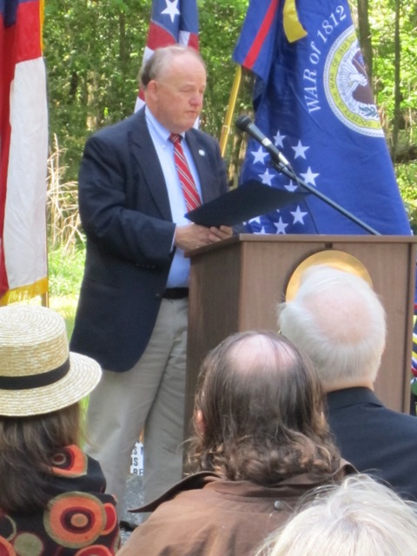

The Society flag is displayed behind the speaker stand

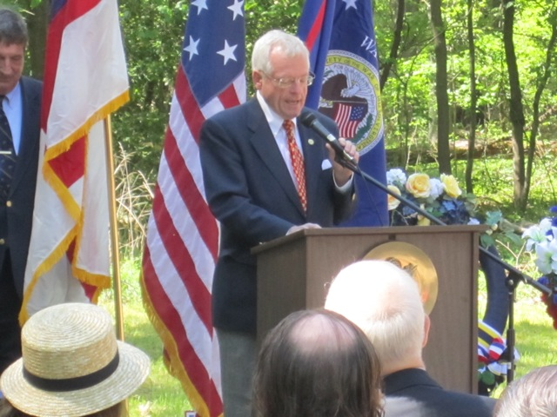
The Society's Star Spangled Banner flag is displayed behind the speaker's stand.
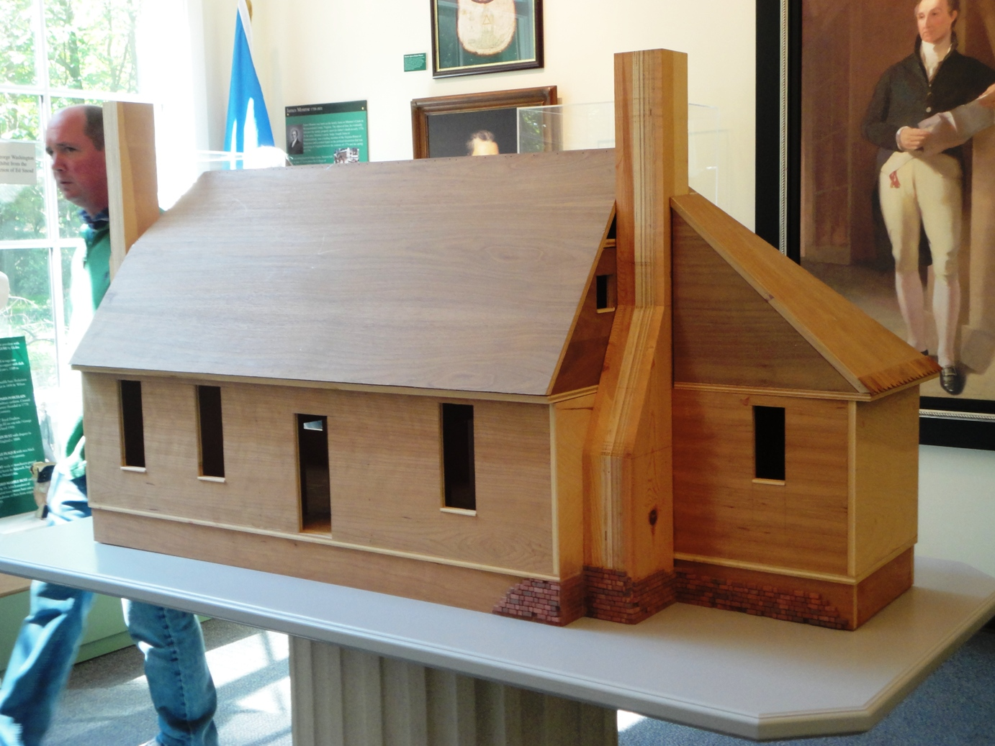
A scale model of the farmhouse where James Monroe resided until he entered college

