JOINT CEREMONY DECEMBER 3, 2011

AT ST JOHN’S CHURCH, NORFOLK, VA

BETWEEN THE VIRGINIA & NORFOLK SOCIETIES, SONS OF THE AMERICAN REVOLUTION AND THE SOCIETY OF THE WAR OF 1812 IN THE COMMONWEALTH OF VIRGINIA & THE VIRGINIA STATE SOCIETY U.S. DAUGHTERS OF 1812

RECOGNIZING & HONORING THE INTERRED AND MEMORIALIZED REVOLUTIONARY WAR PATRIOTS & THE WAR OF 1812 VETERANS IN THE CHURCH’S GRAVEYARD

BY

UNVEILING TWO 2X3 FEET SIZE BRONZE PLAQUES MOUNTED ON THE OUTSIDE WALL OF THE CHURCH DEPICTING THEIR NAMES

AT 2:30 PM
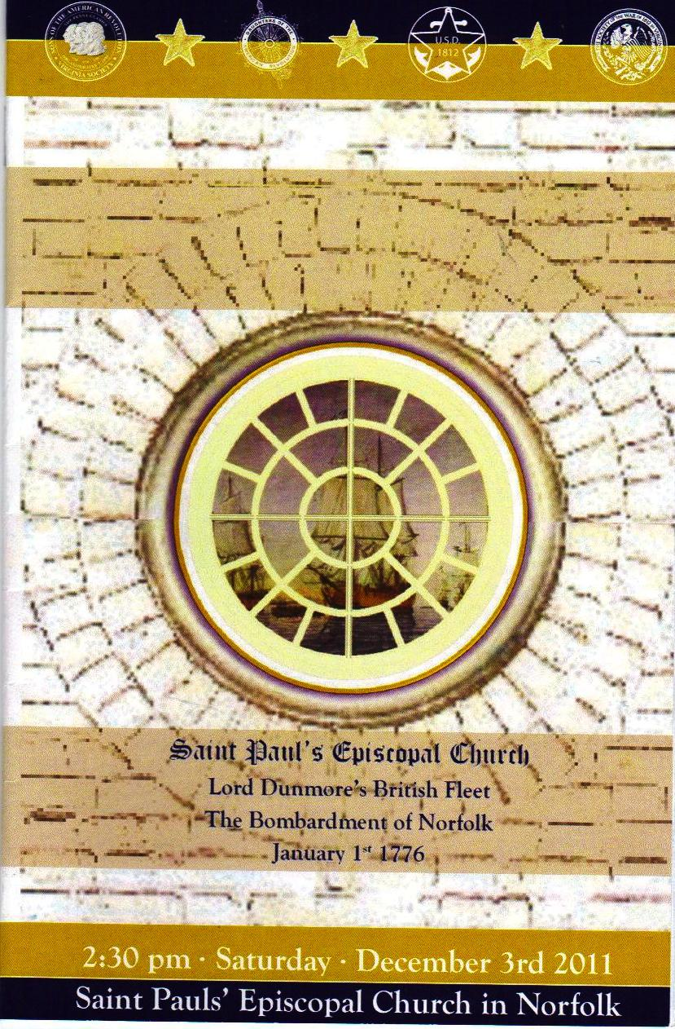
Program Cover Page
Photo inside the church by Paul Hanson
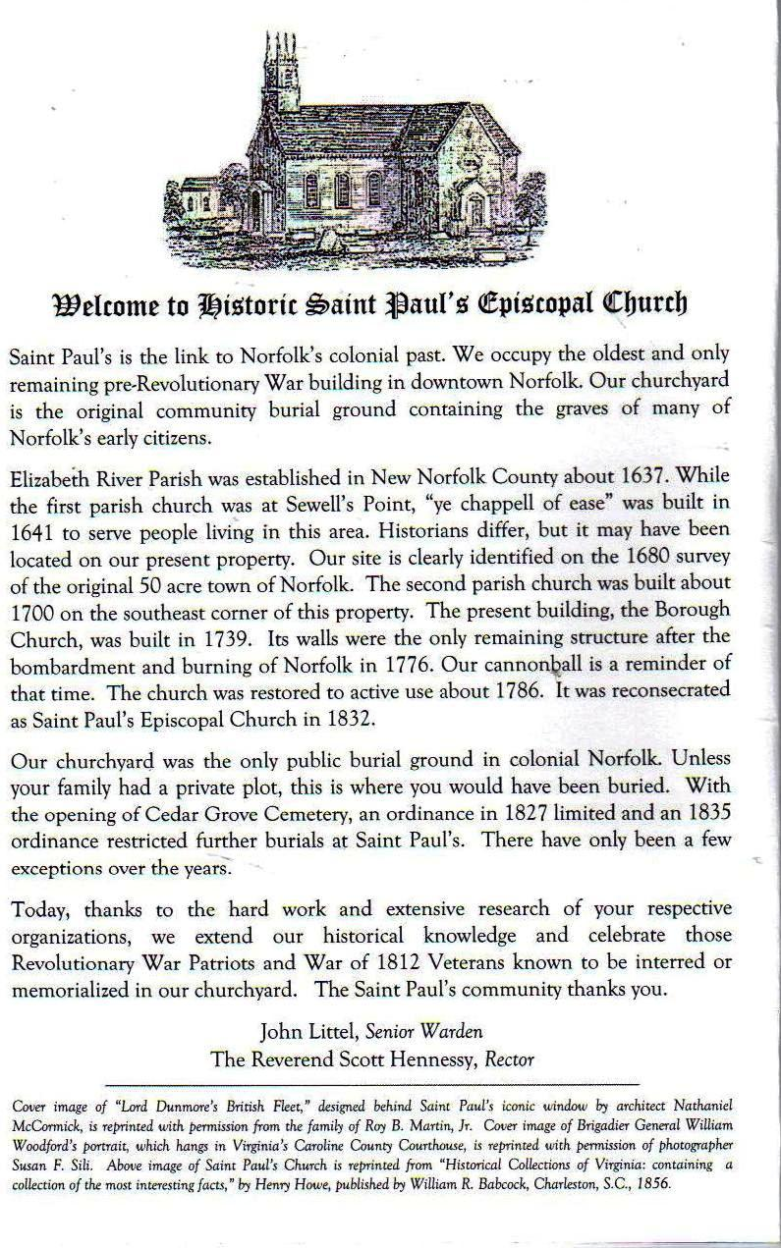
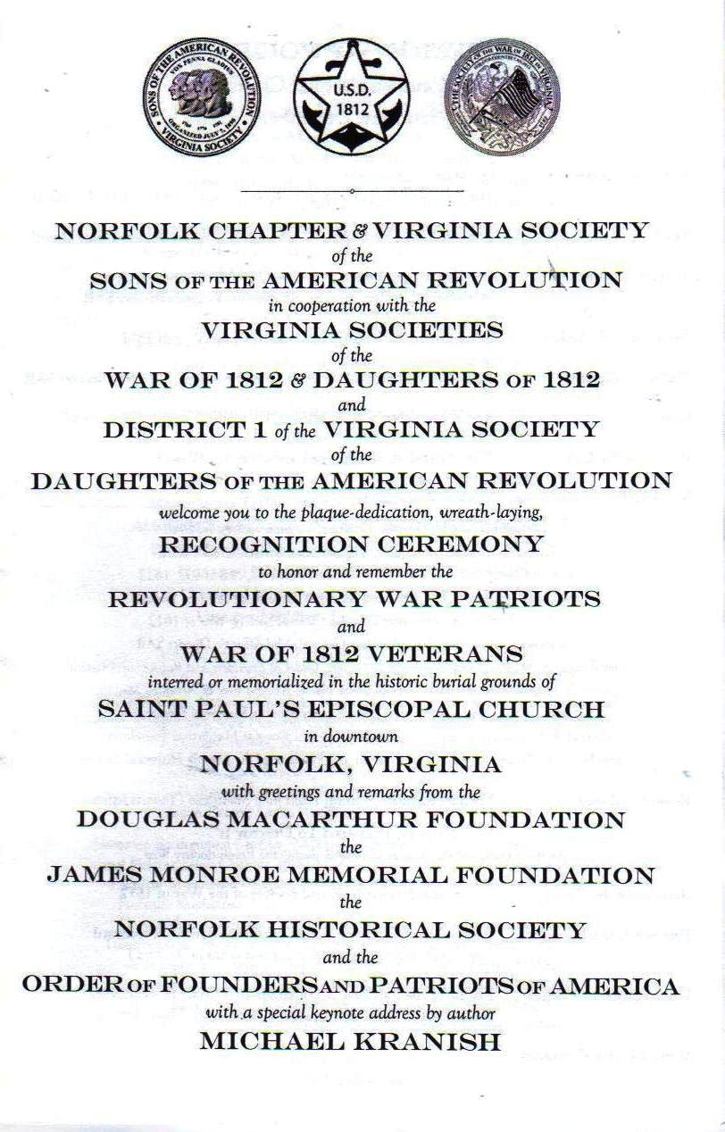
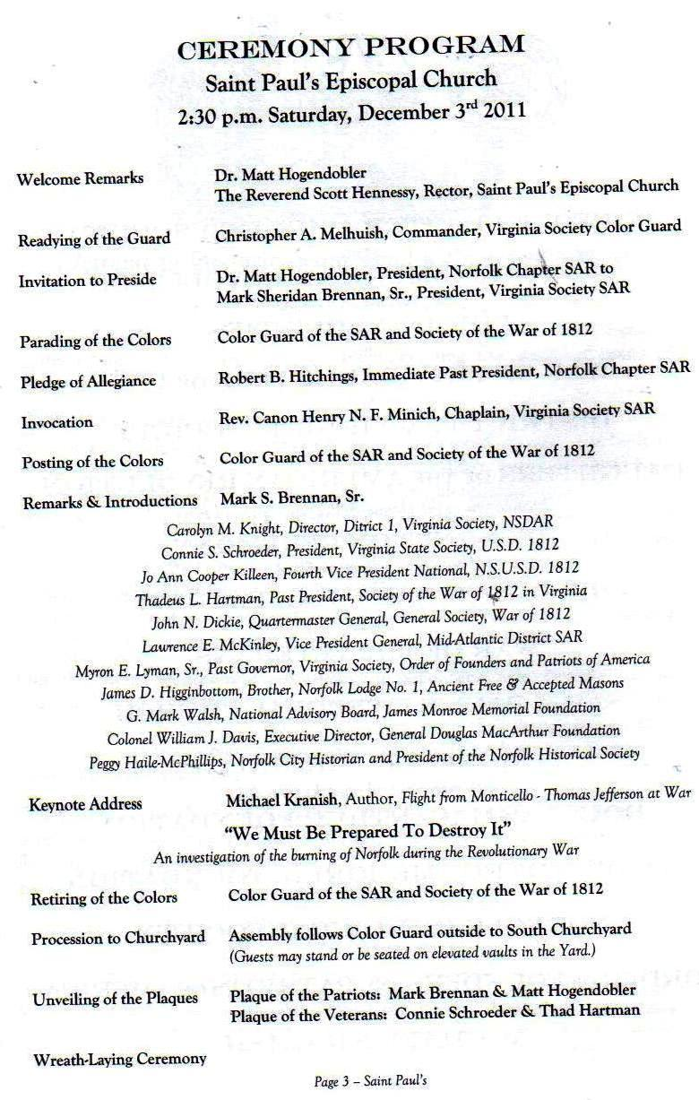
The Star Spangled Banner Flag is forwarded by John D. Dickie, 2d Vice President War of 1812 Society
(Paul Hanson photo)
The Society of the War of 1812 flag with others is forwarded by Councilor C. Dennis Fritts (photo by Paul Hanson)
