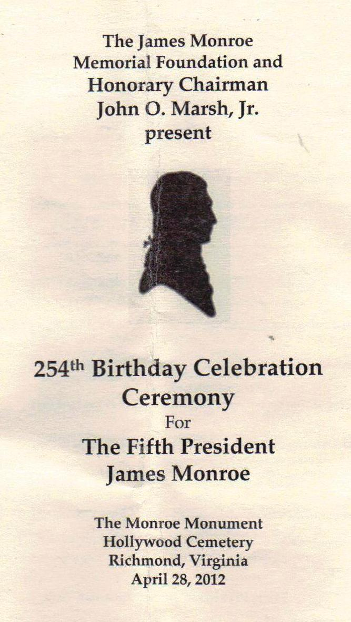

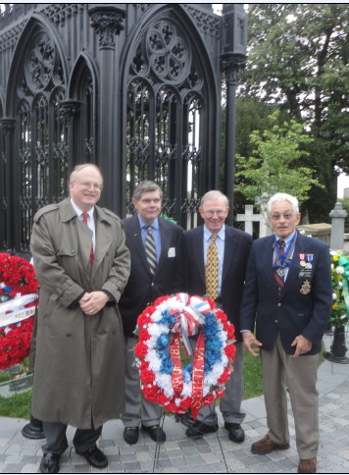

**WAR OF 1812 MEMBERS AT THE JAMES MONROE BIRTHDAY CEREMONY AT HOLLYWOOD CEMETERY, RICHMOND APRIL 28, 2012: From left: Peter E. Broadbent, Jr., Esq., William A. Nash II; Stuart L. Butler & Myron (Mike) E. Lyman, Sr. who presented the society’s wreath.**

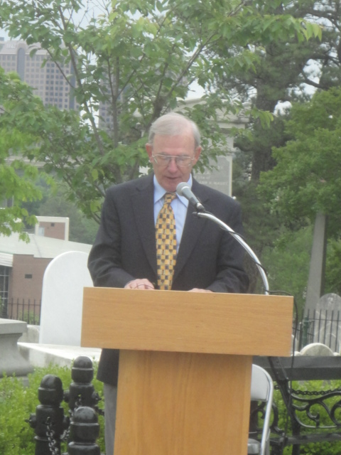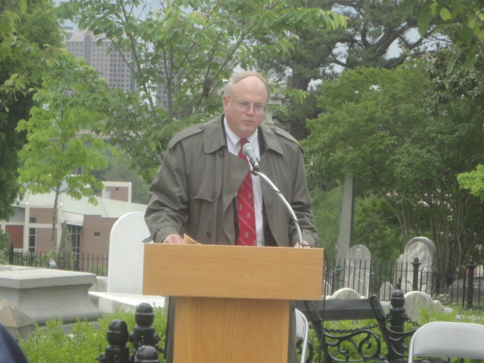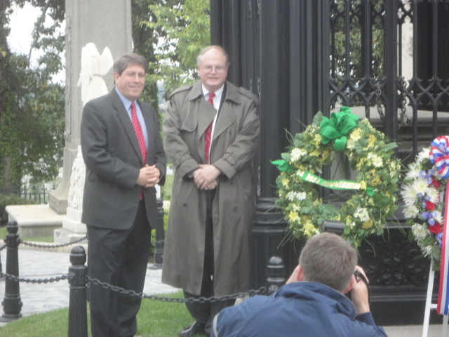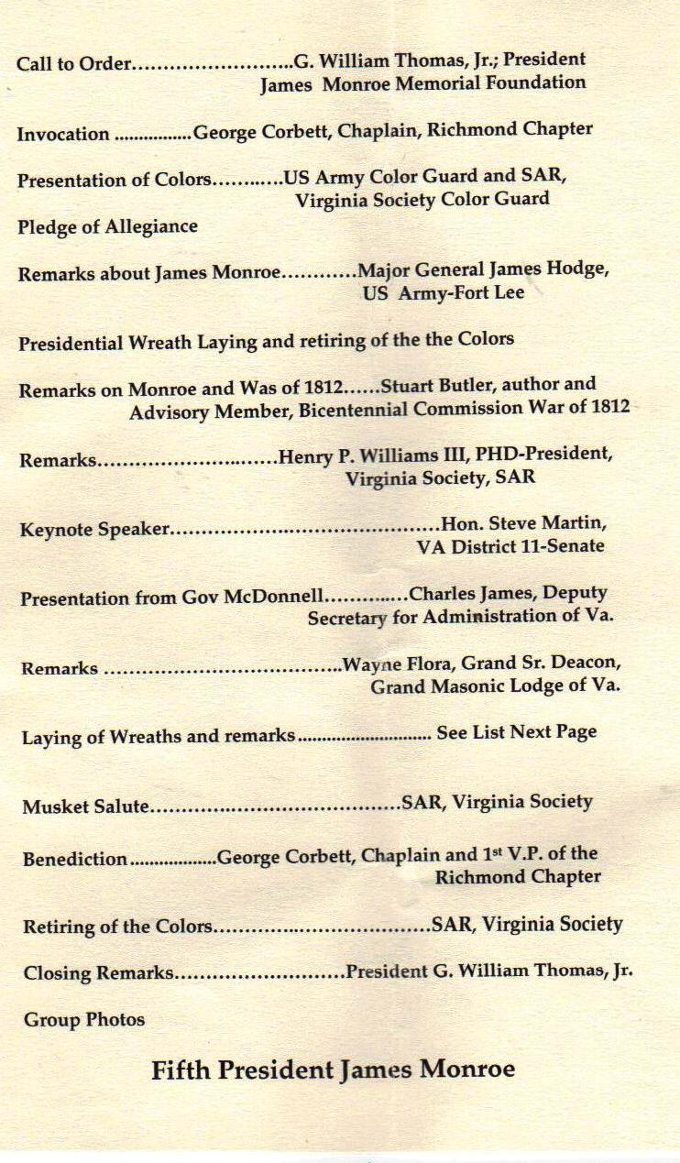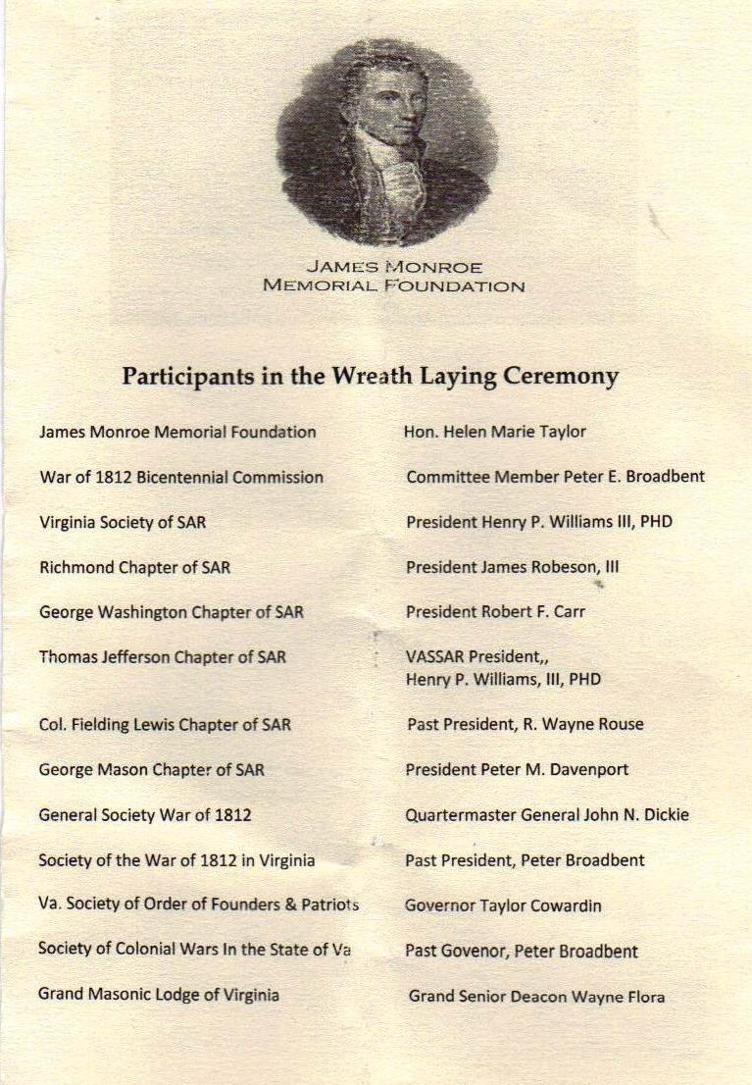

**Stuart Butler details Monroe’s involvement as US Secretary of War in assisting the Governor of Virginia in the preparation and conduct of the conflict in Virginia.**

**Peter E. Broadbent, Jr., Esq. introduces speakers in the ceremony as the War of 1812 Society’s representative to the Virginia’s War of 1812 Bicentennial Commission**

**Virginia Senator, the Honorable Steve Martin & Peter E. Broadbent, Jr. Esq. present the Bicentennial Commission’s wreath**

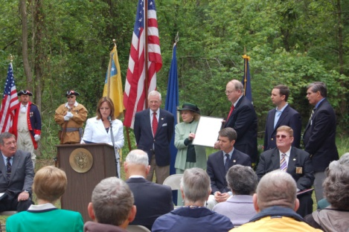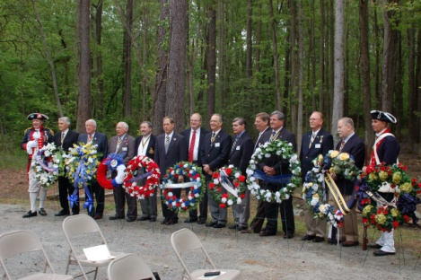

**A photo taken by member Stuart Butler of the ceremony conducted by the James Monroe Foundation on Monroe’s 254th birthday at his birthplace in Westmoreland County, Virginia**

**Peter E. Broadbent, Jr., Esq., Historian of the War of 1812 Society in Virginia (center with red tie) is among the wreath layers from the VA Society SAR at the birthplace of James Monroe in Westmoreland County, VA. He also represented the VA Bicentennial Commission as the Society’s representative.**

**(Photo by Stuart Butler)**