The Society of the War of 1812 in the Commonwealth of Virginia participated in the Smithfield Plantation Ceremony 28 May 2012 honoring War of 1812 Lieutenant Colonel James Patton Preston with a Memorial Marker

James Patton Preston studied law at William and Mary. He married Nancy Taylor of Norfolk and raised six children. Preston was surveyor, justice of the peace, and trustee for the town of Blacksburg, Virginia. In 1802 he was elected to the Virginia State Senate. From 1816 to 1819 he served as Governor. At the time of his death in 1843, his estate was valued at $34,845.
He was son of William Preston (1729-1783) & Susanna Smith (1740-1823) and was educated at the College of William & Mary. He was seriously wounded during the War of 1812 and crippled for life. Representative to House of Delegates 1816 & 20th Governor of VA 1816-1819, under whose term was founded the University of Virginia in Charlottesville. One can find his portrait on-line at findagrave.com. Preston County, VA was named in his honor [now WV]
During the War of 1812 he was Commander of the 75th Virginia Militia Regiment in Montgomery County. He was commissioned Lt Colonel on Feb 13, 1812.
Representing the Society at the Ceremony was Councilor Dennis Fritts who gave remarks regarding his War of 1812 service. Participating in the ceremony from the society also was James J. Owens

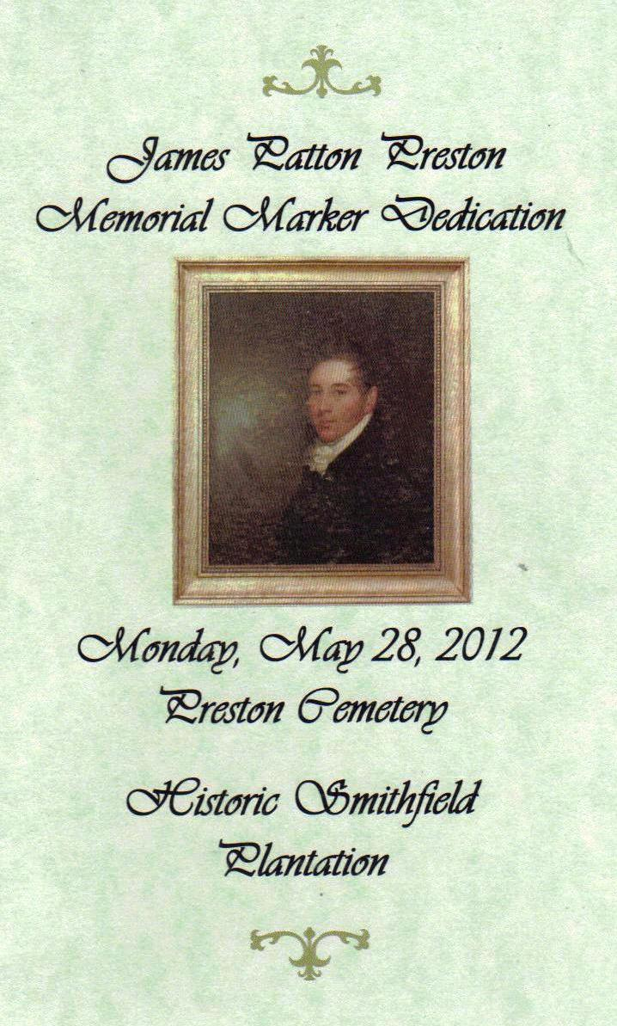
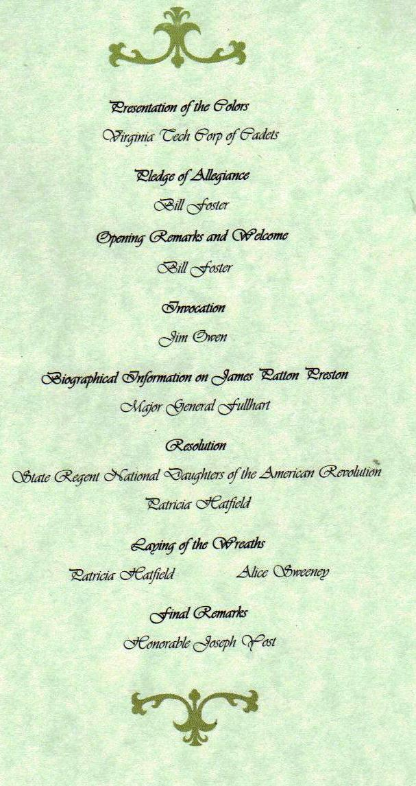
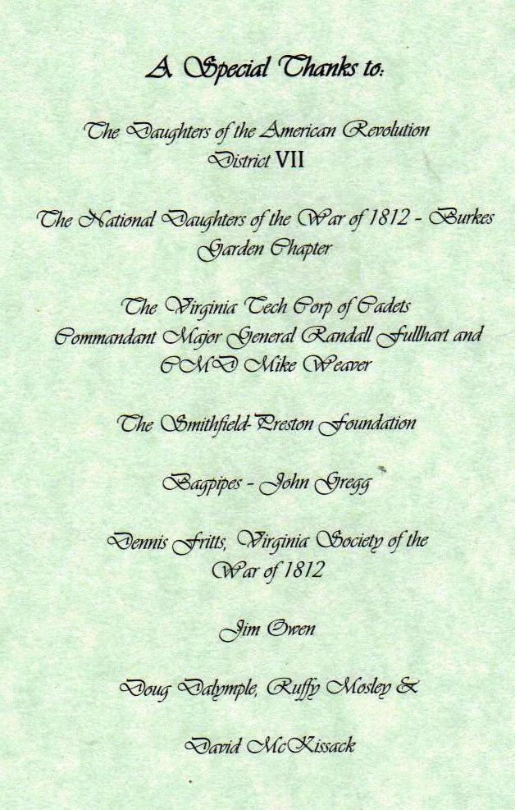
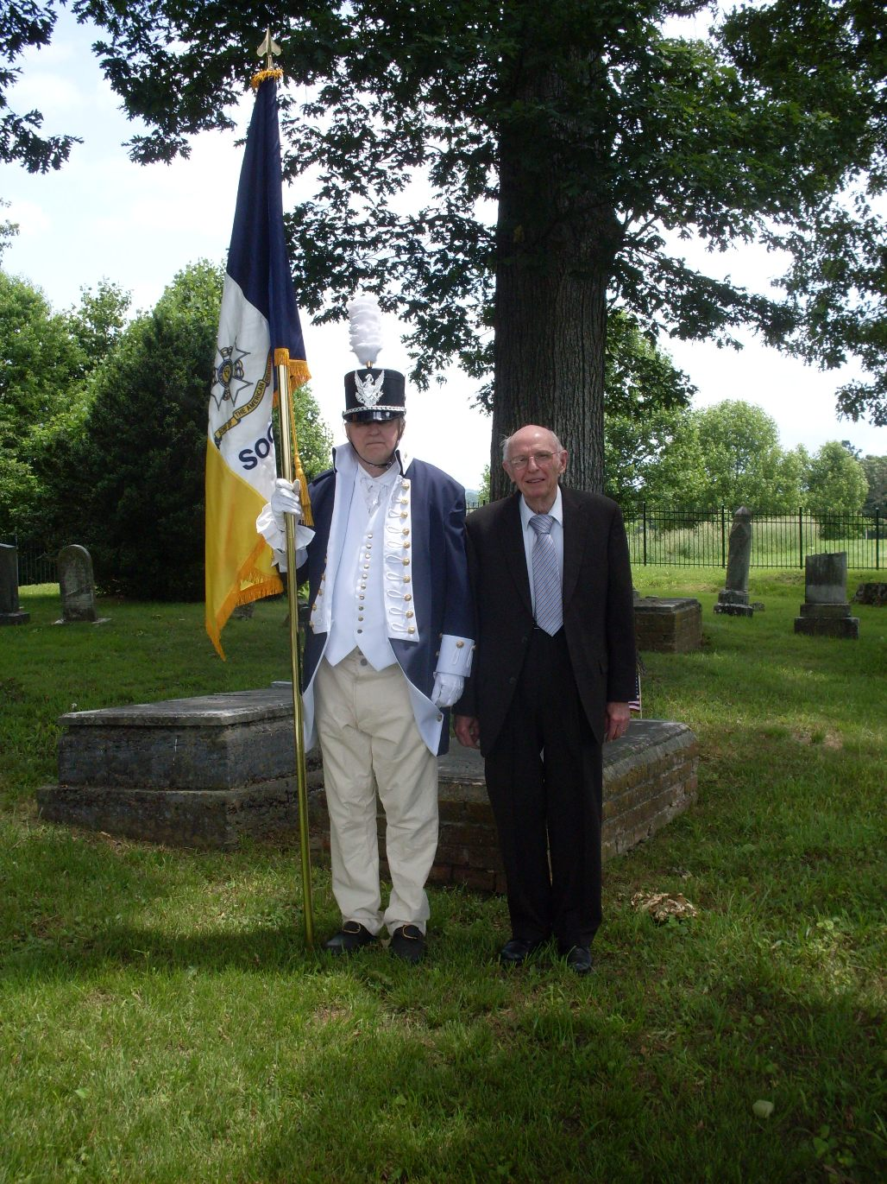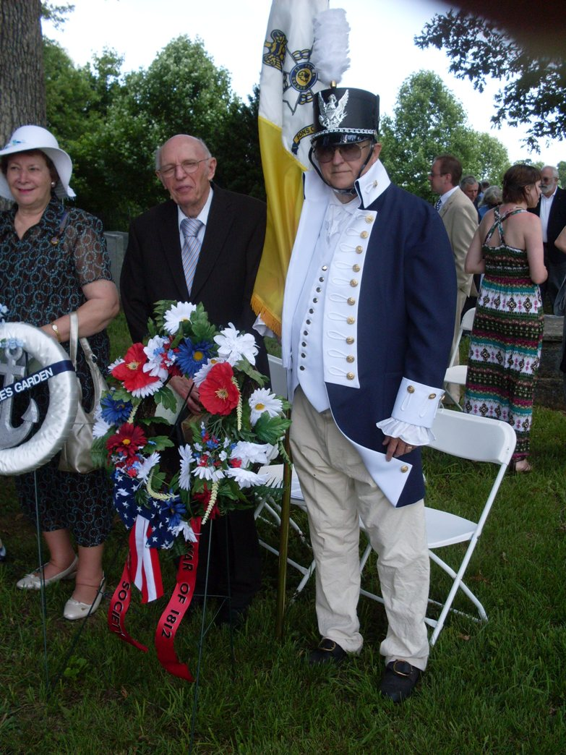
Shown after the ceremony are:
Andy Doss and Dennis Fritts with the War of 1812 Society wreath he presented
Above after the ceremony is Dennis Fritts in War of 1812 attire and Society member James J. Owens by the gravesite of Colonel James Patton Preston

Fritts & Owens are shown with the Society wreath that was presented.

