THE SOCIETY OF THE WAR OF 1812 IN THE COMMONWEALTH OF VIRGINIA PARTICIPATES IN THE DEDICATION CEREMONY OF THE SHENANDOAH VETERANS PARK MAY 25, 2012

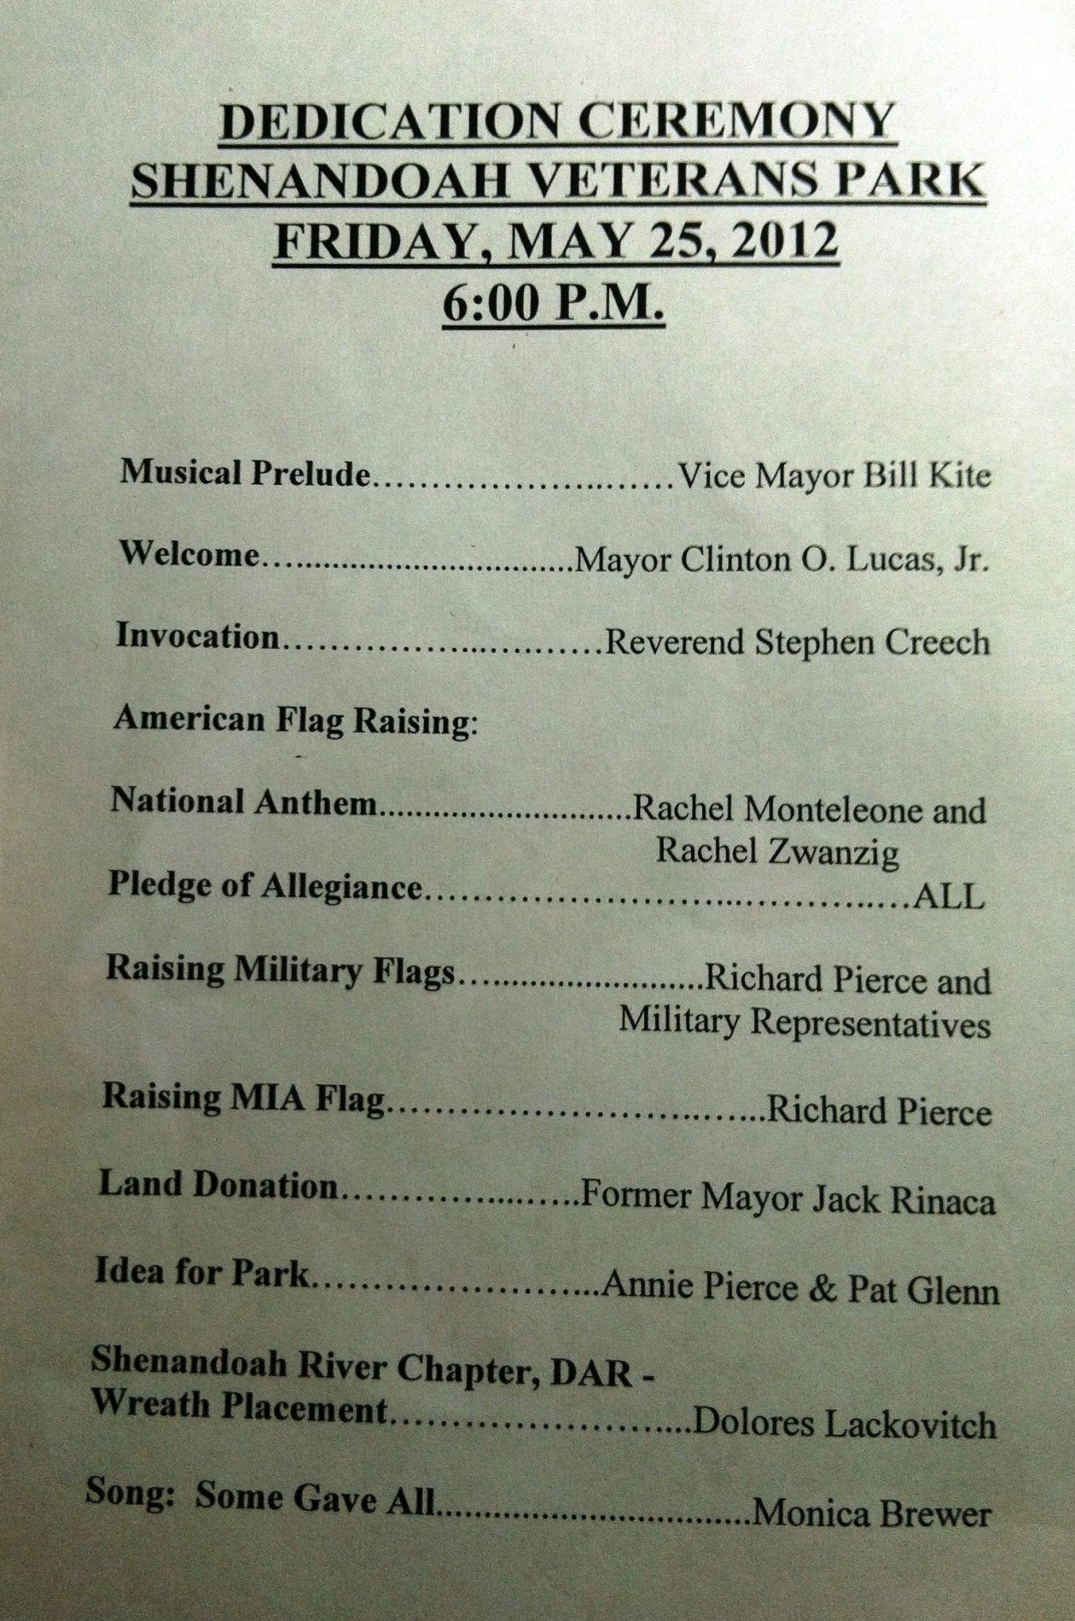
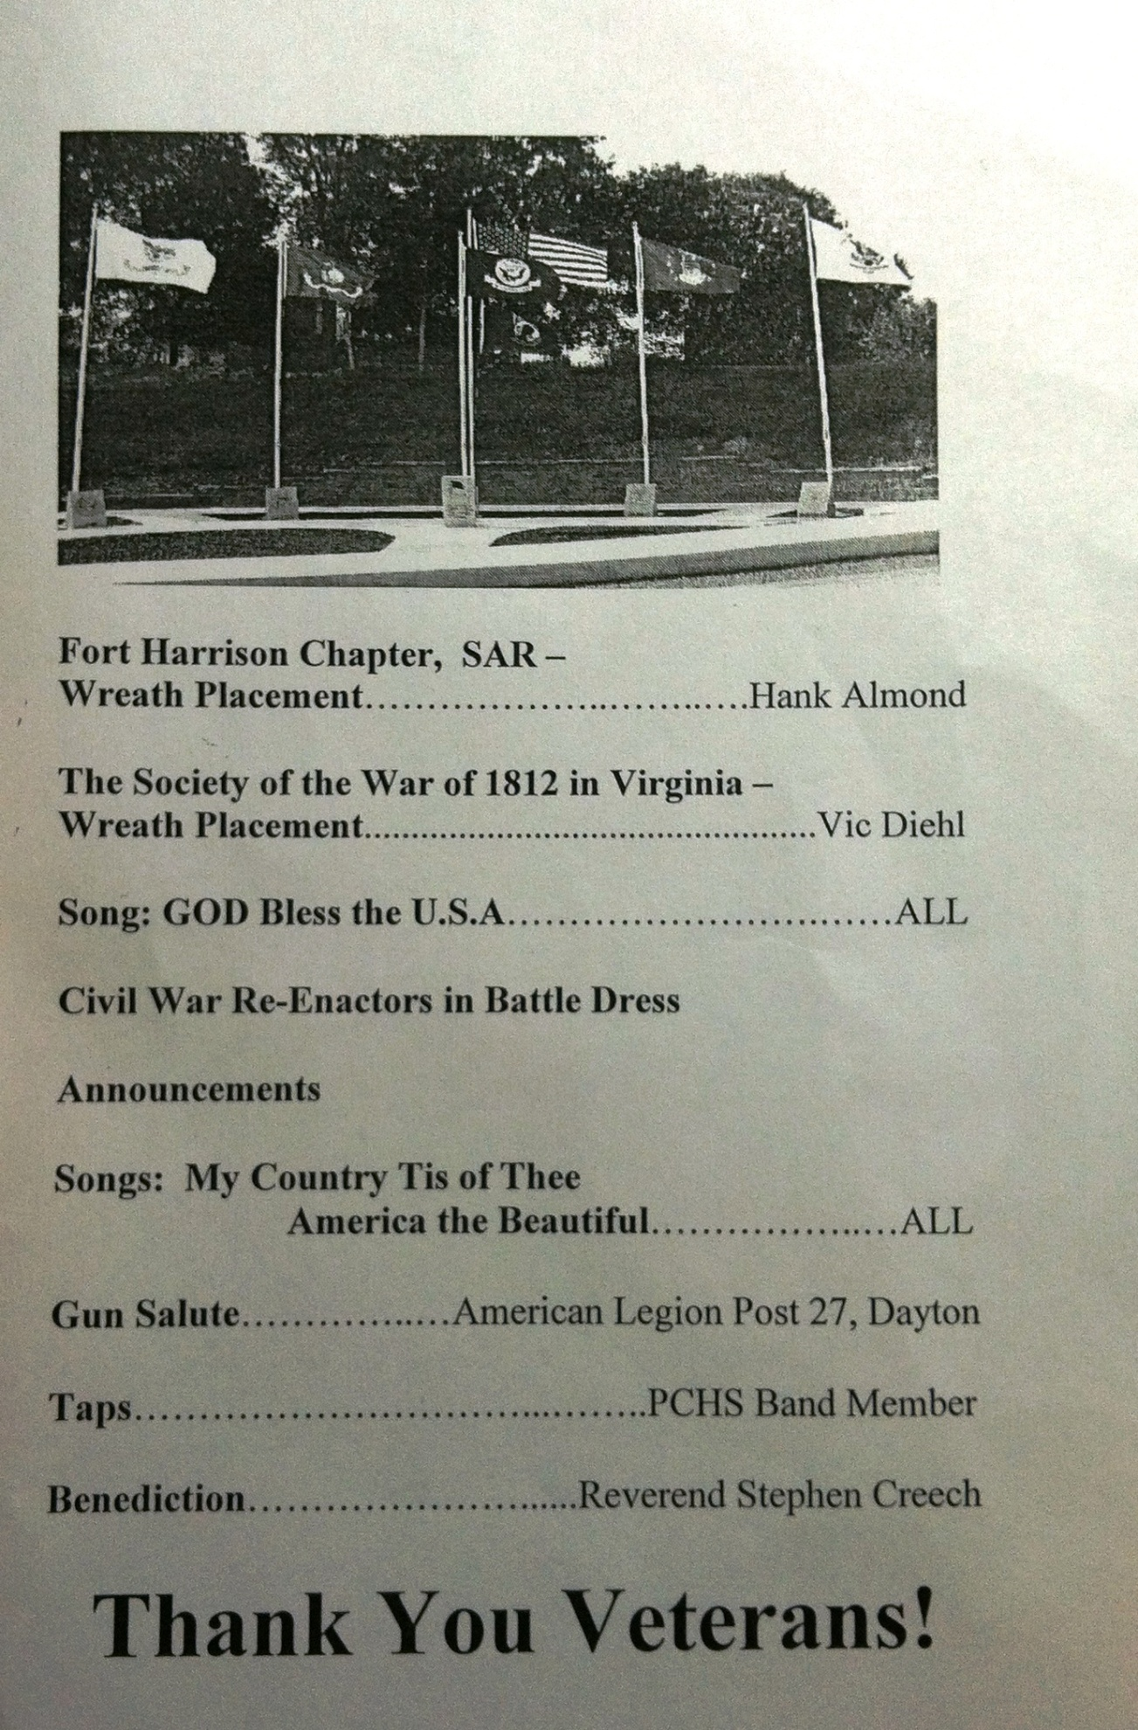
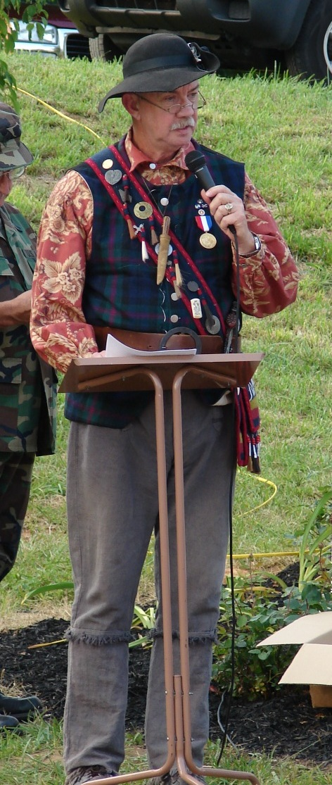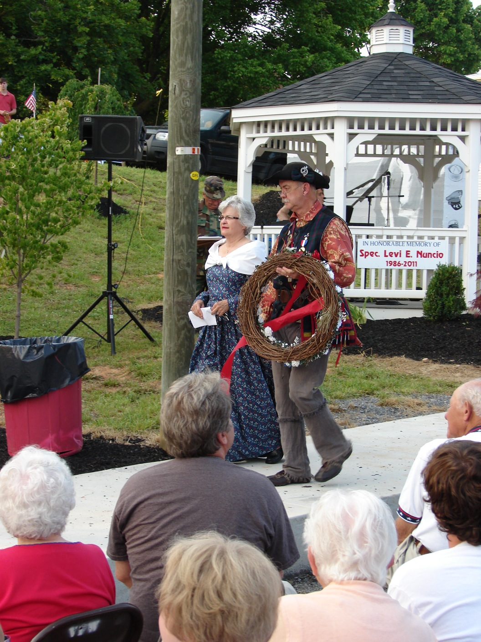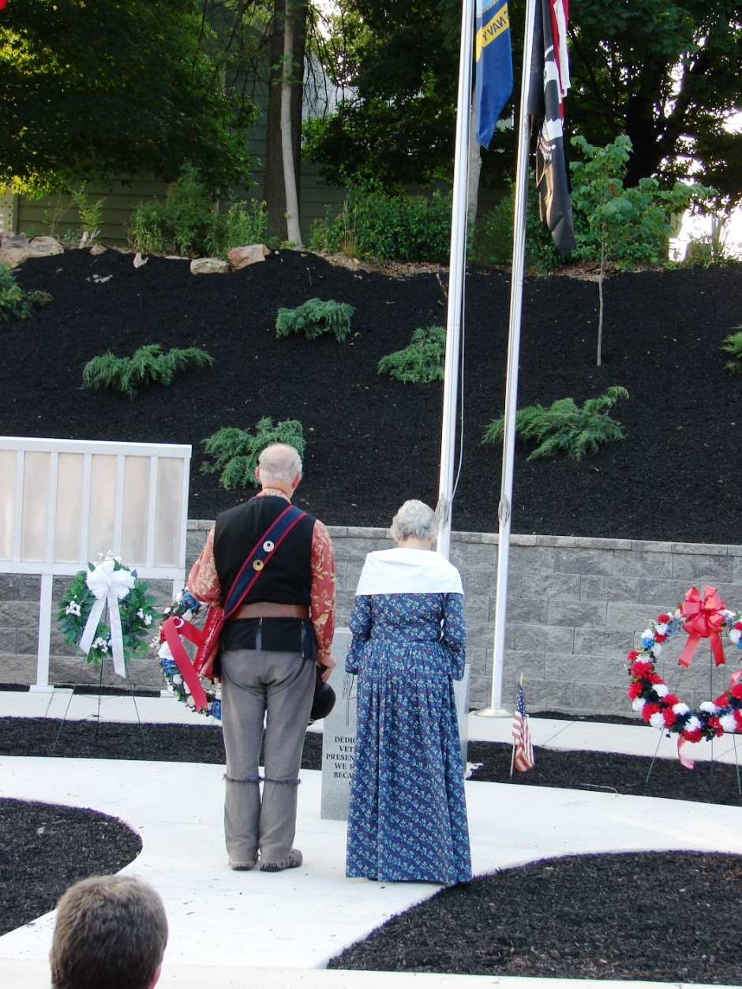
War of 1812 Society in Virginia representative, Carlos Victor
Diehl, Jr. gives greetings and remarks
Diehl and his fiancé, Betty, bring forward the wreath and are shown below presenting it at the monument

