Other Photos from the Fincastle, VA Plaque Unveiling Ceremony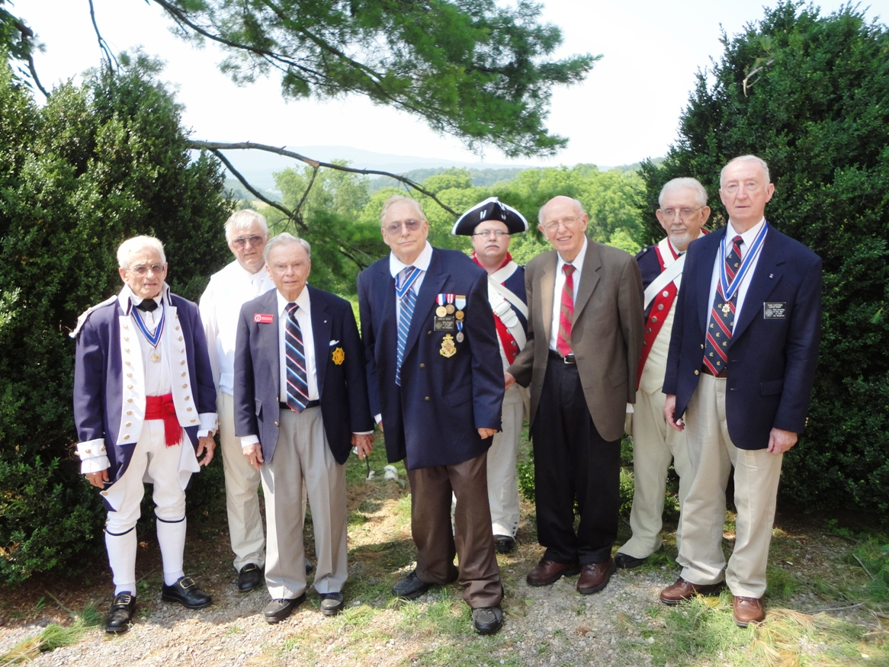
A gathering of some of the members of the Society after the ceremony. (Not shown is John Epperly and Andy Doss) L/R: Mike Lyman, Dennis Fritts, Cranston Williams, John Dickie, Allen Brahin, Jim Owens, Andy Johnson and Thadeus Hartman
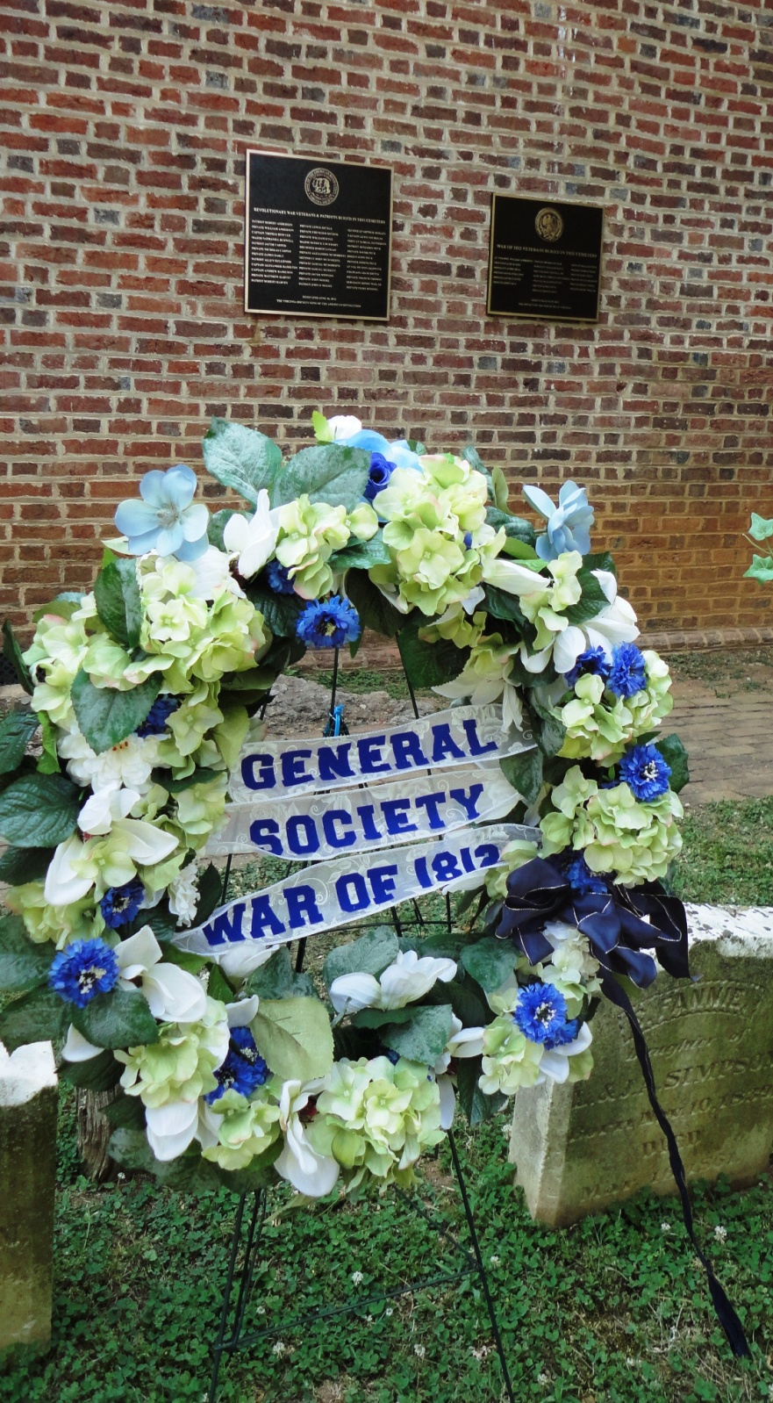
The General Society Wreath Presented by John Dickie
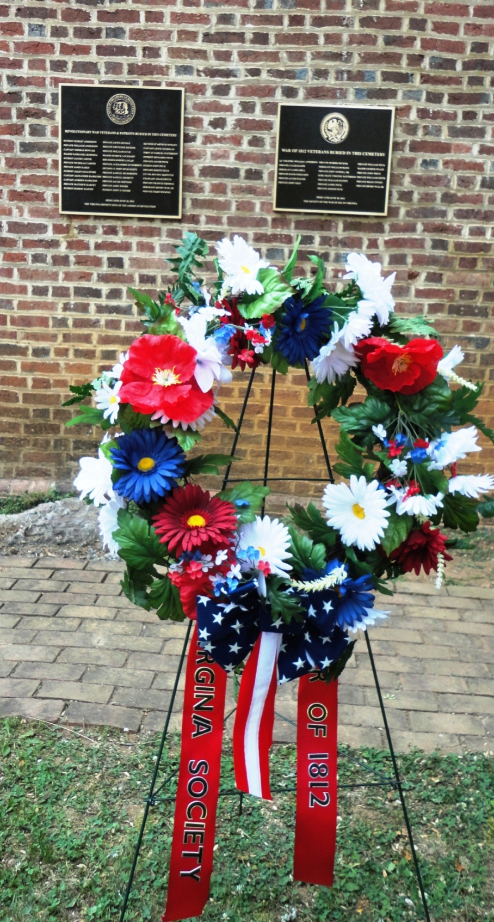
The Virginia Society wreath presented by Thad Hartman
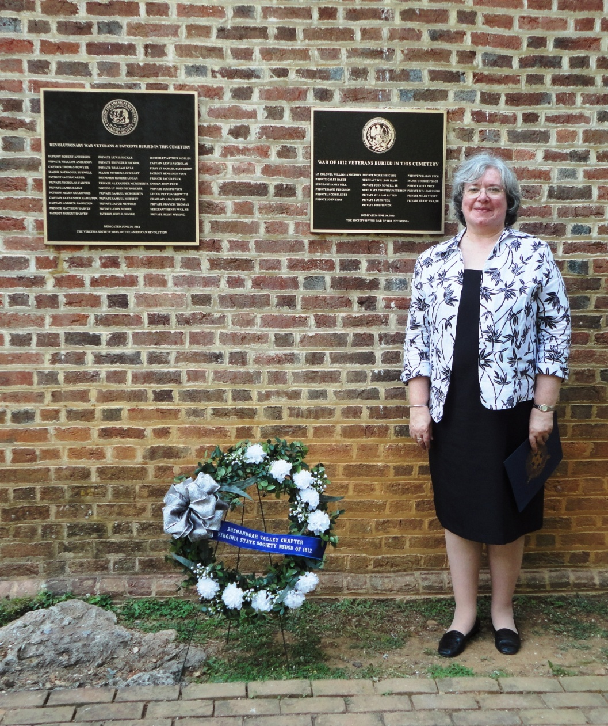
Stephanie Brahin, Treasurer of the Virginia State Society, U.S. Daughters of 1812 is shown by the unveiled plaques. As President of her Shenandoah Valley Chapter she presented that wreath, and she and her husband, R. Allen Brahin, provided many of the photographs for this event.
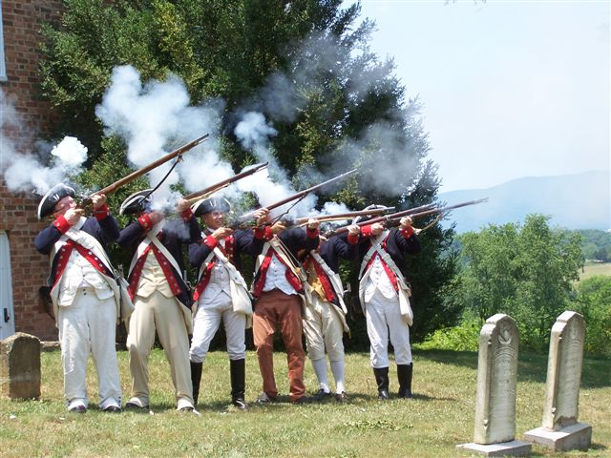
The combined firing party that fired the musket salute.
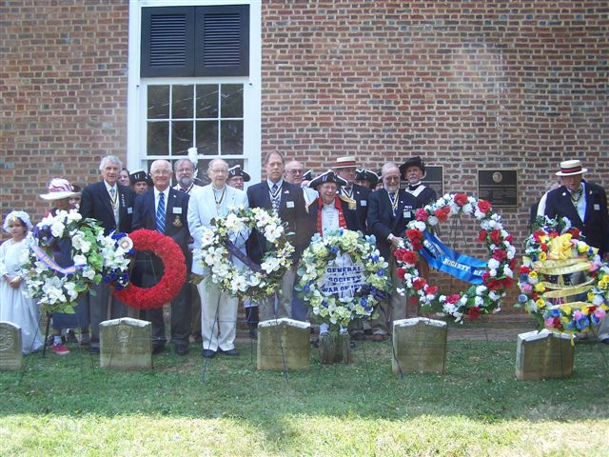
Some of the attendees from both societies
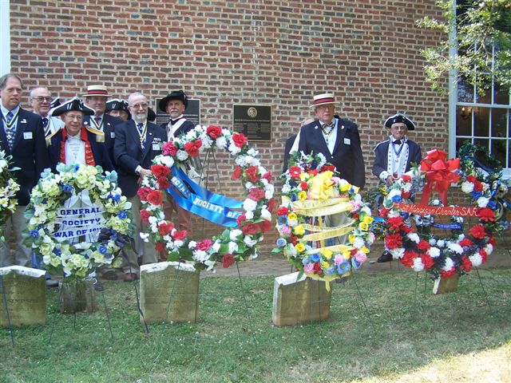
More of the attendees and wreaths

