THE VIRGINIA SOCIETY WAR OF 1812 IN THE COMMONWEALTH OF VIRGINIA CONDUCTS A JOINT GRAVE MARKING CEREMONY WITH THE VIRGINIA SOCIETY, ORDER OF FOUNDERS & PATRIOTS OF AMERICA (OFPA)

The event was conducted at 2:30 pm at the Timberneck farm in Gloucester County, VA on October 20, 2012

The program

The Program:
COMMEMORATION CEREMONY
For

VIRGINIA FOUNDER
JOHN MANN
&
WAR OF 1812 OFFICER
MAJOR ROBERT THRUSTON

Conducted by:
The Virginia Society Order of Founders & Patriots of America
&
The War of 1812 Society in the Commonwealth of Virginia
Call to Order… ………………………….……….……..L. Taylor Cowardin, Governor VA Society, OFPA

Invocation…………………………………….………….Russell C. Scott, Chaplain, VA Society, OFPA

Forwarding & Presentation of Colors …………...……………...………...………Composite Color Guard

Pledge of Allegiance………………………….....led by Past Governor, Donnell J. Hubbard, VA Society, OFPA

Introduction of Attendees, Color Guard & Opening Remarks.............. L. Taylor Cowardin, Governor VA Society, OFPA

Greetings…………………...W. Charles Hampton, Governor General, Order of Founders & Patriots of America

Greetings …………Walter J. Sheffield, Esq., 2d Vice President War of 1812 Society in Commonwealth of Virginia

Greetings…………………………………………..,….. L. Taylor Cowardin, Governor VA Society, OFPA

Greetings…………………………………………………....Bud Noland, Owner of Timberneck Farms

Remarks about the Founder…………………………...Past Governor, Donnell J. Hubbard, VA Society, OFPA
John Mann: was born c1621 in England and was transported to Barbadoes in November 1635. He was appointed as the chief surveyor in Jamaica. He settled in Gloucester County in October 1639 and died 09 Jan 1694 and is buried at Timberneck. He married before 1694, Mary Kemp, (c1648-18 March 1704) widow of Edmund Berkeley. Their only child, Mary, married Matthew Page, who was the son of Sir John Page of Williamsburg. They had children, Mann, Alice and Martha Page. The above reflects the inscription on John Mann’s gravestone which was moved to the Abingdon church cemetery in White Marsh in Gloucester County. The property for many generations remained in the Page family and in the Catlett family that descends from Mary Kemp’s son, Edmund Berkeley Jr. of Gloucester County. A John Catlett built Timberneck Hall about 1776 on or near the location of the original home. A deep water boat landing was on the property where the current docks are located.
Remarks about Timberneck Hall and burials…………………...Jeremy Manning & Lindsay Howard, Caretakers
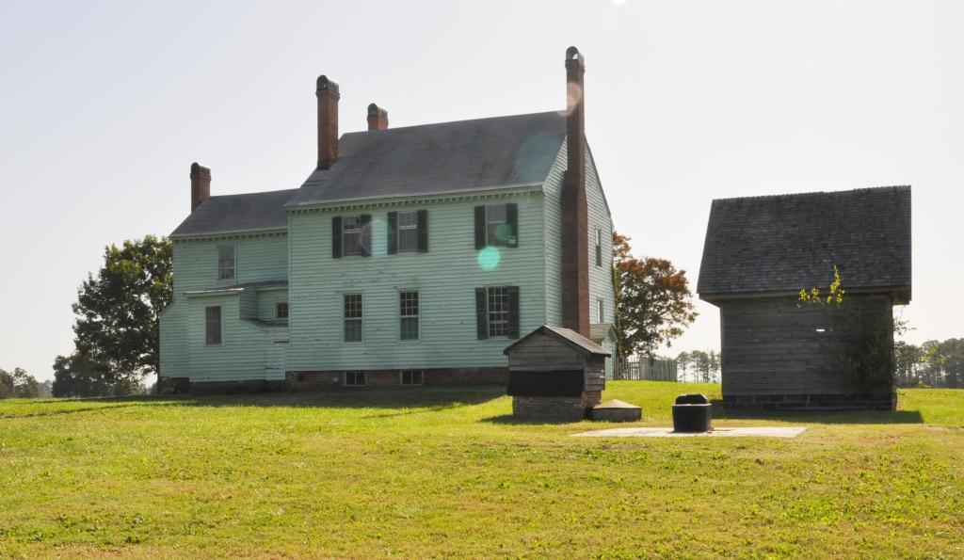

Remarks about the Catlett family…………….Ben Borden. Past President, Gloucester County Historical Society

Remarks about the Page family……………...John Page Aldridge, member, Gloucester County Historical Society

Unveiling of Grave Marker Ritual...Chaplain Russell C. Scott, Cowardin, Hubbard, & Douglas M. Graves VA Soc OFPA

Unveiling of Founder Marker…….W. Charles Hampton, Governor General, Order of Founders & Patriots of America
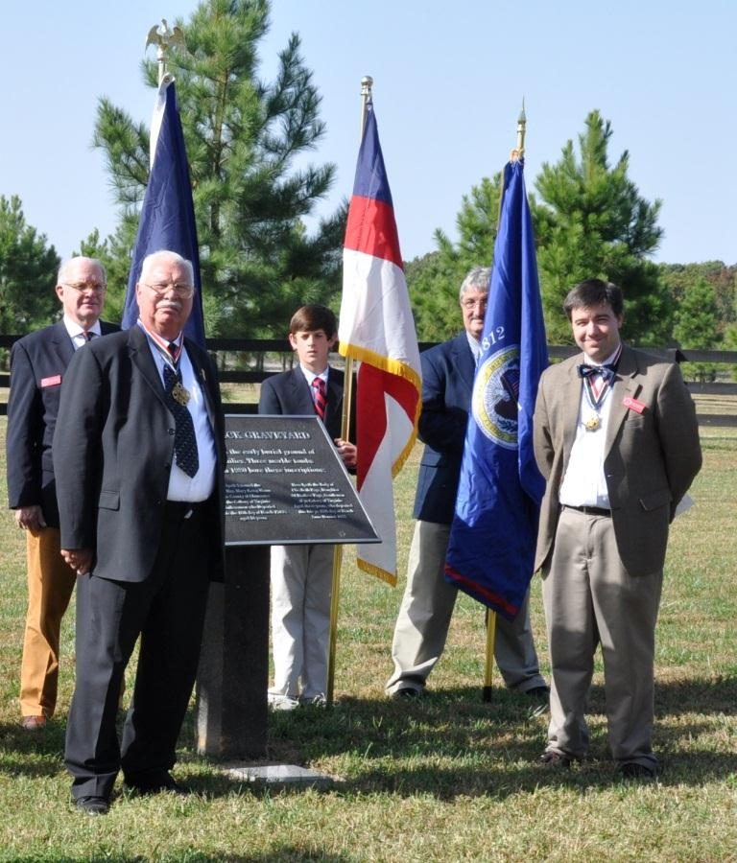
(Photos courtesy of Doug Graves, Registrar, Order of Founders & Patriots of America)
Left to right: Walter Sheffield, Esq., 2d Vice President War of 1812 Society and member of the VA Society OFPA; W. Charles Hampton, Governor General, OFPA and Past President, GA Society War of 1812; Zachary Hall, junior member, VA OFPA holding the Order’s flag; Thomas Sale, Jr. holding the VA Society War of 1812 flag and member of the VA Society OFPA and son of Past President Thomas Sale, Sr. (deceased) of the VA Society War of 1812; and Taylor Cowardin, VA Governor, OFPA and a member of the War of 1812 society in Virginia

Presentation of Wreaths ……………………...Announced by Douglas M. Graves, Registrar, VA Society, OFPA.
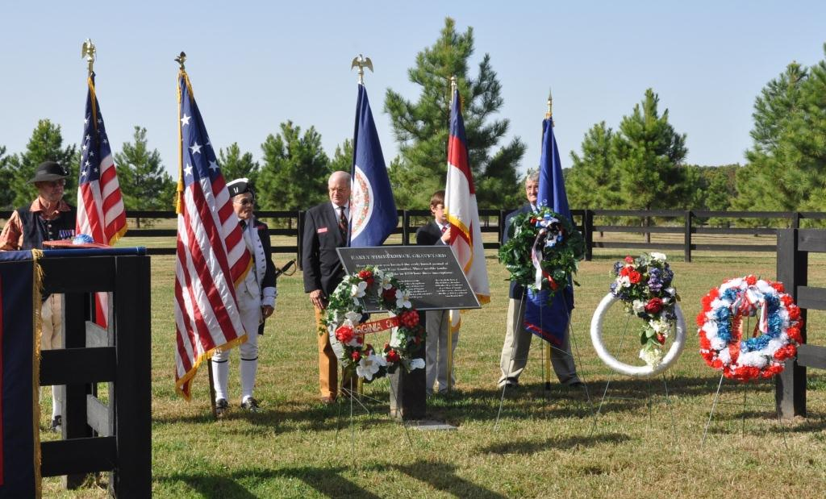
The above photo shows the wreaths that were presented. The OFPA founder grave marker is on the ground in front of the sign

COLOR GUARD LEADS ATTENDEES TO WAR OF 1812 BURIAL SITE

Remarks about the War of 1812 veteran………...Stuart L Butler, Deputy Councilor, War of 1812 Society in Virginia
Major Robert Thruston was a staff officer of the 21st Virginia Militia Regiment of Gloucester County during the War of 1812, having been promoted to this rank on Mar 19, 1814. Previous, as a Captain Company Commander in the county, he had assigned to him 118 men and his unit served at various locations in the county and possibly at Yorktown as well. His unit protected the county’s coastline from British attacks during the periods in 1813 from 16 February to 25 March, 01 May to 03 July, 24 to 31 July, and from 28 August to 23 March 1814, There were numerous enemy incursions and fire fights during these periods. After the war he continued to serve in the county militia and achieved the rank or title of Colonel.
He was born March 30, 1782, at Landsdown in Gloucester County, son of John (20 May 1750-16 Feb 1783) and Sarah (__) Thruston. He died on 22 February 1857. His grandparents were John (21 Oct 1709-20 Feb 1766) and Sarah Haynes (15 Sep 1716-12 May 1785) Thruston. He married Mary Catlett, (c1791-01 Dec 1843), daughter of John and Ann (__) Catlett at Timberneck on 20 December 1820
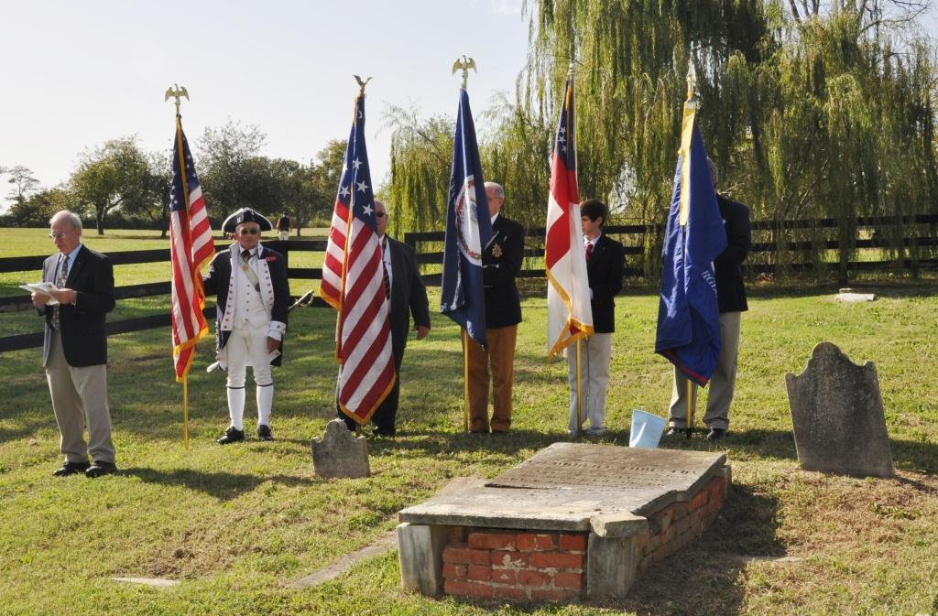
Above; Stuart Butler, Deputy Councilor of the War of 1812 Society in Virginia gives remarks about Major Robert Thruston
Unveiling of War of 1812 Society Grave Marker…J. Shane Newcombe, Quartermaster, War of 1812 Society in Virginia
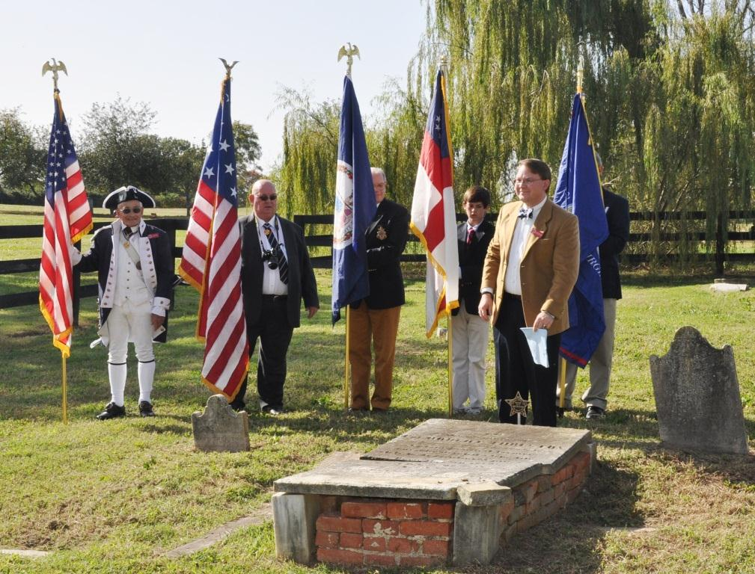
Above: The grave of Major Robert Thruston with the War of 1812 grave marker is shown with Shane Newcombe, Quartermaster of the Society, who has just removed the cover from the marker. Behind them are the colors: The US flag is held by Mike Lyman, Past President of the War of 1812 Society in Virginia; next to the right is Jerry Hubbard, Past Governor of the VA Society OFPA holding the Star Spangled Banner flag of 15 stars and 15 stripes used during the War of 1812; next is Walter Sheffield, 2d Vice President of the Society holding the Virginia state flag; next is Zachary Hall, junior member of the OFPA Society holding the OFPA flag: and Thomas Sale, Jr., son of Former VA State President, Thomas Sale, Sr. (deceased) holding the War of 1812 Society flag.

Presentation of Colors ………………...…………………...……………….... ……….Composite Color Guard

Cannon Salute…………………………..……Carlos Victor (Vic) Diehl, Jr., Secretary, War of 1812 Society in Virginia

Cannon Salute…………………………..……Carlos Victor (Vic) Diehl, Jr., Secretary, War of 1812 Society in Virginia

Taps………………………………………………………………....Tape from Arlington National Cemetery

Retirement of Colors…………………………….…..……………………………….Composite Color Guard

Closing remarks………………………………...….……….......... L. Taylor Cowardin, Governor VA Society, OFPA

Benediction: ……………………………………..…………….....Russell C. Scott, Chaplain, VA Society, OFPA

Adjournment…………………………………………..………...L. Taylor Cowardin, Governor VA Society, OFPA

Group Photos:

Tour of grounds ( Note the inside of Timberneck Hall has deteriorated, thus group tours inside can not be conducted)

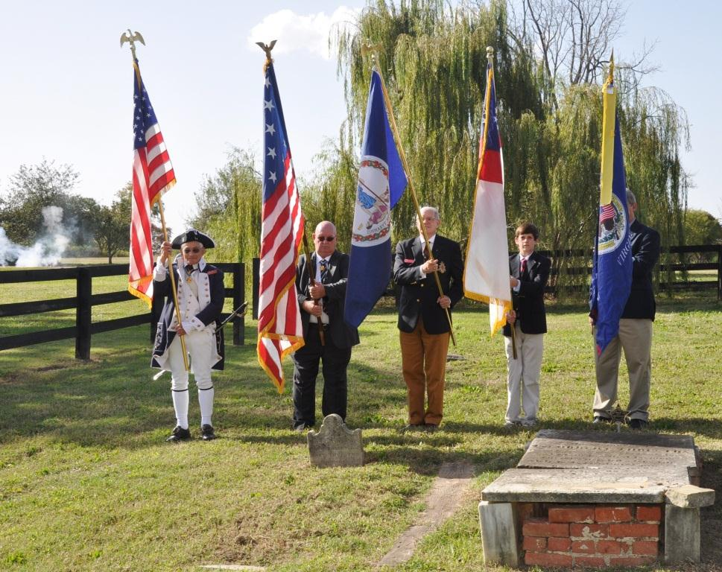
Smoke from the cannon belonging to Victor Diehl is on the left with the colors presented
Below is Victor Diehl, Secretary of the War of 1812 Society in the Commonwealth of Virginia with his antique brass cannon
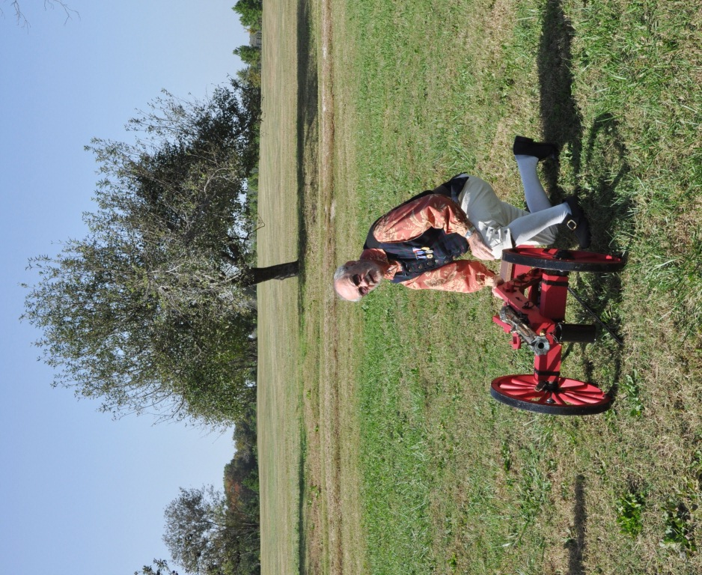

Taps………………………………………………………………....Tape from Arlington National Cemetery

Retirement of Colors…………………………….…..……………………………….Composite Color Guard
