Society of the War of 1812 in Virginia
ANNUAL MUSTER
Friday, June 21, 2013 - Hampton, Virginia
Attire: Coat & Tie (James Monroe Tie: preferred for members)
Schedule of Events:
10:00AM – 11:30AM – BUSINESS MEETING (members only)
Hampton History Museum - Great Room
120 Old Hampton Lane
Hampton, Virginia 23669
11:45AM – 12:45PM – LUNCHEON (guests welcome)
Hampton History Room – Great Room
Guest Speaker: Stuart Butler
Topic: Occupation of Hampton
12:30PM – 1:15PM – GUIDED TOUR of MUSEUM (guests welcome)
2:30PM – Grave Marking and Wreath Laying Ceremony (guests welcome
There is no fee for attendance)
Fourteen War of 1812 society veterans will be honored with in a plaque unveiling ceremony
St. John’s Episcopal Church
100 W. Queens Way
Hampton, Virginia 23669

Mail in this portion with check NLT Thursday 13 June

Our Annual Muster precedes events that will be held at Fort Norfolk on Saturday, June 22.
All Reservations must be received by Monday, June 13, 2013.

_________________________________________ will be attending the Annual Muster.
Title/Society______________________________________________________________
_________________ (number in party) x $35.00 = TOTAL: _______________________
The Luncheon will be a buffet and will be catered by The Grey Goose Restaurant. The menu includes Balsamic Salad, Iced Tea/Water, Chicken Cordon Bleu, Roasted Top Round, Mashed Potatoes, fresh vegetables, and homemade dessert.
Make checks payable to: Society of the War of 1812 in Virginia
Remit to:
Mr. Bill Nash, Treasurer
2701 Main Sail Ct.
Richmond, Virginia 23233-3351
Address for:
HAMPTON HISTORY MUSEUM
Great Room (meeting/luncheon)
120 Old Hampton Museum
Hampton, Virginia 23669
(757)-727-1610
www.hamptonhistorymuseum.org
We will be having our Business Meeting, Luncheon, Guest Speaker, and a guided tour (price included in your Annual Muster reservation fee) at this facility.
Directions:
Coming from Williamsburg Take Interstate 64 east to exit 267. At the bottom of the ramp, bear right onto Settler's Landing Road. At the foot of the bridge, continue straight on Settler's Landing Road. Turn right on History Museum Way. Take an immediate right into the city parking garage; parking is free. The Hampton History Museum is diagonally across the street from the garage, at 120 Old Hampton Lane. Coming from Norfolk Take Interstate 64 west to exit 267 (second exit after the bridge tunnel). At the bottom of the ramp, bear left onto Settler's Landing Road. At the foot of the bridge, continue straight on Settler's Landing Road. Turn right on History Museum Way. Take an immediate right into the city parking garage; parking is free. The Hampton History Museum is diagonally across the street from the garage, at 120 Old Hampton Lane.
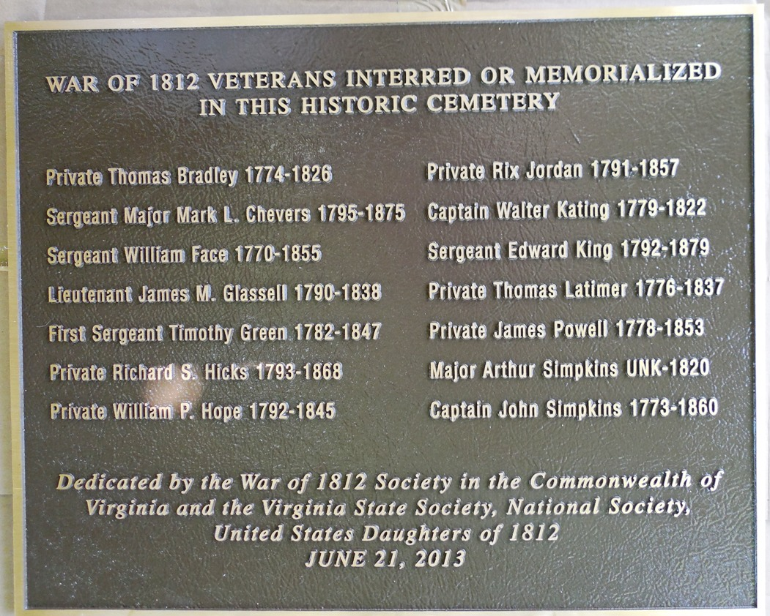
The above plaque will be unveiled

