THE BRITISH CONDUCT RAIDS IN THE SUMMER OF 1813 IN HAMPTON ROADS, VIRGINIA AREA
Descriptions are in the Newport News Daily Press Newspaper shown below .It also shows some uniforms worn during the period and a sword

Mike Lyman possesses this 1812 period artillery sword similar to the one shown in the article below
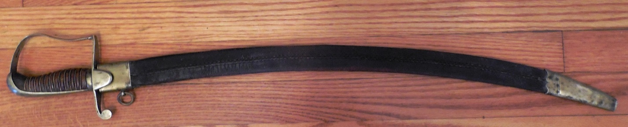

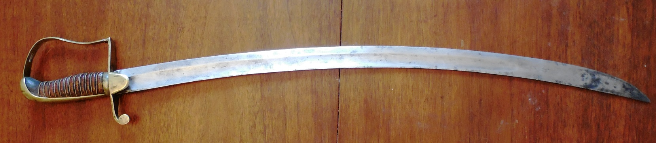
T
