A NEW VIRGINIA HISTORICAL ROAD SIGN IS UNVEILED JULY 20, 2013
A new sign on route 202 in Westmoreland County, Virginia at the location of the Nomini Episcopal Church was unveiled on July 20, 2013 in a ceremony. Below is the wording, the program, and some photos taken.
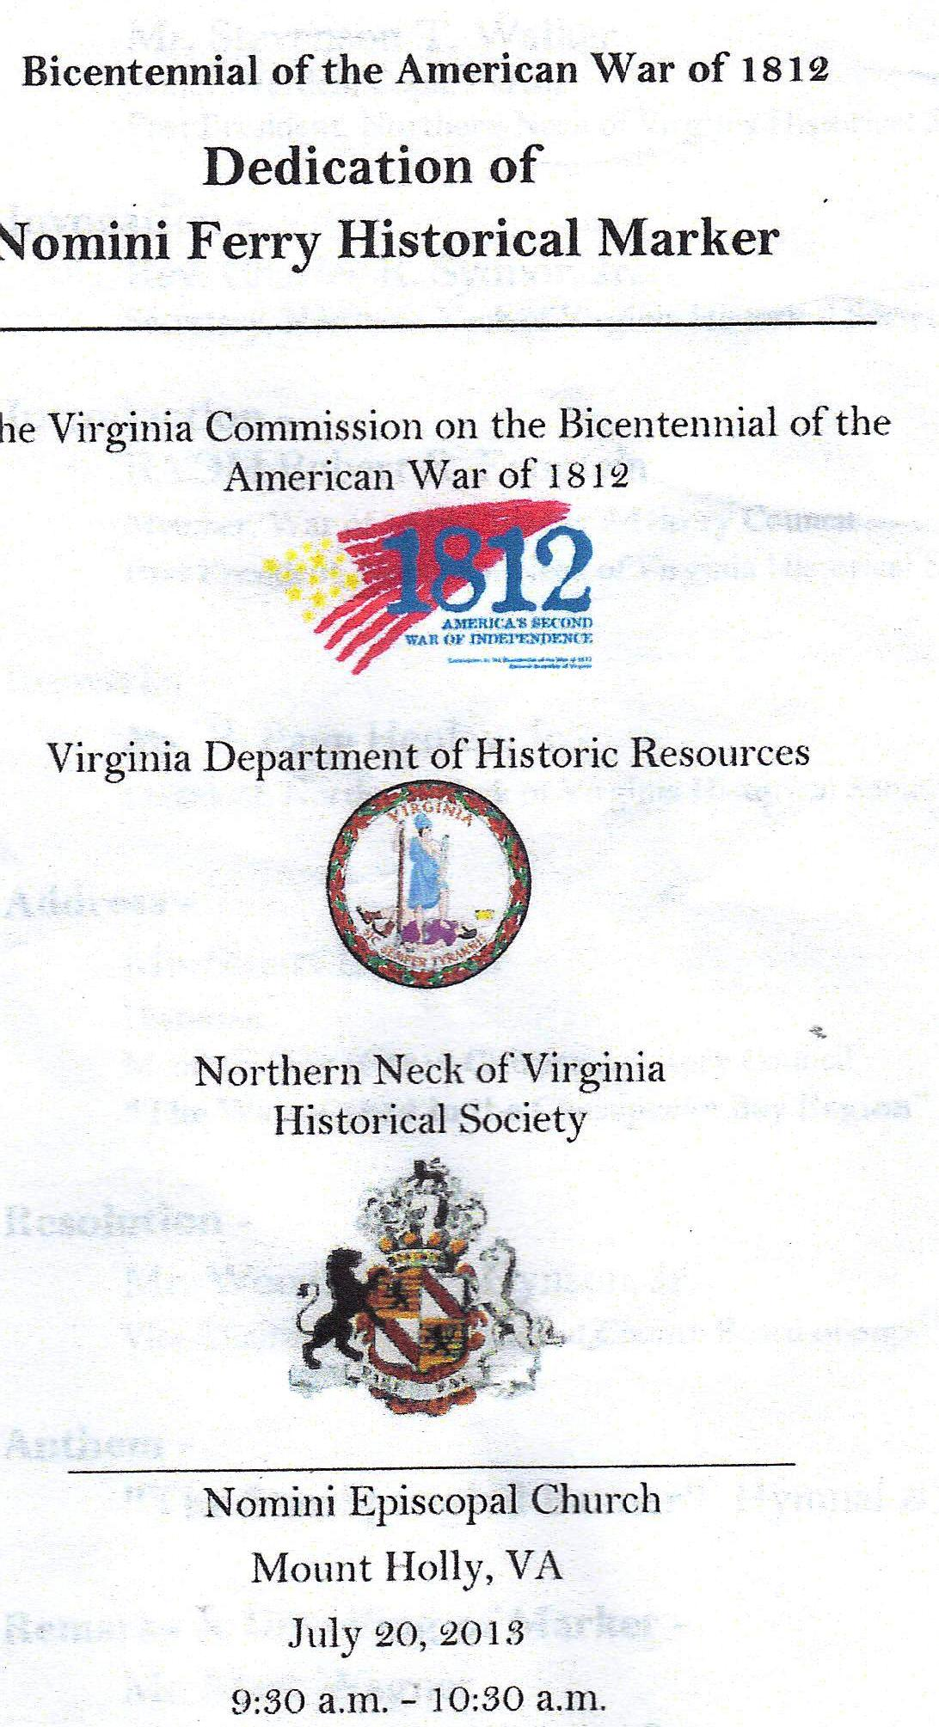
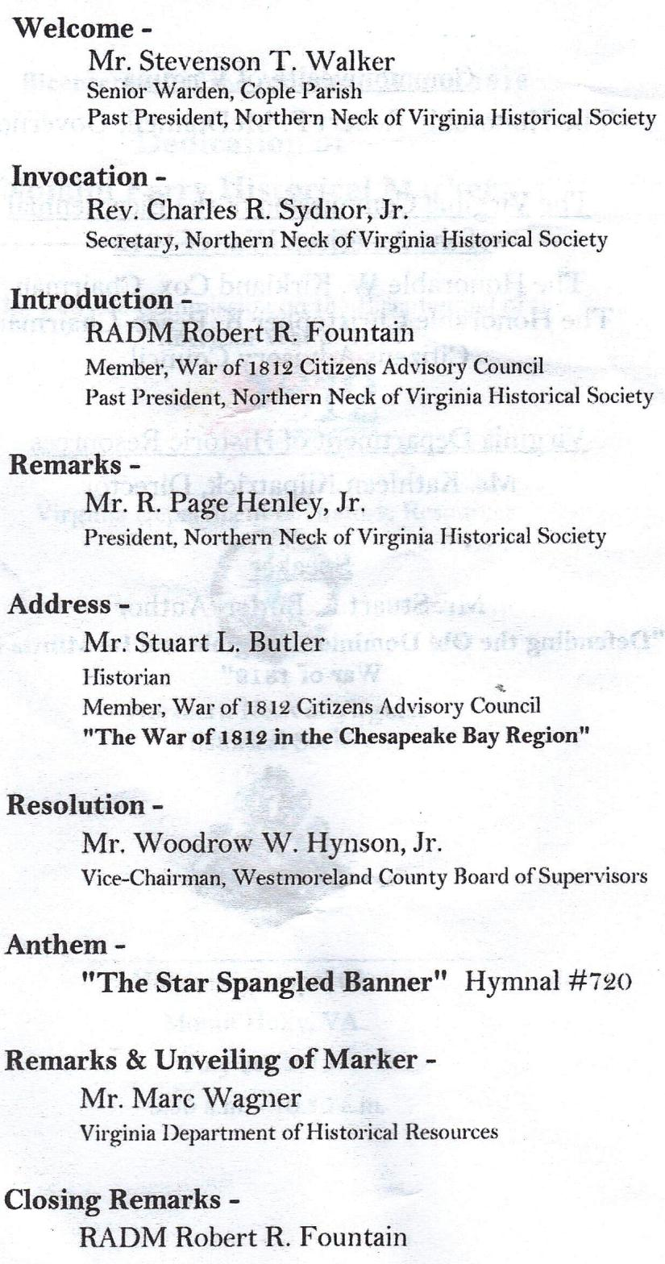
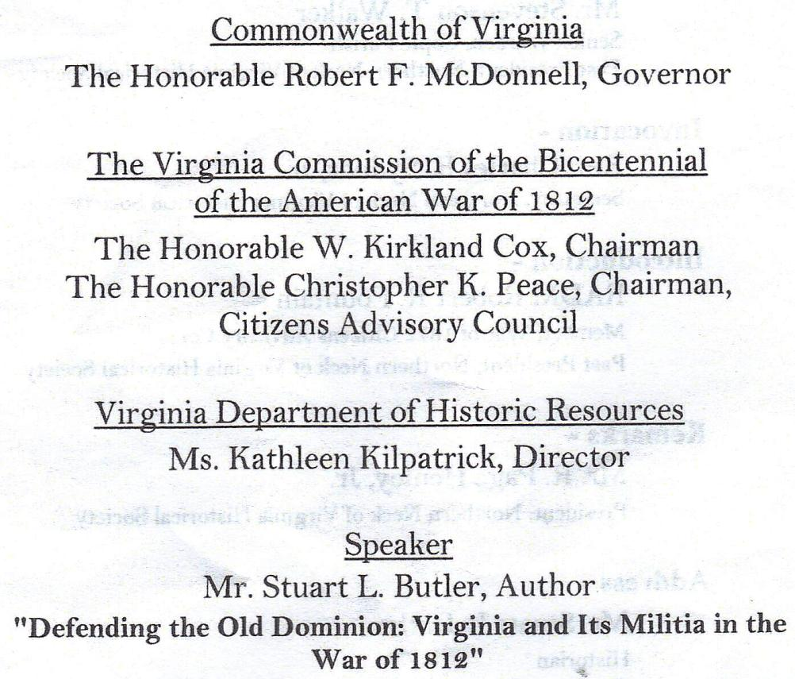
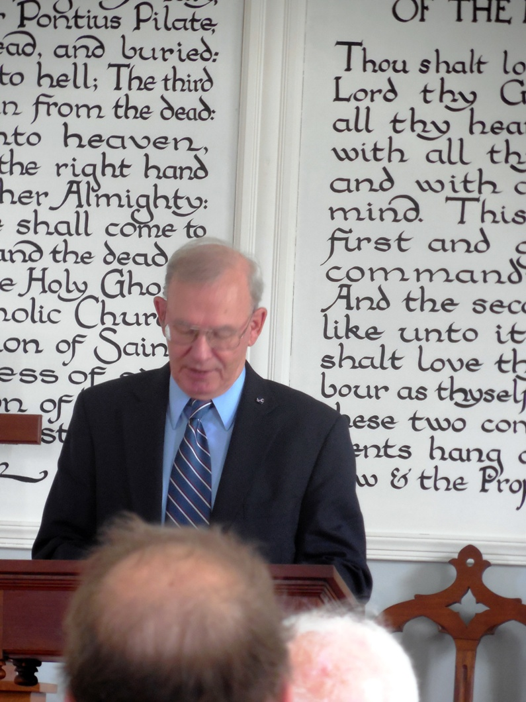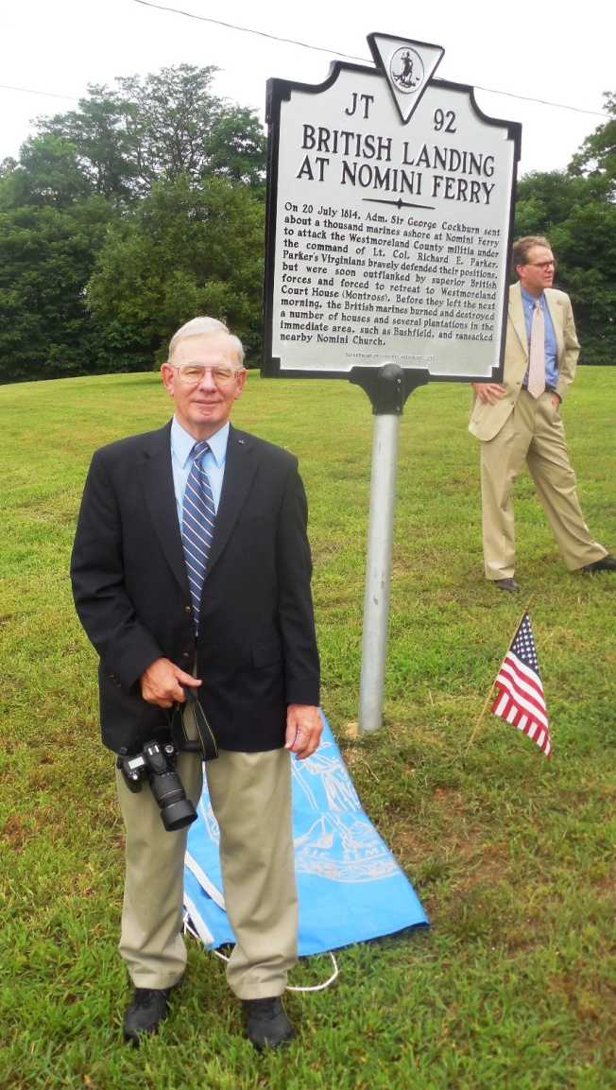
Speaker Stuart L Butler is shown presenting the story about the encounter with the British during the War of 1812 inside Nomini Episcopal Church and outside at the sign after the unveiling

Below is a gathering of key members at the sign after the unveiling
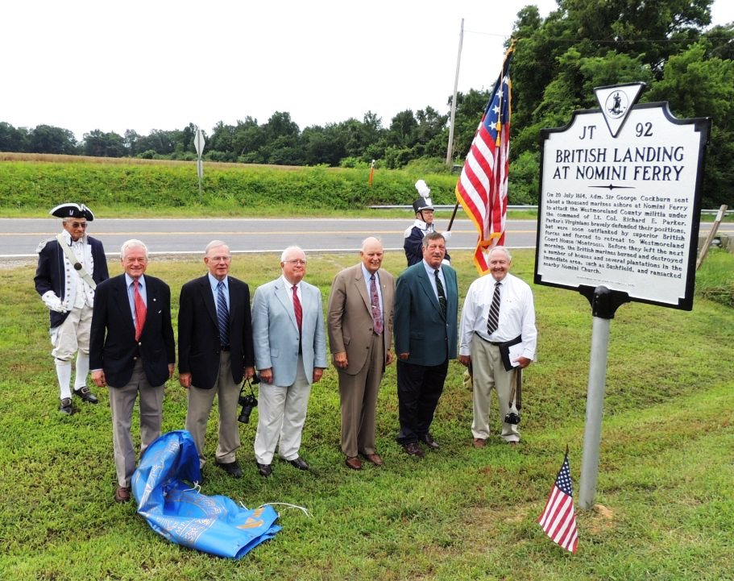
The photos shows Mike Lyman as Past President of the War of 1812 Society in VA as escort of Charles Belfield, Member of the Society presenting the Star Spangled Banner Flag
The rest L/R :
Bill Thomas, representing the VA War of 1812 Bicentennial Commission and the James Monroe Memorial Foundation; Stuart L Butler, Councilor, War of 1812 and author of many books on the War of 1812 in VA; Page Henley, Jr, President of the Northern Neck of VA Historical Society; RADM Robert R. Fountain, Past President Northern Neck of VA Historical Society; Woodrow W. Hynson, Vice-Chairman, Westmoreland County Board of Supervisors; and Stevenson T. Walker, Past President, Northern Neck of VA Historical Society

